ISSUES (Date=2017/11/20)

FB Entity ID=33670708

fbUrl=https://www.facebook.com/oded.zehavi

Insta URL=<https://www.instagram.com/armandzhumageldiev/>

Insta Entity ID=33488360

………..

FacebookUserDetails=OK

FBFriends=OK

FBUserGroups=OK

FBFollowing

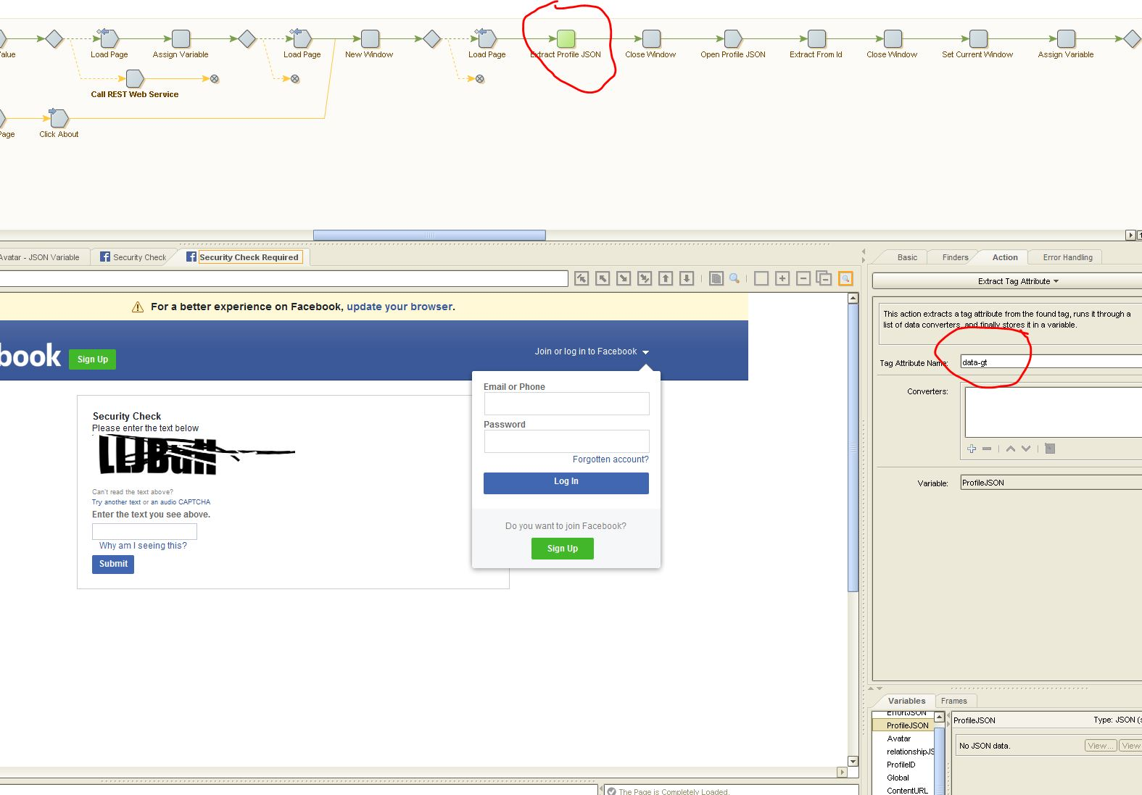

Error message:-

The Extract Tag Attribute step requires a found tag, but the tag finder did not find any tag. There is no tag that matches the attribute name and value.

You should adjust the tag finder, or add another tag finder that finds the right tag on this particular page. If you add another tag finder, make sure that only one of them finds a tag on any given page.

Location:- V 1.0 - Write Log - Load Page - Extract Kapow Server - Extract Entityt Repository - Extract User Name - Extract Password - Extract Document Repository - Extract Node Server - Assign Variable - Assign Variable - Assign Variable - (Unnamed Try step) - Call REST Web Service - Write Log - Open Avatar - Extract User Name - Extract Password - Extract Avatar Id - Extract IP - Extract Port - Extract User Name - Extract Password - (Unnamed Try step) - Test Value - Change Proxy - Load Page - (Unnamed Try step) - Enter Text - Enter Password - Click Log In - Call REST Web Service - (Unnamed Try step) - Test Value - (Unnamed Try step) - Load Page - Assign Variable - (Unnamed Try step) - Load Page - New Window - (Unnamed Try step) - Load Page - Extract Profile JSON

Couldn’t understand what kind of tag that used to extract a JSON file.

GetInstagramDetails

Same Error, Previously mentioned, still didn’t correct.

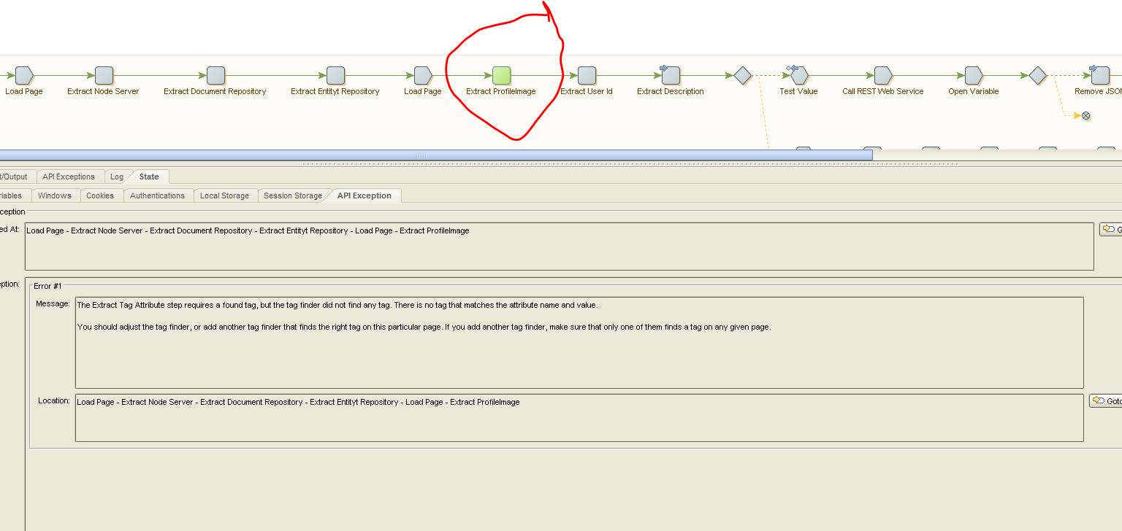

UP(error) , Below (Adding Exception handler )

