**Robot check (Daily) 2018-03-22**

<https://www.facebook.com/chirantha.jananath.9>

43075627

<https://www.instagram.com/delon_dell/?hl=en>

43075628

getInstagramUserDetails=OK

Fbfriends =OK

Fbuserdetails=OK

FbUsergroups =OK

Fbfollowing= error

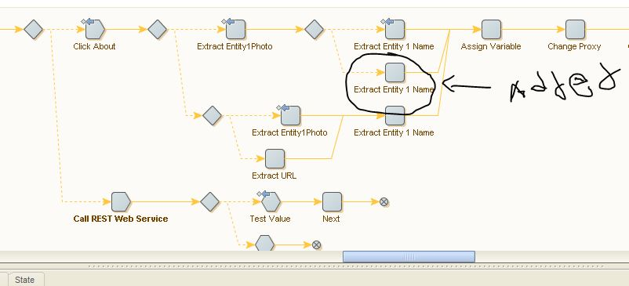

**GS-Crawler**

Server

There was a server error, couldn’t receive data that crawled from news sites.

* <http://www.24-7pressrelease.com/press_releases_today.php> (176)=last crawled date= 2018-03-08, 08:09 am=didn’t crawled
* <http://abcnews.go.com/International> =180)=last crawled date= 2018-03-07, 06:30 pm=didn’t crawled
* <http://abcnews.go.com/Business> =184)=last crawled date=2018-03-05, 04:45 pm=didn’t crawled
* <http://abcnews.go.com/US/Good_News>=186)=last crawled date=2018-03-05, 02:15 am=didn’t crawled
* <https://www.cbsnews.com/world/> =187)=last crawled date=2018-03-05, 03:03 am=didn’t crawled
* <http://www.cbsnews.com/politics/> =188)=last crawled date=2018-03-08, 09:10 pm=didn’t crawled
* <http://www.cbsnews.com/entertainment/> =189)=last crawled date=2018-03-05, 04:57 am=didn’t crawled
* <http://www.cbsnews.com/tech/> =193)=last crawled date=2018-03-05, 05:22 pm=didn’t crawled
* <http://www.cbc.ca/news> =last crawled date =194=2018-03-08, 08:10 am =didn’t crawled 196=2018-03-07, 02:02 am=didn’t crawled
* <http://abcnews.go.com/Entertainment> =181)=last crawled date=2018-03-07, 04:14 pm=didn’t crawled
* <http://abcnews.go.com/Technology> =182)=last crawled date=2018-03-05, 06:22 pm=didn’t crawled
* <http://www.metrotvnews.com/>=(77)= last crawled date==didn’t crawled
* <https://www.sindonews.com/>=(84)= last crawled date==didn’t crawled
* <http://www.republika.co.id/>=(31)= last crawled date==didn’t crawled
* <https://www.merdeka.com/>=44= last crawled date==didn’t crawled
* <http://www.portalkriminal.com/>=81= last crawled date==didn’t crawled
* [https://www.tribunnews.com](https://www.tribunnews.com/)=138= last crawled date==didn’t crawled
* <http://www.beritajatim.com/>=58= last crawled date==didn’t crawled
* <http://www.beritasatu.com/>=86= last crawled date==didn’t crawled

|  |
| --- |
|  |
|  |
|  |
|  |
|  |
|  |
|  |
|  |