**INTRODUCTION:**

An internship is a professional learning experience that offers meaningful, practical work related to a student’s field of study or career interest. An internship gives a student the opportunity for career exploration and development, and to learn new skills. It offers the employer the opportunity to bring new ideas and energy into the workplace, develop talent and potentially build a pipeline for future full-time employees.

An internship serves as a position to help you get valuable. Often acts as a pathway into a specific industry. Companies may hire graduates or final-year students for a predetermined period. While compensation for this opportunity may or may not be provided, the primary aim is for interns to gain experience. Students typically apply for internship opportunities during their undergraduate or graduate studies. It is common for students to undertake an internship during a semester or quarter while their classes may continue simultaneously. A quality internship:

* Consists of a part-time or full-time work schedule that includes no more than 25% clerical or administrative duties.
* Provides a clear job/project description for the work experience.
* Orients the student to the organization, its culture and proposed work assignment(s).
* Helps the student develop and achieve learning goals.
* Offers regular feedback to the student intern.

**BENEFITS OF INTERNSHIP FOR STUDENTS**:

1. Explore a whole new world
2. Help you choose the right career
3. Explore your career path
4. Boost your self-assurance
5. Expand your network
6. Gain experience in your field of interest
7. Discover new interests.
8. Learn new skills

**COMPANY OVERVIEW:**

**AGILETEC:**

Established in the year 2014, Agile TEC in M G Road, Mangalore is a top player in the category Advanced Java Training Institutes in the Mangalore. This well-known establishment acts as a one-stop destination servicing customers both local and from other parts of Mangalore. Over the course of its journey, this business has established a firm foothold in it’s industry. The belief that customer satisfaction is as important as their products and services, have helped this establishment garner a vast base of customers, which continues to grow by the day. This business employs individuals that are dedicated towards their respective roles and put in a lot of effort to achieve the common vision and larger goals of the company. In the near future, this business aims to expand its line of products and services and cater to a larger client base. In Mangalore, this establishment occupies a prominent location in M G Road. It is an effortless task in commuting to this establishment as there are various modes of transport readily available. It is at Lalbagh, Opposite Rama Krishna Girls Hostel, which makes it easy for first-time visitors in locating this establishment. It is known to provide top service in the following categories: Computer Training Institutes, Institutes, Computer Software Training Institutes, Graphic Training Institutes, Programming Training Institutes, Computer Networking Training Institutes, Computer Training Institutes for C++

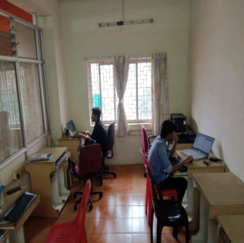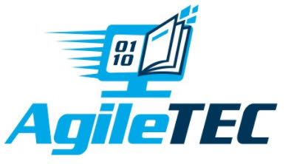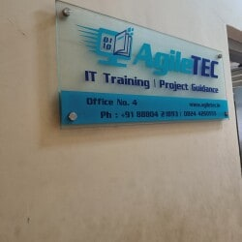

**MISSION:**

Our mission is to deliver quality knowledge transfer through innovative delivery mechanism and technologies.

**OVERVIEW:**

AgileTEC is a company which provides Industry Relevant Training, Services and Solutions in IT/ITES segment. Our focus is on bridge the gap between Corporate and Institutes by providing conventional education and the requirements of the industry. Our training spans both IT and non IT segments and provides a variety of career oriented courses for different segments like students, job seekers and corporate citizens. At AgileTEC, your enthusiasm to master Software, Networking, Internet and enterprise are coupled with our state of art training. The courses of Agile TEC Technologies have been specially created to meet the demand of the industry. We have tailored our courses after in-depth research validated and approved by leading IT Giants. The entire curriculum is designed so as to lead to internationally recognized certification.

**PRODUCT AND SERVICES:**

[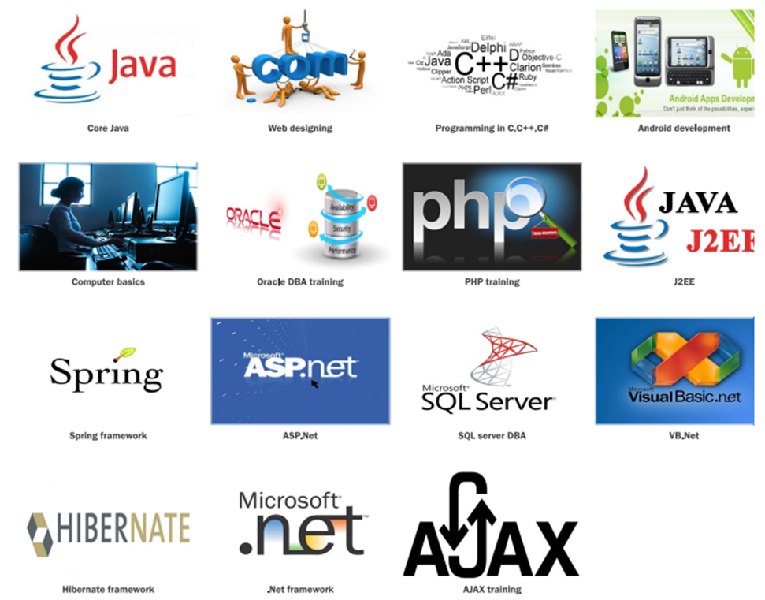](https://www.agiletec.in/Courses/sqlserverDBA.shtml)

**CONTACT:**

Office.no.4, First floor, Lalbagh Commercial Complex (Near Mangalore City Corporation), Lalbagh, Mangalore – 575003,

Phone: 0824-2002253, Mobile : +918880421893  
Email: [info@agiletec.in](mailto:info@ipsum.com)