BANK MARKETING CAMPAIGN ANALYSIS AND CUSTOMER SUBSCRIPTION PREDICTION
INTEGRATIVE CAPSTONE PROJECT
Data Science with Python Internship
Project Report
Submitted as part of the Virtual Data Science with Python Internship

ABSTRACT
This project presents an end-to-end data science analysis of a bank marketing campaign dataset. The main objective is to understand customer characteristics and campaign outcomes, predict whether a customer will subscribe to a term deposit, and identify meaningful customer segments. The project includes data acquisition, cleaning, exploratory data analysis, preprocessing, supervised machine learning, unsupervised clustering, model evaluation and interpretation. Logistic Regression and Random Forest were used for subscription prediction, while K-Means was applied for customer segmentation. The findings demonstrate how data-driven analysis can support better campaign targeting and resource allocation.

1. INTRODUCTION
Bank marketing campaigns involve contacting potential customers to promote financial products such as term deposits. Reaching every customer with equal effort may not be efficient. Data science techniques can help identify customer patterns, estimate subscription likelihood and support more focused marketing strategies.
This project applies Python-based data science methods to analyse a Portuguese bank marketing dataset. Both supervised and unsupervised learning approaches are used to explore the data from different perspectives.

1.1 Problem Statement
To analyse bank marketing campaign data, identify patterns associated with customer subscription, develop machine learning models to predict term deposit subscriptions, and segment customers using clustering.

1.2 Objectives
- Acquire and understand the bank marketing dataset.
- Inspect and clean duplicate and inconsistent records.
- Perform exploratory data analysis using statistical summaries and visualisations.
- Prepare numerical and categorical features for machine learning.
- Develop Logistic Regression and Random Forest classification models.
- Evaluate model performance using suitable classification metrics.
- Identify important predictive features.
- Apply K-Means clustering to identify customer segments.
- Derive insights and recommendations from the results.

2. DATASET DESCRIPTION
The Bank Marketing dataset was obtained from the UCI Machine Learning Repository. It contains information related to direct marketing campaigns conducted by a Portuguese banking institution.
The bank-additional-full.csv file contains 41,188 records and 21 columns, including 20 input attributes and the target variable y. The target indicates whether the customer subscribed to a term deposit.
The attributes include demographic information, contact details, campaign history and economic indicators. Examples include age, job, marital status, education, campaign, previous, pdays and euribor3m.

3. DATA CLEANING AND PREPROCESSING
The dataset was loaded using Pandas. Initial inspection was performed using shape, info, descriptive statistics and missing-value checks.
The original dataset contained 12 duplicate rows. These were removed, resulting in 41,176 records. No conventional null values were detected. However, several categorical attributes contained the value 'unknown'. These values were retained as a separate category rather than being removed, since they represent unavailable information.
The target variable y was encoded as 0 for 'no' and 1 for 'yes'. The duration attribute was excluded from predictive modelling because it is only known after a call has taken place. Including it would create target leakage and would not reflect a genuine pre-call prediction task.
Numerical features were standardised using StandardScaler, while categorical features were converted into numerical representations using OneHotEncoder. A ColumnTransformer and Pipeline were used to organise preprocessing and modelling.

4. EXPLORATORY DATA ANALYSIS
Exploratory data analysis was performed to understand the distribution of customer attributes, target imbalance and relationships between features and subscription outcomes.

4.1 Target Distribution
After duplicate removal, 36,537 customers did not subscribe and 4,639 customers subscribed. Approximately 88.73% of records belong to the non-subscription class and 11.27% to the subscription class. This indicates substantial class imbalance.
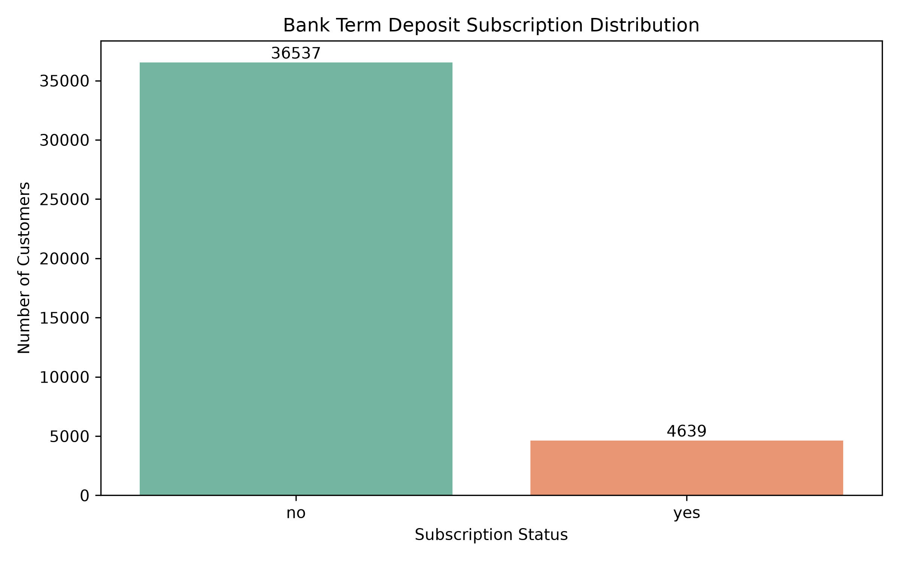
Figure 1: Distribution of the target variable.

4.2 Numerical Feature Distributions
Histograms were used to inspect the distributions of numerical attributes such as age, campaign contacts, previous contacts and economic indicators.
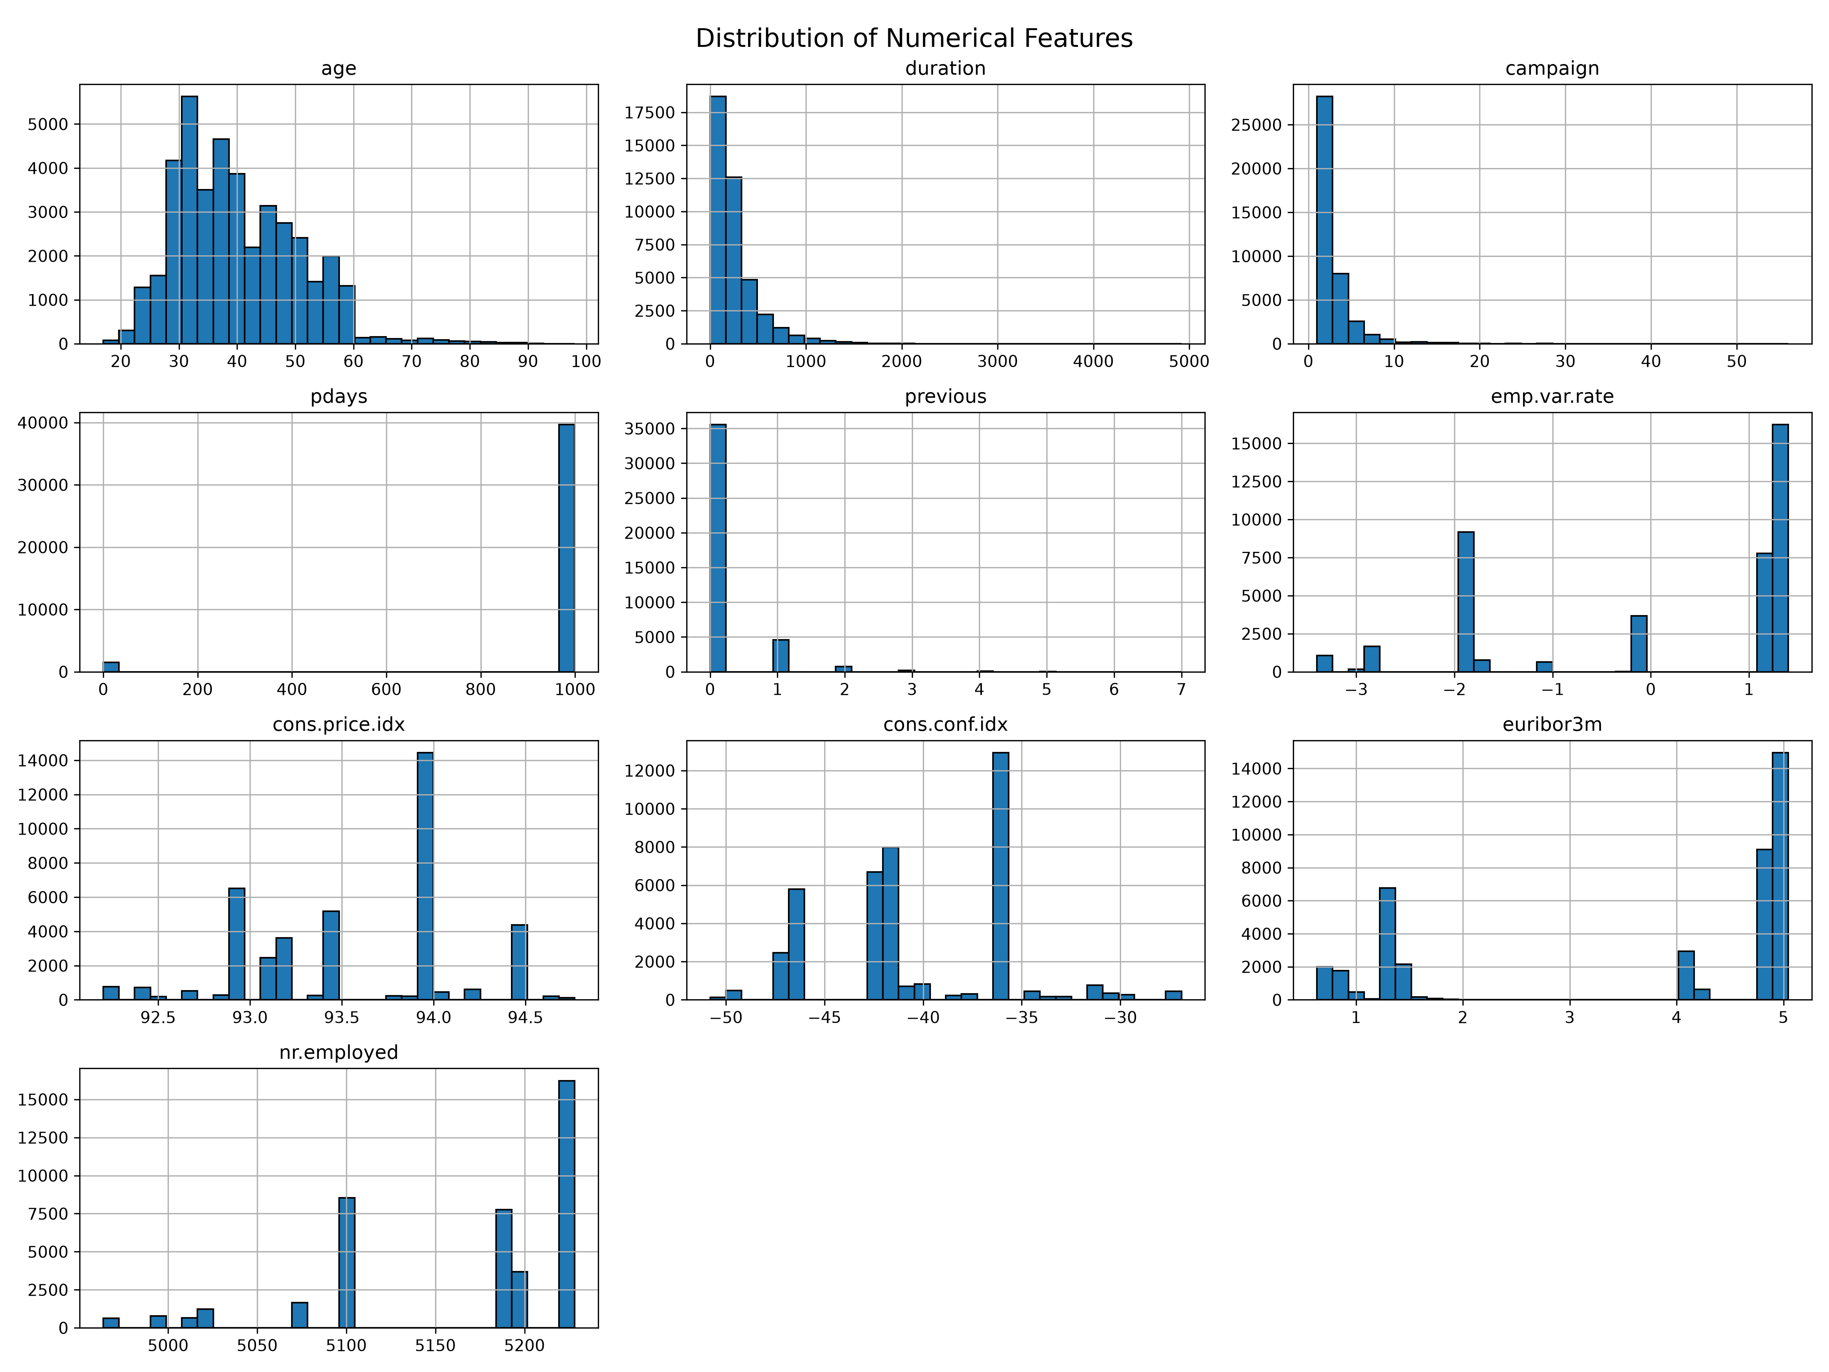
Figure 2: Numerical feature distributions.

4.3 Categorical Feature Distributions
Categorical attributes including job, marital status, education, contact method, month and previous campaign outcome were examined using count plots.
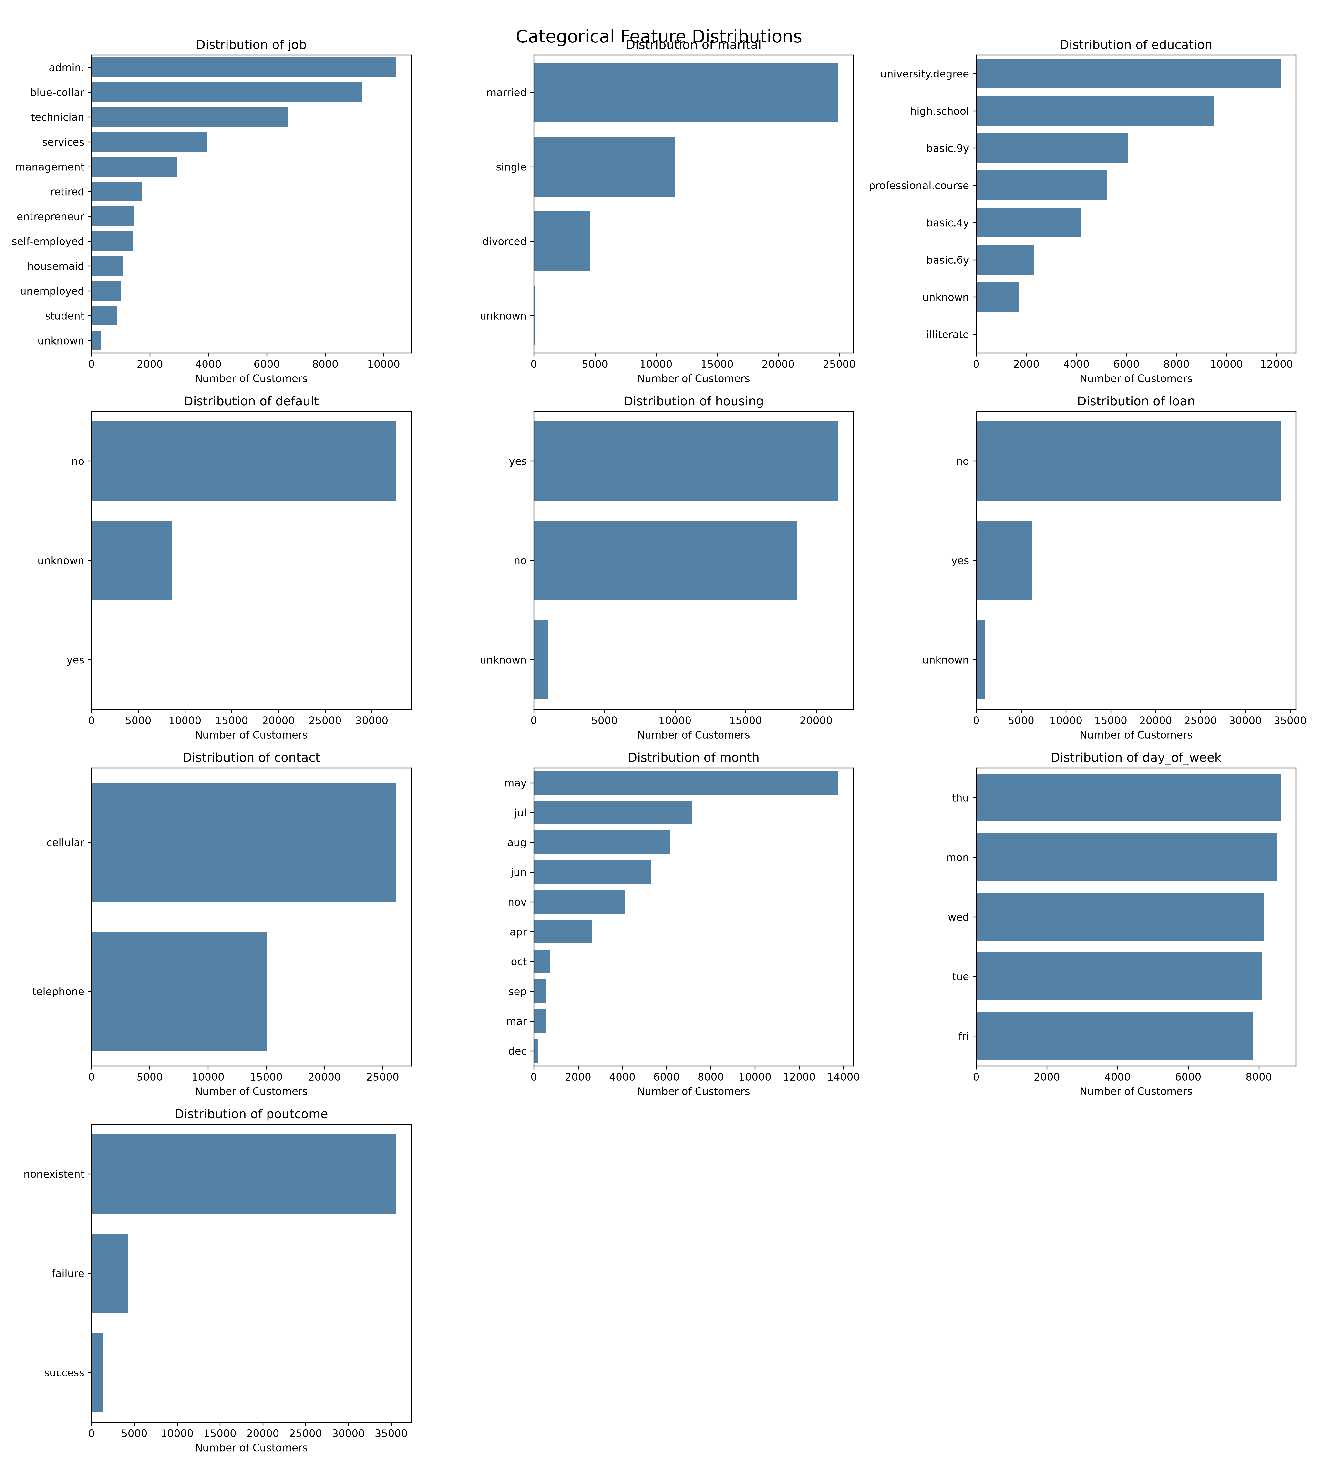
Figure 3: Categorical feature distributions.

4.4 Subscription Patterns
Subscription rates varied across customer categories. Students and retired customers showed comparatively higher subscription rates among job categories. Cellular contact had a higher subscription rate than telephone contact. March, December, September and October showed higher observed subscription rates than several other months. These patterns should be interpreted with consideration of differences in category sample sizes.
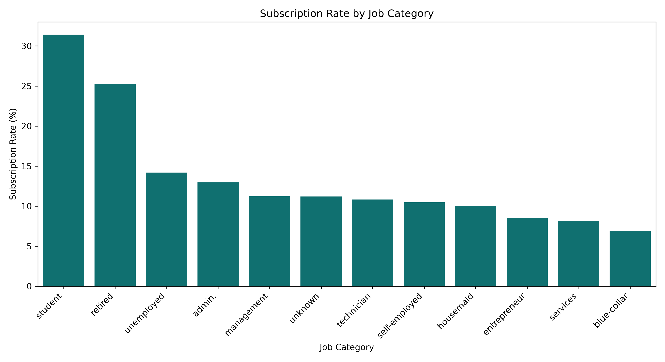
Figure 4: Subscription rate by job.
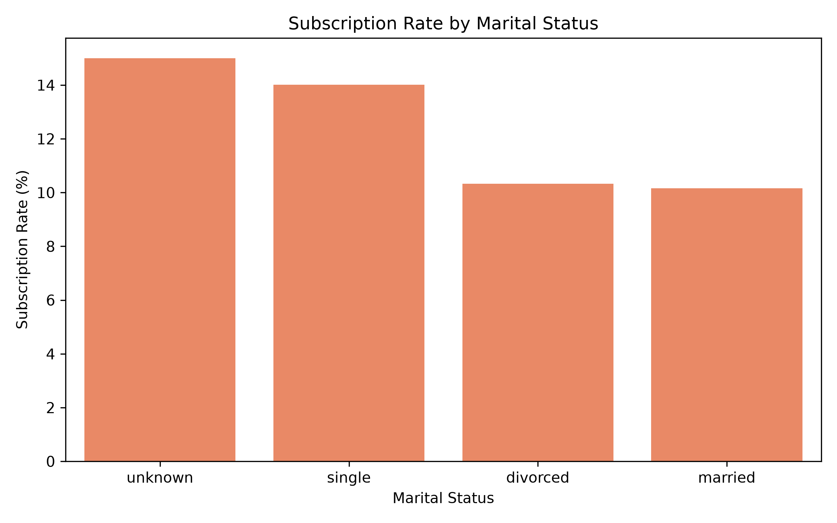
Figure 5: Subscription rate by marital status.
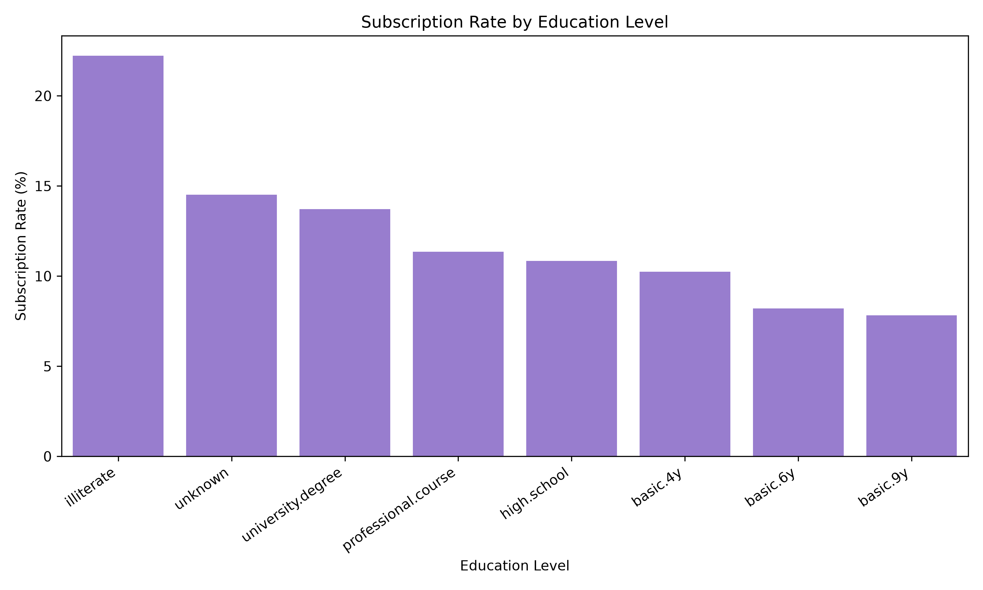
Figure 6: Subscription rate by education.
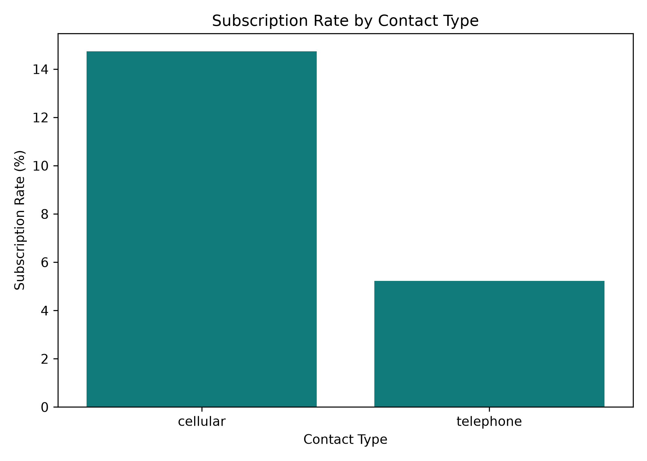
Figure 7: Subscription rate by contact method.
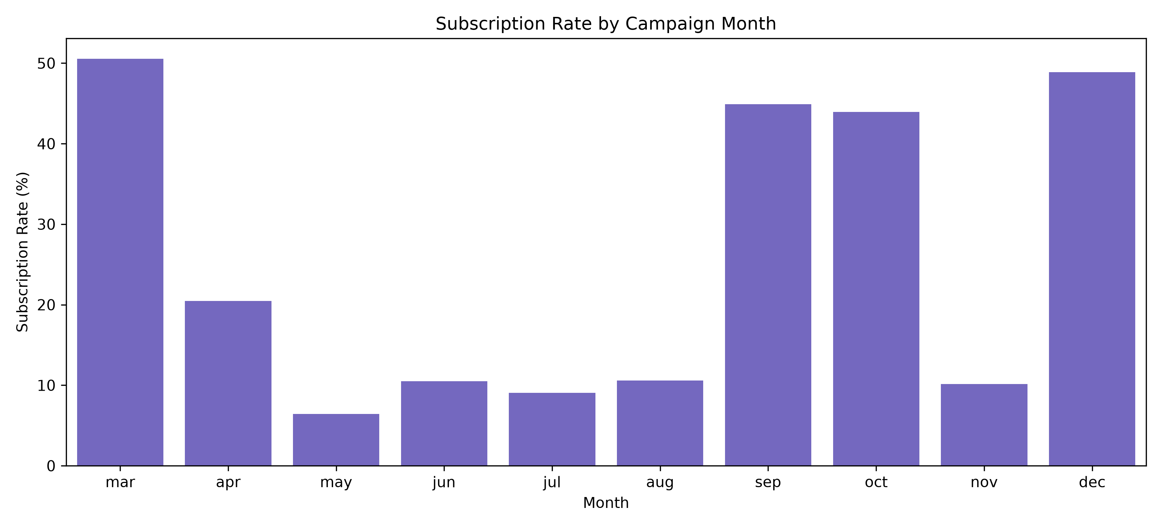
Figure 8: Subscription rate by month.

4.5 Correlation Analysis
A correlation heatmap was generated to inspect relationships among numerical features. Economic indicators such as employment variation, consumer confidence, consumer price index and Euribor rate provide additional context about the campaign period.
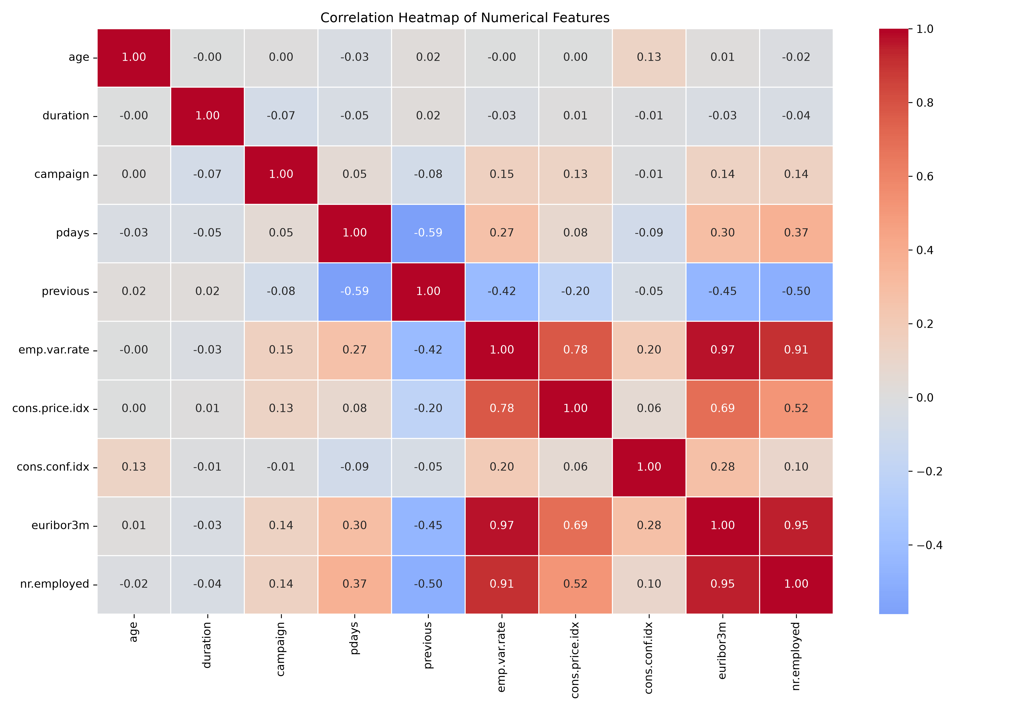
Figure 9: Correlation heatmap of numerical features.

5. SUPERVISED MACHINE LEARNING
The objective of supervised learning was to predict whether a customer would subscribe to a term deposit. The dataset was divided into training and testing sets using an 80:20 split. Stratified sampling was used to preserve the class distribution in both sets.

5.1 Models Developed
Logistic Regression was selected as a baseline classification model. The model used class_weight='balanced' to account for class imbalance.
Random Forest was used as a second model. It combines multiple decision trees and can capture non-linear patterns in the data. Class weighting was also applied.

5.2 Model Evaluation
The models were evaluated using accuracy, precision, recall, F1-score and ROC-AUC. Since the target classes are imbalanced, accuracy alone is insufficient to assess performance.
Metric | Logistic Regression | Random Forest
Accuracy | 0.8303 | 0.8738
Precision | 0.3591 | 0.4422
Recall | 0.6455 | 0.4580
F1-Score | 0.4615 | 0.4500
ROC-AUC | 0.8002 | 0.7851

Random Forest achieved higher accuracy and precision. Logistic Regression achieved higher recall, F1-score and ROC-AUC. Logistic Regression identified a larger proportion of actual subscribers, making it potentially more useful when the priority is to avoid missing interested customers. Random Forest produced fewer false positive predictions relative to its predicted positive cases.
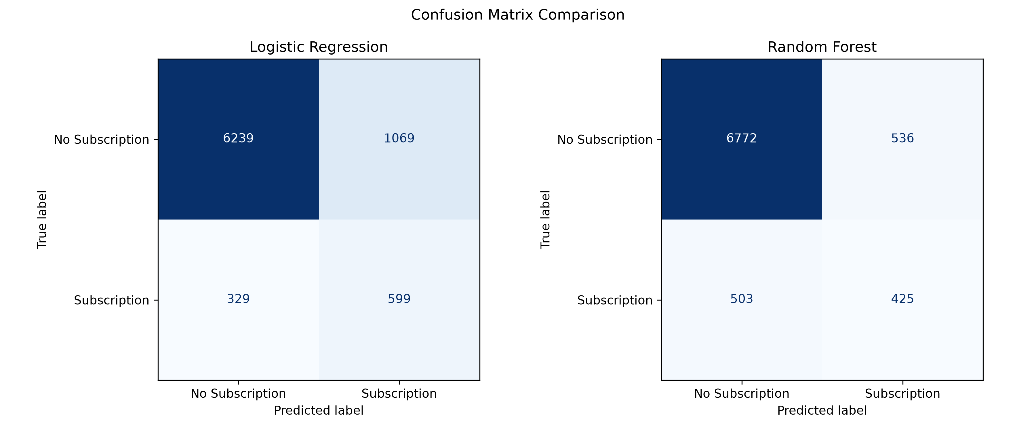
Figure 10: Confusion matrices of the classification models.
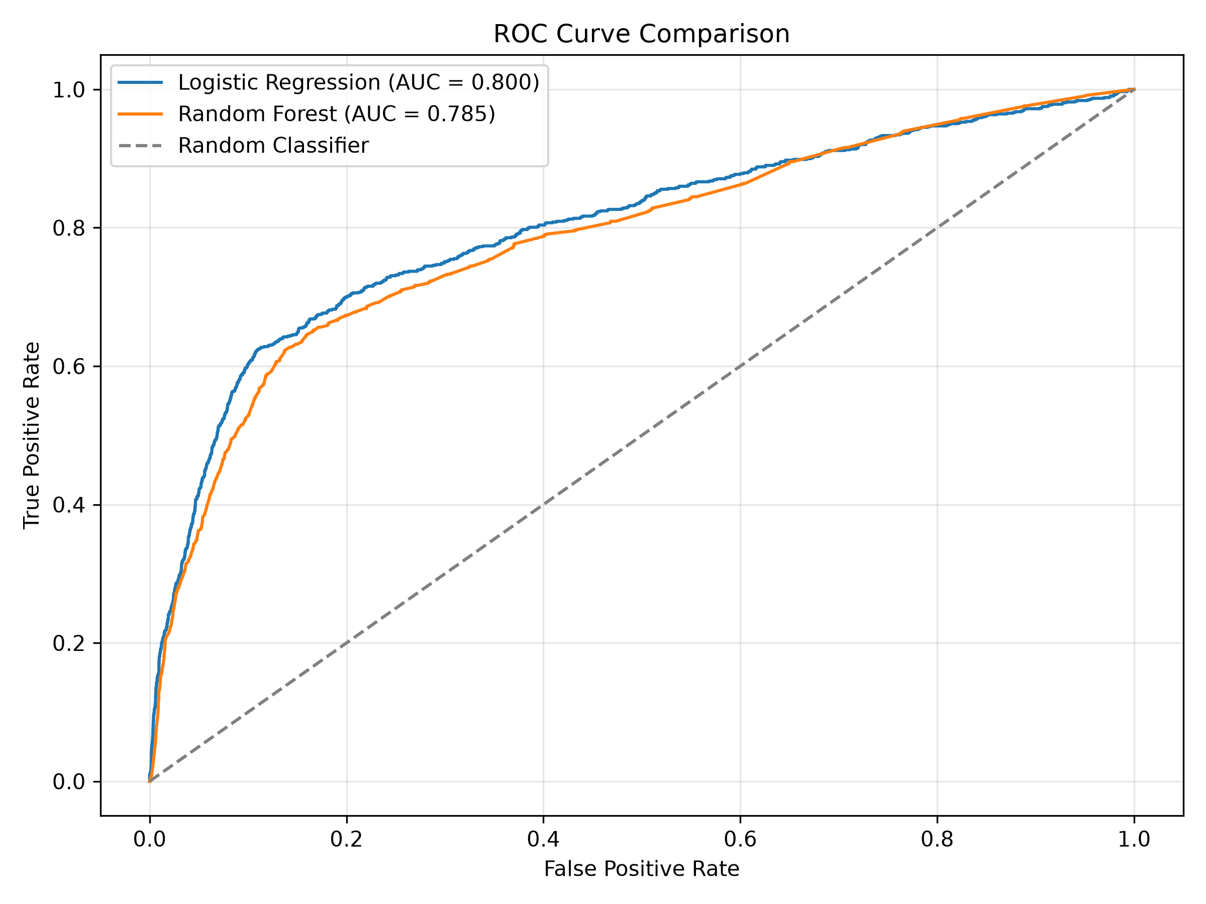
Figure 11: ROC curve comparison.

5.3 Feature Importance
Random Forest feature importance was used to identify attributes that contributed most to the model's predictions. Age had the highest importance, followed by Euribor three-month rate, campaign contacts, number of employees and employment variation rate. These values indicate predictive contribution and should not be interpreted as evidence of causation.
Feature | Importance
age | 0.140632
euribor3m | 0.122340
campaign | 0.078749
nr.employed | 0.060802
emp.var.rate | 0.047892
cons.conf.idx | 0.028683
cons.price.idx | 0.020099
housing_yes | 0.019246
housing_no | 0.019005
pdays | 0.017645

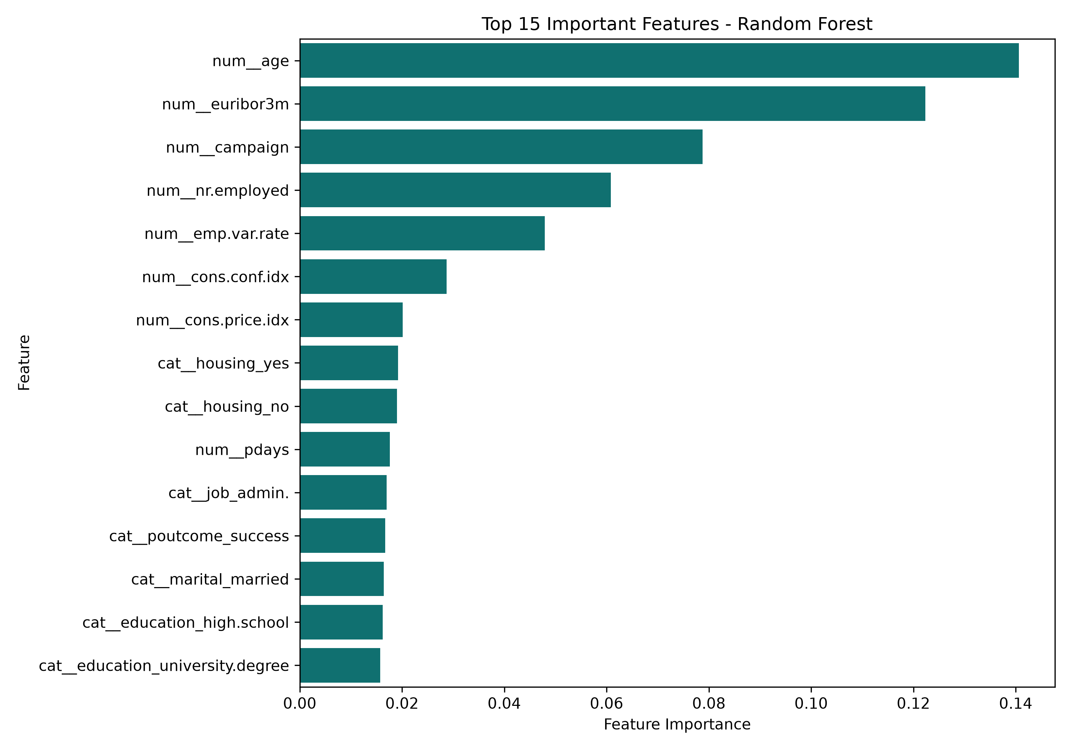
Figure 12: Top features identified by Random Forest.

6. UNSUPERVISED LEARNING: K-MEANS CLUSTERING
K-Means clustering was applied to explore customer segments without using the subscription target during cluster formation. The selected features included age, campaign, previous, pdays, job, marital status, education, housing and loan.
Numerical features were standardised and categorical features were one-hot encoded. The resulting feature matrix contained 34 encoded features. The elbow method and silhouette score were used to assess candidate cluster counts from 2 to 10.
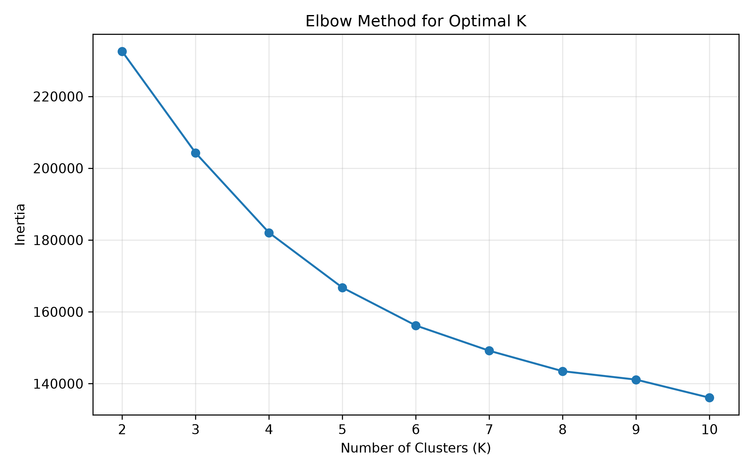
Figure 13: Elbow method for selecting K.
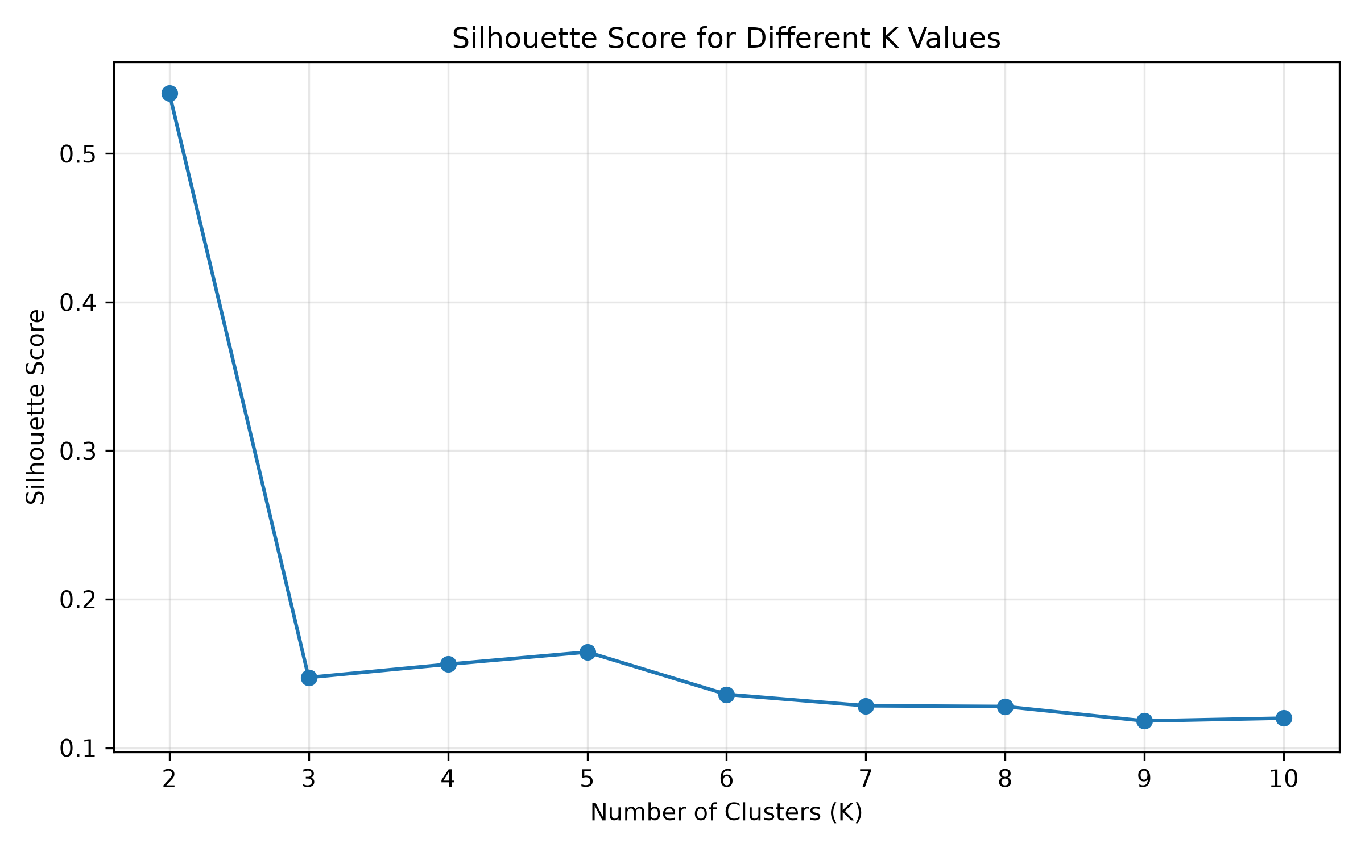
Figure 14: Silhouette scores for different K values.
The highest silhouette score was obtained for K = 2, with a score of 0.5406. The remaining tested values produced substantially lower scores, ranging from 0.1181 to 0.1645. Therefore, two clusters were selected for the final segmentation.

6.1 Customer Segment Profiles
Measure | Cluster 0 | Cluster 1
Customer count | 39,596 | 1,580
Average age | 39.95 | 41.76
Average campaign contacts | 2.60 | 1.84
Average previous contacts | 0.11 | 1.73
Average pdays | 999.00 | 46.87
Subscription rate | 9.24% | 61.96%

Cluster 0 represents the larger customer segment, containing 39,596 customers. It has a low average number of previous contacts and a subscription rate of 9.24%. The average pdays value of 999 indicates that many customers in this group had not previously been contacted during an earlier campaign.
Cluster 1 contains 1,580 customers and has a substantially higher subscription rate of 61.96%. These customers have a higher average number of previous contacts and a much lower average pdays value, indicating more recent previous campaign contact.
The clusters are highly unequal in size. Cluster 1 is a smaller segment but has a higher observed subscription rate. This makes it a potentially valuable group for further campaign analysis. The observed association does not establish that previous contact itself caused subscription.
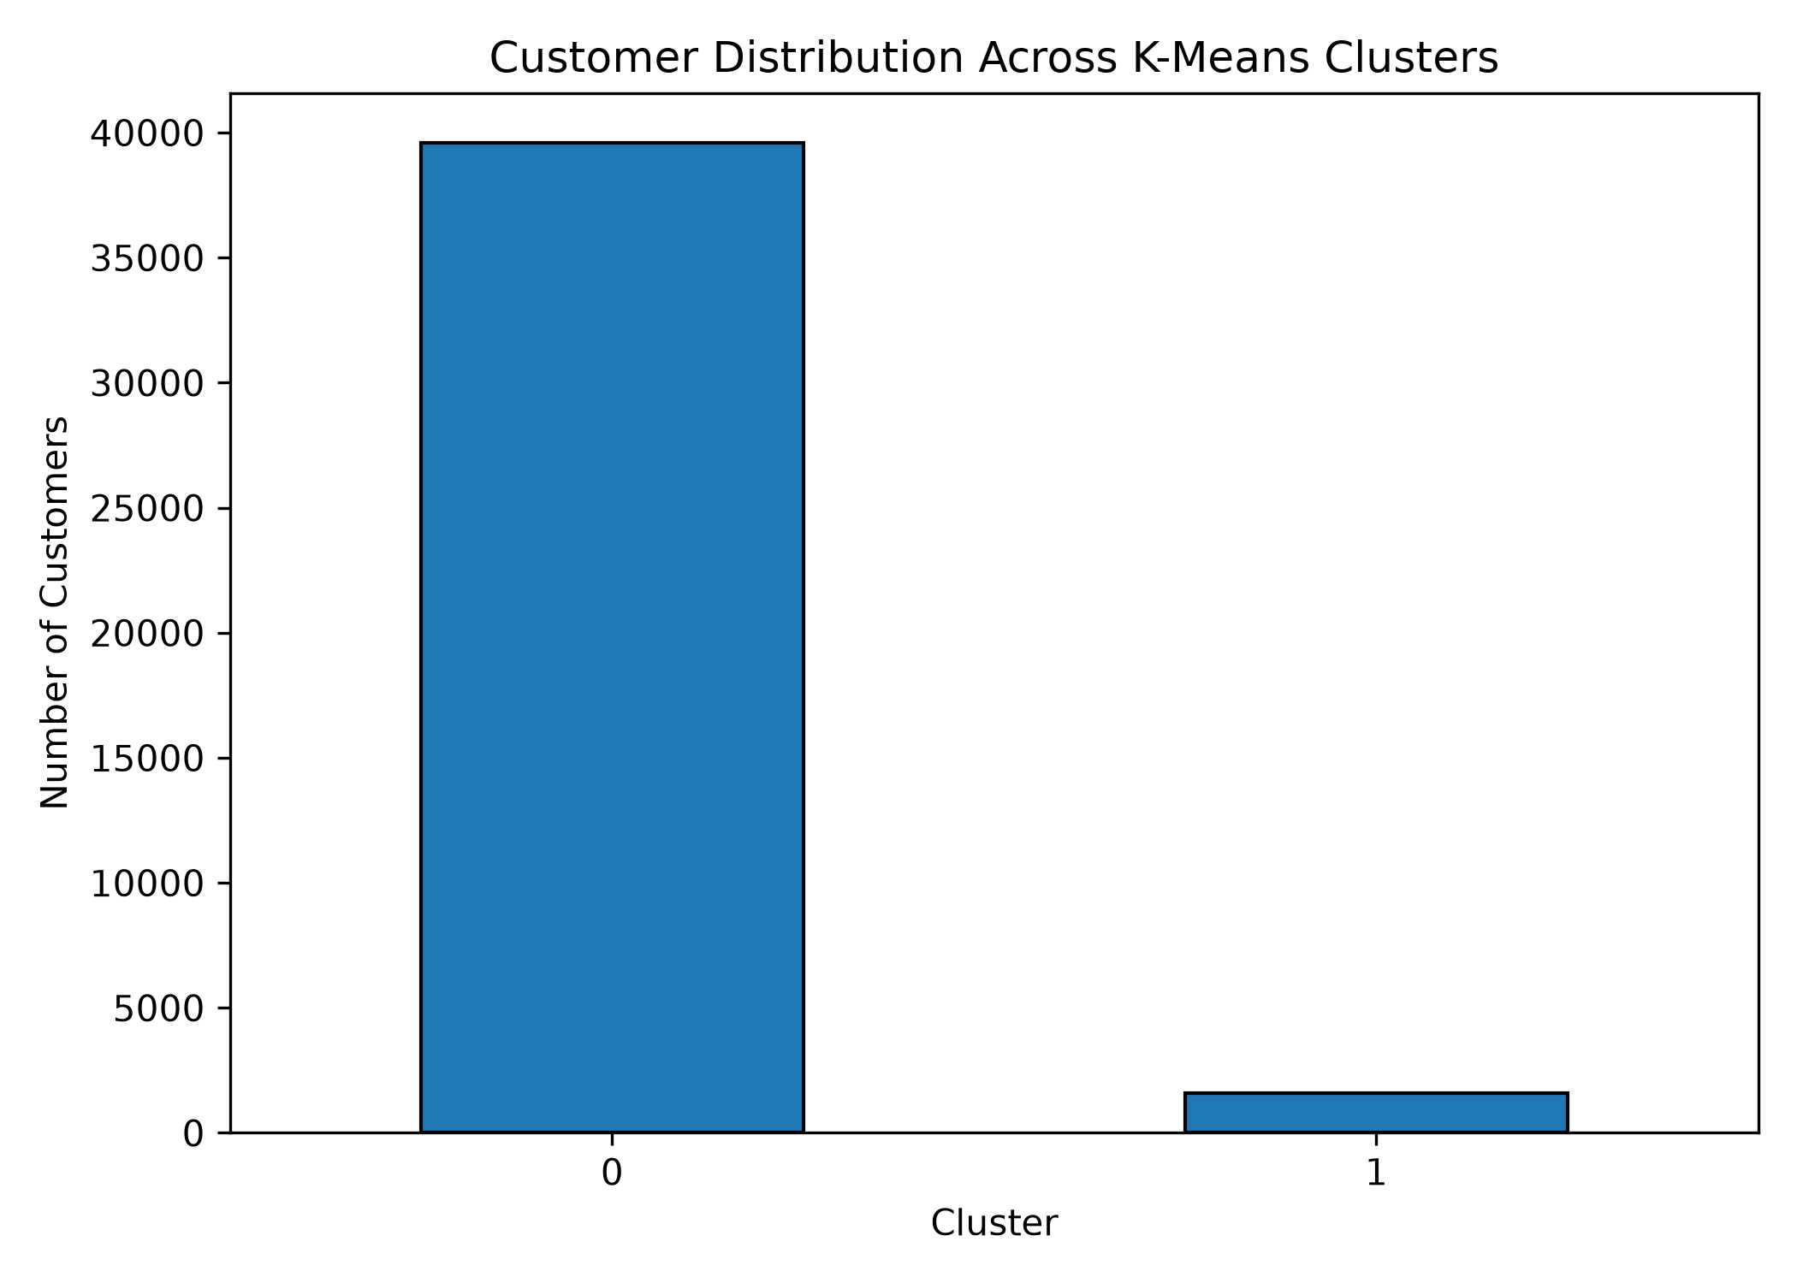
Figure 15: Customer distribution across clusters.
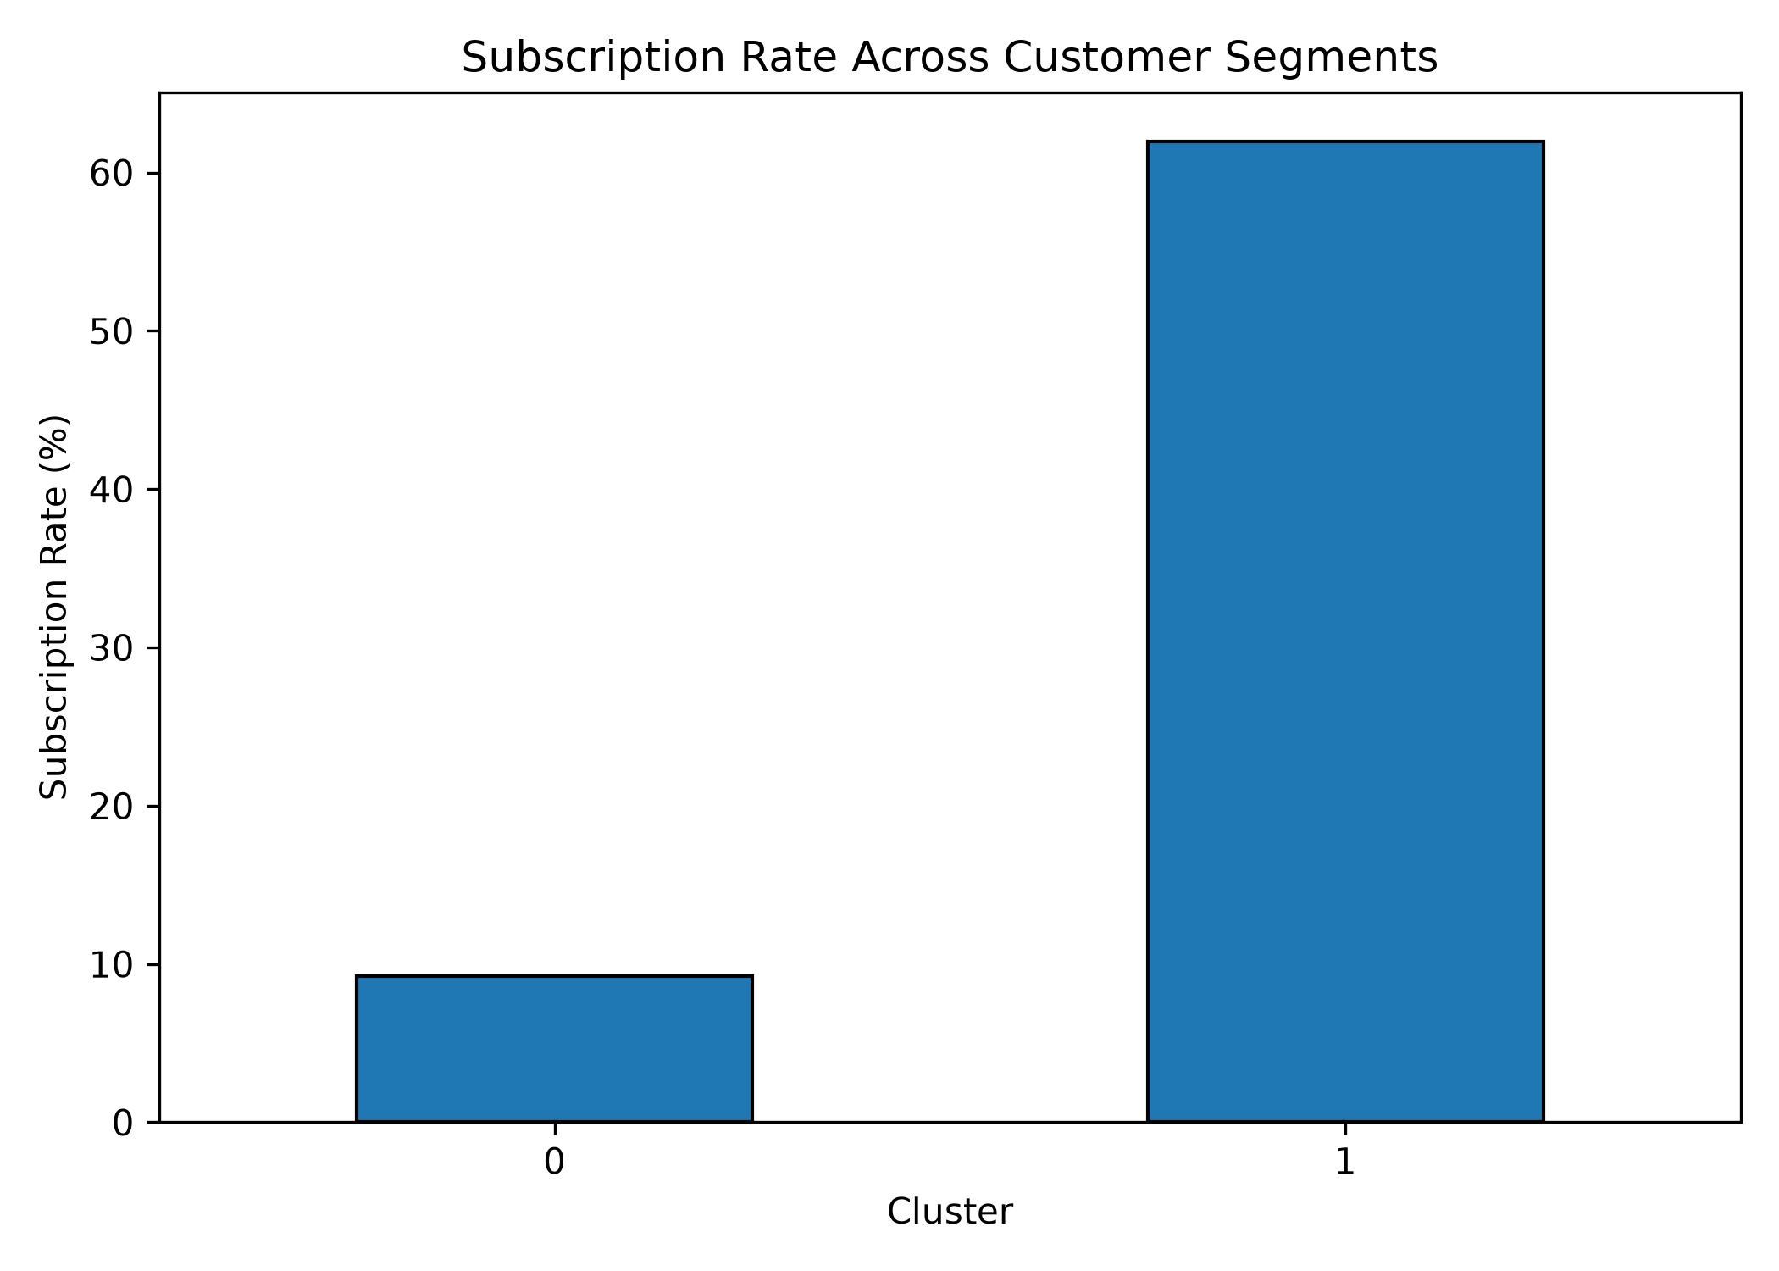
Figure 16: Subscription rate across clusters.

7. KEY FINDINGS AND BUSINESS RECOMMENDATIONS
- The dataset has a substantial class imbalance, with only about 11.27% of customers subscribing.
- Logistic Regression achieved better recall and ROC-AUC than Random Forest in the test evaluation.
- Age, Euribor rate and campaign contact count were among the most important Random Forest features.
- Cellular contact showed a higher observed subscription rate than telephone contact.
- Students and retired customers showed comparatively higher subscription rates among job categories.
- The smaller K-Means segment had a much higher observed subscription rate than the larger segment.
The bank could consider using model scores to prioritise customers for follow-up, while retaining human review and monitoring false positives. Campaign planning could examine contact channel and timing patterns. The smaller high-response segment could be studied further to understand its characteristics and whether similar customers can be identified reliably. Any targeting strategy should be validated on newer campaign data before deployment.

8. CHALLENGES AND LIMITATIONS
- The target variable was imbalanced, which made accuracy alone an inadequate evaluation measure.
- Categorical attributes contained 'unknown' values that required careful treatment.
- The dataset included a duration variable that could cause target leakage if used for pre-call prediction.
- One-hot encoding increased the dimensionality of the feature matrix.
- K-Means produced highly unequal cluster sizes, requiring careful interpretation of the smaller segment.
- The analysis is based on historical campaign data and may not generalise to different banks, regions or time periods.
- Feature importance and observed subscription rates describe associations and do not prove causation.

9. REFLECTION
This capstone project provided practical experience in carrying out a complete data science workflow, from acquiring and inspecting data to cleaning, visualisation, machine learning and interpretation. Working with both supervised and unsupervised methods helped demonstrate how different analytical approaches can answer complementary questions.
An important learning outcome was recognising the effect of class imbalance and the need to compare multiple evaluation metrics. The exclusion of call duration also highlighted the importance of avoiding target leakage. The clustering exercise demonstrated that customer segments can differ substantially in size and observed behaviour.
The project strengthened practical skills in Pandas, NumPy, Matplotlib, Seaborn and Scikit-learn, along with the use of preprocessing pipelines, classification models, model evaluation and K-Means clustering.

10. CONCLUSION
The project successfully implemented an end-to-end analysis of bank marketing campaign data. Exploratory analysis revealed differences in subscription rates across customer characteristics and contact patterns. Logistic Regression and Random Forest provided complementary predictive performance, with Logistic Regression achieving higher recall and ROC-AUC, while Random Forest achieved higher accuracy and precision. K-Means identified two customer segments with markedly different observed subscription rates. Overall, the results demonstrate the potential of data science techniques to support customer understanding and more focused marketing campaign planning.

11. REFERENCES
1. Moro, S., Rita, P., and Cortez, P. (2014). Bank Marketing. UCI Machine Learning Repository. https://doi.org/10.24432/C5K306
2. Pedregosa, F. et al. (2011). Scikit-learn: Machine Learning in Python. Journal of Machine Learning Research, 12, 2825–2830.
3. McKinney, W. (2010). Data Structures for Statistical Computing in Python. Proceedings of the 9th Python in Science Conference.

