BREAST CANCER CLASSIFICATION
Using Supervised Machine Learning
WEEK 4 PROJECT REPORT
Virtual Data Science with Python Internship
Tools: Python | Pandas | NumPy | Matplotlib | Seaborn | Scikit-learn

1. Introduction
Supervised machine learning is a technique in which a model learns patterns from labelled data to make predictions on unseen observations. This project implements a classification workflow using the Wisconsin Breast Cancer Diagnostic dataset available through Scikit-learn.
The objective is to classify observations as malignant or benign using numerical measurements of cell nuclei. Logistic Regression and Random Forest Classifiers are trained and evaluated, and their performance is compared.
This project is intended for educational machine-learning analysis only. It is not a medical diagnostic system.

2. Dataset Description
The dataset was loaded using the load_breast_cancer() function from sklearn.datasets. It contains 569 observations and 30 numerical predictor features, along with one target variable.
Dataset property | Description
Total observations | 569
Predictor features | 30
Target classes | 2
Benign observations | 357
Malignant observations | 212
Missing values | 0
Duplicate rows | 0

The target variable uses 1 for benign and 0 for malignant. The dataset contains more benign than malignant observations, so stratified sampling was used when splitting the data.
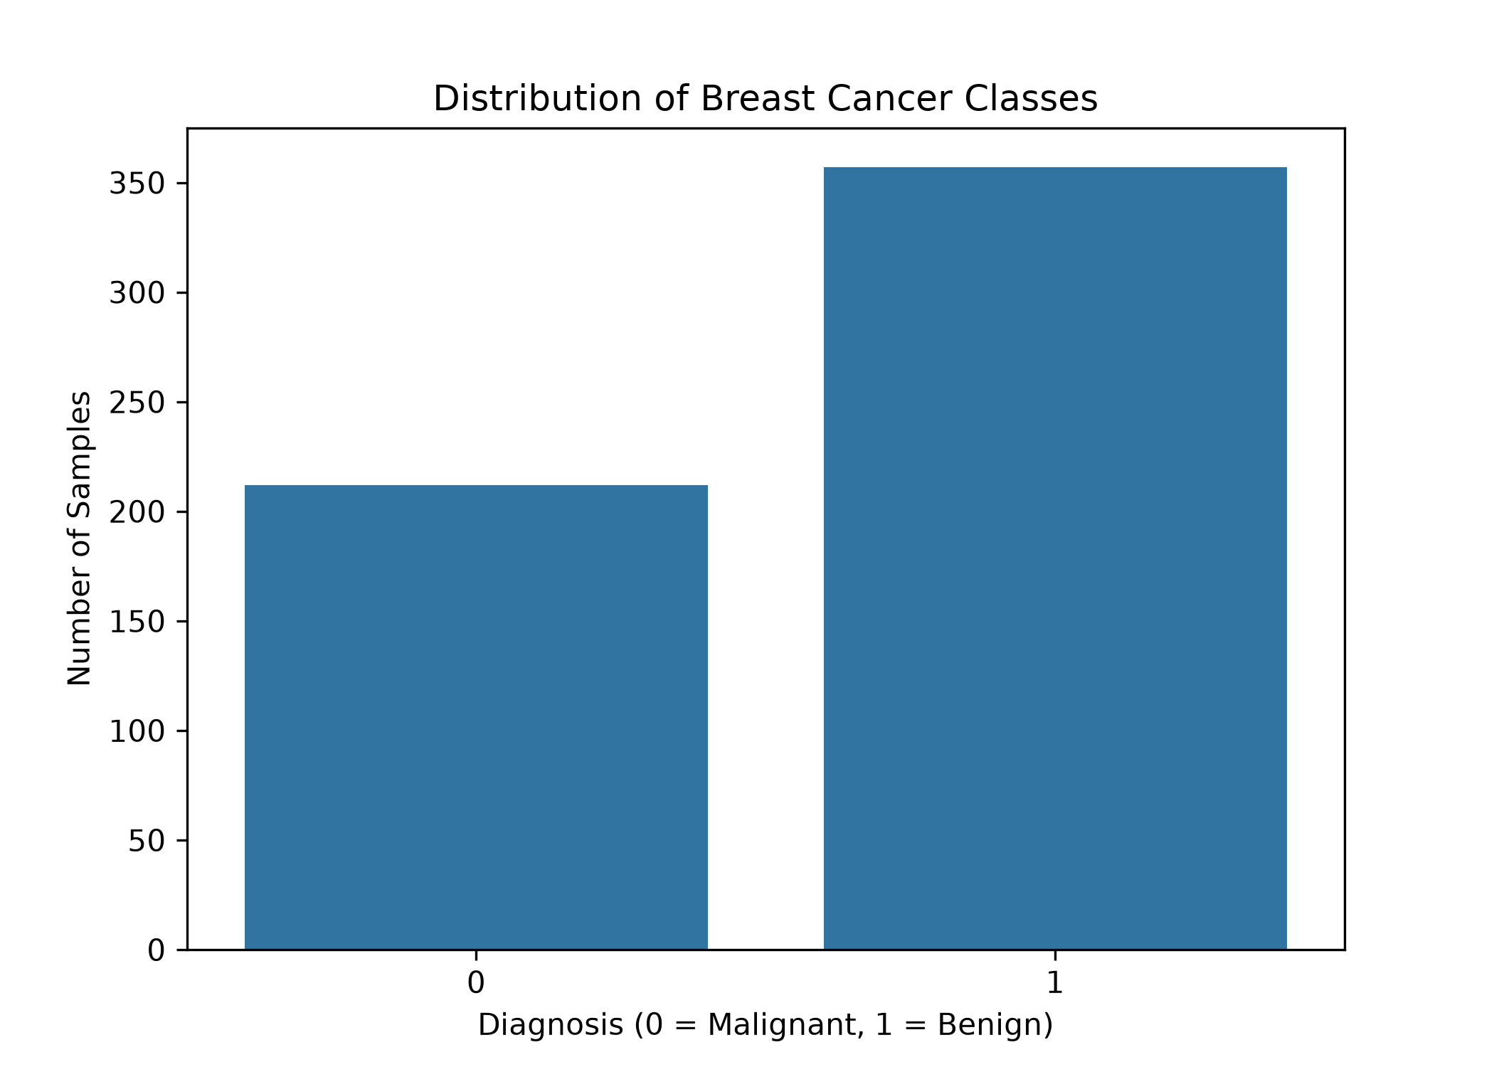
Figure 1. Distribution of benign and malignant observations.

3. Exploratory Data Analysis
Exploratory analysis was performed to understand the distribution of the target classes and the relationship between selected features.
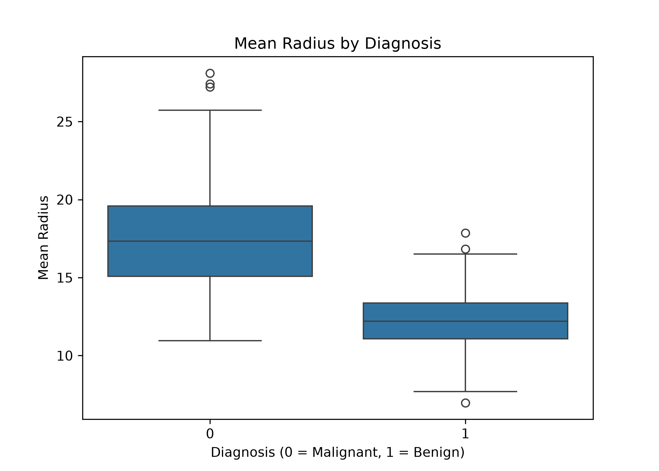
Figure 2. Mean radius distribution across target classes.
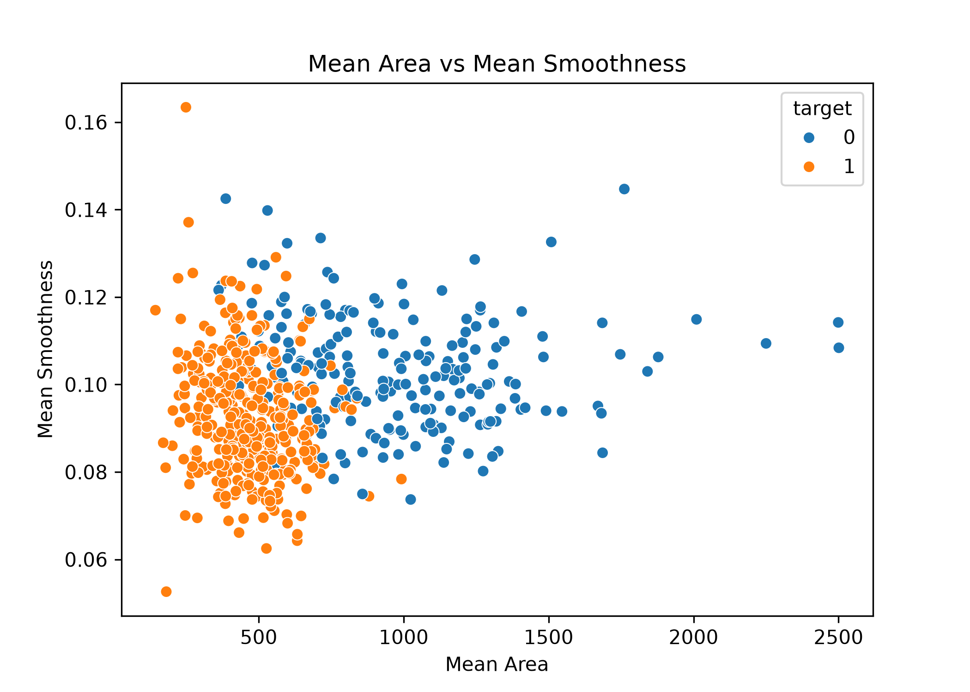
Figure 3. Relationship between area and smoothness.
The visualisations provide an initial understanding of how measurements differ between classes. They also help identify potentially useful predictors for classification.

4. Data Preprocessing
- Separated the predictor variables from the target variable.
- Checked the dataset for missing values and duplicate records.
- Used an 80:20 training and testing split.
- Applied stratified sampling to preserve class proportions.
- Used StandardScaler for Logistic Regression.
- Used a Scikit-learn Pipeline to combine scaling and classification.
The training set contained 455 observations, while the test set contained 114 observations. Feature scaling was applied to Logistic Regression because it is sensitive to differences in feature scales. Random Forest does not require standardisation.

5. Model Implementation

5.1 Logistic Regression
Logistic Regression was selected as a baseline classification algorithm. It estimates the probability of an observation belonging to a particular class. StandardScaler was included in the model pipeline to standardise the input features.

5.2 Random Forest Classifier
Random Forest is an ensemble learning algorithm that combines predictions from multiple decision trees. A classifier with 200 trees was implemented. It can model nonlinear relationships and provide feature-importance scores.

6. Model Evaluation
Both models were evaluated using accuracy, precision, recall and F1-score. For precision, recall and F1-score, the malignant class was treated as the positive class because identifying malignant observations is particularly important in this educational classification exercise.
Metric | Logistic Regression | Random Forest
Accuracy | 98.25% | 95.61%
Malignant precision | 97.62% | 95.12%
Malignant recall | 97.62% | 92.86%
Malignant F1-score | 97.62% | 93.98%

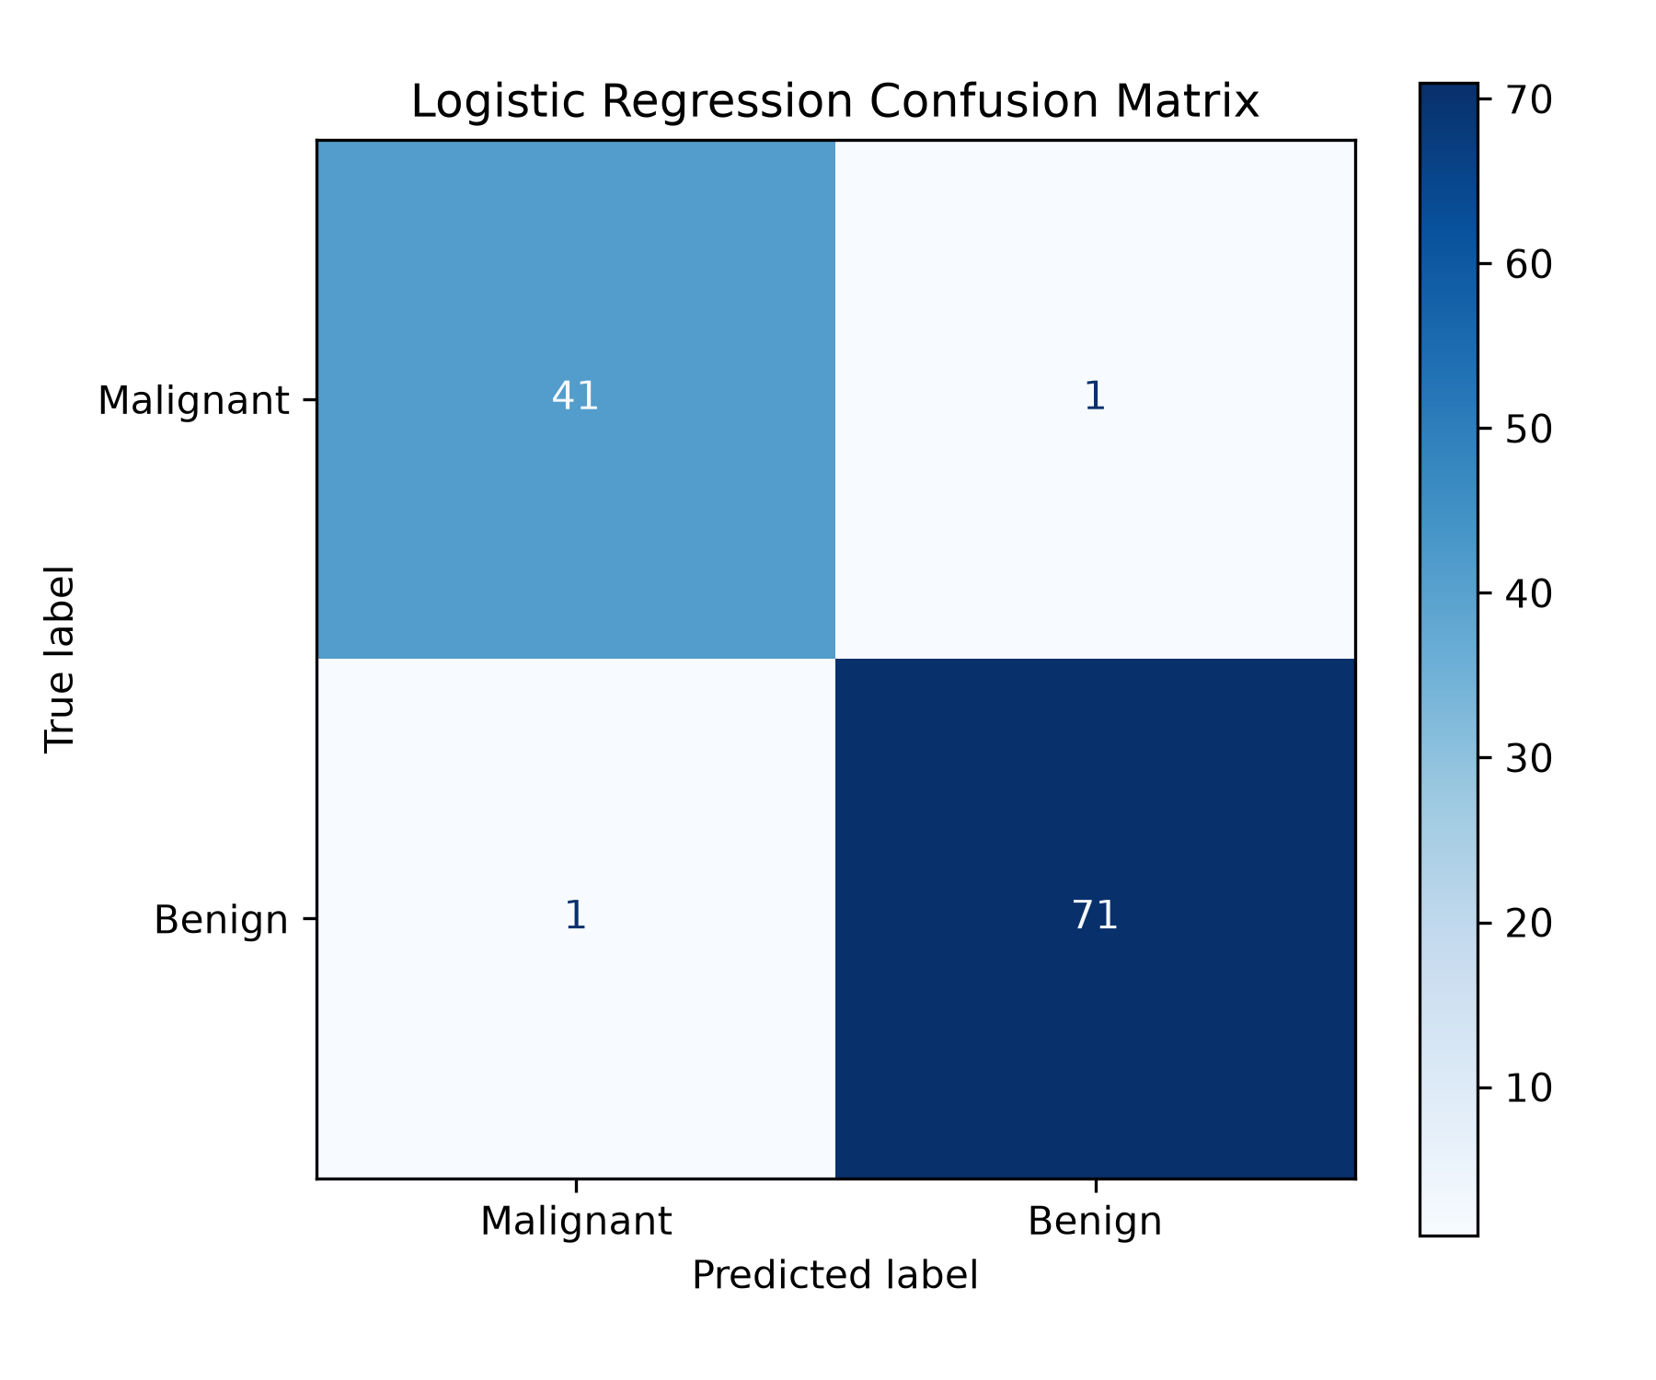
Figure 4. Confusion matrix for Logistic Regression.
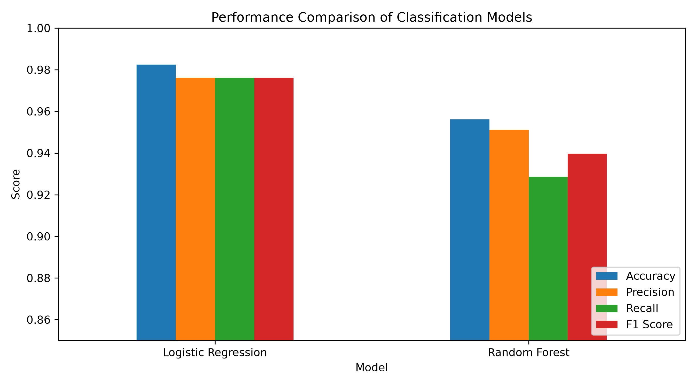
Figure 5. Comparison of classification metrics.
Logistic Regression achieved an accuracy of approximately 98.25%, while Random Forest achieved approximately 95.61% on the held-out test set. Logistic Regression correctly identified 41 of the 42 malignant test observations. Random Forest correctly identified 39 of the 42 malignant observations.

7. Cross-Validation
Five-fold Stratified Cross-Validation was performed on the training data. This method divides the training data into five folds while preserving class proportions. Each fold is used for validation once.
Model | Mean CV Accuracy | Mean Malignant Recall
Logistic Regression | 97.80% | 96.47%
Random Forest | 96.26% | 95.29%

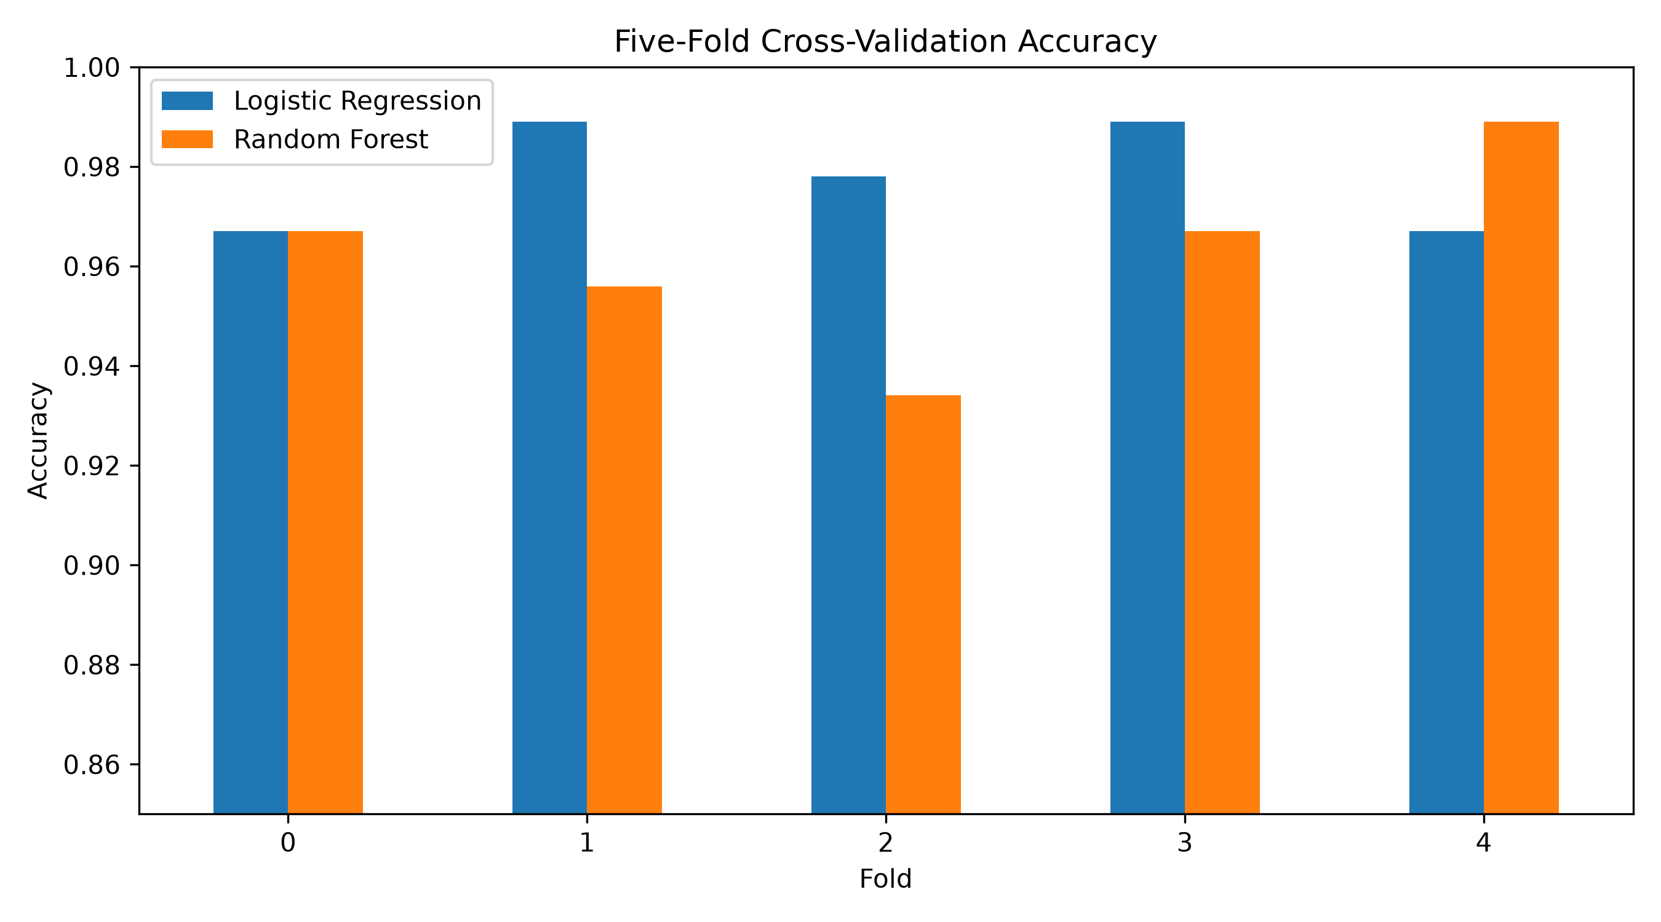
Figure 6. Five-fold cross-validation accuracy comparison.
Logistic Regression achieved a higher mean cross-validation accuracy and malignant recall in this experiment. Its cross-validation accuracy also showed lower variation across folds. These results support selecting Logistic Regression as the preferred model for this dataset and setup.

8. Feature Importance Analysis
Feature importance was extracted from the trained Random Forest classifier. The analysis identifies which input features contributed most to the classifier predictions.
Feature | Importance
Worst perimeter | 0.133100
Worst area | 0.128052
Worst concave points | 0.108107
Mean concave points | 0.094414
Worst radius | 0.090639
Mean radius | 0.058662
Mean perimeter | 0.055242
Mean area | 0.049938
Mean concavity | 0.046207
Worst concavity | 0.035357

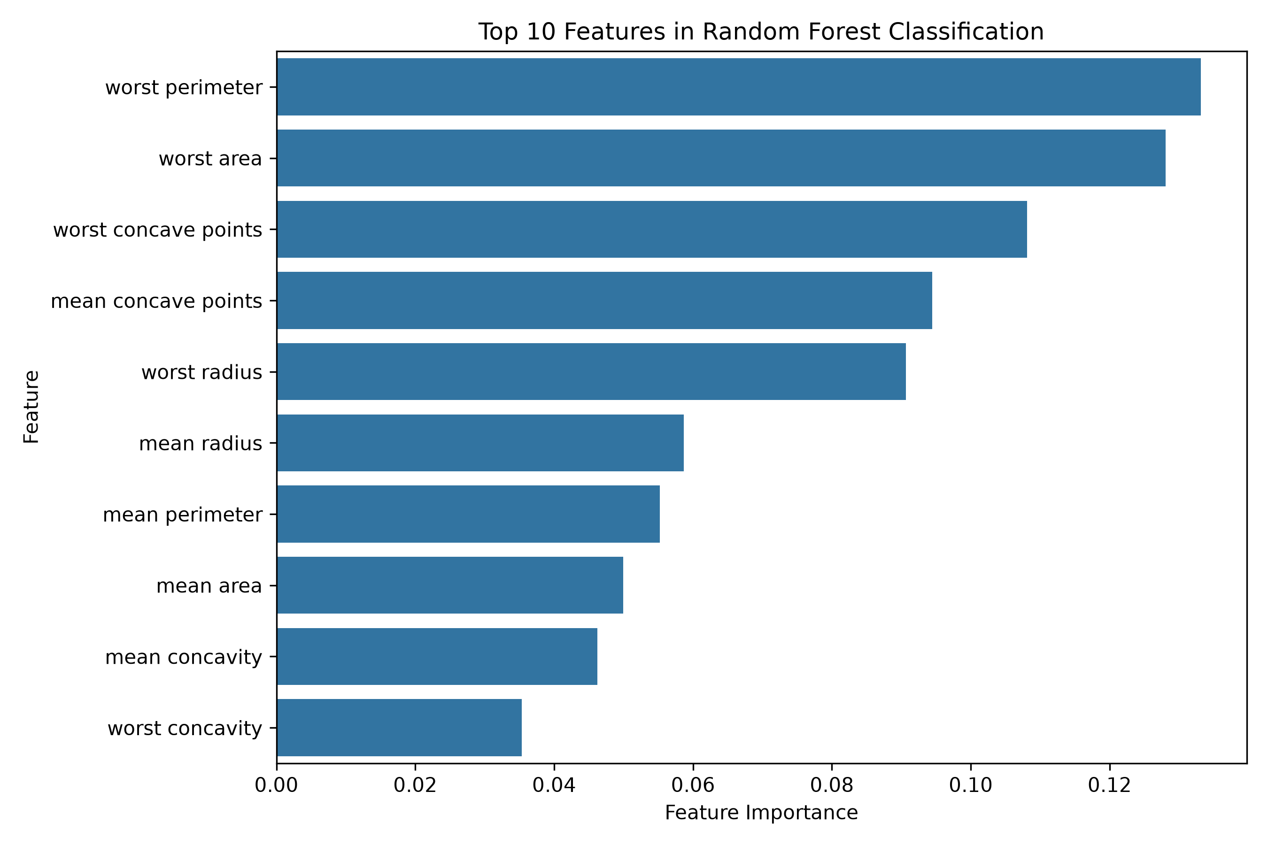
Figure 7. Top 10 features according to Random Forest importance.
Worst perimeter, worst area and worst concave points were the three most influential features in the Random Forest model. This suggests that measurements related to tumour size and boundary characteristics contributed substantially to the model predictions. Feature importance indicates predictive contribution, not causation or clinical significance.

9. Discussion and Findings
The experiment demonstrated how supervised learning can be applied to a binary classification problem. Both Logistic Regression and Random Forest performed well on the selected dataset. Logistic Regression achieved the higher test accuracy and cross-validation scores in this experiment.
The use of stratified splitting and cross-validation helped provide a more reliable evaluation than relying on a single training result. The confusion matrix also provided insight into the types of classification errors made by the selected model.

10. Strengths and Limitations

10.1 Strengths
- Used a recognised public dataset available through Scikit-learn.
- Compared two different supervised classification algorithms.
- Evaluated models using multiple classification metrics.
- Applied stratified train-test splitting and five-fold cross-validation.
- Used visualisations to support model evaluation and interpretation.

10.2 Limitations
- The experiment used a single dataset and a limited set of models.
- Results may vary with different train-test splits and model settings.
- Random Forest feature importance does not explain causal relationships.
- The dataset and model are not sufficient for real-world clinical diagnosis.

11. Future Improvements
- Perform hyperparameter tuning using GridSearchCV or RandomizedSearchCV.
- Evaluate additional models such as Support Vector Machines and Gradient Boosting.
- Study precision-recall curves and ROC-AUC scores.
- Use explainability methods such as permutation importance or SHAP.
- Validate performance on additional independent datasets.

12. Conclusion
This project implemented a complete supervised machine-learning workflow for breast cancer classification using Python and Scikit-learn. Logistic Regression and Random Forest were trained and evaluated using a held-out test set and five-fold stratified cross-validation.
Logistic Regression achieved the strongest overall results in this experiment, with 98.25% test accuracy and 97.80% mean cross-validation accuracy. The project provided practical experience in data preprocessing, model training, validation, evaluation, visualisation and feature-importance analysis.

