CUSTOMER SEGMENTATION
USING K-MEANS CLUSTERING
WEEK 3 PROJECT REPORT
Unsupervised Learning and Clustering Analysis
Virtual Data Science with Python Internship
Tools: Python | Pandas | NumPy | Matplotlib | Seaborn | Scikit-learn

1. Introduction
Customer segmentation is the process of dividing customers into groups based on shared characteristics and behaviour. It helps businesses understand different customer groups and develop more focused marketing strategies. This project applies K-Means clustering, an unsupervised machine learning algorithm, to segment customers using annual income and spending score.

2. Project Objectives
- Explore and understand the customer dataset.
- Perform data inspection and preprocessing.
- Apply K-Means clustering to identify customer segments.
- Determine a suitable number of clusters using the Elbow Method and Silhouette Score.
- Visualize and interpret the resulting customer groups.
- Discuss possible business applications and limitations.

3. Dataset Description
The Mall Customer Segmentation dataset was obtained from Kaggle. It contains 200 customer records and five attributes: CustomerID, Gender, Age, Annual Income (k$), and Spending Score (1-100). The spending score represents a score assigned to customers based on their spending behaviour.
Attribute | Description
CustomerID | Unique customer identifier
Gender | Customer gender
Age | Customer age in years
Annual Income (k$) | Annual income in thousands of dollars
Spending Score (1-100) | Spending score ranging from 1 to 100

4. Exploratory Data Analysis
The dataset was examined using Pandas functions such as info(), describe(), isnull().sum(), and duplicated(). The dataset contained 200 rows and five columns. No missing values or duplicate records were identified. The gender distribution consisted of 112 female customers and 88 male customers.
The average customer age was 38.85 years. The mean annual income was 60.56 thousand dollars, while the mean spending score was 50.20.

4.1 Gender Distribution
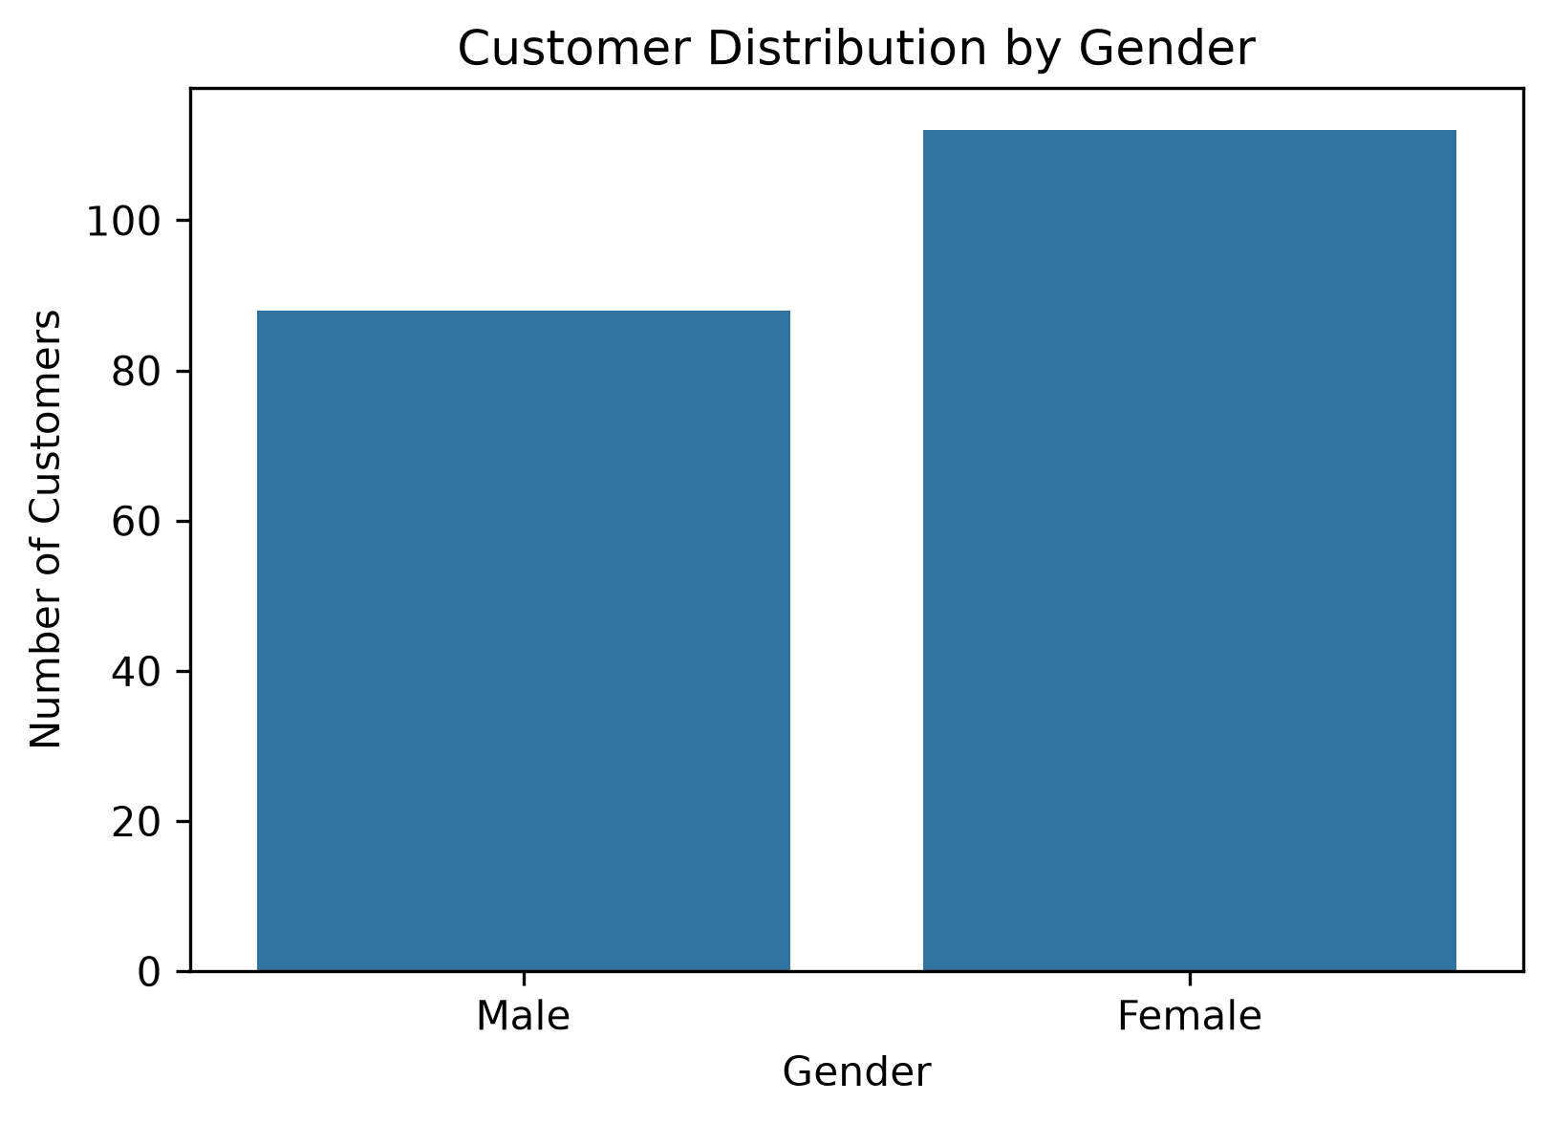
Figure 1: Distribution of customers by gender.

4.2 Age Distribution
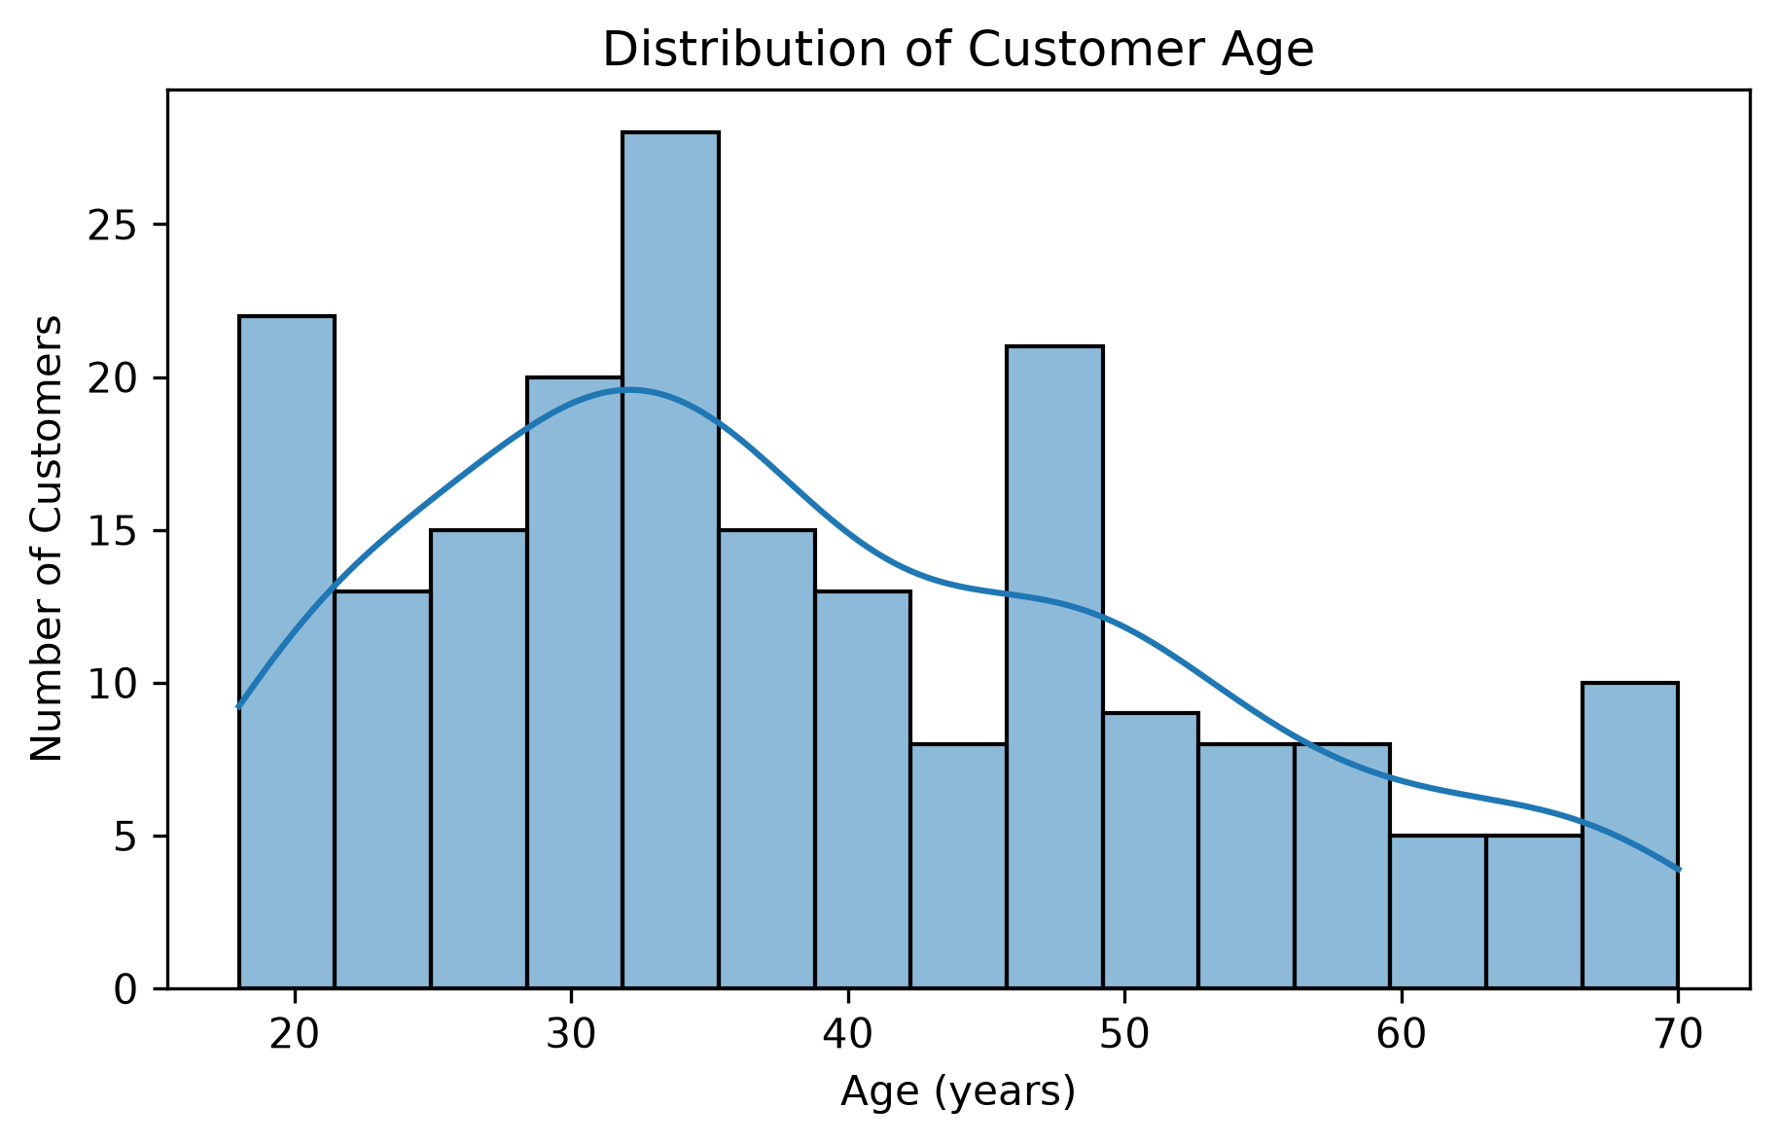
Figure 2: Age distribution of customers.

4.3 Annual Income Distribution
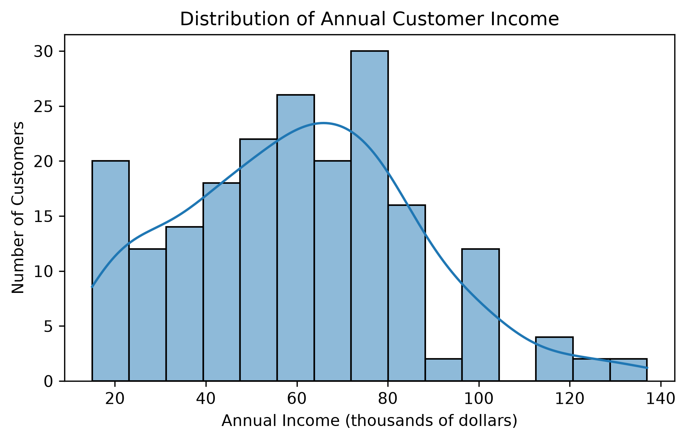
Figure 3: Distribution of annual income.

4.4 Income and Spending Relationship
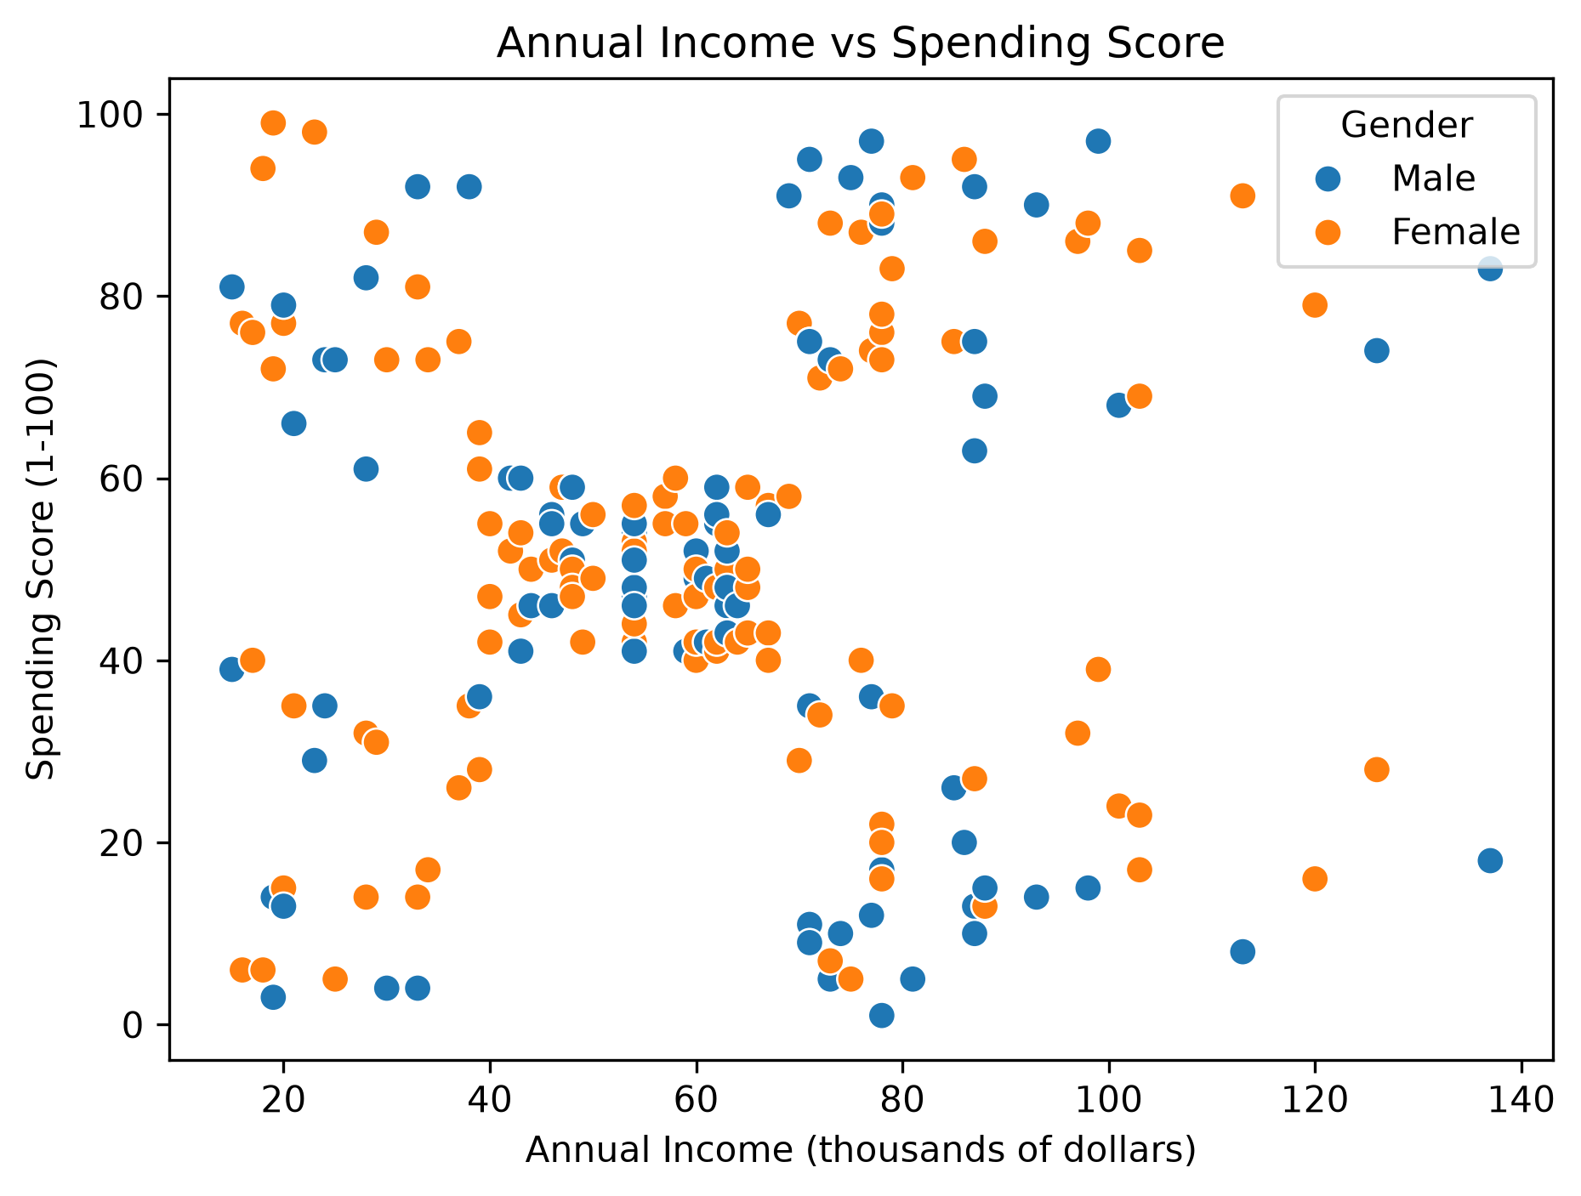
Figure 4: Relationship between annual income and spending score.

4.5 Age and Spending Relationship
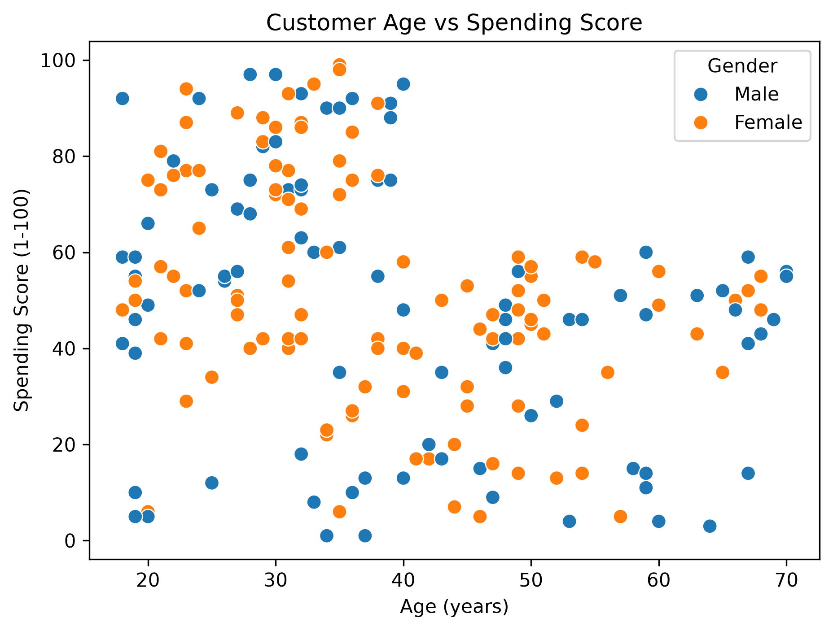
Figure 5: Relationship between customer age and spending score.

5. Data Preprocessing and Feature Selection
CustomerID was excluded because it is an identifier and does not represent customer behaviour. Gender and Age were retained for exploratory analysis and later cluster profiling, but were not used as input features in the initial clustering model.
Annual Income (k$) and Spending Score (1-100) were selected as the two clustering features. StandardScaler was applied to standardize both features before clustering. Standardization places the features on comparable scales and prevents differences in their numerical ranges from disproportionately influencing distance calculations.

6. Clustering Methodology
K-Means is an unsupervised learning algorithm that partitions data into a predefined number of clusters. It assigns observations to the nearest cluster centroid and iteratively updates the centroids to reduce within-cluster variation.
The model was implemented using Scikit-learn. The random_state parameter was set to 42 for reproducibility, and n_init was set to 10 to run the algorithm with multiple centroid initializations.

6.1 Elbow Method
The Elbow Method was used to compare the inertia values obtained for different cluster counts. Inertia measures the sum of squared distances between data points and their assigned cluster centres. The method helps identify a point beyond which adding more clusters provides diminishing improvements.
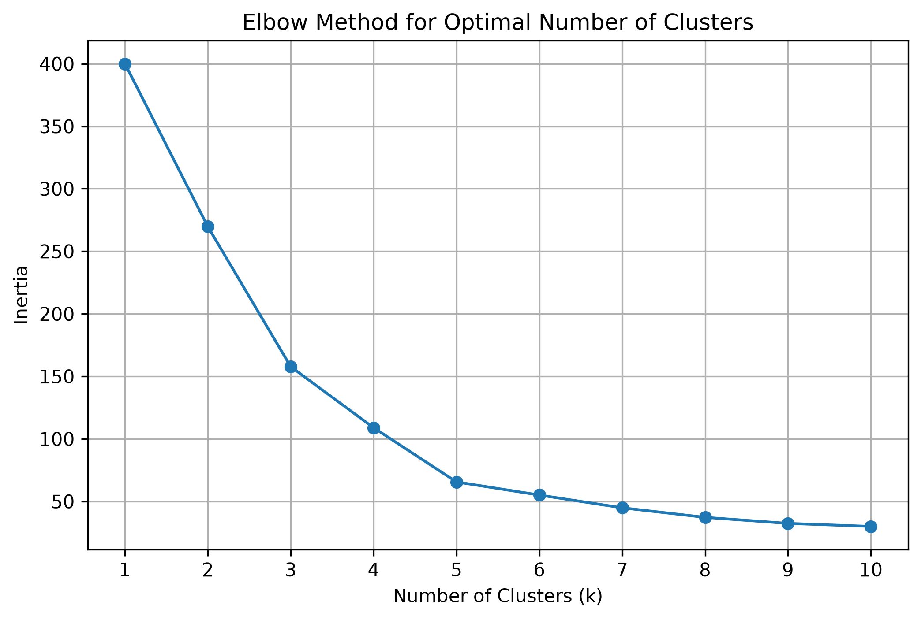
Figure 6: Elbow Method for selecting the cluster count.

6.2 Silhouette Score
Silhouette analysis was performed for cluster counts from 2 to 10. The silhouette score measures how similar an observation is to its own cluster compared with other clusters. Higher values generally indicate better-separated and more cohesive clusters.
Number of Clusters | Silhouette Score
2 | 0.3213
3 | 0.4666
4 | 0.4939
5 | 0.5547
6 | 0.5399
7 | 0.5281
8 | 0.4552
9 | 0.4571
10 | 0.4432
The highest silhouette score was 0.5547 at k = 5. Therefore, five clusters were selected for the final model. This choice was also considered alongside the Elbow Method and the practical interpretability of the resulting customer groups.
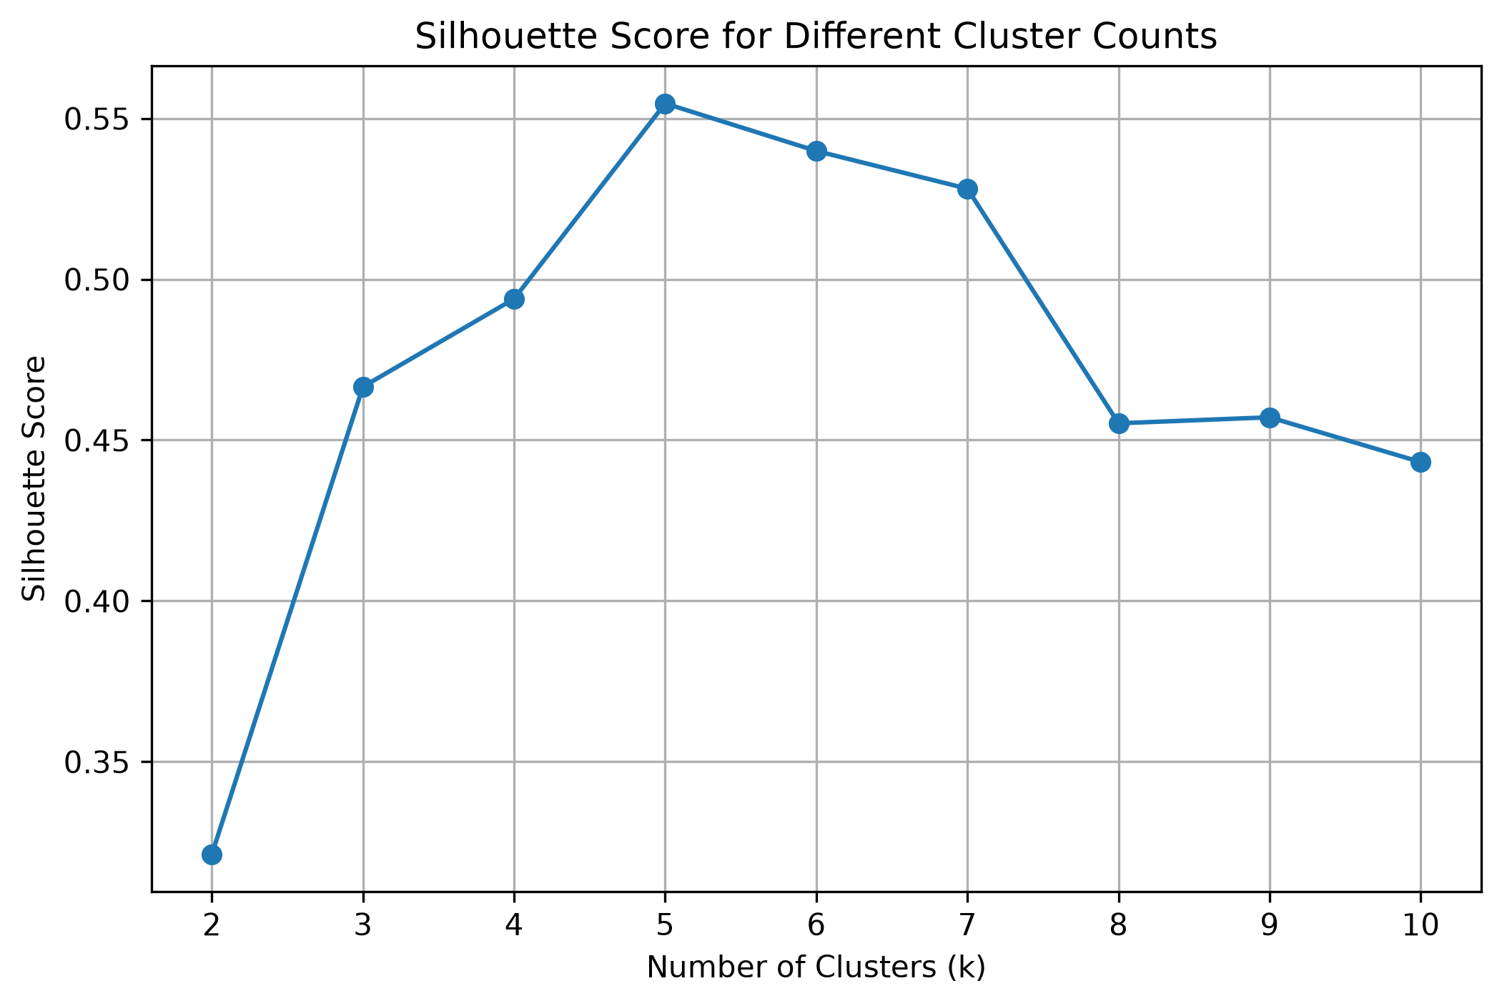
Figure 7: Silhouette scores for different cluster counts.

7. Final K-Means Model and Results
The final K-Means model was trained using five clusters and the standardized income and spending features. All 200 customers were assigned to one of the five clusters. The final silhouette score was 0.5547.
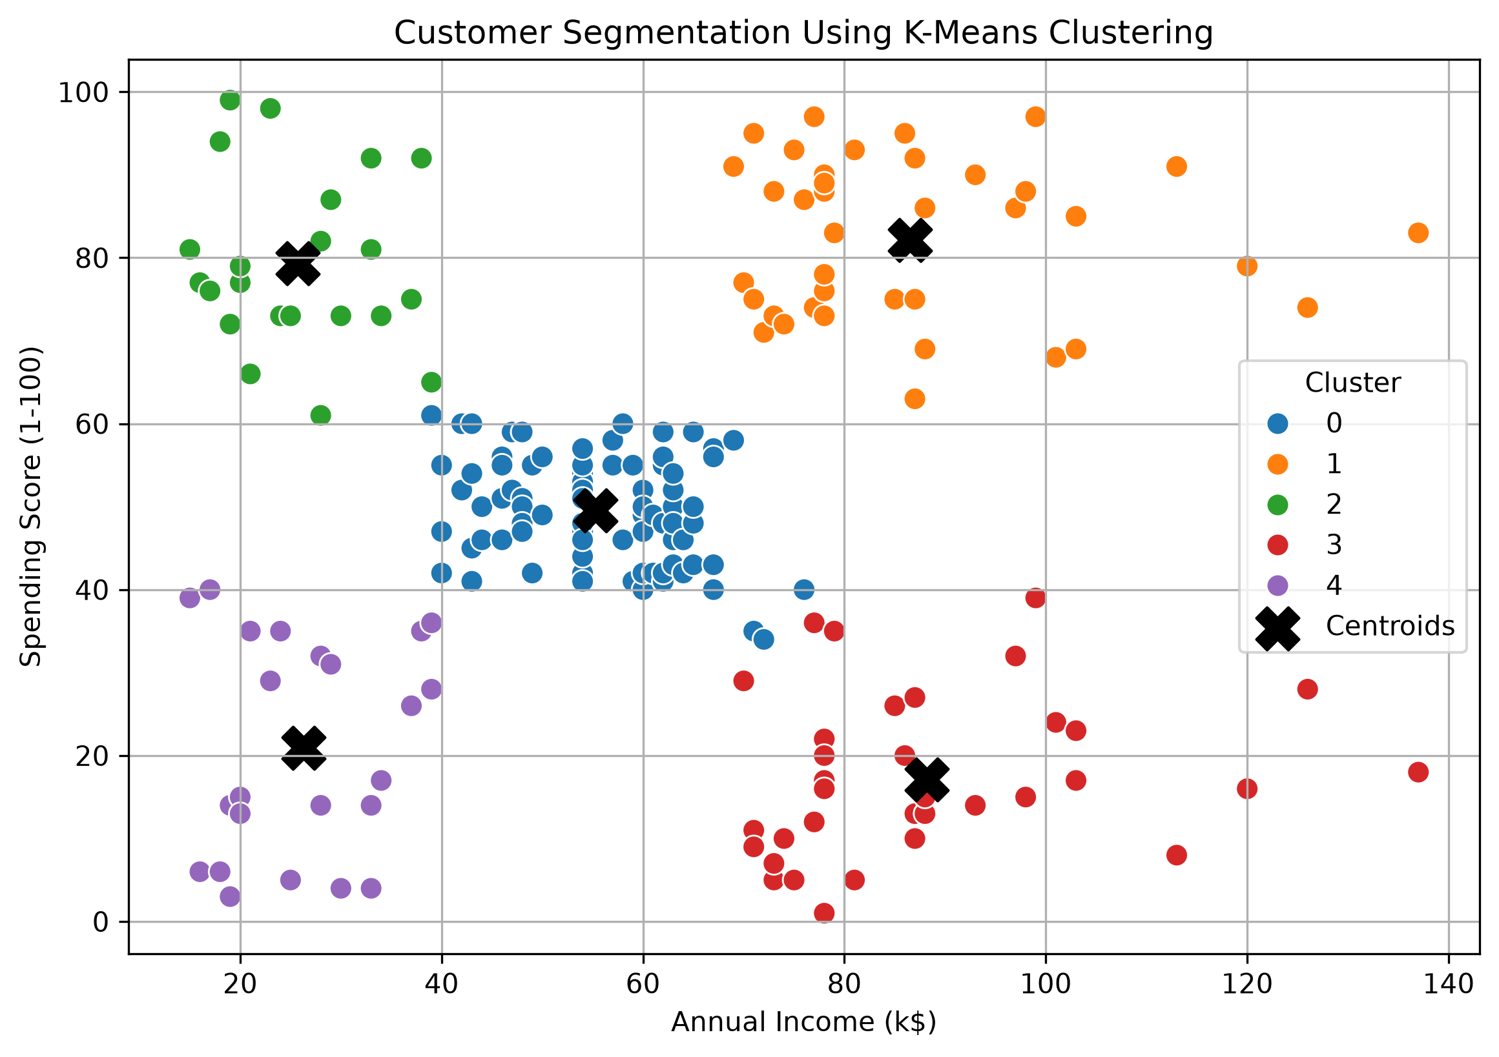
Figure 8: Customer clusters and their centroids.
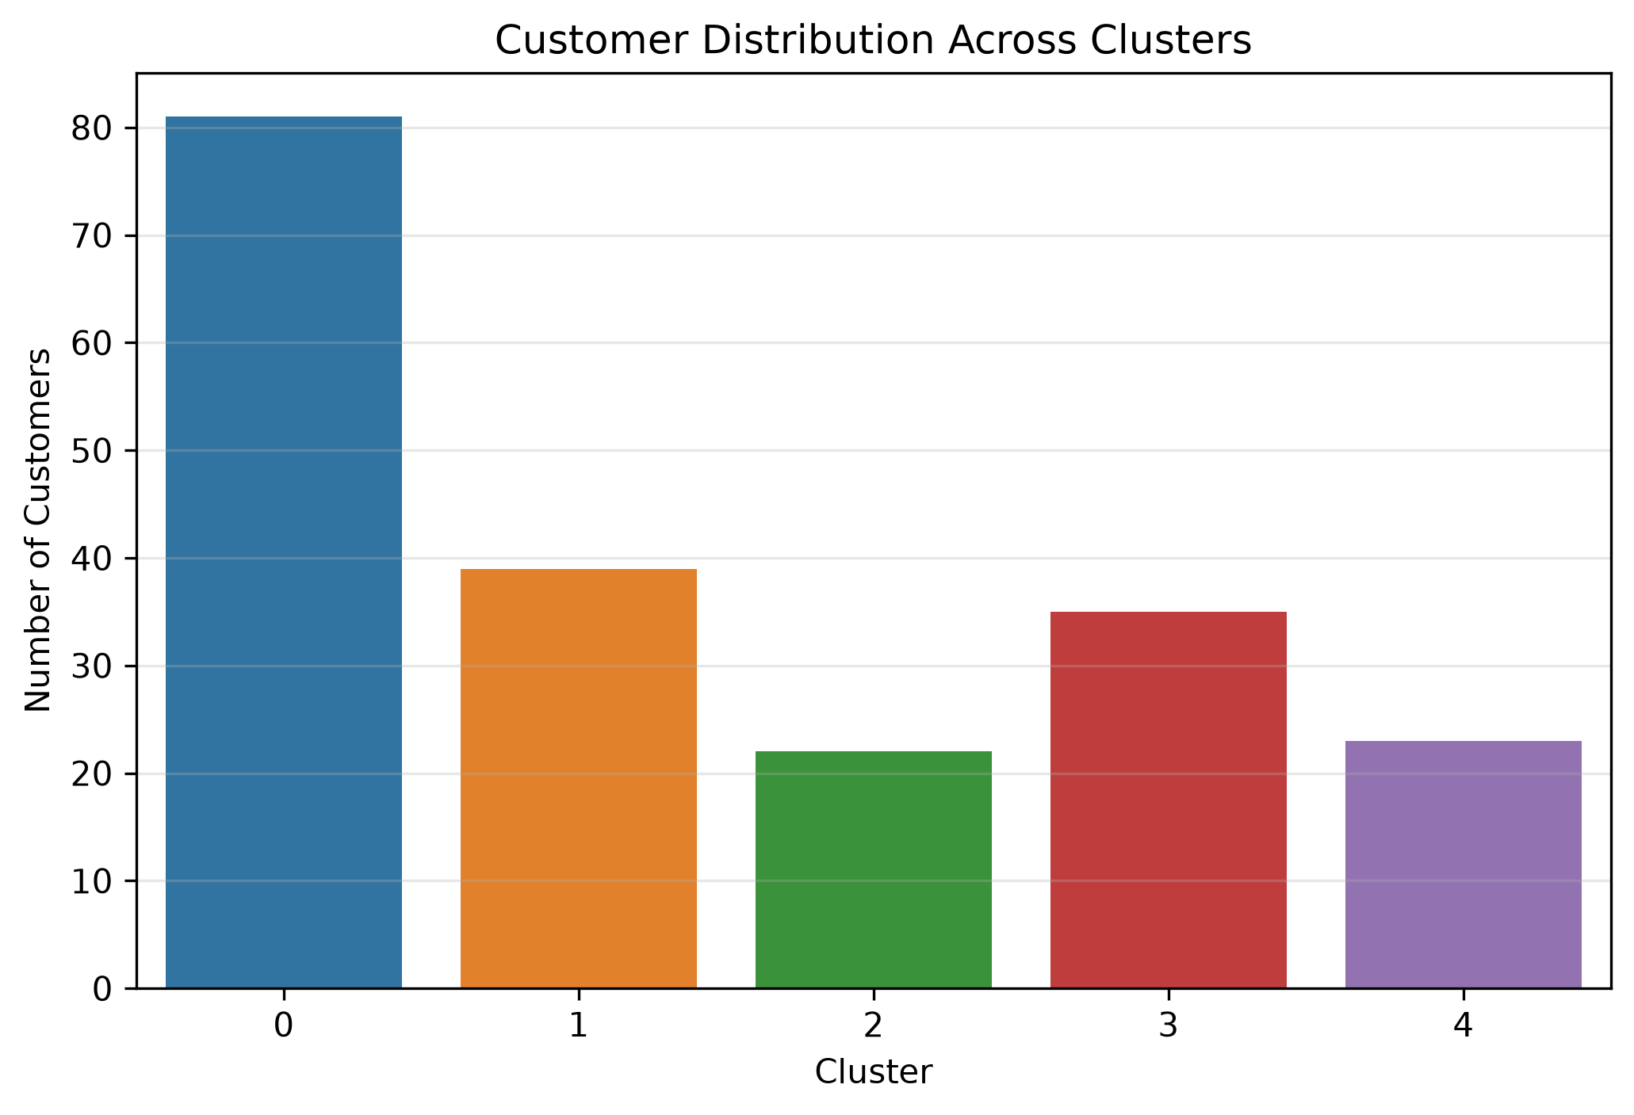
Figure 9: Number of customers in each cluster.

7.1 Cluster Distribution
Cluster | Number of Customers
0 | 81
1 | 39
2 | 22
3 | 35
4 | 23

7.2 Customer Profile and Cluster Interpretation
Cluster | Count | Avg. Age | Avg. Income (k$) | Avg. Spending
0 | 81 | 42.72 | 55.3 | 49.52
1 | 39 | 32.69 | 86.54 | 82.13
2 | 22 | 25.27 | 25.73 | 79.36
3 | 35 | 41.11 | 88.2 | 17.11
4 | 23 | 45.22 | 26.3 | 20.91
Cluster 0 – Average-income, average-spending customers: This is the largest segment, containing 81 customers. Their average income and spending score are close to the overall dataset averages. General promotions and loyalty programmes may be suitable for this group.
Cluster 1 – High-income, high-spending customers: This segment contains 39 customers. They have the highest average spending score and high annual income. Premium offers, exclusive rewards and loyalty programmes may help retain these customers.
Cluster 2 – Low-income, high-spending customers: This group contains 22 customers. Despite their lower average income, they have high spending scores. Affordable product bundles, discounts and reward programmes may be relevant.
Cluster 3 – High-income, low-spending customers: This group contains 35 customers. They have high average income but the lowest spending score among the high-income segments. Personalised recommendations and targeted promotions could be explored to improve engagement.
Cluster 4 – Low-income, low-spending customers: This group contains 23 customers. They have lower average income and spending scores. Value-oriented offers and essential-product promotions may be more appropriate for this segment.

7.3 Gender Distribution Within Clusters
Cluster | Female (%) | Male (%)
0 | 59 | 41
1 | 54 | 46
2 | 59 | 41
3 | 46 | 54
4 | 61 | 39
Female customers form a slight majority in four of the five clusters. The differences are modest, and gender was not used as a clustering feature. Therefore, these observations should not be interpreted as evidence that gender determines spending behaviour.

8. Business Implications
- Develop premium loyalty programmes for high-income, high-spending customers.
- Use affordable offers and reward schemes to engage lower-income, high-spending customers.
- Explore personalised recommendations for high-income, low-spending customers.
- Provide value-oriented promotions for lower-income, low-spending customers.
- Use broad engagement campaigns for customers with average income and spending.
These suggestions are possible applications of the identified segments. Actual marketing decisions should be tested using further customer and sales data.

9. Limitations
- The analysis uses a relatively small dataset of 200 customers.
- Only annual income and spending score were used for clustering.
- K-Means requires the number of clusters to be selected in advance.
- Results may vary with feature selection, scaling and centroid initialization.
- The clusters describe patterns in the available data and do not establish causation.
- The dataset does not contain purchase histories or customer responses to marketing campaigns.

10. Conclusion
This project applied K-Means clustering to the Mall Customer Segmentation dataset to identify groups based on annual income and spending score. Exploratory analysis and feature standardization were performed before model training. The Elbow Method and Silhouette Score were used to evaluate different cluster counts. Five clusters were selected, producing a silhouette score of 0.5547. The resulting segments represented average customers, high-income high-spending customers, low-income high-spending customers, high-income low-spending customers, and low-income low-spending customers. The analysis demonstrates how unsupervised learning can support customer profiling and help businesses explore targeted strategies.

11. Tools and Technologies
Python 3, Pandas, NumPy, Matplotlib, Seaborn, Scikit-learn, Jupyter Notebook and python-docx were used in this project.

