HANDWRITTEN DIGIT RECOGNITION USING A CONVOLUTIONAL NEURAL NETWORK
WEEK 5 PROJECT REPORT
Virtual Data Science with Python Internship

Tools: Python | TensorFlow | Keras | NumPy | Pandas | Matplotlib | Seaborn | Scikit-learn

1. Introduction
Handwritten digit recognition is an image classification problem in which a computer identifies numerical digits from handwritten images. It is an important application of computer vision and deep learning, with potential uses in automated form processing, postal code recognition and document digitization.
This project develops a Convolutional Neural Network (CNN) using TensorFlow and Keras to classify handwritten digits from the MNIST dataset. The model identifies images belonging to ten classes, representing digits from 0 to 9.

2. Problem Statement
The objective is to develop a deep learning model capable of accurately recognizing handwritten numerical digits from grayscale images. The model must learn visual patterns such as edges, curves and shapes and use these features to predict the corresponding digit.

3. Project Objectives
- Load and explore the MNIST handwritten digit dataset.
- Preprocess images through normalization and reshaping.
- Design and implement a CNN architecture.
- Train the model and monitor training and validation performance.
- Evaluate the trained model using test accuracy and classification metrics.
- Visualize model performance and sample predictions.

4. Dataset Description
The MNIST dataset was obtained using the built-in dataset loader provided by TensorFlow Keras. It contains 70,000 grayscale images of handwritten digits, each having a resolution of 28 × 28 pixels.
The dataset is divided into 60,000 training images and 10,000 testing images. Each image is associated with a label from 0 to 9.
Dataset dimensions:
- Training images: 60,000
- Testing images: 10,000
- Image dimensions: 28 × 28 pixels
- Number of classes: 10
- Image channels: 1 (grayscale)
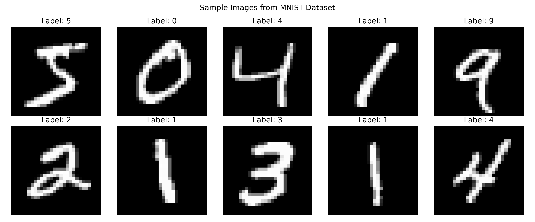
Figure 1: Sample handwritten digit images from the MNIST dataset.

5. Data Preprocessing
The original pixel values range from 0 to 255. The images were converted to floating-point values and normalized by dividing each pixel by 255. This scales the pixel values to the range 0 to 1.
The images were reshaped to include a channel dimension, resulting in an input shape of (28, 28, 1), which is suitable for the CNN.
Preprocessing operations:
- Conversion to float32 data type.
- Pixel normalization using division by 255.
- Reshaping images to include one grayscale channel.

6. CNN Architecture
A Sequential Convolutional Neural Network was implemented using TensorFlow Keras. The architecture consists of convolutional layers, max-pooling layers, a flattening operation, a dense layer, dropout regularization and a final classification layer.
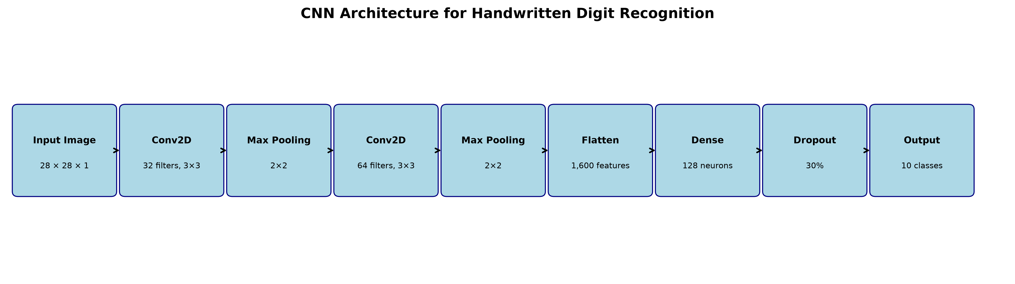
Figure 2: Architecture of the CNN used for digit recognition.

6.1 Layer Description
Layer | Configuration | Purpose
Input | 28 × 28 × 1 | Accepts grayscale images
Conv2D | 32 filters, 3 × 3 | Extracts image features
Max Pooling | 2 × 2 | Reduces spatial dimensions
Conv2D | 64 filters, 3 × 3 | Extracts deeper features
Max Pooling | 2 × 2 | Further reduces dimensions
Flatten | 1,600 features | Converts feature maps to a vector
Dense | 128 neurons | Learns feature relationships
Dropout | 0.3 | Helps reduce overfitting
Output | 10 neurons | Predicts digit classes 0–9
The convolutional layers use ReLU activation functions. The final dense layer uses softmax activation to produce class probabilities for the ten digit categories.
The model contains 225,034 trainable parameters.

7. Model Training
The CNN was compiled using the Adam optimizer, sparse categorical cross-entropy loss function and accuracy as the evaluation metric.
- Optimizer: Adam
- Loss function: Sparse categorical cross-entropy
- Evaluation metric: Accuracy
- Epochs: 5
- Batch size: 128
- Validation split: 10% of the training dataset
The model was trained on the training dataset while 10% of the training data was reserved for validation. Training and validation accuracy and loss were monitored across five epochs.
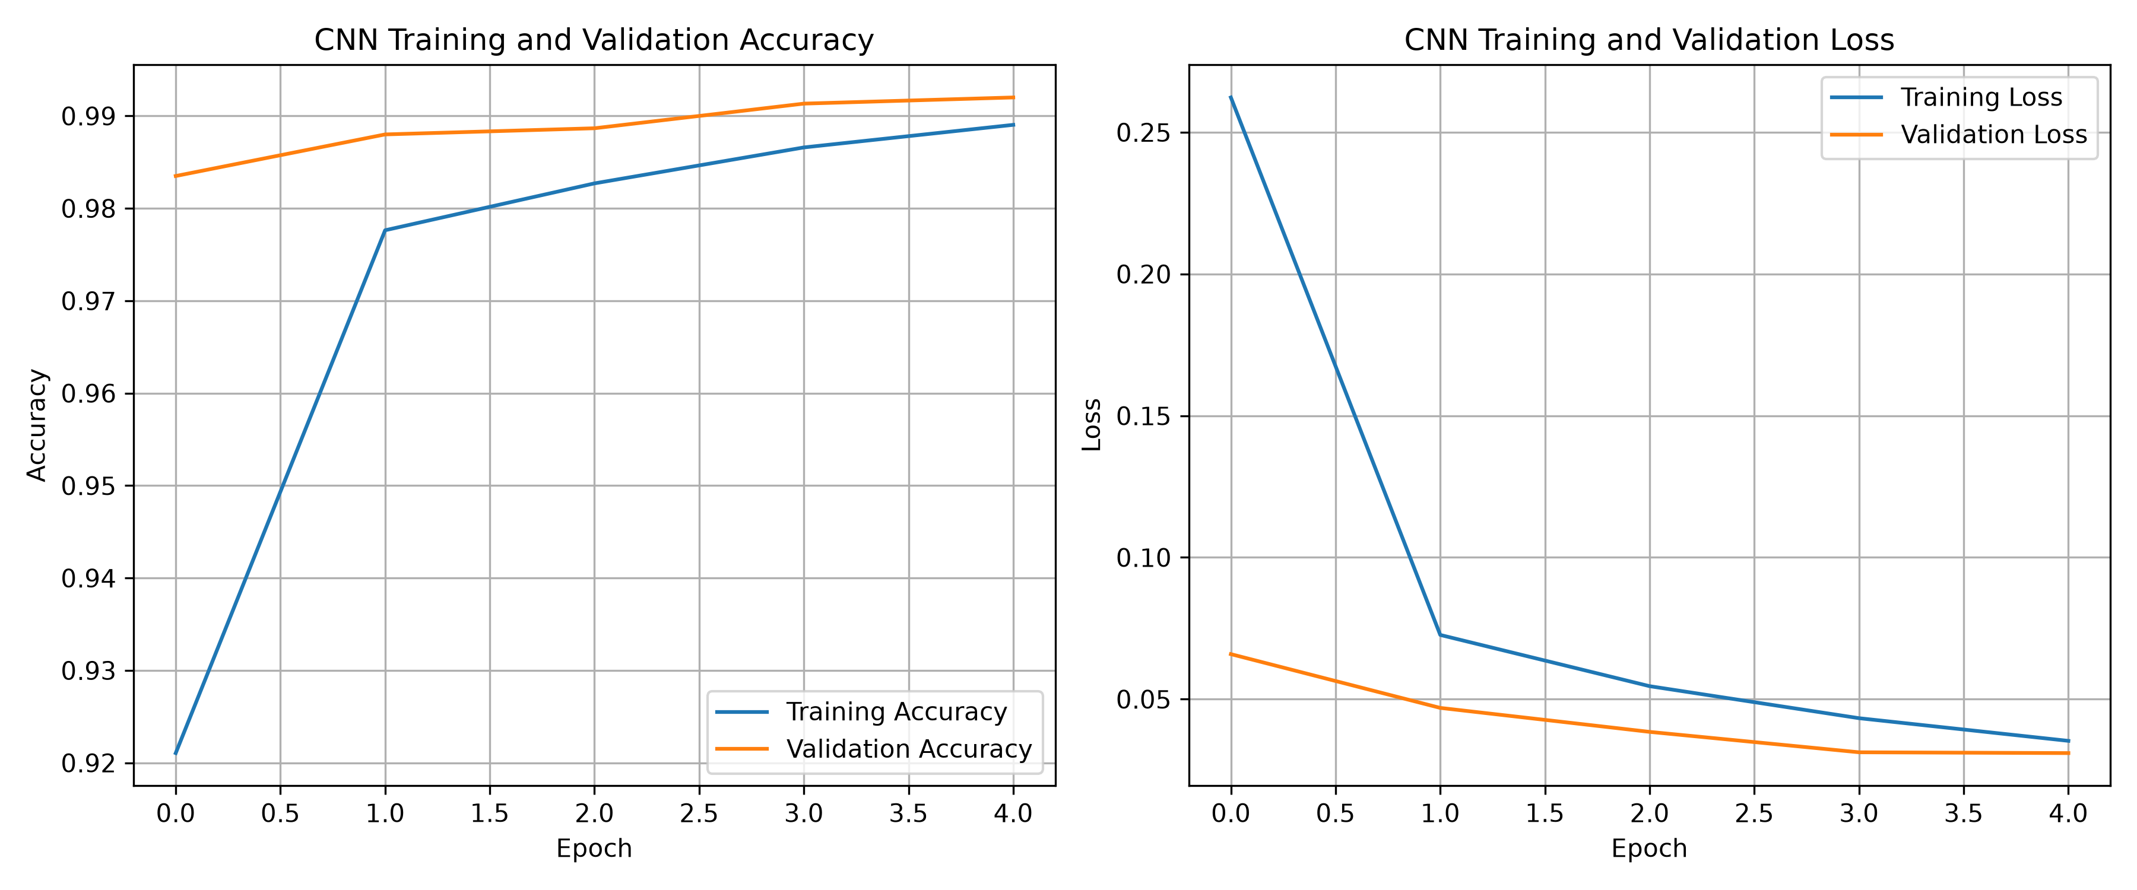
Figure 3: Training and validation accuracy and loss across five epochs.

8. Model Evaluation
The trained CNN was evaluated using the separate test dataset containing 10,000 images. The model achieved a test accuracy of 99.12%, demonstrating strong classification performance on unseen handwritten digit images.

8.1 Performance Summary
Metric | Result
Training Accuracy | 98.90%
Validation Accuracy | 99.20%
Test Accuracy | 99.12%
Final Training Loss | 0.0353
Final Validation Loss | 0.0310
Total Parameters | 225,034

8.2 Classification Report
Precision, recall and F1-score were calculated for each digit class. The model achieved consistently high scores across all ten classes, with F1-scores ranging from 0.98 to 0.99.
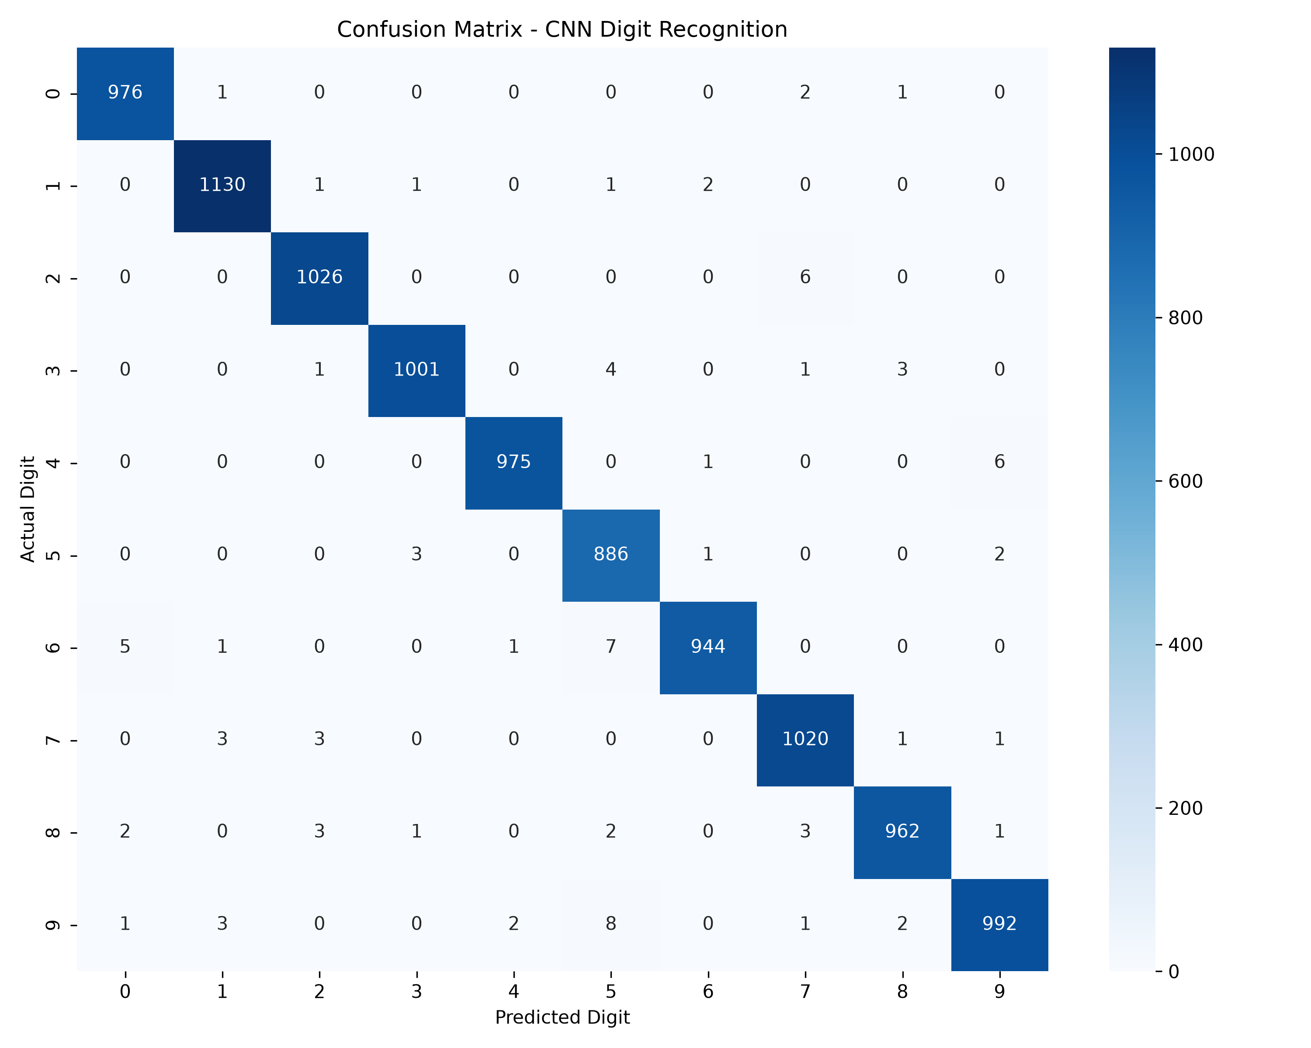
Figure 4: Confusion matrix showing actual and predicted digit classes.
The confusion matrix provides a class-wise view of correct predictions and misclassifications. Most predictions lie along the main diagonal, indicating strong classification performance.
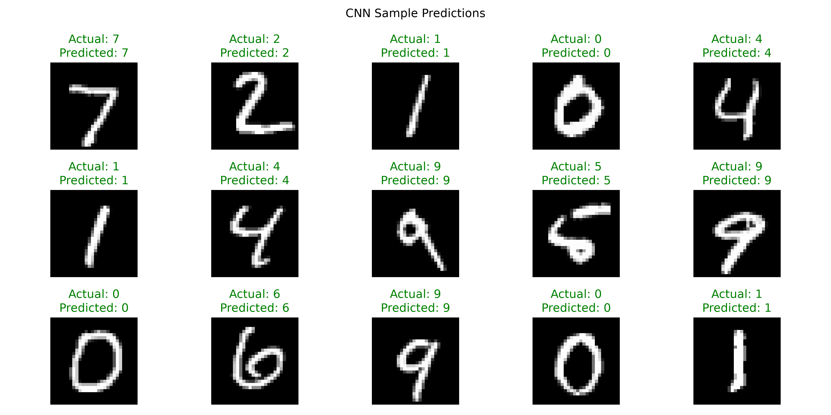
Figure 5: Sample test images with actual and predicted labels.
The displayed sample predictions were all correct. This provides a visual demonstration of the model output, while the overall test accuracy represents performance across the complete test set.

9. Challenges and Observations
One practical challenge was the execution environment. TensorFlow reported that GPU acceleration was unavailable for the installed version on native Windows. The model was therefore trained using the CPU. Training completed successfully without requiring a GPU.
The model also required appropriate image preprocessing, including normalization and reshaping, to provide input in the format expected by the convolutional layers.
The training and validation accuracy increased consistently, while their losses decreased across the five epochs. No major divergence between training and validation performance was observed during this training run.

10. Limitations
Although the model achieved high accuracy on MNIST, the dataset contains relatively small, centered grayscale digit images. Performance on real-world handwriting, noisy images, different backgrounds or complex document layouts may differ. Further testing on more varied handwriting datasets would be required before deployment in practical applications.

11. Conclusion
This project successfully implemented a Convolutional Neural Network for handwritten digit recognition using TensorFlow and Keras. The model was trained on the MNIST dataset and evaluated on 10,000 unseen test images.
The CNN achieved 99.12% test accuracy with 225,034 trainable parameters. The results demonstrate the effectiveness of convolutional neural networks in extracting image features and performing handwritten digit classification.
The project provided practical experience in dataset preparation, deep learning model development, training, evaluation and visualization. Future improvements could include testing the model on more diverse handwriting samples and exploring model optimization.

12. Technologies and Libraries Used
- Python: Programming language.
- TensorFlow and Keras: CNN development and model training.
- NumPy: Numerical operations and image array processing.
- Pandas: Data handling and analysis support.
- Matplotlib: Visualization of images and training performance.
- Seaborn: Confusion matrix visualization.
- Scikit-learn: Classification metrics and model evaluation.

