EXPLORATORY DATA ANALYSIS
AND DATA VISUALIZATION
A Study of the Palmer Penguins Dataset

WEEK 2 PROJECT REPORT
Virtual Data Science with Python Internship
Tools: Python | Pandas | NumPy | Matplotlib | Seaborn

1. Introduction
Exploratory Data Analysis (EDA) is an important stage of data science that involves examining datasets to understand their structure, identify patterns, discover relationships, and detect possible anomalies. Data visualization helps communicate these findings through graphical representations.
This project uses the Palmer Penguins dataset to explore physical measurements and species distributions among Adelie, Chinstrap, and Gentoo penguins. The analysis uses Python libraries to perform data inspection, statistical analysis, visualization, and comparison.

2. Objectives
- Understand the structure and characteristics of a public dataset.
- Perform initial data inspection and descriptive statistical analysis.
- Identify missing values and examine data quality.
- Create visualizations to explore distributions and relationships.
- Compare physical measurements across penguin species and islands.
- Interpret the findings and discuss limitations.

3. Dataset Description
The Palmer Penguins dataset contains observations of three penguin species from islands in the Palmer Archipelago, Antarctica. It includes categorical information and physical measurements.
Dataset source: https://github.com/mcnakhaee/palmerpenguins/blob/master/palmerpenguins/data/penguins.csv
The dataset contains 344 observations and 8 columns. The columns include species, island, bill length, bill depth, flipper length, body mass, sex, and year.
Column | Description
species | Penguin species
island | Island where the penguin was observed
bill_length_mm | Bill length in millimetres
bill_depth_mm | Bill depth in millimetres
flipper_length_mm | Flipper length in millimetres
body_mass_g | Body mass in grams
sex | Recorded sex of the penguin
year | Year of observation

4. Tools and Libraries Used
Library | Purpose
Pandas | Data loading, inspection, grouping and analysis
NumPy | Numerical operations
Matplotlib | Plot creation and customization
Seaborn | Statistical data visualization
python-docx | Generation of the final Word report

The CSV dataset was loaded into a Pandas DataFrame. Matplotlib and Seaborn were used to generate graphs, while Pandas was used for descriptive statistics, missing-value checks, correlation analysis, and group comparisons.
import pandas as pd
import numpy as np
import matplotlib.pyplot as plt
import seaborn as sns
df = pd.read_csv("penguins.csv")

5. Initial Data Inspection
The dataset was examined using head(), shape, info(), and describe() to understand its structure, data types, and statistical properties.
Dataset dimensions: 344 rows and 8 columns.
Column | Data type
species | object
island | object
bill_length_mm | float64
bill_depth_mm | float64
flipper_length_mm | float64
body_mass_g | float64
sex | object
year | Int64

5.1 Descriptive Statistics
Measurement | Mean | Median | Minimum | Maximum
Bill length (mm) | 43.92 | 44.45 | 32.1 | 59.6
Bill depth (mm) | 17.15 | 17.3 | 13.1 | 21.5
Flipper length (mm) | 200.92 | 197 | 172 | 231
Body mass (g) | 4201.75 | 4050 | 2700 | 6300

The descriptive statistics provide an overview of the central tendency and spread of the numerical measurements. The four measurement columns each contain 342 valid observations because two values are missing in each column.

6. Missing-Value Analysis
Column | Missing values
species | 0
island | 0
bill_length_mm | 2
bill_depth_mm | 2
flipper_length_mm | 2
body_mass_g | 2
sex | 11
year | 0
Total | 19

The dataset contains 19 missing cells. The four numerical measurement columns contain two missing values each, while the sex column contains 11 missing values. The species, island, and year columns have no missing values.
The missing values were retained rather than automatically deleting entire rows. This allowed available observations to be used in analyses wherever possible. Individual calculations may therefore use slightly different sample sizes.
missing_values = df.isnull().sum()
print(missing_values)
print(df.isnull().sum().sum())

7. Exploratory Data Analysis and Visualizations
Eight visualizations were created to examine species counts, measurement distributions, differences between species, correlations, and species distribution across islands.

Visualization 1: Distribution of Penguin Species
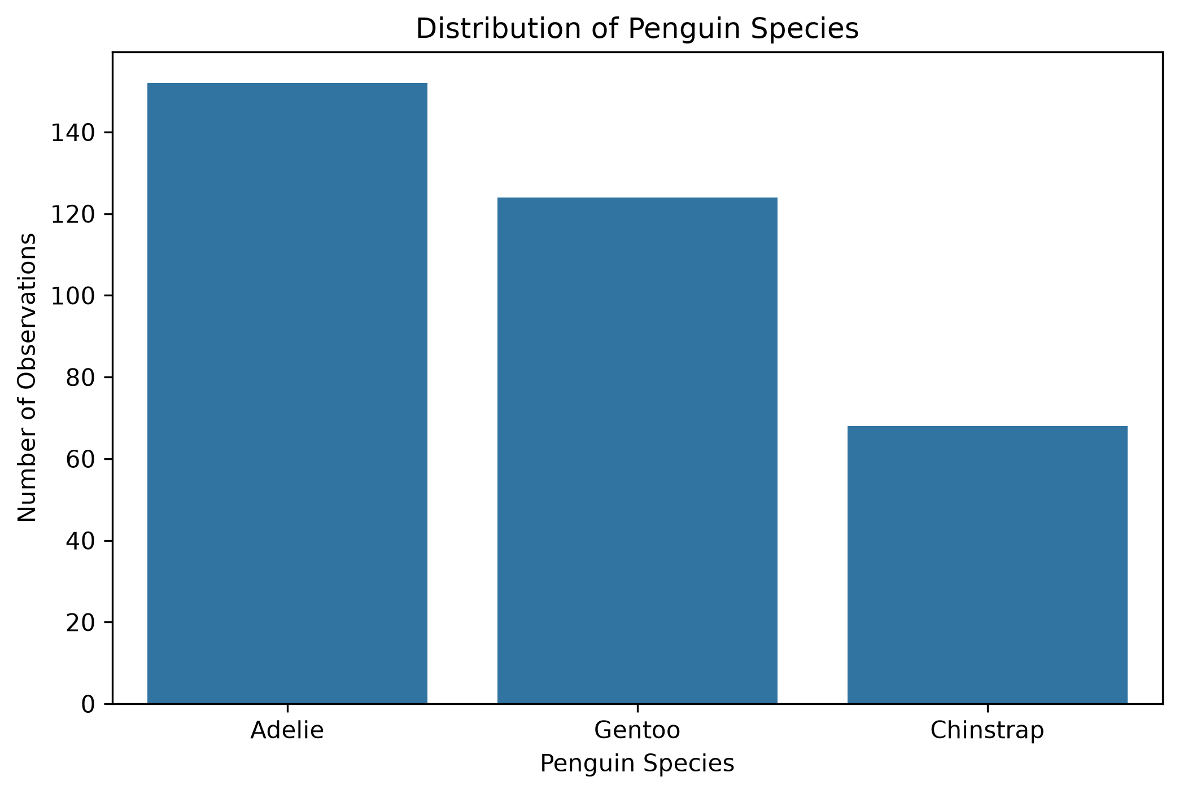
Interpretation: The dataset contains 152 Adelie penguins, 124 Gentoo penguins, and 68 Chinstrap penguins. Adelie is the most frequently represented species, while Chinstrap is the least represented.
Python code:
sns.countplot(data=df, x='species')
plt.title('Distribution of Penguin Species')
plt.xlabel('Penguin Species')
plt.ylabel('Number of Observations')
plt.show()

Visualization 2: Distribution of Penguin Body Mass
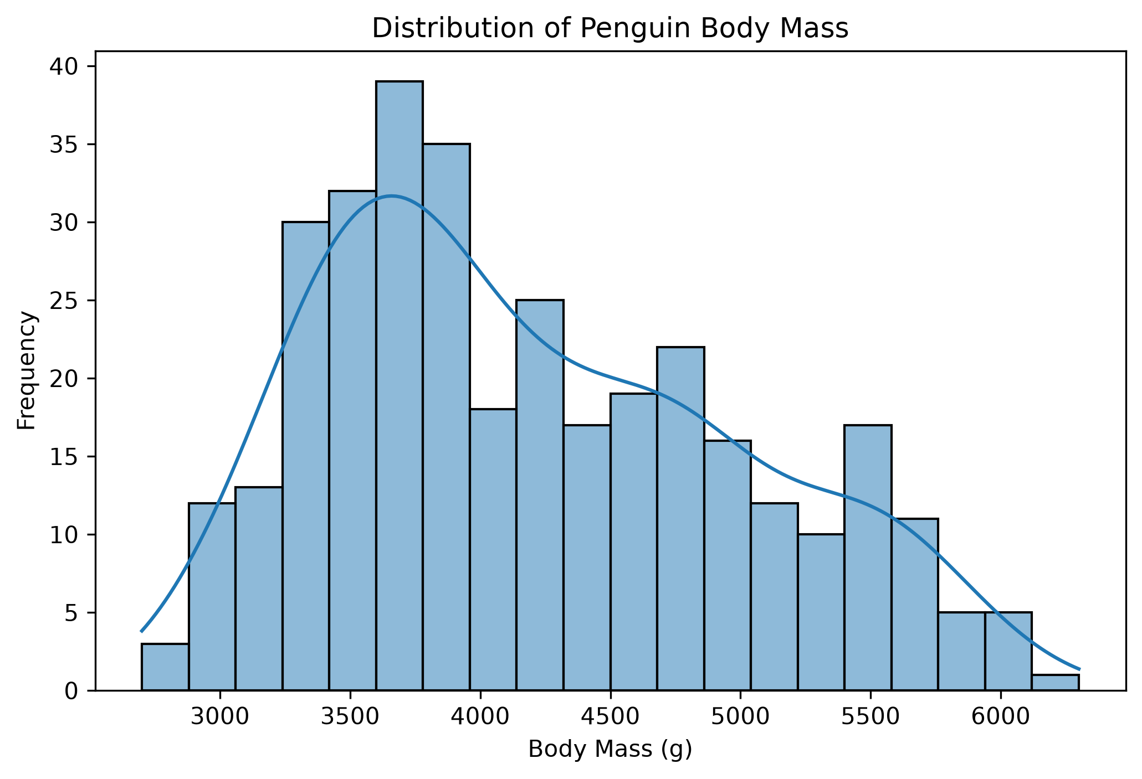
Interpretation: The histogram shows variation in penguin body mass, with multiple peaks rather than one single concentrated distribution. This pattern may reflect differences in body mass among species.
Python code:
sns.histplot(data=df, x='body_mass_g', bins=20, kde=True)
plt.title('Distribution of Penguin Body Mass')
plt.xlabel('Body Mass (g)')
plt.ylabel('Frequency')
plt.show()

Visualization 3: Body Mass Distribution by Species
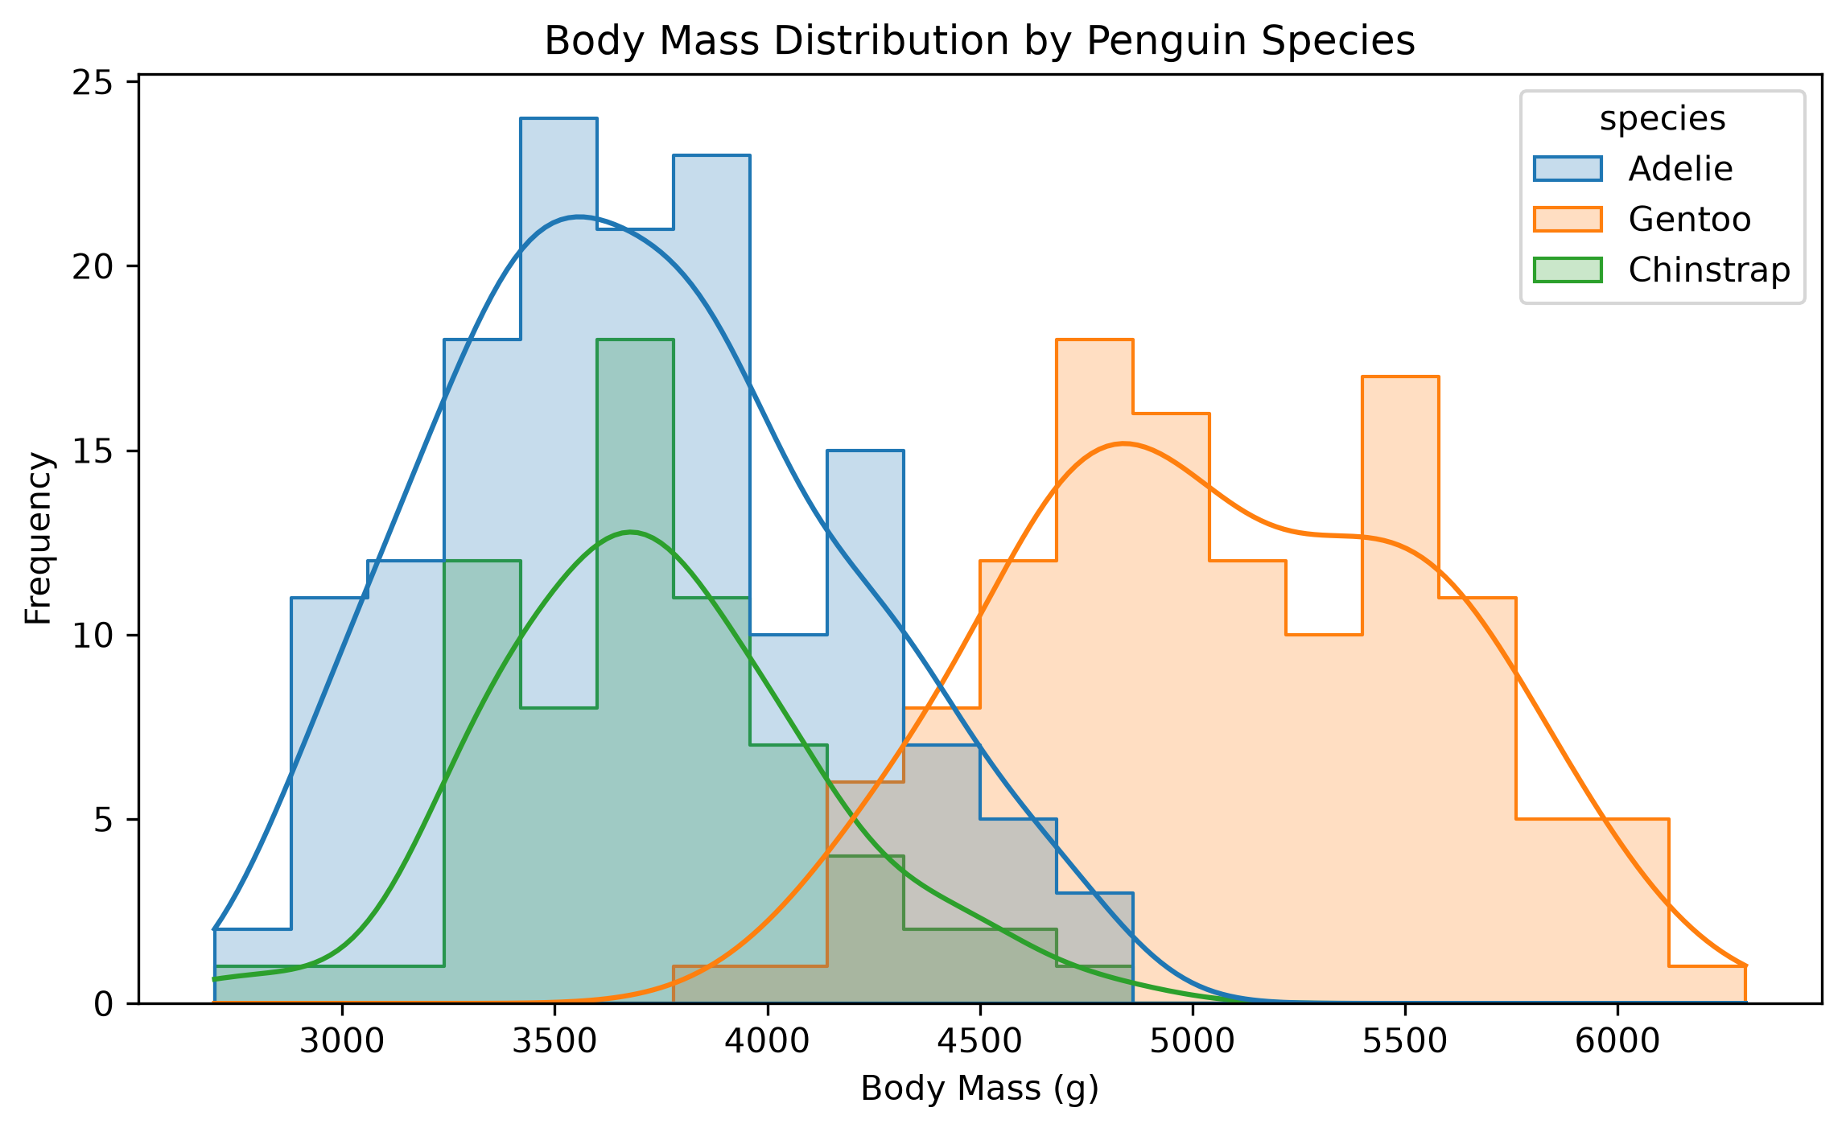
Interpretation: Gentoo penguins generally have higher body mass values, with most observations concentrated around 4700–5500 g. Adelie and Chinstrap penguins have lower and partially overlapping distributions, mainly around 3400–4000 g. Species differences help explain the multiple peaks in the overall histogram.
Python code:
sns.histplot(
data=df, x='body_mass_g', hue='species',
bins=20, kde=True, element='step'
)
plt.title('Body Mass Distribution by Penguin Species')
plt.show()

Visualization 4: Flipper Length by Species
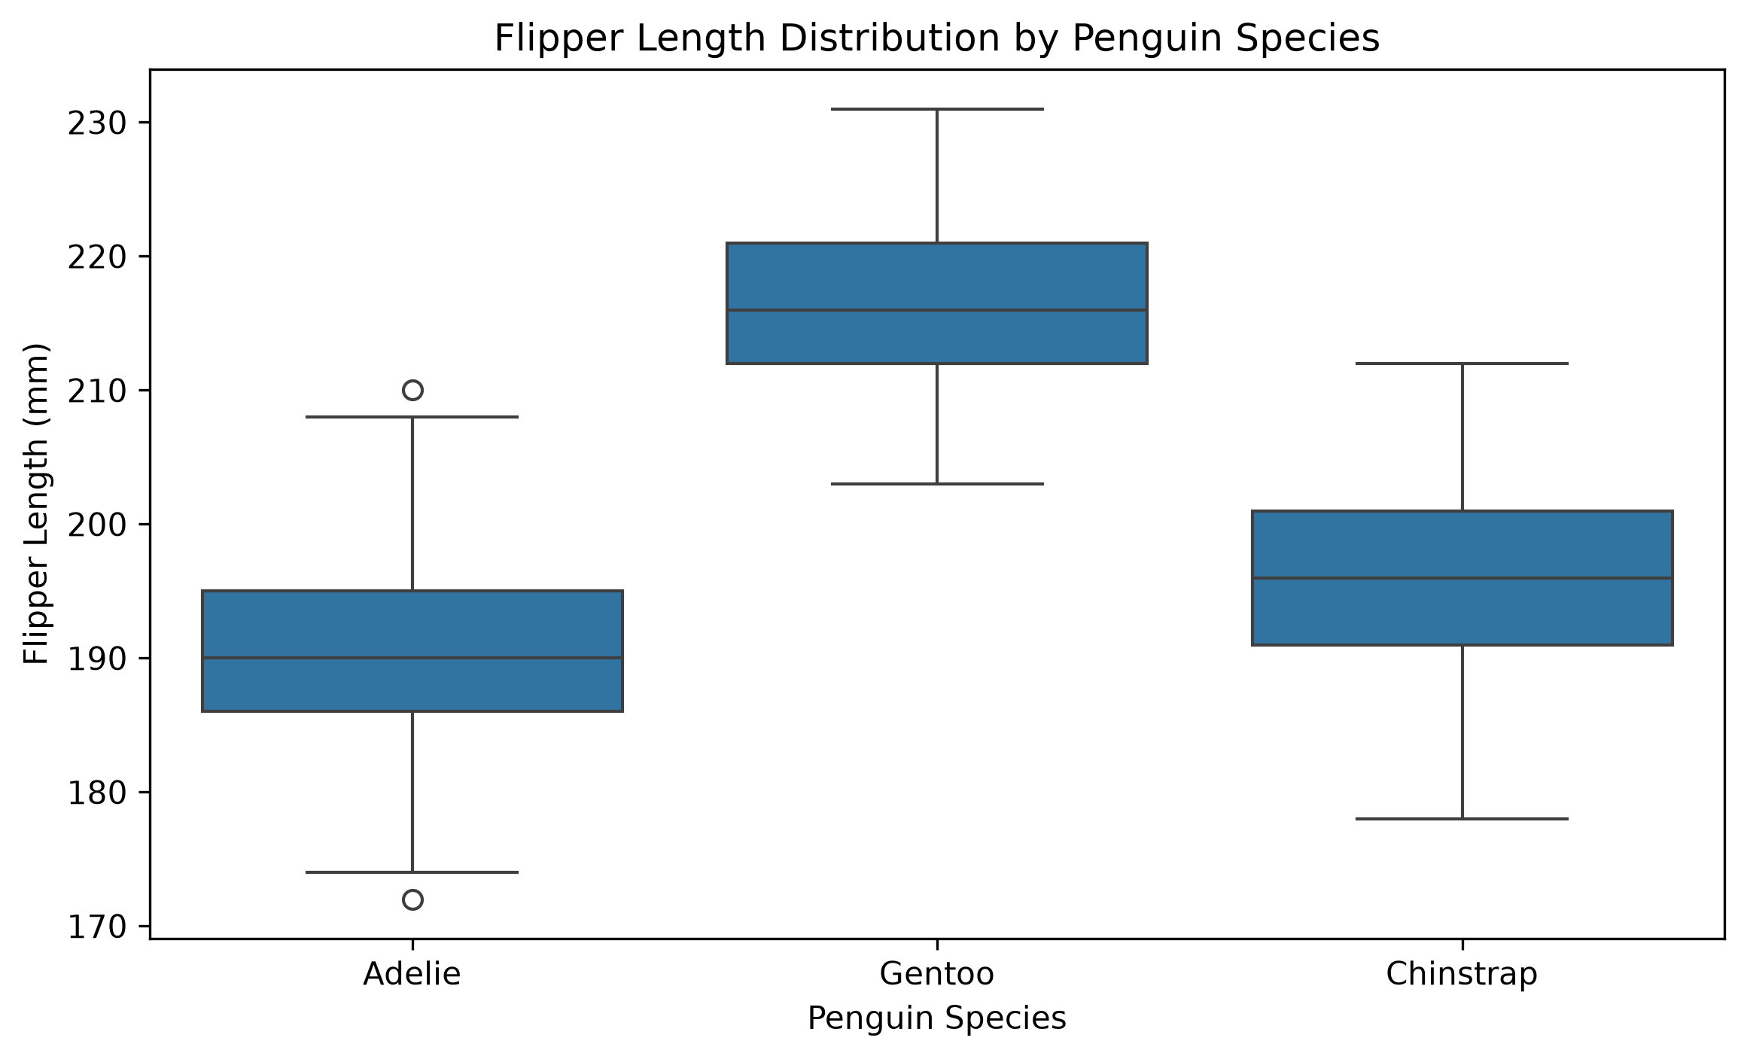
Interpretation: Gentoo penguins have the highest median flipper length at approximately 216 mm, followed by Chinstrap at 196 mm and Adelie at 190 mm. Adelie penguins also show potential outliers. Flipper length is therefore a useful feature for comparing the species.
Python code:
sns.boxplot(data=df, x='species', y='flipper_length_mm')
plt.title('Flipper Length Distribution by Penguin Species')
plt.xlabel('Penguin Species')
plt.ylabel('Flipper Length (mm)')
plt.show()

Visualization 5: Relationship Between Flipper Length and Body Mass
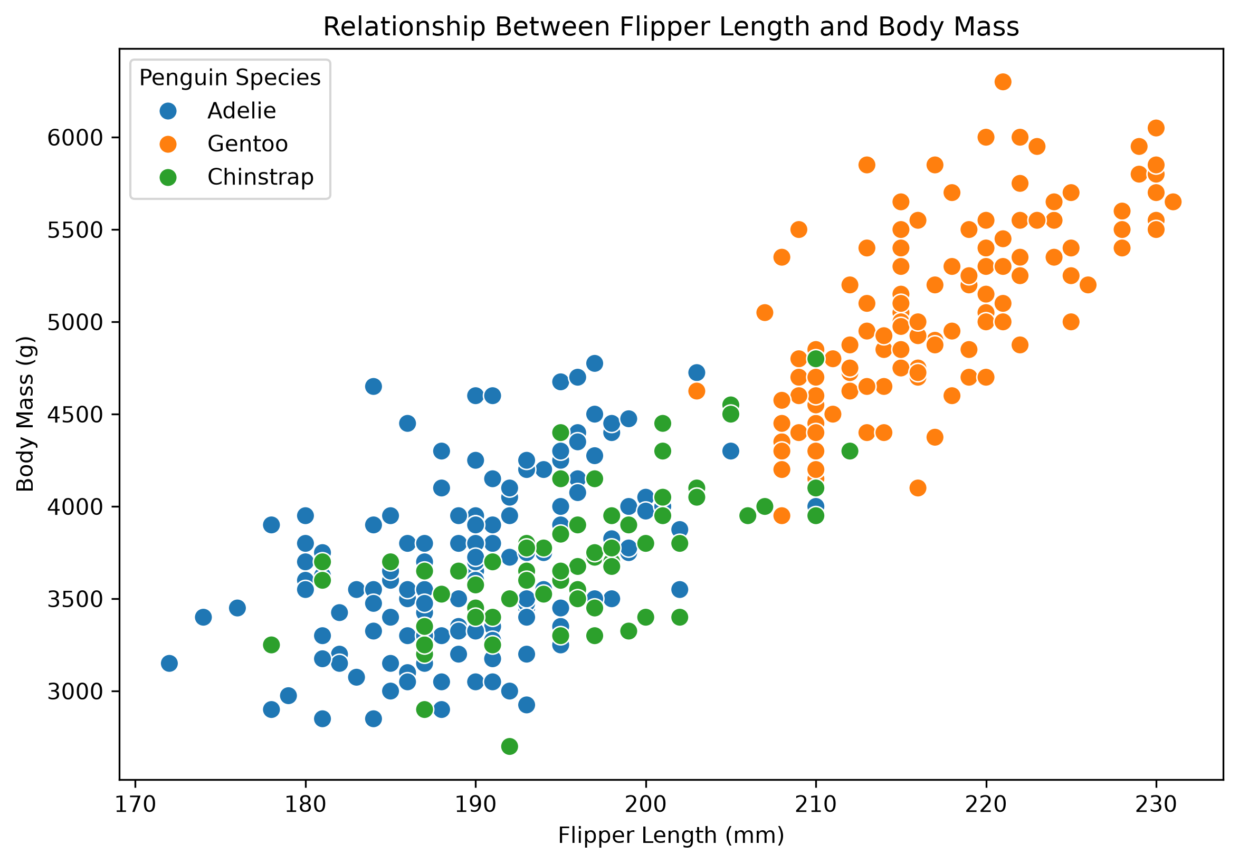
Interpretation: The scatter plot shows a positive relationship between flipper length and body mass. Penguins with longer flippers generally tend to have higher body mass. Species groupings are also visible, suggesting that differences between species may contribute to this overall relationship.
Python code:
sns.scatterplot(
data=df, x='flipper_length_mm',
y='body_mass_g', hue='species', s=70
)
plt.title('Relationship Between Flipper Length and Body Mass')
plt.legend(title='Penguin Species')
plt.show()

Visualization 6: Correlation Between Penguin Body Measurements
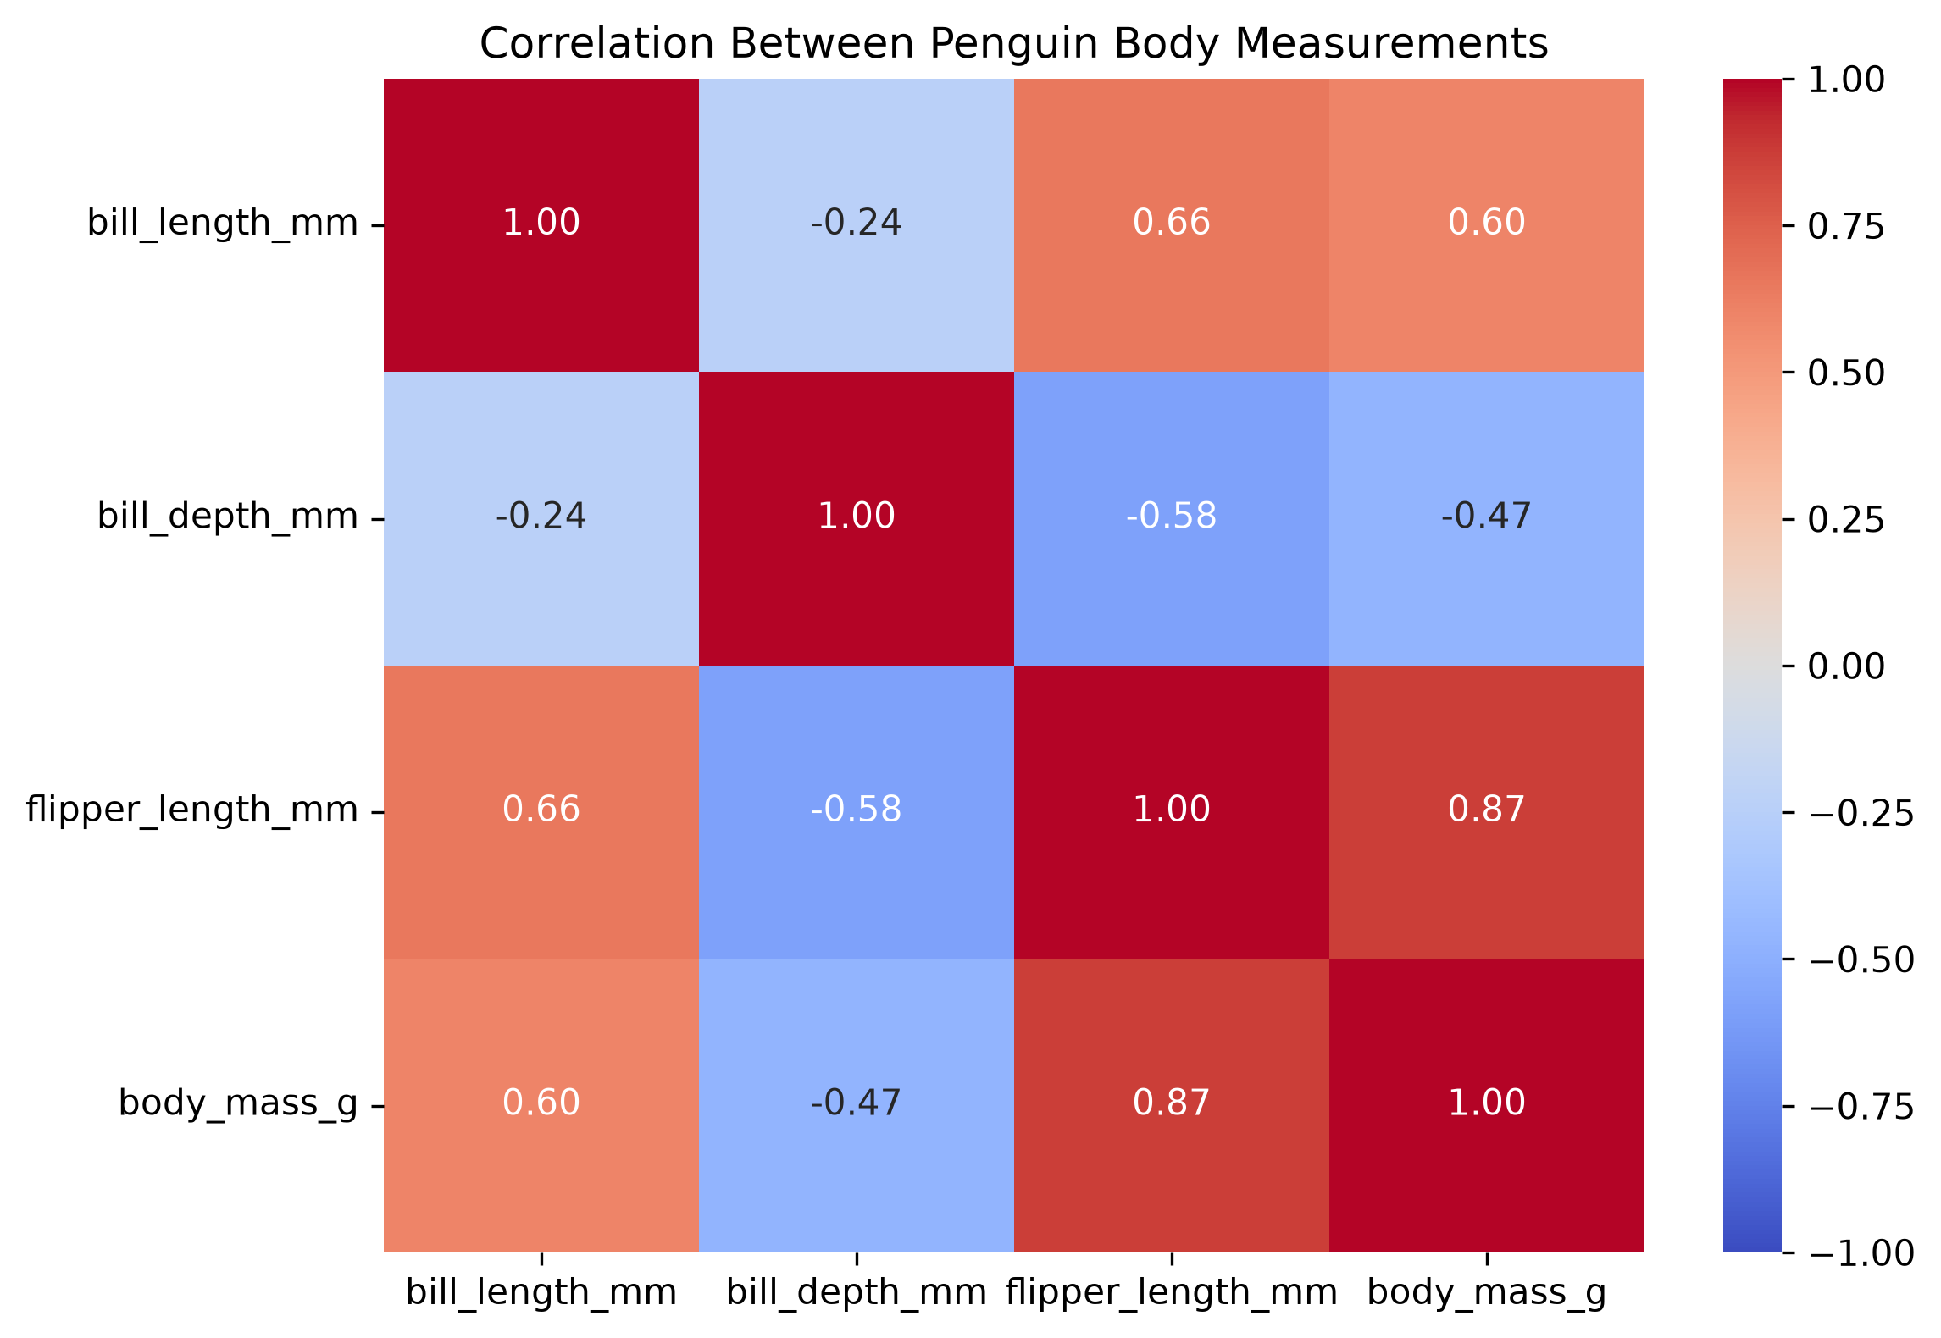
Interpretation: The correlation heatmap summarizes the relationships among bill length, bill depth, flipper length, and body mass. The previously calculated correlation between flipper length and body mass is approximately 0.8712, indicating a strong positive linear relationship. Correlation does not establish causation.
Python code:
numeric_cols = [
'bill_length_mm', 'bill_depth_mm',
'flipper_length_mm', 'body_mass_g'
]
correlation_matrix = df[numeric_cols].corr()
sns.heatmap(
correlation_matrix, annot=True,
cmap='coolwarm', fmt='.2f',
vmin=-1, vmax=1
)
plt.title('Correlation Between Penguin Body Measurements')
plt.show()

Visualization 7: Bill Length Distribution by Species
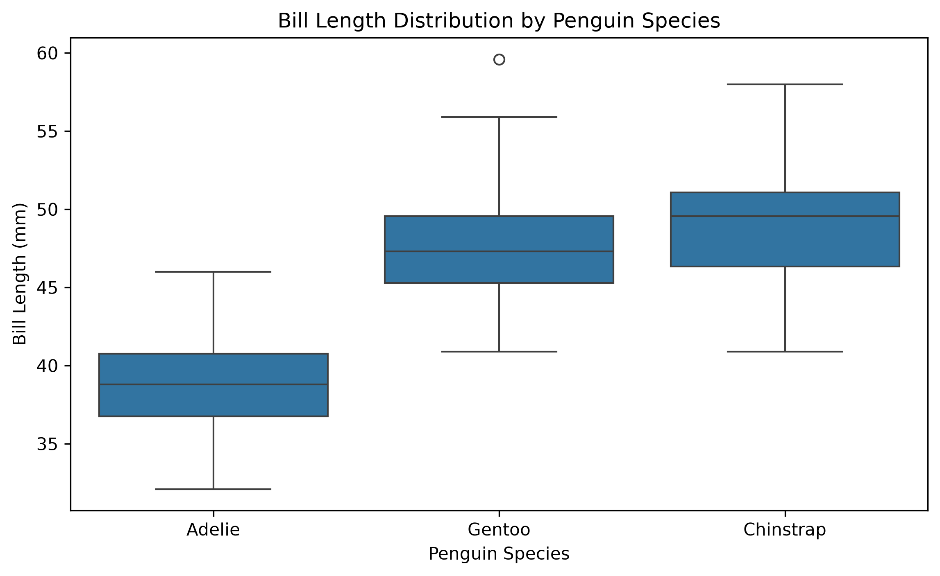
Interpretation: Adelie penguins generally have shorter bill lengths, with whiskers extending approximately from 35 mm to 46 mm. Gentoo penguins extend approximately from 40 mm to 56 mm, while Chinstrap penguins extend approximately from 40 mm to 58 mm. The overlapping distributions indicate that bill length alone may not reliably distinguish every individual penguin.
Python code:
sns.boxplot(data=df, x='species', y='bill_length_mm')
plt.title('Bill Length Distribution by Penguin Species')
plt.xlabel('Penguin Species')
plt.ylabel('Bill Length (mm)')
plt.show()

Visualization 8: Penguin Species Distribution Across Islands
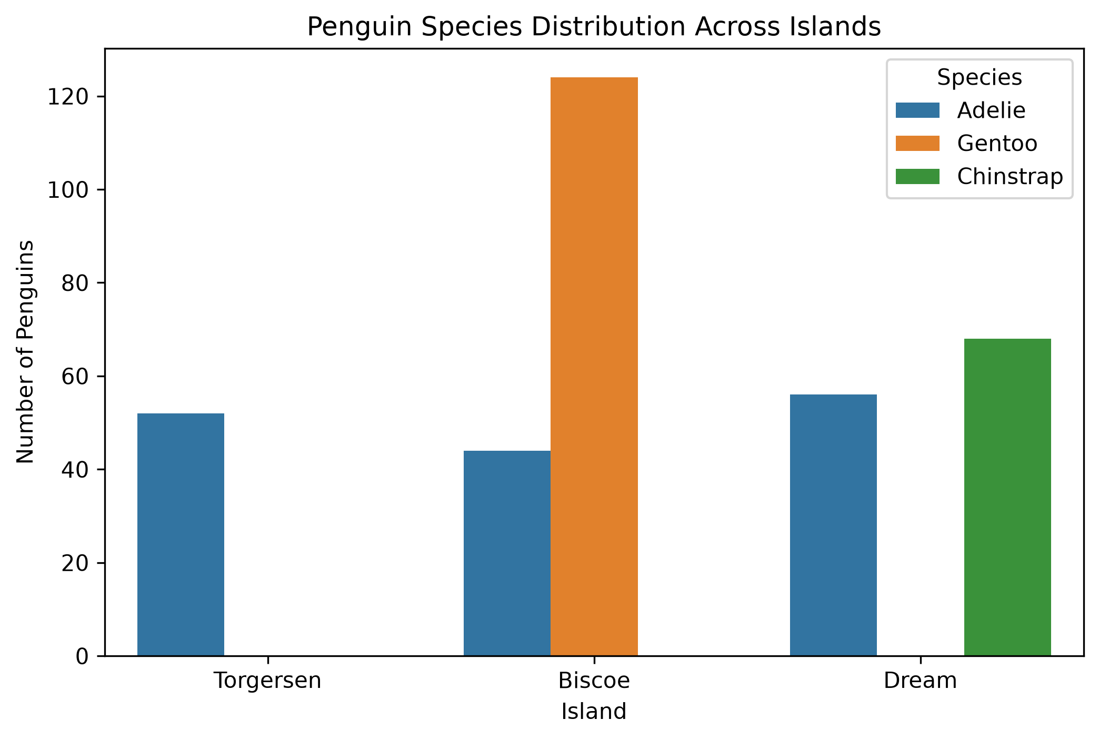
Interpretation: Adelie penguins appear on all three islands. Gentoo penguins appear on Biscoe Island, while Chinstrap penguins appear on Dream Island. Biscoe has the largest overall number of observations in this dataset.
Python code:
sns.countplot(
data=df, x='island', hue='species'
)
plt.title('Penguin Species Distribution Across Islands')
plt.xlabel('Island')
plt.ylabel('Number of Penguins')
plt.legend(title='Species')
plt.show()

8. Species-wise Numerical Analysis
The mean values of the four physical measurements were calculated separately for each species using Pandas groupby().
Measurement | Adelie | Chinstrap | Gentoo
Bill length (mm) | 38.79 | 48.83 | 47.50
Bill depth (mm) | 18.35 | 18.42 | 14.98
Flipper length (mm) | 189.95 | 195.82 | 217.19
Body mass (g) | 3700.66 | 3733.09 | 5076.02

Adelie penguins have the shortest average bill length and flipper length. Chinstrap penguins have the highest average bill length and bill depth. Gentoo penguins have the greatest average flipper length and body mass. Adelie and Chinstrap have relatively similar average body masses.
species_analysis = df.groupby('species')[
['bill_length_mm', 'bill_depth_mm',
'flipper_length_mm', 'body_mass_g']
].mean()
print(species_analysis.round(2))

9. Island-wise Body Mass Analysis
Island | Average body mass (g)
Biscoe | 4716.02
Dream | 3712.90
Torgersen | 3706.37

Biscoe Island has the highest average body mass at approximately 4716.02 g. Dream and Torgersen have lower and relatively similar averages. This difference may partly reflect species composition, because Gentoo penguins, which have a higher average body mass, occur on Biscoe Island in this dataset. The result does not establish that island location itself causes differences in mass.
island_analysis = df.groupby('island')['body_mass_g'].mean()
print(island_analysis.round(2))

10. Challenges and Reflective Discussion
One challenge during the project was setting up and maintaining the Python notebook environment. The notebook was launched through Python's notebook module when the direct command was not recognized. A kernel restart also cleared the variables stored in memory, resulting in a NameError when an earlier analysis cell was executed. Re-running the import and dataset loading cells restored the working environment.
Another challenge was handling missing values. The dataset contained missing measurements and missing sex entries. Rather than deleting observations without considering their effect, the missing-value distribution was inspected and available data were retained for the analysis.
Interpreting the visualizations also required care. For example, the overall body mass histogram contained multiple peaks. Comparing body mass by species helped show that the peaks were associated with differences between species. Similarly, island-wise body mass averages were interpreted alongside species distribution to avoid attributing differences to location alone.
The project demonstrated the importance of combining graphs with numerical analysis. Visualizations help identify patterns, while statistical summaries provide more precise comparisons. It also highlighted the need to distinguish correlation from causation and to avoid making conclusions beyond what the dataset supports.

11. Limitations
- The dataset contains missing values, which reduce the number of valid observations for some calculations.
- The numbers of observations are not equal across species and islands.
- The analysis is observational and cannot establish causal relationships.
- Some visual interpretations are approximate and depend on the graph scale and grouping.
- The findings describe this dataset and should not automatically be generalized to every penguin population.

12. Conclusion
This project used Exploratory Data Analysis and visualization techniques to examine the Palmer Penguins dataset. The analysis identified differences in physical measurements among Adelie, Chinstrap, and Gentoo penguins. Gentoo penguins showed the highest average flipper length and body mass, while Chinstrap penguins had the highest average bill length and bill depth.
A strong positive correlation of approximately 0.8712 was observed between flipper length and body mass. The island-wise analysis also showed differences in average body mass, which may partly be explained by the distribution of species across islands.
Overall, the project provided practical experience in data inspection, missing-value analysis, statistical summaries, visualization, correlation analysis, and interpretation using Python. It demonstrated how combining numerical and graphical methods can provide a clearer understanding of a dataset.

