Date: 09/09/2014

Group Member: Chet Michals

Operating System: Android

1. The main reason that I choice the Android Operating System is due its rapid rate of adoption in the mobile phone industry, becoming the de facto standard for smart phones and being the most used mobile operating system in the world, being used in over 80% of all ‘Smartphones’ worldwide. (IDC, 2014)
2. The primary type of device Android is aimed at is mobile devices, such as cellphones and tablet computers. In addition, the operating system has found its way into other consumer electronics, such a televisions, cars, and dedicated video game systems.
3. The Android Operating System’s Architecture is set up into multiple layers. At the bottom is the underlying Linux Kernel. It acts as the abstraction layer between the hardware running android devices and the software layers the run on them, as such is handles all the device drivers for the OS, along with core tasks such as memory and power management. Above that is two layers, the native library layer, which handles the libraries to various types of data the specific device can handle, and the Android Runtime, which is a virtual machine that applications invoke to access the system’s kernel. Above these two is the Application Framework, a set of APIs implemented as Java Classes that handle core functions of the device, such as call management and resource management. Above this layer is the Application Layer, which is the top layer of the Android Operating System. This is the Layer where user applications run on. (Andriod App Market, 2012)
4. Here is a figure of the OS Structure: (Andriod App Market, 2012)  
   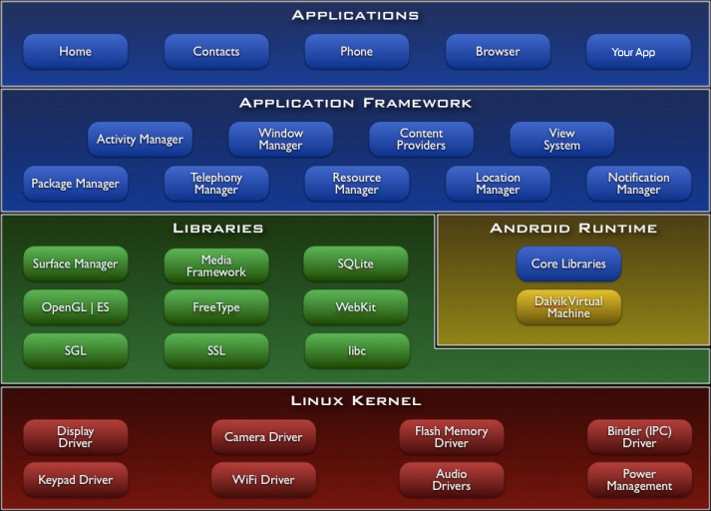
5. As Android is built on top of the Linux kernel, it makes use of the same implementation as Linux. The process descriptor contains info such as run state, address space used, list of open files, and process priority. It is implemented as a doubly linked list known as the task list, consisting of structures called ‘task_struct’. (Informit, 2005)
6. The Linux kernel, and by extension the Android Operating System, has 5 process states. They are “TASK_RUNNING”, for a process currently running, “TASK_INTERRUPTABLE”, for a process that is currently sleeping but is allowed to be killed, “TASK_UNINTERRUPTABLE” for a process that is currently sleeping but is not allowed to be killed (Normally reserved for kernel functions), “TASK_ZOMBIE”, used to report to a parent process that it has run into issue during execution, and “TASK_STOPPED”, which is used when a process has been halted by ether a debugger or a job controller. (Mohr, 2010)
7. I am unable to find out if Android truly supporting or utilizing long term scheduling. Considering its main function would be to control the admissions of a large amount of processes, I don’t believe android would actually utilize one.
8. Yes, Android Supports Medium Term scheduling
9. Since Android is based on top of Linux version 2.6.25 and newer, it makes use of the Completely Fair Scheduler, which aims at giving all tasks a “fair” amount of execution time. Instead of maintaining the tasks in a run queue, it makes use of a time-ordered red-black tree, which allows for faster insertions and deletions of tasks. (Jones, 2009)
10. Works Cited

# Bibliography

Andriod App Market. (2012, 02 17). *Android Architecture – The Key Concepts of Android OS*. Retrieved 09 09, 2014, from Android Aapp Market: http://www.android-app-market.com/android-architecture.html

IDC. (2014). *Smartphone OS Market Share, Q2 2014*. Retrieved 09 09, 2014, from IDC: http://www.idc.com/prodserv/smartphone-os-market-share.jsp

Informit. (2005, 1 31). *Process Management*. Retrieved 9 9, 2014, from Informit: http://www.informit.com/articles/article.aspx?p=368650

Jones, M. T. (2009, 12 15). *Inside the Linux 2.6 Completely Fair Scheduler*. Retrieved 9 9, 2014, from IBM: http://www.ibm.com/developerworks/linux/library/l-completely-fair-scheduler/

Mohr, J. (2010, 10 13). *The Life Cycle of Processes*. Retrieved 9 9, 2014, from The Linux Tutorial : http://www.linux-tutorial.info/modules.php?name=MContent&pageid=84