**“A PROTECTED AND VIBRANT MULTI-KEYWORD RANKED SEARCH SYSTEM OVER ENCRYPTED CLOUD DATA”**

***A Dissertation Submitted in partial fulfillment of requirement***

***for the award of degree in***

**MASTER OF COMPUTER APPLICATIONS**

**of**



**Visvesvaraya Technological University**

**By**

**AKSHATHA B V**

**(1AX15MCA72)**

**Under the guidance of**

**Prof. A.C.M.V Srinivas**



**Department of Master of Computer Applications,**

**AMC Engineering College,**

**18thKM, Bannerghatta Road, Bengaluru -560083**

**June 2017**

**“A PROTECTED AND VIBRANT MULTI-KEYWORD RANKED SEARCH SYSTEM OVER ENCRYPTED CLOUD DATA”**

***A Dissertation Submitted in partial fulfillment of requirement***

***for the award of degree in***

**MASTER OF COMPUTER APPLICATIONS**

**of**



**Visvesvaraya Technological University**

**By**

**AKSHATHA B V**

**(1AX15MCA72)**

**Under the guidance of**

**INTERNAL GUIDE: EXTERNAL GUIDE:**

**Prof. A.C.M.V Srinivas Mr. Ram Mohan,**

**Professor & Head, Dept. of MCA, IT Technical Manager,**

**AMC Engineering College , Ardent STPL,**

**Bengaluru – 83, Mobile: 9741551588, Bengaluru – 34**

**Email: mouliac@yahoo.co.in** **Email:rammohanstpl@gmail.com**



**Department of Master of Computer Applications**

**AMC ENGINEERING COLLEGE**

**18thKM, Bannerghatta Road, Bengaluru-560083.**

**June 2017**

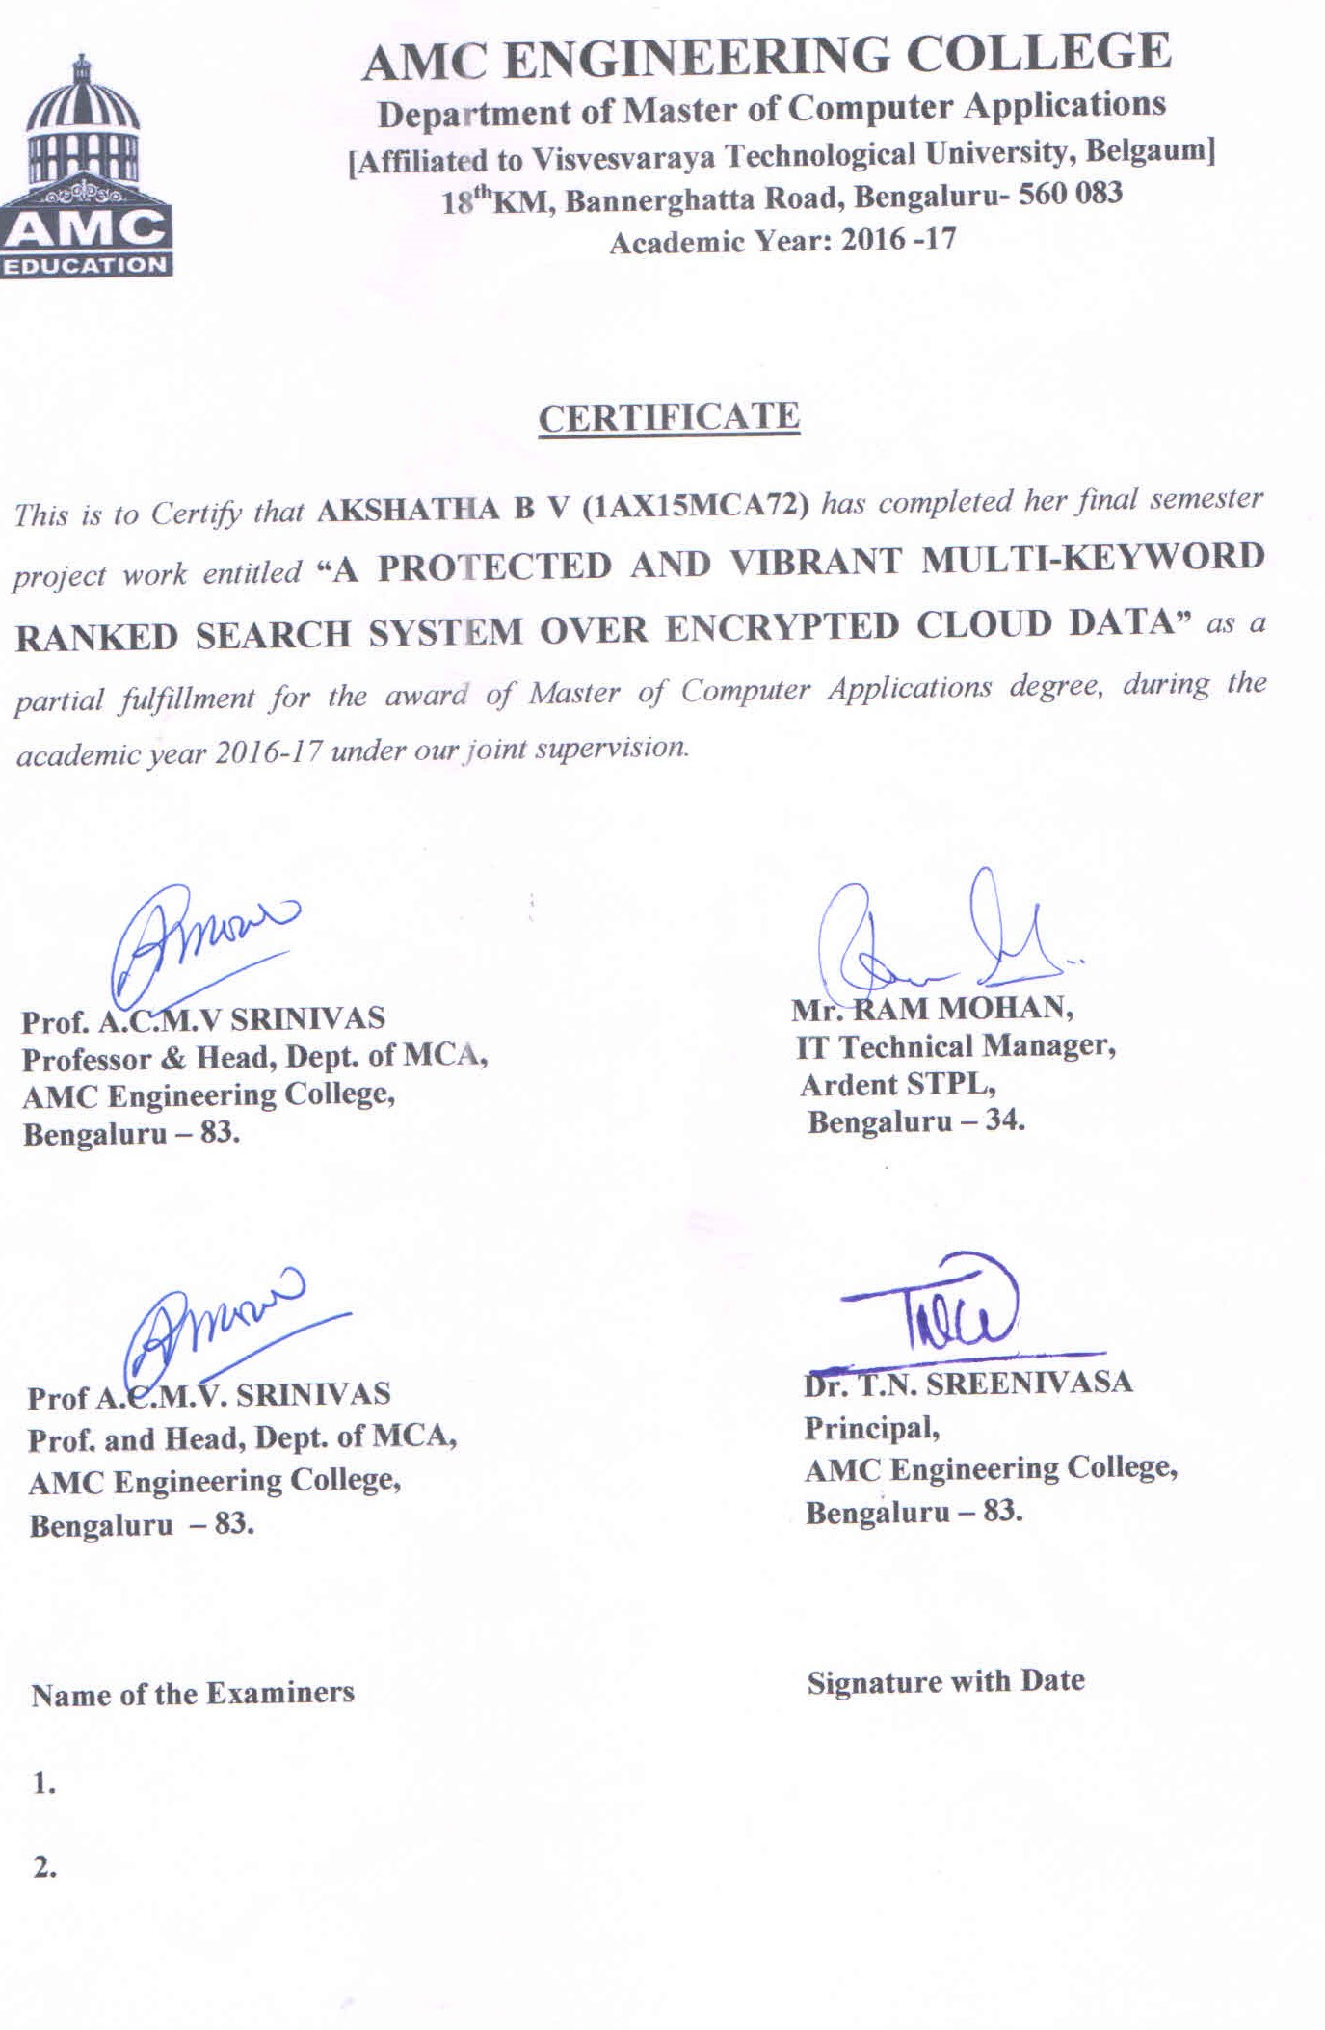

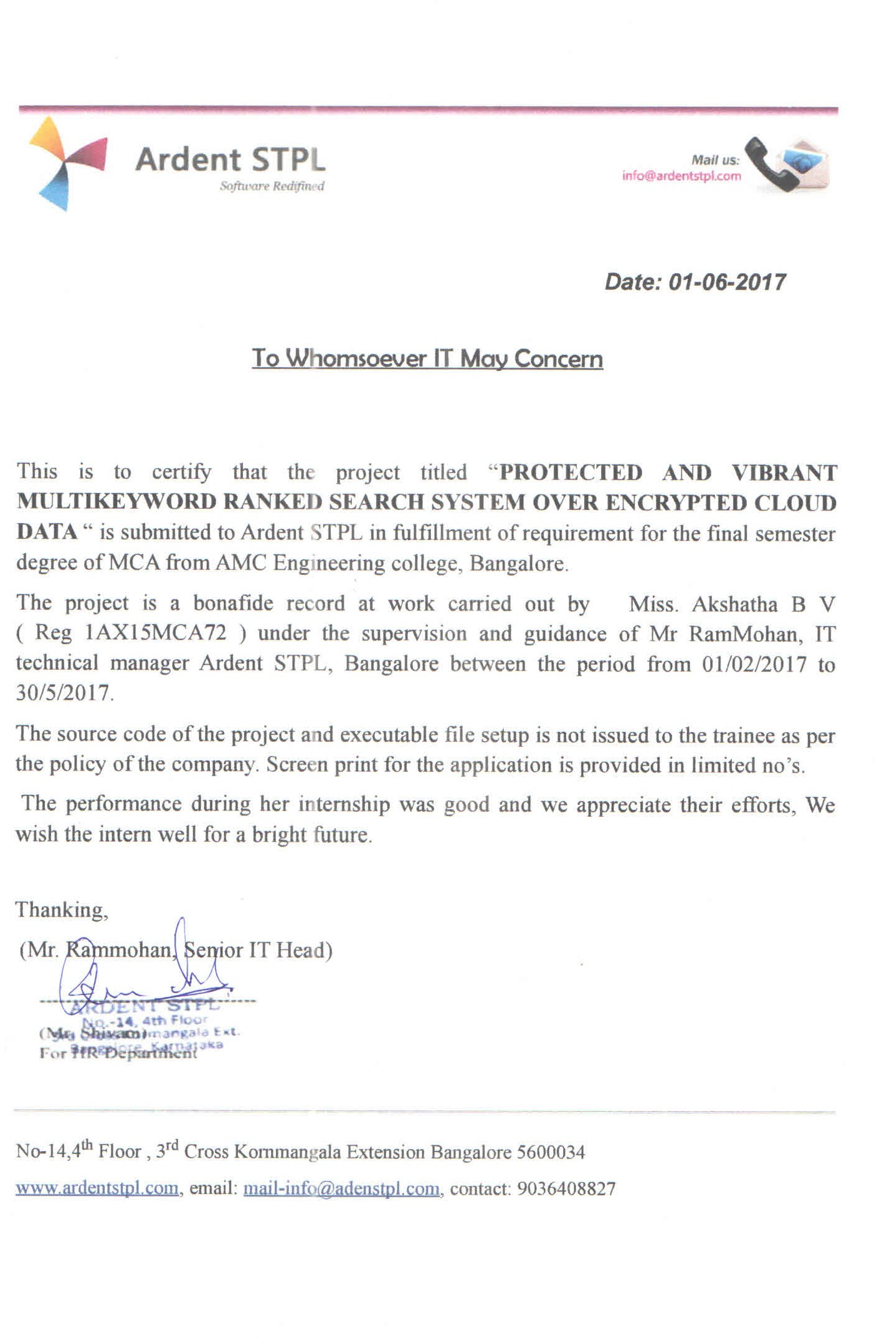

**ACKNOWLEDGEMENT**

First I thank God Almighty for helping me throughout this project and strengthening me to complete this work at my best and successfully. I would like to dedicate this work to my parents, my brother and my sister for their constant support and encouragement during the course of this work.

We take this opportunity to express our sincere gratitude to all those who helped us in various capacities in undertaking this project and devising the report.

I express my sincere thanks to **Dr. K PARAMAHAMSA** Chairman, AMC Engineering College, Bengaluru, for providing all the resources required for the timely completion of this project.

I thank **Dr. T.N. SREENIVASA,** Principal, AMC Engineering College, for his support to provide the best faculty and his guidance.

I would like to profusely thank my internal guide Prof. A.C.M.V. SRINIVAS, Professor &HOD, Department of MCA, AMCEC who has guided me and encouraged me for the  
completion of this project.

My deepest gratitude to my external project guide **Mr. Ram Mohan** for his guidance and encouragement given to me in the preparation of this project and report.

I also take this opportunity to thank all our staff members of the MCA Department and my parents and my sister and my friends for all their cooperation and support they have given me for the completion of this project.

**AKSHATHA B V**

**(1AX15MCA72)**

**ABSTRACT**

Due to the increasing popularity of cloud computing, more and more data owners are motivated to outsource their data to cloud servers for great convenience and reduced cost in data management. However, sensitive data should be encrypted before outsourcing for privacy requirements, which obsoletes data utilization like keyword-based document retrieval.

In this project, a protected and vibrant multi-keyword ranked search system over encrypted cloud data, which simultaneously supports dynamic update operations like deletion and insertion of documents. Specifically, the vector space model and the widely used

TF x IDF model are combined in the index construction and query generation. We construct a special tree-based index structure and propose a “Greedy Depth-first Search” Algorithm to provide efficient multi-keyword ranked search.

Due to the use of our special tree-based index structure, the proposed scheme can achieve sub linear search time and deal with the deletion and insertion of documents flexibly.

**CONTENTS PAGE NO**

**1. INTRODUCTION 01**

1.1 PROJECT DESCRIPTION 01

1.2 PROJECT DEFINITION 04

1.3 COMPANY PROFILE 05

**2. LITERATURE SURVEY 06**

2.1 EXISTING AND PROPOSED SYSTEM 07

2.2 FEASIBILITY STUDY 09

2.3 TOOLS AND TECHNOLOGIES USED 11

2.4 HARDWARE AND SOFTWARE REQUIREMENTS 16

**3. SOFTWARE REQUIREMENTS SPECIFICATION 17**

3.1 USERS 18

3.2 FUNCTIONAL REQUIREMENTS 20

3.3 NON-FUNCTIONAL REQUIREMENTS 21

**4. SYSTEM DESIGN 22**

4.1 SYSTEM PERSPECTIVE 23

4.2 CONTEXT DIAGRAM 26

**5. DETAILED DESIGN 30**

5.1 USE CASE DIAGRAM 31

5.2 CLASS DIAGRAM 32

5.3 SEQUENCE DIAGRAM 33

5.4 COLLABARATION DIAGRAMS 34

5.5 ACTIVITY DIAGRAM 35

5.6 DATABASE DESIGN 37

**6. IMPLEMENTATION 47**

6.1 SCREEN SHOTS 48

**7. SOFTWARE TESTING 61**

7.1 TESTING APPROACH 62

**8. CONCLUSION 69**

**9. FUTURE ENHANCEMENTS 71**

**Appendix A BIBLIOGRAPHY 74**

**Appendix B USER MANUAL 75**

**LIST OF FIGURES AND TABLES**

|  |  |  |
| --- | --- | --- |
| FIQURE NO | PARTICULARS | PAGE NO |
| 2.3.1 | Structural design of Cloud Computing | 11 |
| 2.3.2 | Web Application Development with ASP.NET | 13 |
| 4.1.1.1 | System Design | 23 |
| 4.2.1 | Level-0 DFD | 26 |
| 4.2.2 | Level-1 DFD | 27 |
| 4.2.3 | Level-2-DataUser | 28 |
| 4.2.4 | 2-Level DFD: Data Owner | 29 |
| 5.1.1 | UseCase Diagram | 31 |
| 5.2.1 | Class Diagram | 32 |
| 5.3.1 | Sequence Diagram | 33 |
| 5.4.1 | Collaboration Diagram | 34 |
| 5.5.1 | Activity Diagram for data user | 35 |
| 5.5.2 | Activity Diagram for data owner | 36 |
| 5.6.1 | E-R Diagram | 37 |
| 5.6.2.1 | New User | 38 |
| 5.6.2.2 | New Owner | 39 |
| 5.6.2.3 | Upload Files | 40 |
| 5.6.2.4 | Review | 41 |
| 6.1.1 | All users home page | 48 |
| 6.1.2 | New data user page | 49 |
| 6.1.3 | Login Page | 50 |
| 6.1.4 | My Profile | 51 |
| 6.1.5 | Search Files | 52 |
| 6.1.6 | Graph | 53 |
| 6.1.7 | Request Files | 54 |
| 6.1.8 | Download Files | 55 |
| 6.1.9 | Upload Files | 56 |
| 6.1.10 | View Request | 57 |
| 6.1.11 | File Details | 58 |
| 6.1.12 | View Reviews | 59 |
| 6.1.13 | Review | 60 |
| 7.1.1 | V-Model | 62 |
| 7.1.1.1 | Test case level for component testing | 63 |
| 7.1.2.1 | Test case level for integration testing | 65 |
| 7.1.3.1 | Test case level for security testing | 67 |
| 7.1.3.2 | Test case level for configuration testing | 68 |