
PROJECT REPORT
ON

MACHINE LEARNING BASED PREDICTIVE MODELING FOR DIABETES DIAGNOSIS USING PYTHON
By
CHETNA SAHARAN
Under the supervision of
Prof. Dr. Millie Pant
Applied Mathematics and scientific Computing, IIT Roorkee
Duration: 08 June 2026- 15 July 2026

ACKNOWLEDGEMENT
I would like to express my sincere gratitude to my Supervisor Prof. Millie Pant, Department of Applied Mathematics and Scientific Computing, Indian Institute of Technology Roorkee, and my Internship Mentor, Ms Riya, for the constant guidance, encouragement, and valuable feedback provided throughout the duration of this internship. Their expertise and support were instrumental in helping me understand the practical applications of Python programming and Machine Learning.
I extend my heartfelt thanks to my family and friends for their constant motivation and support during this internship period. Finally, I would like to thank all the online resources, documentation, and open-source communities (Python.org, Real Python, GeeksforGeeks, Kaggle, and scikit-learn documentation) that supported my self-learning process.
Chetna Saharan, 2025204020

INDEX OF CONTENTS
1. Introduction
2. Dataset Overview
3. Methodology
3.1 Exploratory Data Analysis
3.1.1 Class Distribution
3.1.2 Feature Distribution
3.1.3 Outlier Detection via Boxplots
3.1.4 Correlation Analysis
3.1.5 Pairwise Relationships
3.1.6 Distributions Stratified by Outcome
3.2 Data Cleaning
3.3 Class Imbalance Correction
3.4 Feature Scaling
3.5 Feature Selection
3.6 Train-Test Split
4. Model Results
4.1 Logistic Regression
4.2 K-Nearest Neighbors (KNN)
4.3 Support Vector Machine (SVM)
4.4 Decision Tree
4.5 Random Forest.
5. Model Comparison
6. Recommendation
6.1 Model Selection
6.2 Data Quality Improvements
6.3 Feature Engineering and Further Modeling
6.4 Deployment Consideration
7. Conclusion

Executive Summary

This report presents a comprehensive machine learning study aimed at predicting the onset of diabetes using the Pima Indians Diabetes dataset, a widely used clinical benchmark comprising 768 patient records and eight diagnostic measurements. The objective of this project was twofold: first, to conduct a thorough exploratory data analysis (EDA) to understand the structure, quality, and clinical patterns embedded in the data; and second, to design, train, and rigorously evaluate five distinct classification algorithms — Logistic Regression, K-Nearest Neighbors (KNN), Support Vector Machines (SVM), Decision Trees, and Random Forest — in order to identify the model best suited for deployment in a screening context.
The dataset exhibited a moderate class imbalance (500 non-diabetic vs. 268 diabetic cases) and contained a substantial number of biologically implausible zero values in features such as Glucose, Blood Pressure, Skin Thickness, Insulin, and BMI. These were treated as missing data and imputed using column medians. Class imbalance was addressed using the Synthetic Minority Over-sampling Technique (SMOTE), and all features were standardized prior to model training.
Across all five models, Random Forest delivered the strongest overall performance, achieving 83.5% accuracy and a ROC-AUC of 0.903, closely followed by a pruned Decision Tree (83.0% accuracy, ROC-AUC 0.853) and a hyperparameter-tuned SVM with an RBF kernel (81.0% accuracy, ROC-AUC 0.893). KNN and Logistic Regression trailed with 80.5% and 73.5% accuracy respectively. Feature importance analysis consistently identified Glucose, BMI, and Age as the most predictive clinical indicators across nearly every model, aligning with established diabetes risk literature.
Based on these findings, this report recommends Random Forest as the primary candidate model for further validation and potential deployment, given its superior discriminative power and robustness to noise, while also highlighting Logistic Regression's continued value as an interpretable baseline for clinical stakeholders who require transparent decision rationale.

1. Introduction
Diabetes mellitus is a chronic metabolic disorder affecting hundreds of millions of people worldwide, and early identification of at-risk individuals remains a critical component of preventive healthcare. Traditional diagnostic pathways rely on clinical laboratory testing, which, while accurate, can be resource-intensive and is not always accessible in low-resource settings. Machine learning offers a complementary approach: by learning patterns from historical patient data, predictive models can flag high-risk individuals for further clinical evaluation using only routinely collected measurements.
This project uses the Pima Indians Diabetes dataset, originally compiled by the National Institute of Diabetes and Digestive and Kidney Diseases, to build and compare several supervised classification models. The dataset restricts its population to female patients of Pima Indian heritage aged 21 and above, and includes eight predictor variables: number of pregnancies, plasma glucose concentration, diastolic blood pressure, triceps skinfold thickness, two-hour serum insulin, body mass index (BMI), diabetes pedigree function (a proxy for genetic predisposition), and age. The binary target variable, Outcome, indicates whether the patient developed diabetes within five years of the initial measurement.
The goals of this study were to: (1) characterize the dataset through exploratory analysis, identifying data quality issues, feature distributions, and correlations; (2) apply appropriate pre-processing techniques to handle missing values, class imbalance, and feature scaling; (3) train and tune five different classification algorithms; and (4) compare their performance using a consistent set of evaluation metrics to determine the most suitable model for this task.

2. Dataset Overview
The dataset consists of 768 records across 9 columns (8 features plus the binary Outcome target). All feature columns are numeric — seven integer-typed and two floating-point (BMI and DiabetesPedigreeFunction). Table 1 summarizes the key descriptive statistics for each feature.
Feature | Mean | Std Dev | Min | Max
Pregnancies | 3.85 | 3.37 | 0 | 17
Glucose | 120.89 | 31.97 | 0 | 199
BloodPressure | 69.11 | 19.36 | 0 | 122
SkinThickness | 20.54 | 15.95 | 0 | 99
Insulin | 79.80 | 115.24 | 0 | 846
BMI | 31.99 | 7.88 | 0 | 67.1
DiabetesPedigreeFunction | 0.47 | 0.33 | 0.078 | 2.42
Age | 33.24 | 11.76 | 21 | 81
Table 1. Descriptive statistics of the raw dataset (n = 768).
The target variable Outcome is moderately imbalanced: 500 patients (65.1%) were non-diabetic, while 268 (34.9%) were diabetic. This imbalance was addressed during pre-processing using SMOTE (see Section 3.3).

3. Methodology
This section outlines the full analytical pipeline, from exploratory data analysis through pre-processing, feature selection, and model training.

3.1 Exploratory Data Analysis
Exploratory analysis began by examining the distribution of the target class, followed by univariate and bivariate visualizations of all numerical features.

3.1.1 Class Distribution
The target variable showed a class split of 500 non-diabetic to 268 diabetic cases, confirming the moderate imbalance noted above and motivating the use of resampling techniques prior to model training.

3.1.2 Feature Distributions
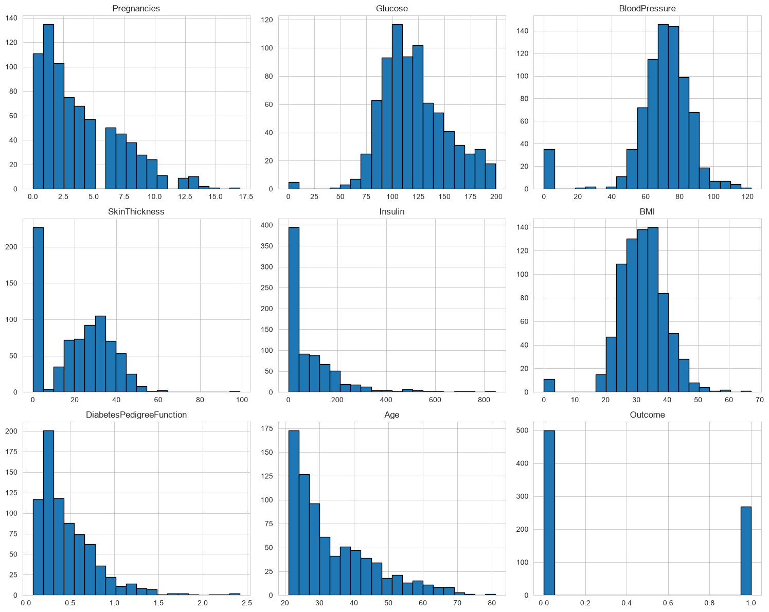
Figure 1. Histograms of all numerical features, showing right-skewed distributions for Insulin, DiabetesPedigreeFunction, and Age, and a large mass of zero values in Insulin and SkinThickness.

3.1.3 Outlier Detection via Boxplots
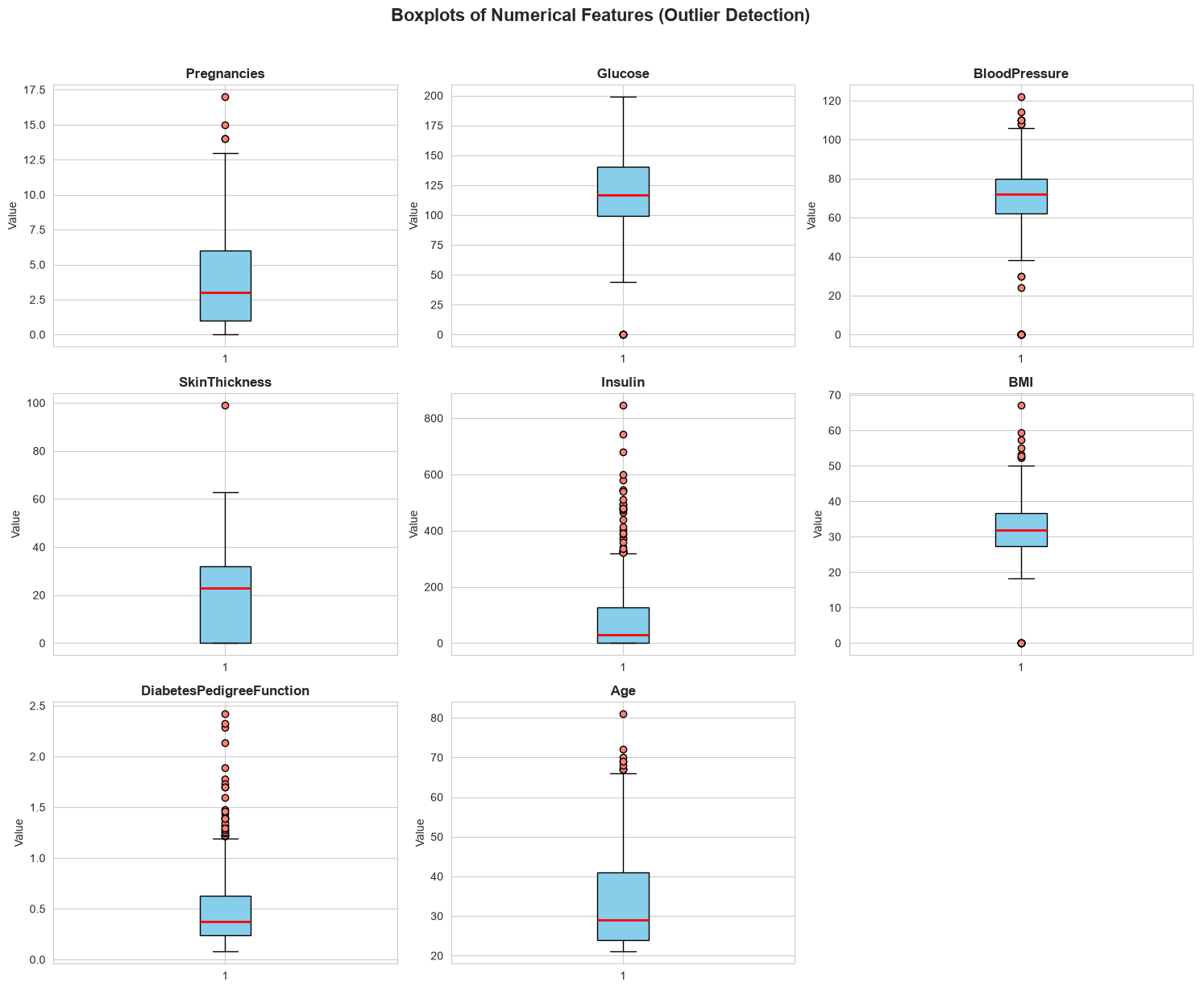
Figure 2. Boxplots of all numerical features. Insulin, SkinThickness, DiabetesPedigreeFunction, and Pregnancies display the highest concentration of outliers beyond the upper whisker.
The boxplot analysis revealed pronounced outliers in Insulin and SkinThickness, consistent with the skewed histograms above. Notably, many of these 'outliers' at the value zero are not true extreme measurements but rather missing data encoded as zero — a common artefact in this dataset that required explicit handling during pre-processing.

3.1.4 Correlation Analysis
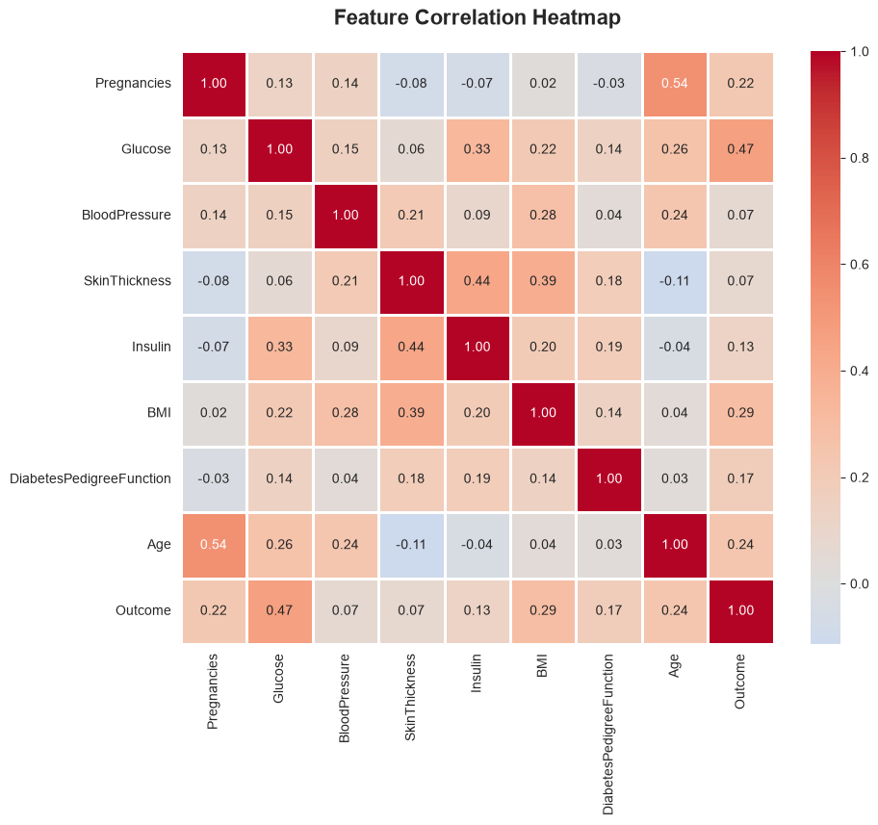
Figure 3. Correlation heatmap of all features against the Outcome target.
Glucose showed the strongest positive correlation with Outcome, followed by BMI and Age. Insulin and SkinThickness showed weaker but still positive correlations, while BloodPressure exhibited the weakest relationship with diabetes status among all predictors.

3.1.5 Pairwise Relationships
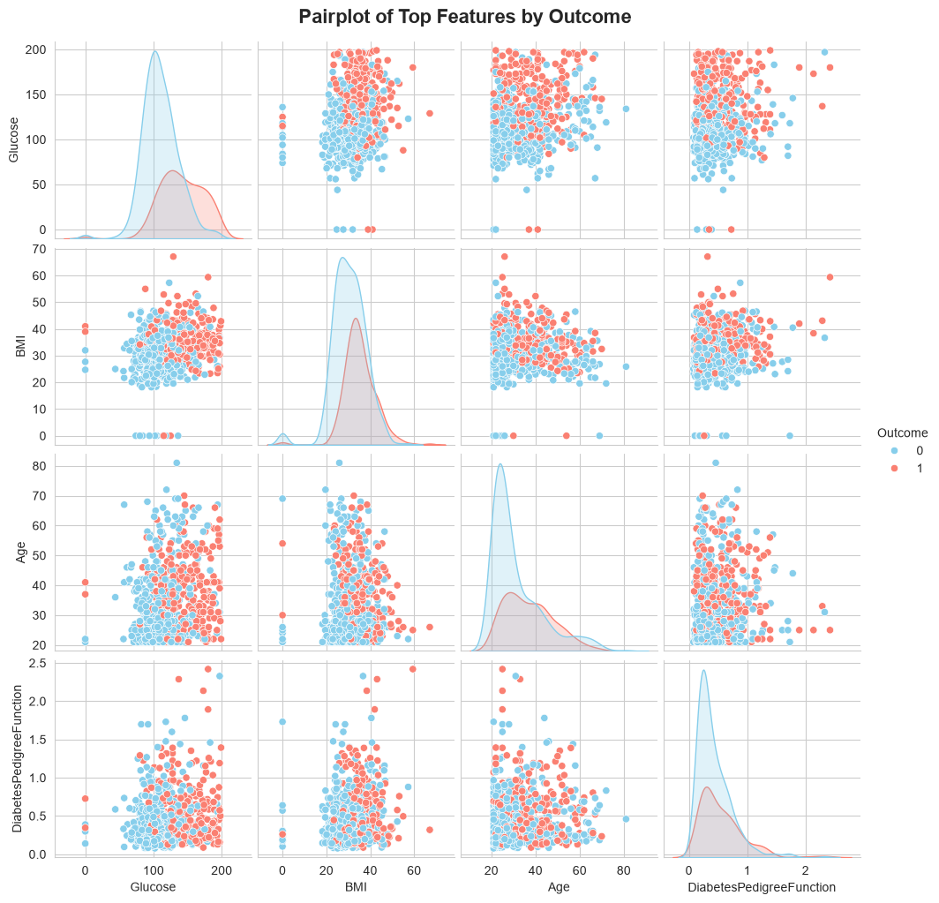
Figure 4. Pairplot of Glucose, BMI, Age, and DiabetesPedigreeFunction colored by Outcome.
The pairplot confirms visible separation between diabetic and non-diabetic patients along the Glucose axis, with diabetic cases clustering at higher glucose concentrations. BMI shows a similar, though less pronounced, separating trend.

3.1.6 Distributions Stratified by Outcome
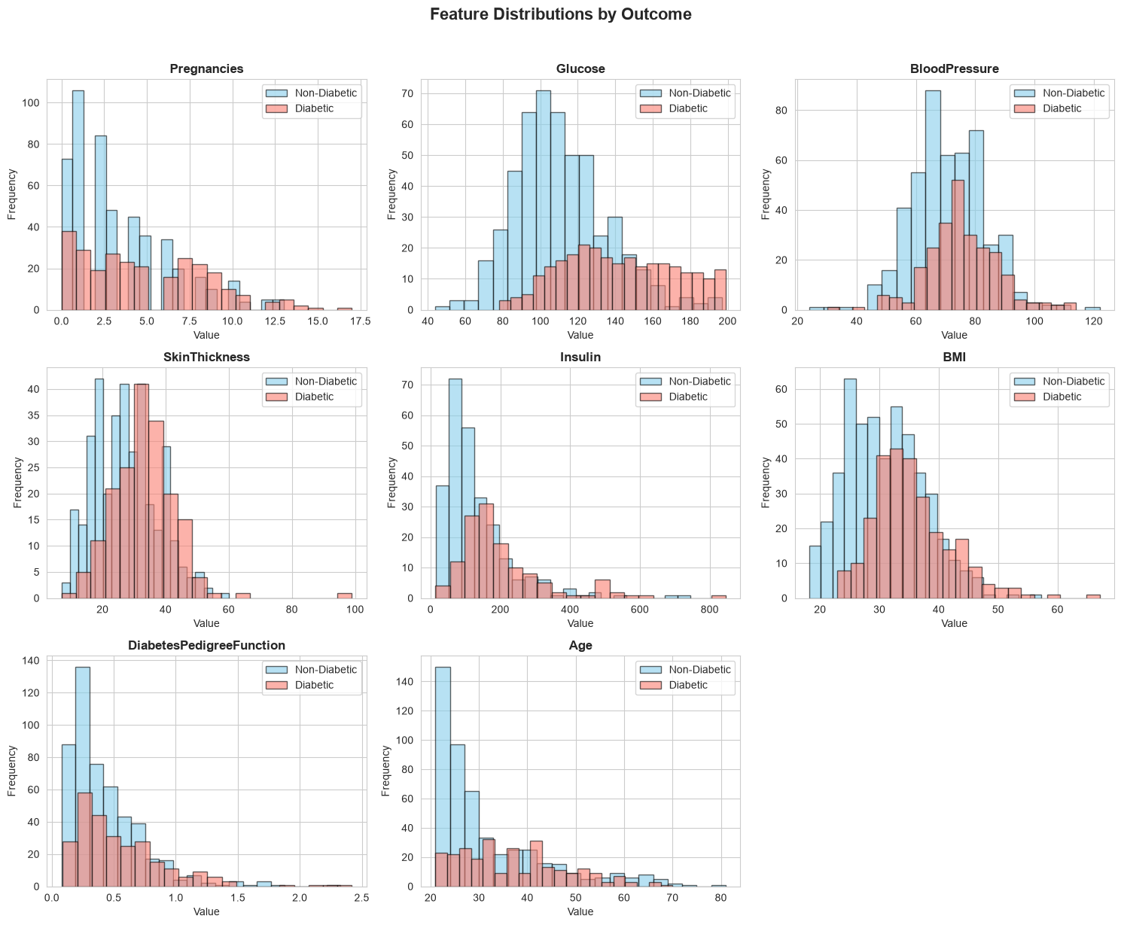
Figure 5. Feature distributions split by diabetes outcome. Diabetic patients show visibly higher median Glucose, BMI, and Age values than non-diabetic patients.

3.2 Data Cleaning
A review of zero values across five clinically implausible features revealed the following counts, treated as missing data:
Feature | Zero-Value Count | % of Records
Glucose | 5 | 0.7%
BloodPressure | 35 | 4.6%
SkinThickness | 227 | 29.6%
Insulin | 374 | 48.7%
BMI | 11 | 1.4%
Table 2. Zero-value counts across clinically implausible features.
Given that Insulin and SkinThickness had substantial proportions of missing data (48.7% and 29.6% respectively), simple median imputation was applied across all five columns to preserve sample size while minimizing distortion of the central tendency. No duplicate records were found in the dataset (0 duplicates across 768 rows).

3.3 Class Imbalance Correction
To correct the 500:268 class imbalance, the Synthetic Minority Over-sampling Technique (SMOTE) was applied to the training data, generating synthetic minority-class (diabetic) samples until both classes reached parity at 500 samples each, for a balanced total of 1,000 records used in subsequent modeling.

3.4 Feature Scaling
All resampled features were standardized using StandardScaler (zero mean, unit variance) prior to distance-based and gradient-based model training. A comparison with MinMaxScaler (0-1 range) was also performed; both scaling approaches preserved the relative feature relationships, but StandardScaler was retained for all downstream models due to its compatibility with the linear and kernel-based methods used in this study.

3.5 Feature Selection
An ANOVA F-test (SelectKBest) was used to rank feature importance relative to the target variable. The top five features identified were Glucose, BMI, Age, SkinThickness, and Insulin, with F-scores of 335.6, 129.2, 62.1, 56.8, and 46.2 respectively. Glucose's F-score was over 2.5 times higher than the next-ranked feature, underscoring its dominant predictive role. All eight features were nonetheless retained for model training to preserve information that ensemble methods could later exploit.

3.6 Train-Test Split
The resampled and scaled dataset was split into training (80%, 800 records) and testing (20%, 200 records) sets using stratified sampling to preserve the balanced class ratio in both partitions.

4. Model Results
Five classification algorithms were trained and evaluated on the held-out test set using Accuracy, Precision, Recall, F1-Score, and ROC-AUC as evaluation metrics.

4.1 Logistic Regression
A baseline Logistic Regression model was trained with default L2 regularization and a maximum of 1,000 iterations.
Metric | Value
Accuracy | 0.7350
Precision | 0.7374
Recall | 0.7300
F1-Score | 0.7337
ROC-AUC | 0.8277
Table 3. Logistic Regression performance metrics.
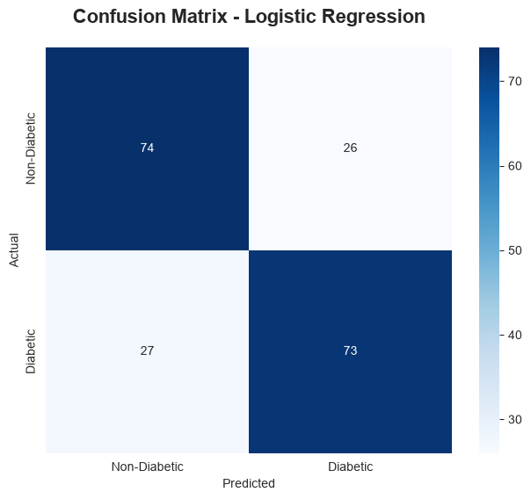
Figure 6. Confusion matrix for Logistic Regression.
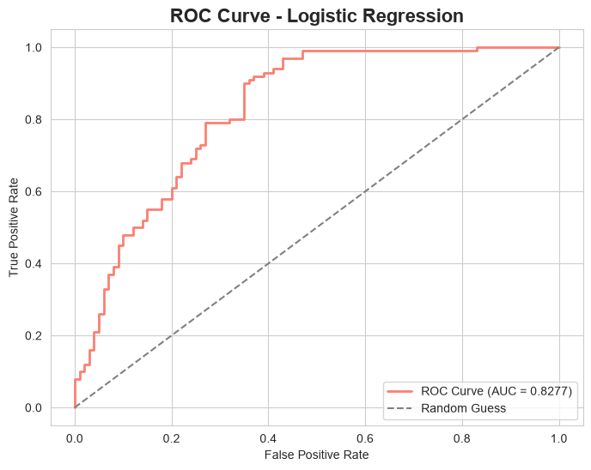
Figure 7. ROC curve for Logistic Regression (AUC = 0.828).
Interpreting the model coefficients as odds ratios revealed that Glucose (odds ratio 3.39), BMI (1.99), and Pregnancies (1.49) were associated with the greatest increase in diabetes risk per unit increase, while Insulin and BloodPressure showed odds ratios slightly below 1, indicating negligible or slightly protective associations in this linear model.
Overall, Logistic Regression achieved the lowest accuracy among all five models (73.5%), reflecting the presence of non-linear relationships in the data that a purely linear decision boundary cannot fully capture. Nonetheless, its ROC-AUC of 0.828 and fully interpretable coefficients make it a valuable baseline, particularly in clinical settings where transparency in decision-making is prioritized over marginal gains in predictive accuracy.

4.2 K-Nearest Neighbors (KNN)
The optimal number of neighbors (K) was determined using both the elbow method (error rate vs. K) and 10-fold cross-validation across K = 1 to 30.
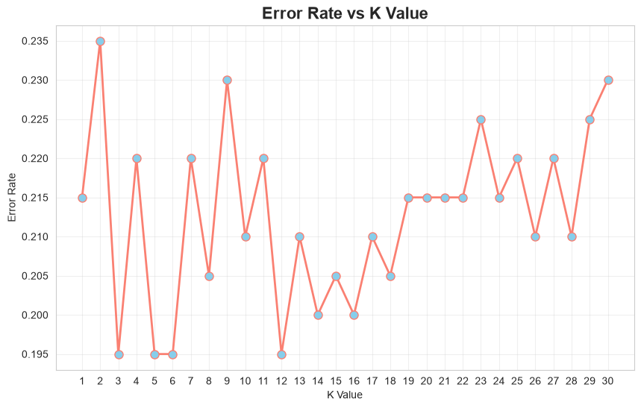
Figure 8. Error rate vs. K value (elbow method).
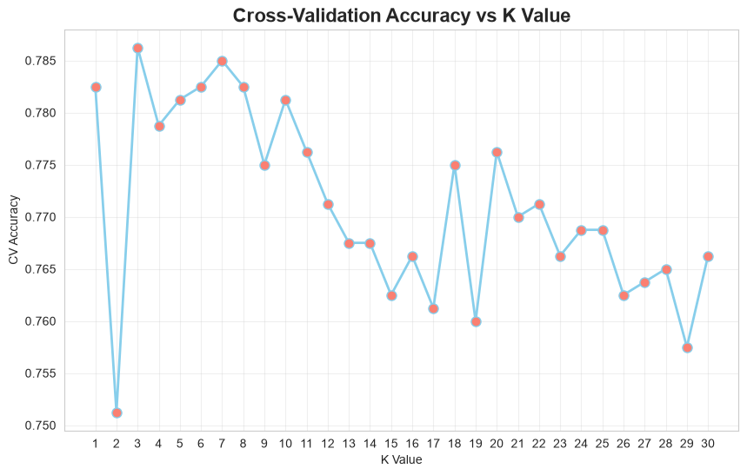
Figure 9. Cross-validation accuracy vs. K value. The optimal K was identified as 3.

Metric | Value
Accuracy | 0.8050
Precision | 0.7652
Recall | 0.8800
F1-Score | 0.8186
ROC-AUC | 0.8625
Table 4. KNN performance metrics (K = 3).
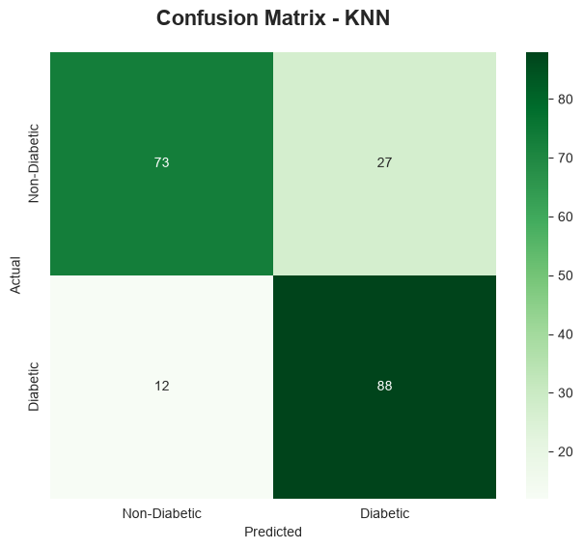
Figure 10. Confusion matrix for KNN.
Comparing distance metrics at the optimal K value showed the Manhattan distance slightly outperforming both Euclidean and Minkowski (p=3) metrics:
Distance Metric | Accuracy | Precision | Recall | F1-Score
Euclidean | 0.8050 | 0.7652 | 0.8800 | 0.8186
Manhattan | 0.8250 | 0.7982 | 0.8700 | 0.8325
Minkowski (p=3) | 0.8050 | 0.7652 | 0.8800 | 0.8186
Table 5. Comparison of distance metrics for KNN.
KNN achieved strong recall (0.88), making it particularly effective at correctly identifying diabetic patients, at some cost to precision. Its performance was highly sensitive to the choice of K, with very small or very large K values producing higher error rates. The Manhattan distance metric offered a modest but consistent improvement over the Euclidean and Minkowski alternatives, suggesting that absolute rather than squared feature differences are marginally more informative in this standardized feature space. As a non-parametric, instance-based method, KNN's chief limitation is its sensitivity to local noise and its computational cost at prediction time relative to parametric alternatives.

4.3 Support Vector Machine (SVM)
Four kernel functions were evaluated to determine the most suitable decision boundary shape for this dataset:
Kernel | Accuracy | Precision | Recall | F1-Score
Linear | 0.7350 | 0.7423 | 0.7200 | 0.7310
RBF | 0.8050 | 0.7798 | 0.8500 | 0.8134
Polynomial | 0.7800 | 0.7745 | 0.7900 | 0.7822
Sigmoid | 0.6500 | 0.6500 | 0.6500 | 0.6500
Table 6. Kernel comparison for SVM (default hyperparameters).
The RBF kernel outperformed all others, indicating that the true decision boundary between diabetic and non-diabetic patients is non-linear. The sigmoid kernel performed markedly worse, consistent with its known instability on standardized tabular data.
Hyperparameter tuning was then performed on the RBF kernel, varying the regularization parameter C and the kernel coefficient gamma independently:
C | Accuracy
0.1 | 0.765
1 | 0.805
10 | 0.820
100 | 0.790
Table 7. Accuracy vs. C (RBF kernel, gamma fixed at default).
Gamma | Accuracy
0.01 | 0.745
0.1 | 0.800
1 | 0.810
10 | 0.680
Table 8. Accuracy vs. gamma (RBF kernel, C fixed at default).
A full GridSearchCV over C ∈ {0.1, 1, 10, 100} and gamma ∈ {0.01, 0.1, 1, 10} identified C = 1 and gamma = 1 as the optimal combination, yielding a cross-validation accuracy of 80.1%. The final tuned model's test-set performance is summarized below:

Metric | Value
Accuracy | 0.8100
Precision | 0.8100
Recall | 0.8100
F1-Score | 0.8100
ROC-AUC | 0.8928
Table 9. Tuned RBF-kernel SVM performance metrics.
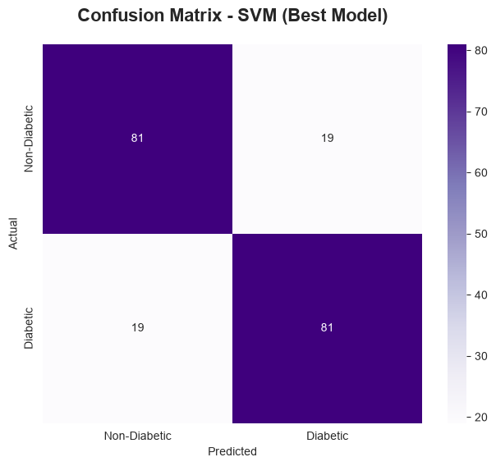
Figure 11. Confusion matrix for the tuned SVM (RBF kernel).
The tuned SVM achieved a well-balanced set of metrics, with precision and recall both at 0.81 — indicating no strong bias toward either false positives or false negatives — and a strong ROC-AUC of 0.893, the second-highest among all five models. This suggests that the RBF kernel's ability to model non-linear boundaries generalizes well beyond raw accuracy, capturing meaningful separation between classes across a range of decision thresholds.

4.4 Decision Tree
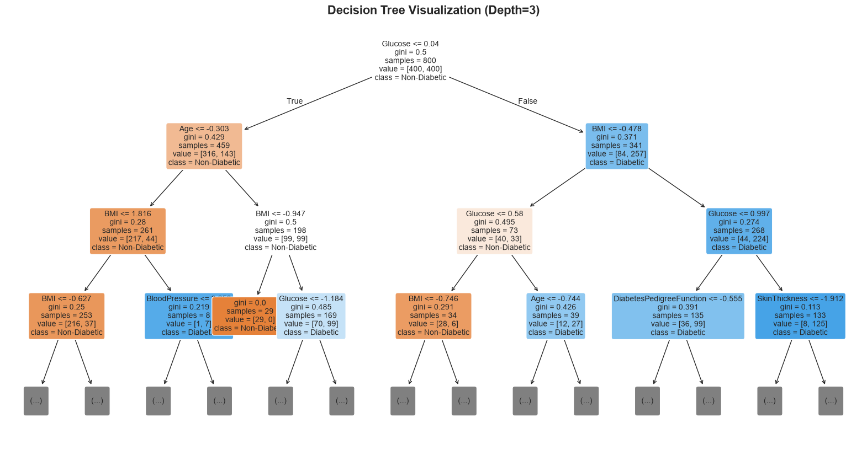
Figure 12. Visualization of the Decision Tree (depth limited to 3 for readability).
Hyperparameter sensitivity was assessed across three parameters. Increasing max_depth generally improved test accuracy up to a point:
max_depth | Accuracy
3 | 0.780
5 | 0.805
7 | 0.820
10 | 0.805
15 | 0.825
Table 10. Accuracy vs. max_depth.
min_samples_split | Accuracy
2 | 0.815
5 | 0.775
10 | 0.795
20 | 0.780
Table 11. Accuracy vs. min_samples_split.

min_samples_leaf | Accuracy
1 | 0.815
2 | 0.795
4 | 0.795
8 | 0.810
Table 12. Accuracy vs. min_samples_leaf.
To control overfitting, cost-complexity pruning (ccp_alpha) was applied. The optimal pruning strength was identified at ccp_alpha = 0.00310, balancing training and test accuracy:
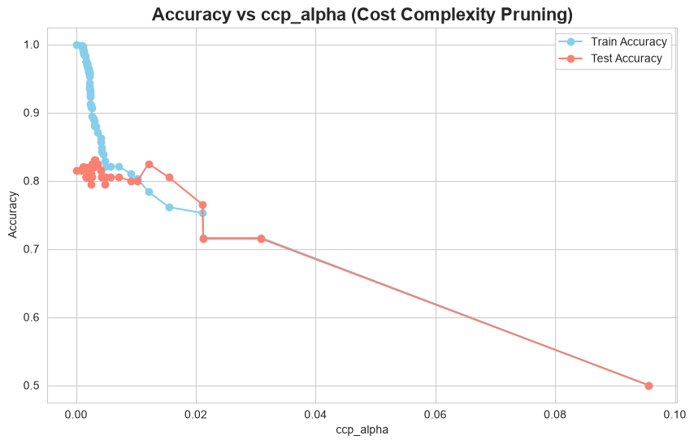
Figure 13. Train vs. test accuracy across increasing ccp_alpha values.
Metric | Value
Accuracy | 0.8300
Precision | 0.8173
Recall | 0.8500
F1-Score | 0.8333
ROC-AUC | 0.8530
Table 13. Pruned Decision Tree performance metrics.
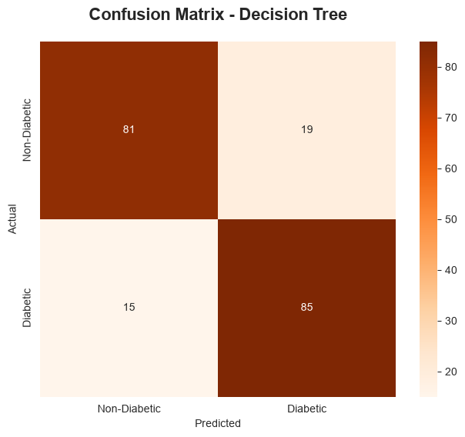
Figure 14. Confusion matrix for the pruned Decision Tree.
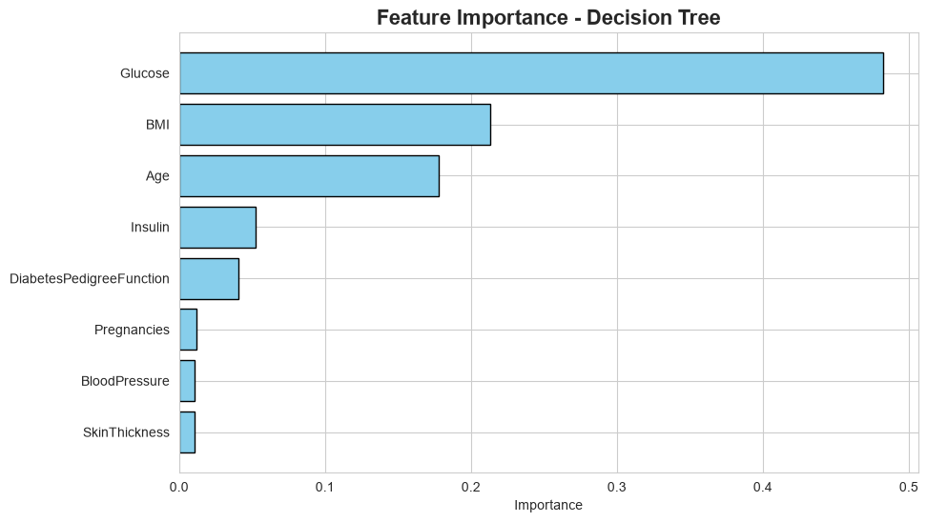
Figure 15. Feature importance from the pruned Decision Tree.
The pruned Decision Tree's feature importance ranking placed Glucose overwhelmingly first (48.2% of total importance), followed distantly by BMI (21.3%) and Age (17.8%), together accounting for over 87% of the model's decision-making weight. This concentration on a small number of features suggests the tree relies heavily on a few strong splits, consistent with the correlation analysis in Section 3.1.4. With an accuracy of 83.0% and ROC-AUC of 0.853, the pruned Decision Tree was the second-best performing model overall, narrowly trailing Random Forest.

4.5 Random Forest
Hyperparameter tuning was conducted across four dimensions: number of trees, maximum depth, feature sampling strategy, and minimum samples per split.
n_estimators | Accuracy
50 | 0.825
100 | 0.810
200 | 0.810
500 | 0.805
Table 14. Accuracy vs. n_estimators.
max_depth | Accuracy
5 | 0.825
10 | 0.805
15 | 0.810
20 | 0.810
None | 0.810
Table 15. Accuracy vs. max_depth.
max_features | Accuracy
sqrt | 0.810
log2 | 0.820
None | 0.815
Table 16. Accuracy vs. max_features.
min_samples_split | Accuracy
2 | 0.810
5 | 0.820
10 | 0.810
Table 17. Accuracy vs. min_samples_split.
A full GridSearchCV identified the optimal configuration as n_estimators = 50, max_depth = 15, max_features = 'sqrt', and min_samples_split = 5, achieving a cross-validation accuracy of 81.1%. On the held-out test set, this configuration produced the best overall results of all five models:

Metric | Value
Accuracy | 0.8350
Precision | 0.8190
Recall | 0.8600
F1-Score | 0.8390
ROC-AUC | 0.9027
Table 18. Tuned Random Forest performance metrics.
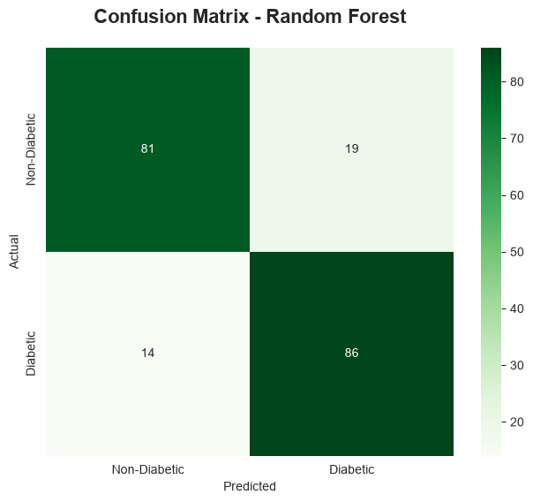
Figure 16. Confusion matrix for the tuned Random Forest.
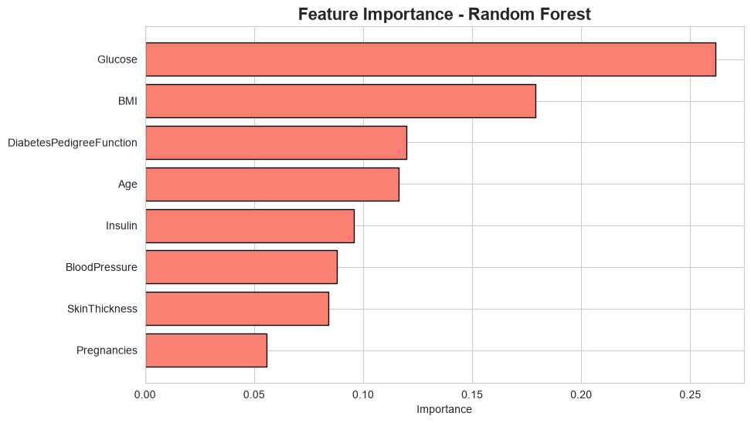
Figure 17. Feature importance from Random Forest.
Unlike the single Decision Tree, Random Forest distributed importance more evenly across features: Glucose (26.1%), BMI (17.9%), DiabetesPedigreeFunction (12.0%), and Age (11.6%) were the top four contributors, with the remaining features each contributing meaningfully rather than being effectively ignored. This more balanced reliance on multiple features likely explains the model's superior generalization performance.
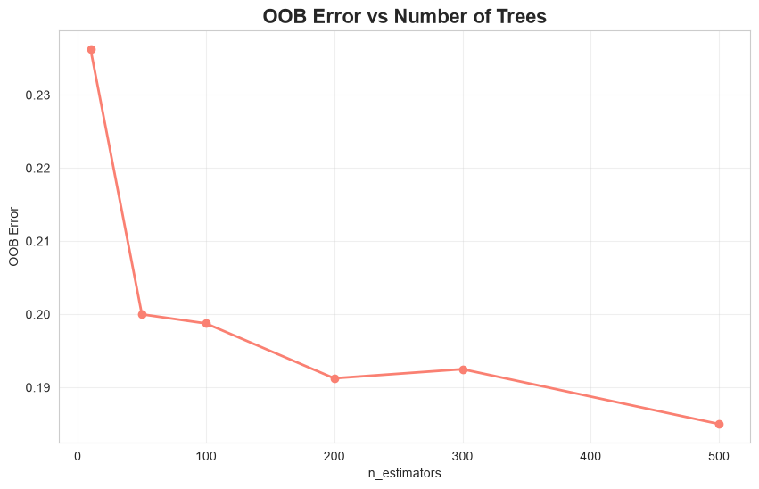
Figure 18. Out-of-bag (OOB) error rate as a function of the number of trees.
Out-of-bag error analysis, using the tuned hyperparameters, produced an OOB score of 0.7875 (OOB error of 0.2125), broadly consistent with the test-set accuracy and confirming that the model was not substantially overfitting to the training data. The OOB error curve stabilizes quickly as the number of trees increases, indicating that relatively few estimators are needed to achieve near-optimal ensemble performance for this dataset.

5. Model Comparison
Table 19 consolidates all five models' test-set performance across the five-evaluation metrics used throughout this study, ranked by accuracy.
Model | Accuracy | Precision | Recall | F1-Score | ROC-AUC
Random Forest | 0.8350 | 0.8190 | 0.8600 | 0.8390 | 0.9027
Decision Tree | 0.8300 | 0.8173 | 0.8500 | 0.8333 | 0.8530
SVM (RBF) | 0.8100 | 0.8100 | 0.8100 | 0.8100 | 0.8928
KNN | 0.8050 | 0.7652 | 0.8800 | 0.8186 | 0.8625
Logistic Regression | 0.7350 | 0.7374 | 0.7300 | 0.7337 | 0.8277
Table 19. Consolidated model comparison, sorted by test accuracy.
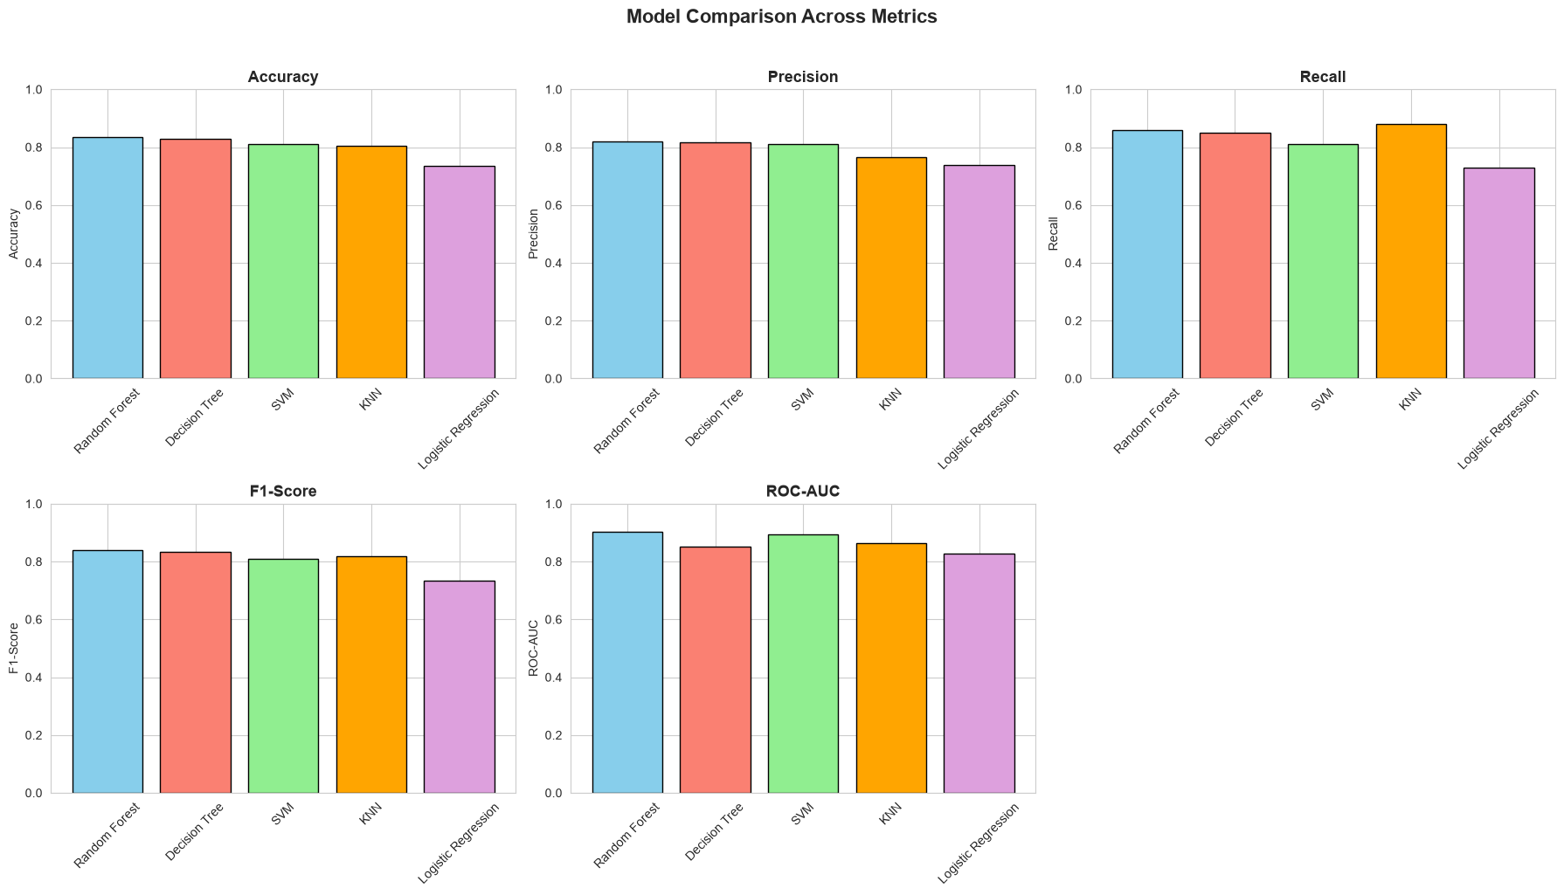
Figure 19. Bar chart comparison of Accuracy, Precision, Recall, F1-Score, and ROC-AUC across all five models.
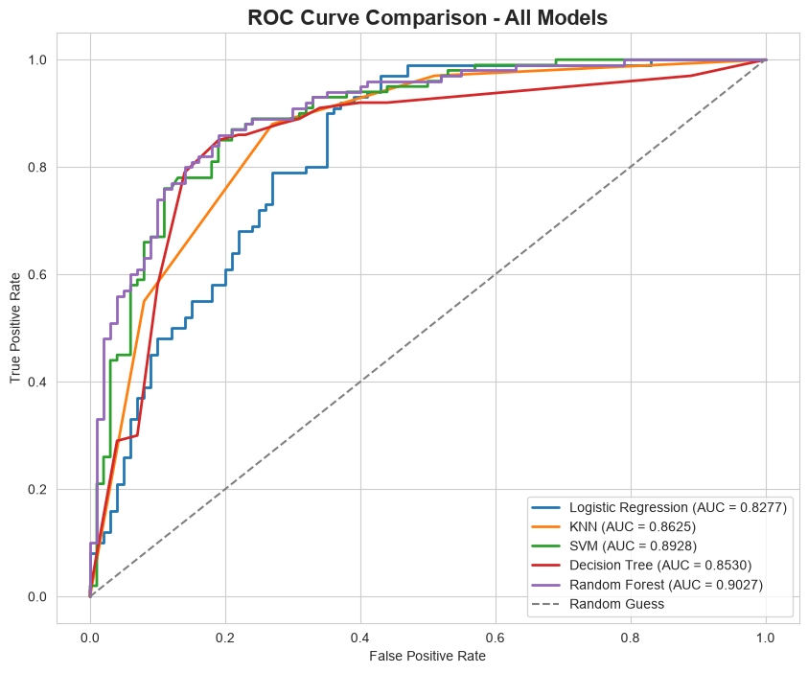
Figure 20. ROC curves for all five models plotted on a single graph.
Across all five models, Random Forest achieved the highest overall performance, with an accuracy of 83.5% and a ROC-AUC of 0.903, while Logistic Regression lagged behind with the lowest scores on nearly every metric — highlighting the impact of model complexity and decision-boundary flexibility on this dataset. Ensemble-based methods such as Random Forest and, to a lesser extent, the pruned Decision Tree, outperformed single-model approaches, benefiting from either aggregation of multiple learners or careful complexity control, while the tuned SVM with an RBF kernel remained highly competitive on ROC-AUC by effectively capturing non-linear relationships between features. KNN's performance was comparatively more sensitive to feature scaling and local data density, trading precision for very strong recall, and Logistic Regression, despite being the simplest and most interpretable model, still provided a reasonable baseline given the largely (though not entirely) linear relationship between key features like Glucose and the target outcome. Overall, the comparison suggests that Random Forest offers the best trade-off between predictive performance and generalization for this diabetes prediction task, though Logistic Regression remains valuable for interpretability in clinical settings where transparent, auditable decision rules are required.

6. Recommendations

6.1 Model Selection
- Adopt Random Forest as the primary candidate model for further validation, given its top ranking on four of five evaluation metrics and its resistance to overfitting, as confirmed by the closely aligned OOB and test-set error rates.
- Retain the tuned SVM (RBF kernel) as a secondary candidate, particularly where the highest ROC-AUC is prioritized, such as in threshold-tunable screening applications.
- Preserve Logistic Regression as an interpretable fallback model for contexts where clinicians or regulators require transparent, coefficient-level explanations of risk factors.

6.2 Data Quality Improvements
- Future data collection should explicitly distinguish true zero measurements from missing data, rather than encoding both identically, to avoid the need for imputation-based assumptions.
- Given that Insulin was missing in nearly half of all records, consider whether alternative or supplementary biomarkers with more complete coverage could improve model reliability.
- Expand the dataset beyond its current single-population scope (Pima Indian women) to improve generalizability of any deployed model to broader patient populations.

6.3 Feature Engineering and Further Modeling
- Investigate interaction terms between Glucose, BMI, and Age, which consistently ranked as the top predictors across all models, to capture potential compounding risk effects.
- Explore gradient boosting methods (e.g., XGBoost, LightGBM), which often outperform Random Forest on tabular clinical data and were not evaluated in this study.
- Consider cost-sensitive learning or threshold adjustment to explicitly optimize for recall in a screening context, where false negatives (missed diabetic patients) carry a higher clinical cost than false positives.

6.4 Deployment Considerations
- Prior to any clinical deployment, validate the selected model on an external, independent patient cohort to confirm that performance generalizes beyond this dataset.
- Pair any automated risk score with clear guidance that a positive prediction warrants confirmatory laboratory testing rather than a standalone diagnosis.
- Monitor model performance over time for data drift, particularly if the deployment population differs demographically from the training cohort.

7. Conclusion
This study demonstrated a complete, end-to-end machine learning workflow for diabetes risk prediction, from exploratory data analysis and careful handling of missing values through the training, tuning, and comparison of five distinct classification algorithms. Glucose, BMI, and Age emerged as the most consistently important predictors across nearly every model, reinforcing established clinical understanding of diabetes risk factors and lending confidence to the models' learned patterns.
Random Forest emerged as the best-performing model overall, striking the strongest balance between accuracy, recall, and generalization, while simpler models such as Logistic Regression continue to offer meaningful value where interpretability is paramount. With further validation on external data and refinement of data collection practices, the modeling approach outlined in this report provides a solid foundation for a practical, clinically useful diabetes screening tool.

