Living Off the Land (LOLBins) – PowerShell Deep Dive
Prepared by: Chetna Solanki
Dates: September 14–16, 2026
Topic: Living Off the Land (LOLBins) – PowerShell Deep Dive
MITRE ATT&CK: T1059.001 – PowerShell
Focus: Threat Research, Lab Testing, Logging and Detection

DAY 1 — Research and Analysis

September 14, 2026

1. Introduction
PowerShell is a powerful command-line shell and scripting language developed by Microsoft. It is widely used by system administrators and security professionals for automation, troubleshooting, configuration and system management.
Because PowerShell is a legitimate component of Windows, attackers may also abuse it after gaining access to a system. This behavior is associated with the Living off the Land (LOTL) concept.
This research focuses on PowerShell abuse, legitimate versus malicious usage, MITRE ATT&CK T1059.001, logging and defensive monitoring.

2. What are LOLBins?
LOLBins means Living Off the Land Binaries.
These are legitimate operating-system tools that can potentially be abused by attackers to perform malicious activities.
Examples include:
- PowerShell
- Windows Command Shell
- WMI
- MSHTA
- Rundll32
- Regsvr32
- Certutil

3. PowerShell Overview
PowerShell can be used for:
- System administration
- Process management
- Service management
- File management
- System information gathering
- Network configuration
- Automation
- Security administration
The same capabilities can become dangerous when used by an unauthorized user.

4. MITRE ATT&CK T1059.001
PowerShell is mapped to:
T1059 – Command and Scripting Interpreter
Sub-technique: T1059.001 – PowerShell
This technique describes the use of PowerShell to execute commands and scripts.
PowerShell can be observed during different stages of an attack, particularly after an attacker gains access to a Windows environment.
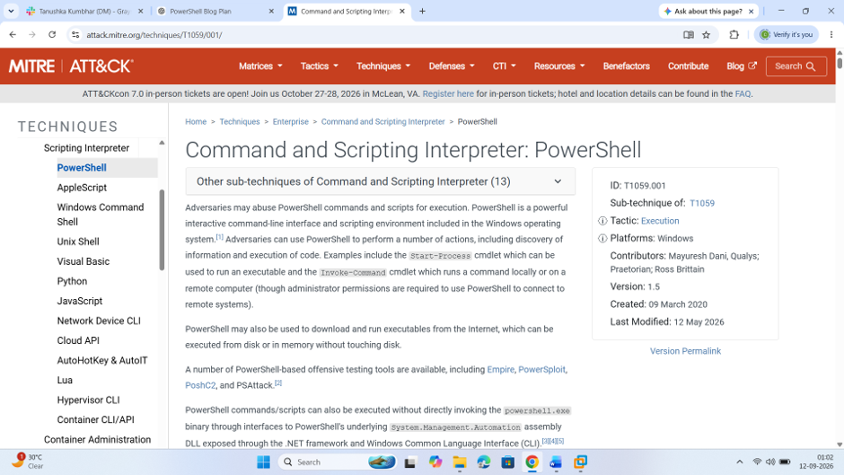Caption:Figure 1: MITRE ATT&CK T1059.001 – PowerShell

5. PowerShell Environment Verification
The PowerShell environment was verified using:
$PSVersionTable
This command displays the installed PowerShell version and environment information.
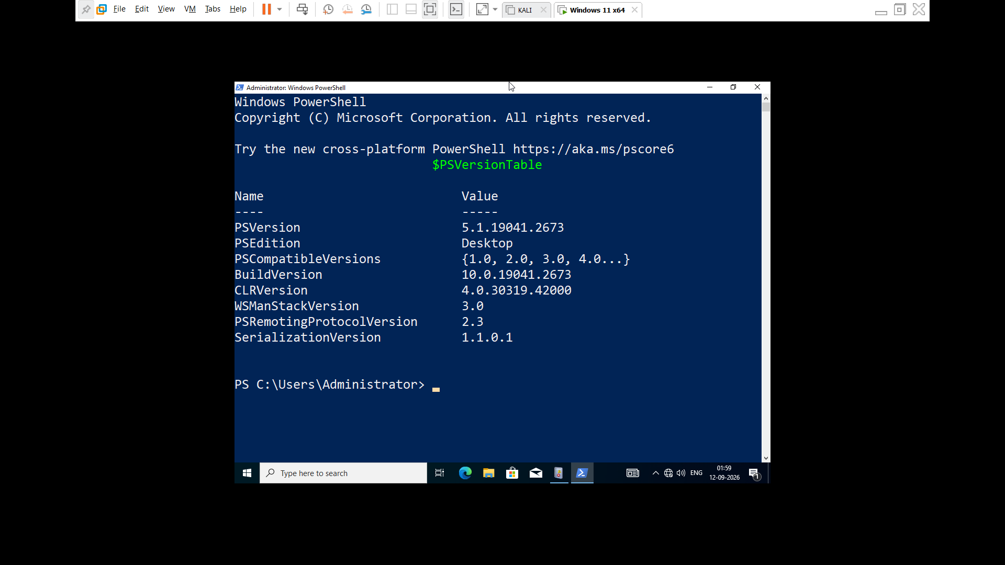Caption:Figure 2: Windows PowerShell version and environment verification

6. Legitimate vs Malicious PowerShell Usage
Legitimate Usage | Potentially Malicious Usage
System administration | Unauthorized script execution
Automation | Obfuscated commands
Troubleshooting | Encoded commands
Process management | Suspicious downloads
Service management | Unusual parent process
Security administration | Suspicious user context
PowerShell itself is not malicious. The command, user, parent process and surrounding activity must be considered.

7. Why Attackers Abuse PowerShell
Attackers may abuse PowerShell because:
- It is commonly available on Windows.
- It supports scripting.
- It provides extensive system functionality.
- It can interact with Windows components.
- It can automate actions.
- Its activity may sometimes resemble legitimate administration.

8. Common PowerShell Abuse

Command Obfuscation
Attackers may modify commands to make them harder to understand or detect.

Encoded Commands
PowerShell supports encoded command input. A suspicious parameter that defenders may monitor is:
-EncodedCommand
or:
-enc

Script Execution
Attackers may execute scripts after compromising a system.

Suspicious Parent Process
PowerShell launched unexpectedly by another application can require investigation.

9. PowerShell Logging
Important sources of PowerShell-related security telemetry include:
- PowerShell Operational logs
- Script Block Logging
- Module Logging
- Windows Process Creation logs
Windows Security Event ID 4688 can provide process creation information when appropriate auditing is enabled.
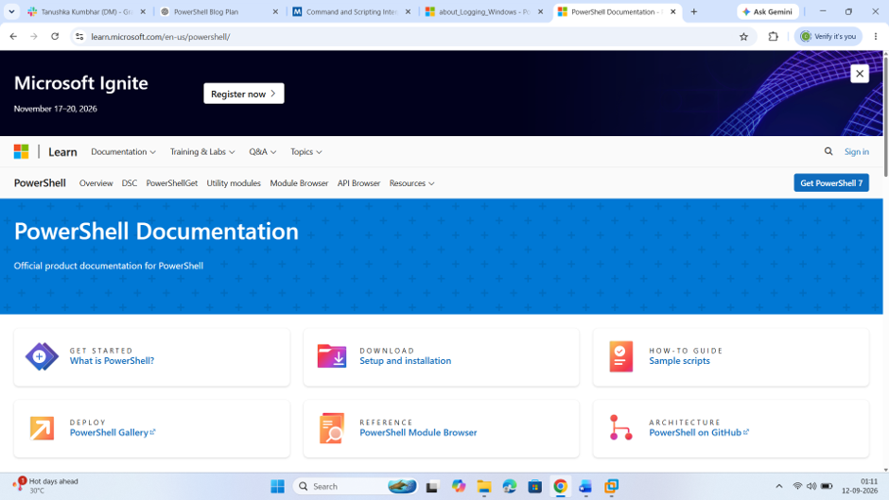Caption:Figure 3: Microsoft PowerShell documentation
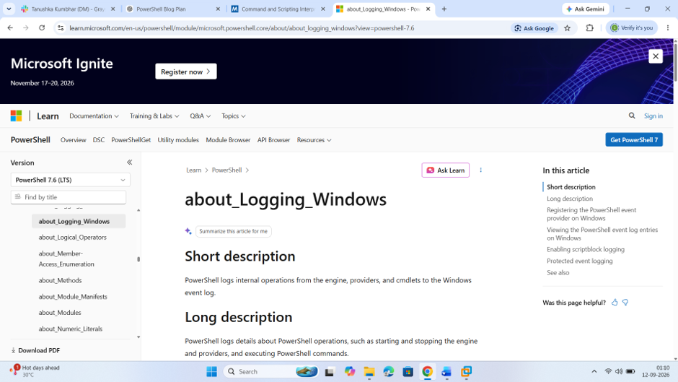Caption:Figure 4: PowerShell Script Block Logging documentation
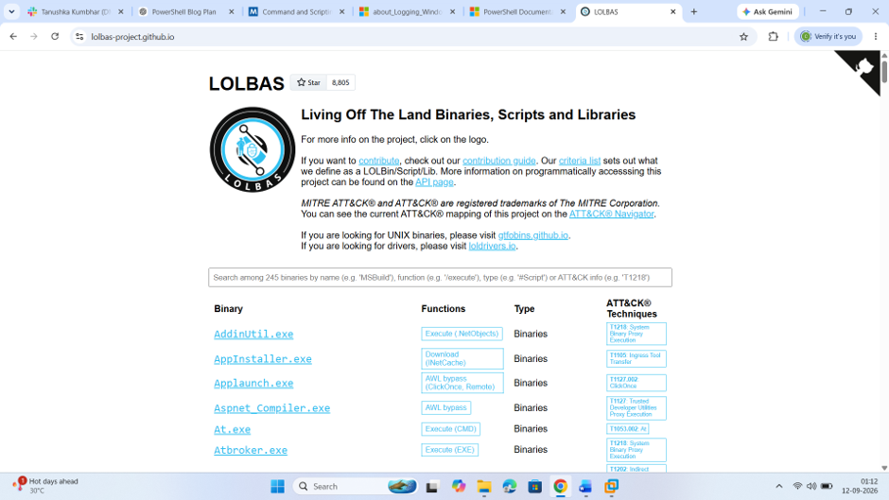
Caption:
Figure 5: Living off the Land and LOLBins concept

DAY 2 — Lab Setup, Execution and Logging

September 15, 2026

10. Lab Environment
A controlled Windows environment was used for the practical demonstration.
Operating System: Windows 11
Tool: Windows PowerShell
Environment: Authorized laboratory
Purpose: Defensive security testing
Only harmless commands were used for the practical demonstration.

11. Process Enumeration
The following command was executed:
Get-Process
This command displays running processes on the Windows system.
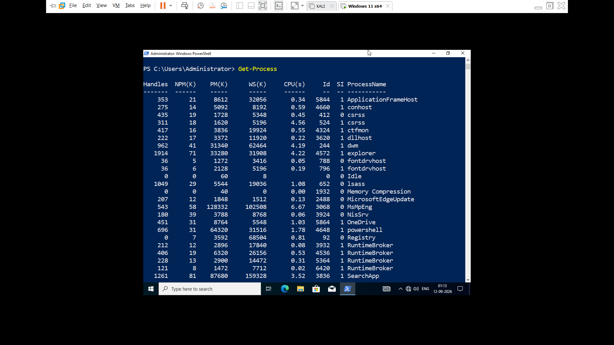
Caption:
Figure 6: Process enumeration using PowerShell

12. Service Enumeration
Command:
Get-Service
This displays Windows services and their current status.
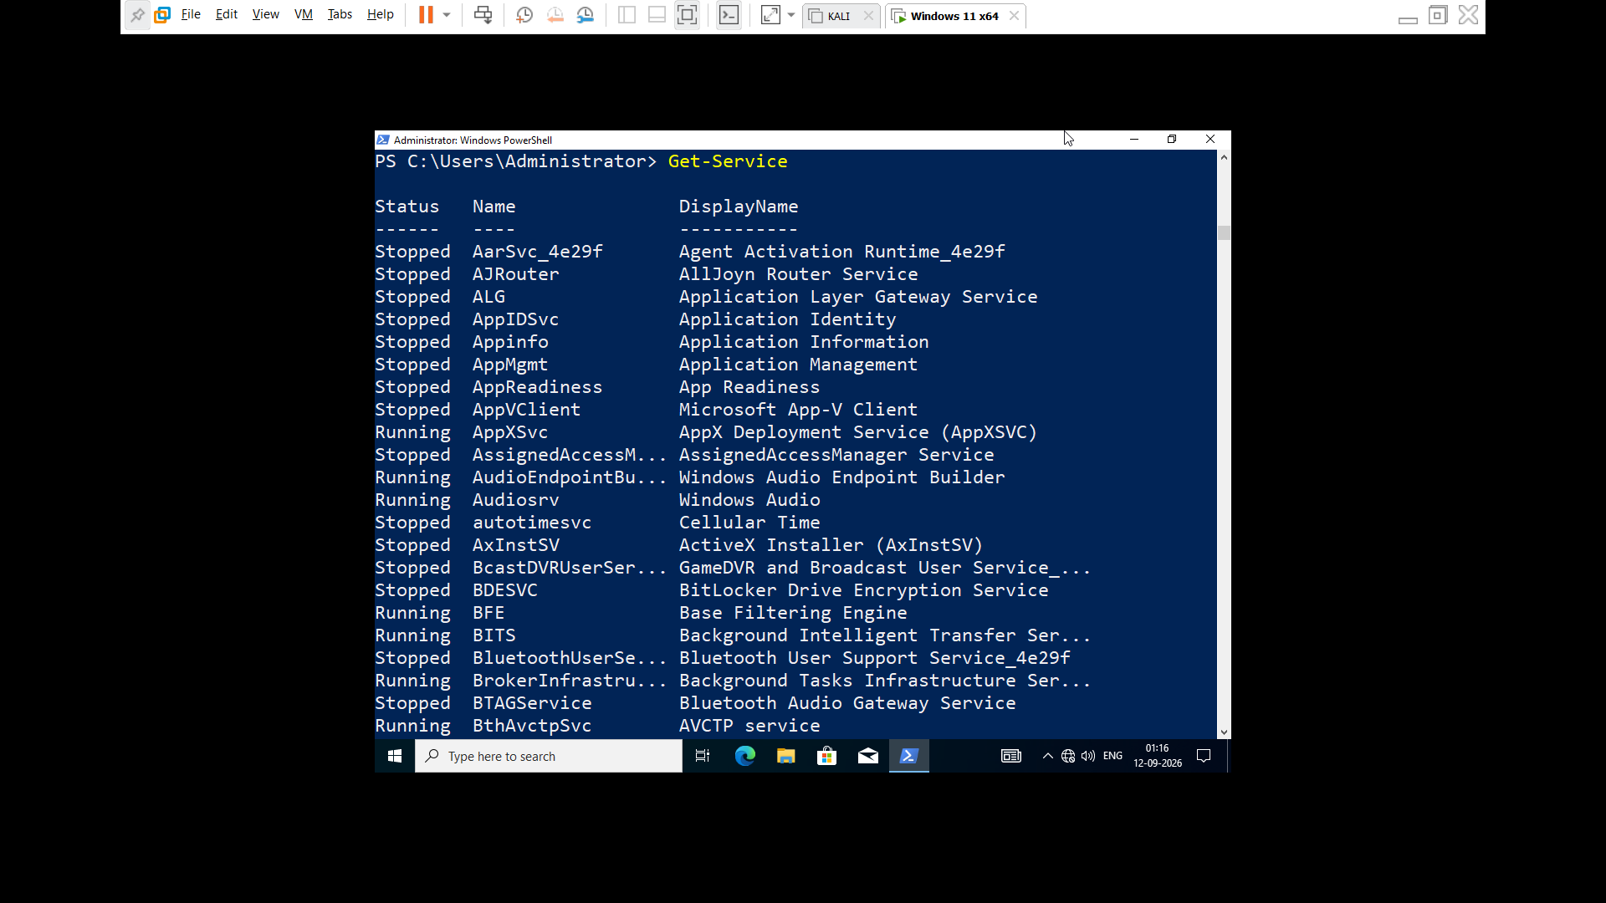
Caption:
Figure 7: Windows service enumeration using PowerShell

13. System Information
Command:
Get-ComputerInfo
This displays Windows and system information.
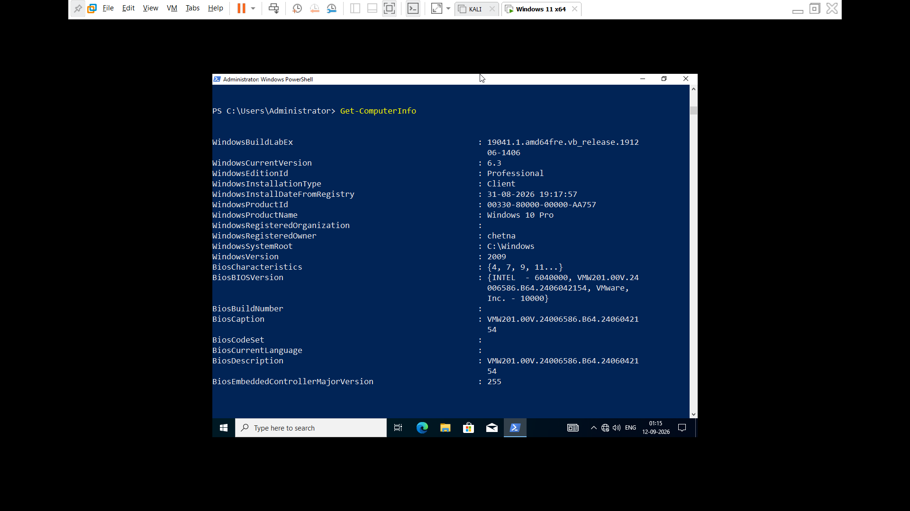
Caption:
Figure 8: System information collected using PowerShell

14. PowerShell Operational Logs
Windows Event Viewer was used to inspect PowerShell activity.
Path:
Event Viewer → Applications and Services Logs → Microsoft → Windows → PowerShell → Operational
The lab generated PowerShell operational events.
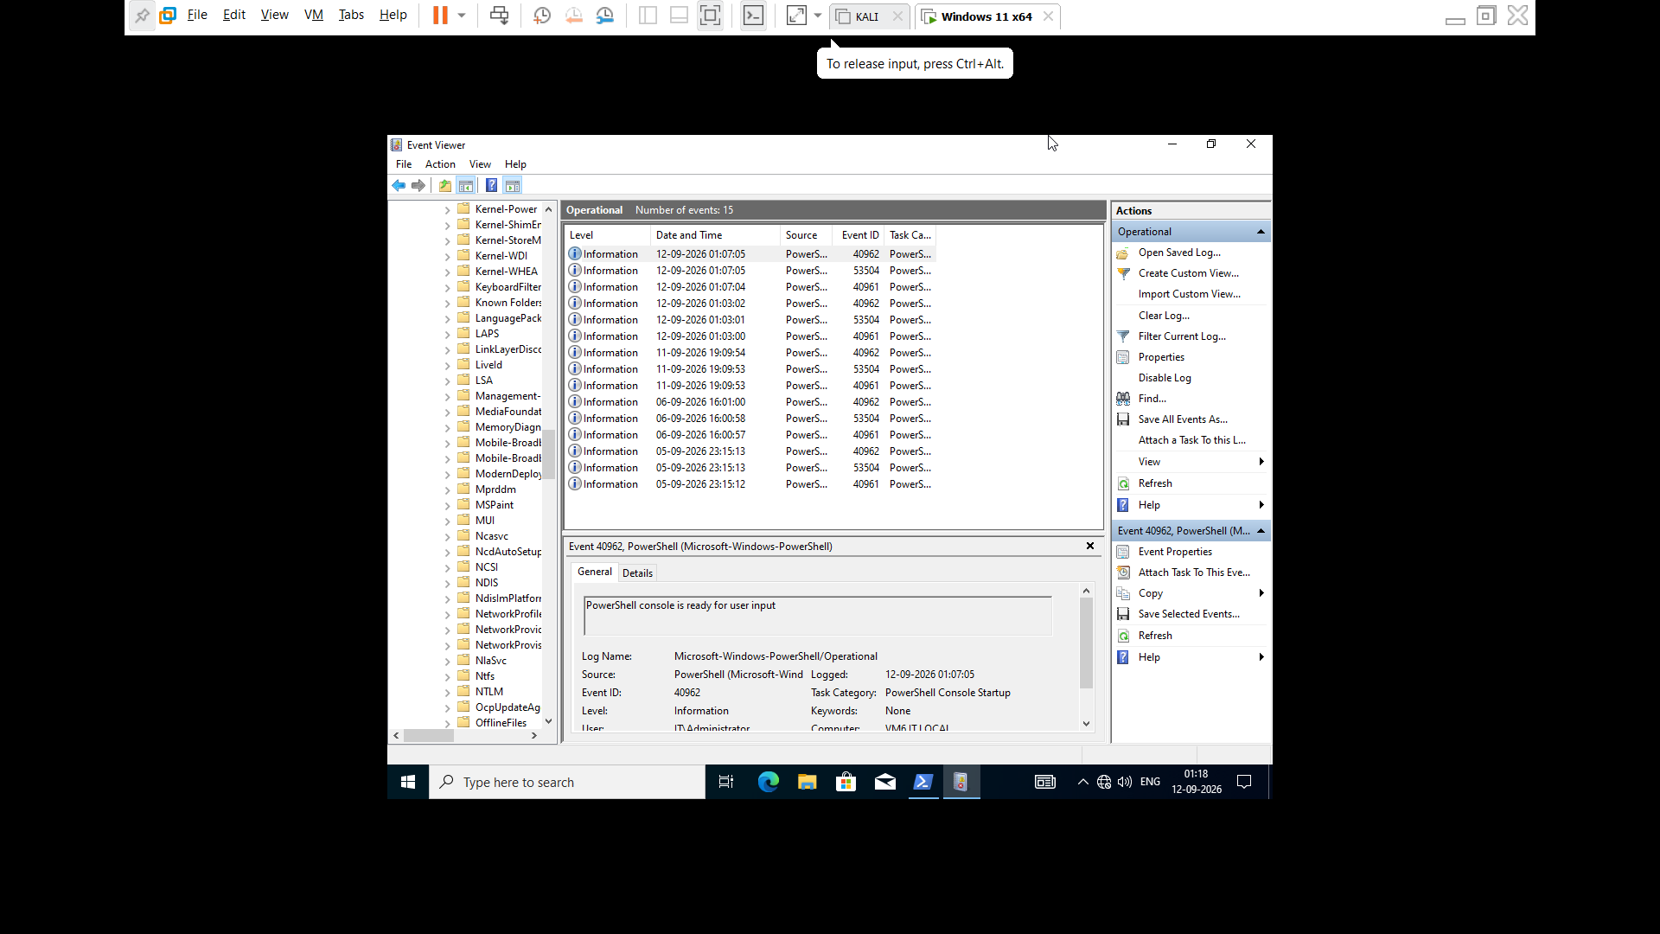
Caption:
Figure 9: PowerShell Operational event log

15. Script Block Logging
Script Block Logging can provide additional visibility into PowerShell script activity.
Event ID 4104 is commonly associated with PowerShell Script Block Logging.
In this lab environment, Event ID 4104 was not observed.
Therefore, no artificial event was created, and the available PowerShell Operational evidence was used instead.
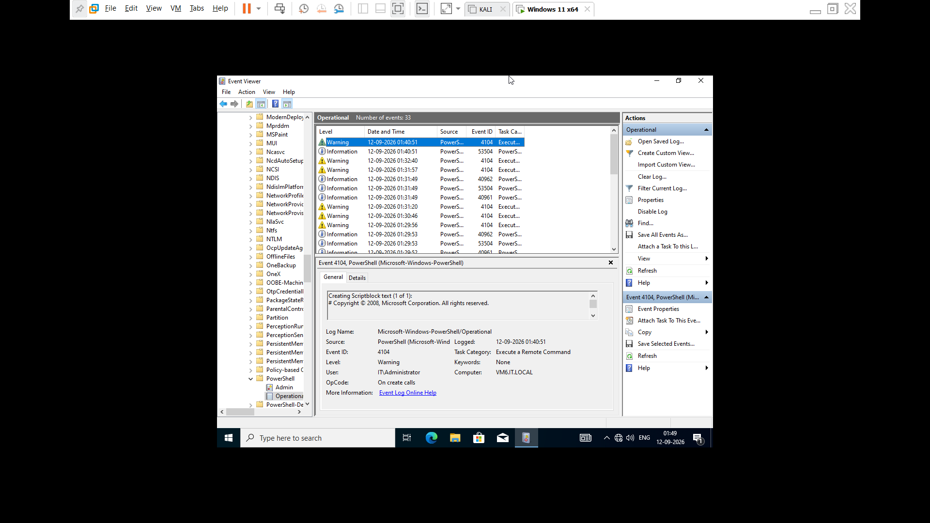
Caption:
Figure 10: Available PowerShell Operational logging evidence

16. Process Creation Monitoring
Windows Security logging can provide process creation information.
Event ID: 4688 – A new process has been created
This type of event can help analysts investigate:
- Process name
- User
- Parent process
- Command line
- Timestamp
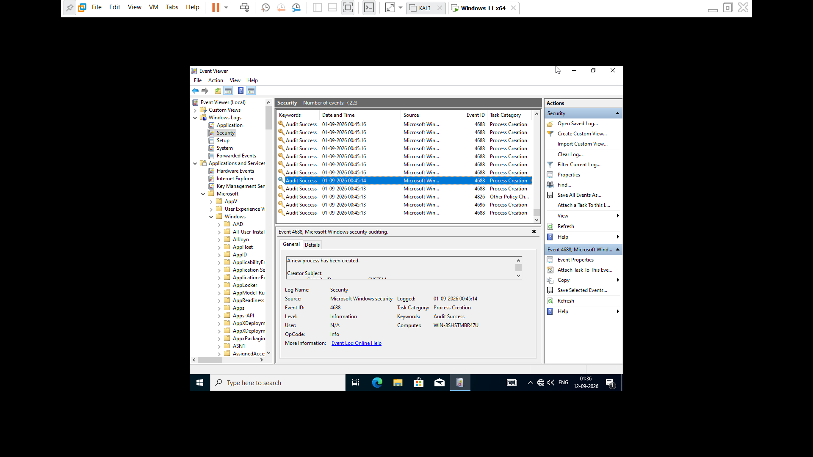

DAY 3 — Detection and Monitoring

September 16, 2026

17. Detection Strategy
PowerShell detection should not depend on powershell.exe alone.
A basic investigation flow is:
PowerShell Process → Command Line → Parent Process → User → Logs → Correlation → Detection
Analysts should investigate suspicious characteristics such as:
- Encoded commands
- Obfuscation
- Unexpected parent processes
- Unusual users
- Unusual execution locations
- Unexpected administrative activity

18. Sigma Detection Rule
The following Sigma rule is a basic laboratory detection example:
title: Suspicious PowerShell Encoded Command
status: experimental

logsource:
category: process_creation
product: windows

detection:
selection:
CommandLine|contains:
- '-EncodedCommand'
- '-enc'
condition: selection

level: high

tags:
- attack.execution
- attack.t1059.001
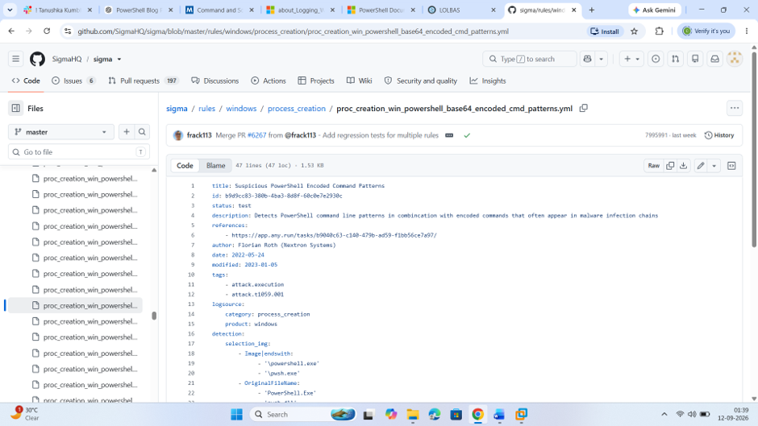
Caption:
Figure 12: Sigma detection rule for suspicious PowerShell activity

19. Splunk Detection Query
If Splunk available use this query :
index=windows
(EventCode=4688 OR EventID=4688)
(Image="*\\powershell.exe" OR New_Process_Name="*\\powershell.exe")
| table _time User ParentProcessName New_Process_Name CommandLine
| sort - _time
Encoded PowerShell hunting:
index=windows
(EventCode=4688 OR EventID=4688)
CommandLine="*-EncodedCommand*"
| table _time User ParentProcessName New_Process_Name CommandLine
Note: Splunk was not available in the current local lab environment. Therefore, the SIEM detection queries were documented for future implementation.

20. Detection Evidence
The final detection approach correlates PowerShell activity with available Windows telemetry.
The investigation process is:
1. Detect PowerShell
↓
2. Examine command line
↓
3. Check for suspicious parameters
↓
4. Check parent process
↓
5. Identify user
↓
6. Review Windows logs
↓
7. Determine whether activity is legitimate or suspicious

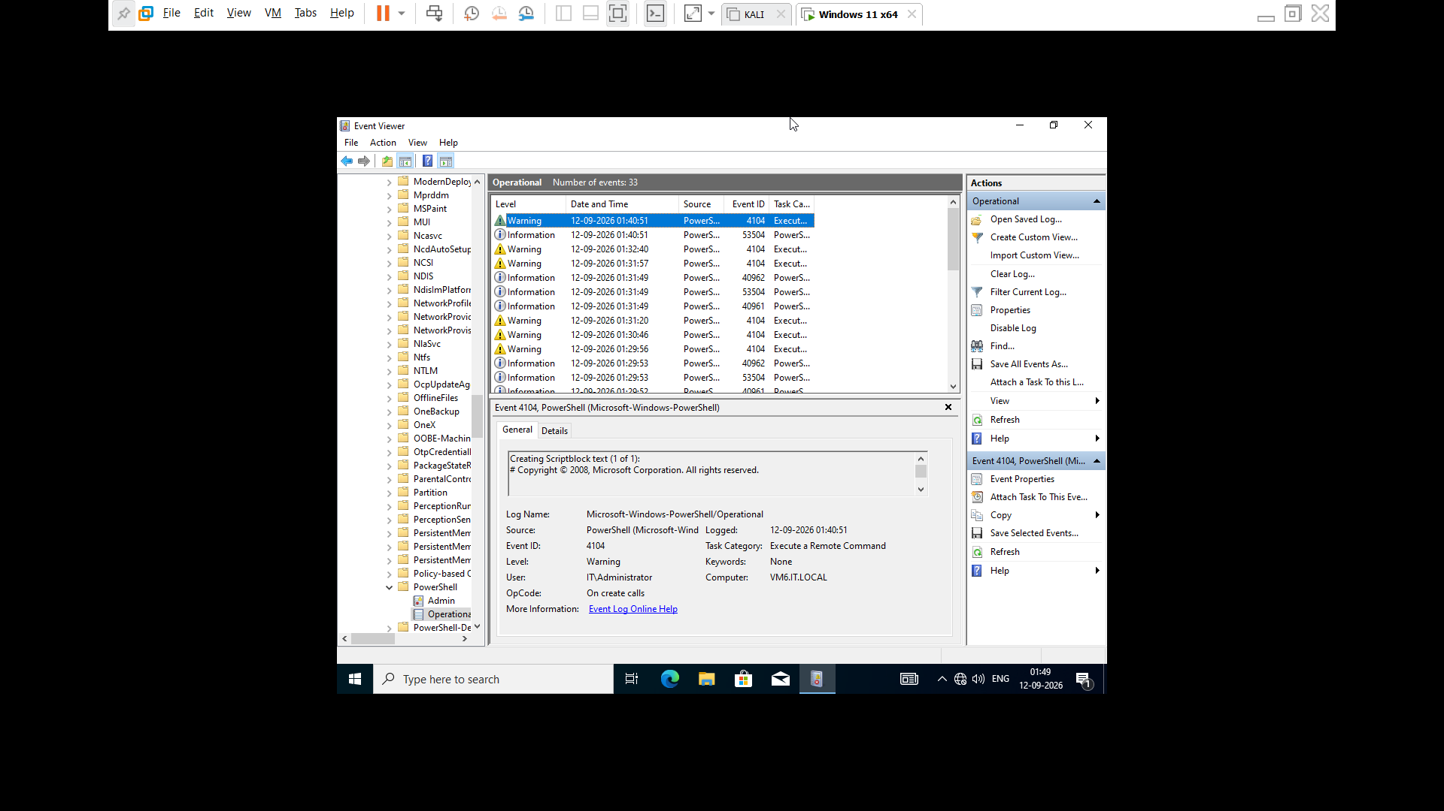Caption:
Figure 15: PowerShell activity and Windows logging evidence

21. Verification Matrix
Activity | Evidence | Risk
PowerShell execution | PowerShell process | Low/Contextual
Get-Process | PowerShell output | Low
Get-Service | PowerShell output | Low
Get-ComputerInfo | PowerShell output | Low
Encoded command parameter | Command line | High investigation priority
Obfuscated command | Script/process logs | Suspicious
Unusual parent process | Process creation logs | Suspicious

22. Detection and Monitoring Recommendations
Organizations should:
- Enable PowerShell logging.
- Monitor PowerShell command lines.
- Monitor process creation.
- Investigate encoded commands.
- Investigate obfuscated PowerShell.
- Monitor unusual parent-child process relationships.
- Use SIEM detection rules.
- Apply least privilege.
- Use application control where appropriate.
- Correlate PowerShell activity with other security telemetry.

23. Full Execution and Detection Chain
The controlled lab workflow was:
Windows 11
↓
PowerShell
↓
Normal PowerShell Commands
↓
Get-Process / Get-Service / Get-ComputerInfo
↓
PowerShell Operational Logs
↓
Detection Analysis
↓
Sigma Rule
↓
Splunk Query
↓
Investigation
↓
Mitigation
This demonstrates a basic Blue Team workflow for monitoring PowerShell activity.

24. Key Findings
The research and laboratory exercise demonstrated that:
- PowerShell is a legitimate Windows administration tool.
- PowerShell can also be abused by attackers.
- Encoded and obfuscated commands are useful detection indicators.
- PowerShell Operational logs provide useful security evidence.
- Event ID 4688 can provide process creation visibility when enabled.
- Sigma can be used to describe detection logic.
- SIEM platforms such as Splunk can be used to search and correlate PowerShell activity.
- PowerShell should not automatically be considered malicious simply because it was executed.

25. Conclusion
PowerShell is an important example of Living off the Land because it is a legitimate Windows component with extensive administrative capabilities.
Attackers can abuse PowerShell to execute commands and scripts after gaining access to a system.
From a Blue Team perspective, effective monitoring requires analysis of PowerShell execution, command-line arguments, parent processes, users and Windows security telemetry.
Combining PowerShell logging, process monitoring, Sigma detection and SIEM queries can improve the detection and investigation of suspicious PowerShell activity.

26. References
- MITRE ATT&CK – T1059.001 PowerShell: https://attack.mitre.org/techniques/T1059/001/
- Microsoft PowerShell Documentation: https://learn.microsoft.com/en-us/powershell/
- Microsoft PowerShell Logging Documentation: https://learn.microsoft.com/en-us/powershell/module/microsoft.powershell.core/about/about_logging_windows?view=powershell-7.6
- https://github.com/SigmaHQ/sigma/blob/master/rules/windows/process_creation/proc_creation_win_powershell_base64_encoded_cmd_patterns.yml
- LOLBAS : https://lolbas-project.github.io/

27. Legal Notice
This report is intended for educational purposes, defensive security research and authorized laboratory testing only. All activities were performed or designed for controlled environments. Unauthorized access, malware deployment, system disruption or other illegal activity is not intended.

