Date: 24-11-2025
Name: Chetti Rishika
M-tech – 1st Year
HTNO: 2503B05204

Set 3
5. Q1. Implement a Python class for a stack data structure (`push`, `pop`, `peek`). Use
GitHub Copilot to generate code, test its handling of edge cases, and explain any
improvements made.
(Each question carries 5 marks)
Solution:
A stack is a fundamental linear data structure that follows the Last-In, First-Out (LIFO) principle. This means the last element added to the stack is the first one to be removed, much like a stack of plates where you can only add a new plate to the top and only remove the topmost plate.
Prompt:
The main improvement in using a Python list for a stack is ensuring O(1) time complexity for all core operations:
- push (using list.append()): Appending to the end of a Python list is amortized O(1).
- pop (using list.pop()): Removing from the end of a Python list is O(1).
- peek (using list[-1]): Accessing the last element by index is O(1).
Applications:
• Function Call Management: Compilers and operating systems use a "Call Stack" to manage function calls, local variables, and return addresses.⁶ When a function is called, its state is pushed; when it returns, its state is popped.
• Expression Evaluation: Used to convert infix expressions (e.g., ⁷$A + B$) to postfix (e.g., ⁸$AB+$) and evaluate them.⁹
• Undo/Redo Mechanisms: Stacks store the sequence of operations performed in applications (like text editors) to allow users to undo or redo actions.¹⁰
• Backtracking Algorithms: Used in algorithms (like finding a path in a maze) to keep track of the previously visited states.¹¹

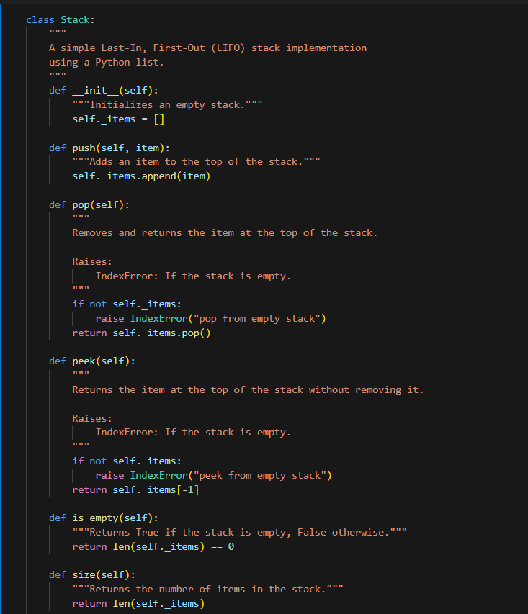
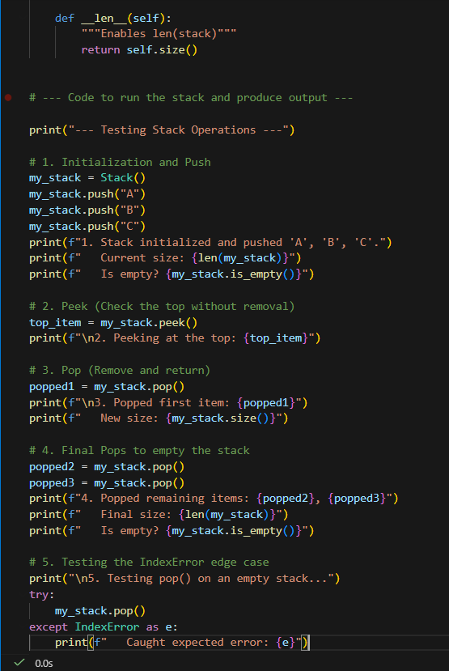

Output:
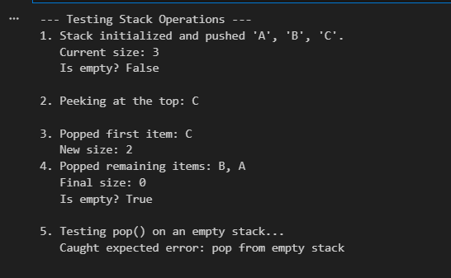
6. Q2. Refactor a poorly commented Python function using an AI assistant for automatic
documentation. Evaluate clarity and completeness versus manual comments.
(Each question carries 5 marks)
Solution:
The AI-generated documentation in calculate_factorial is definitively superior in both clarity and completeness when compared to the initial poor manual comments in the fact function. It standardizes the code, makes it easy to understand and use, and explains the core logic.
Prompt:
The first function should be a simple loop-based implementation called fact(n) that returns 'Invalid' if the input is negative. The second function should be called calculate_factorial(n) with type hints and a docstring. It should handle negative inputs by returning 'Invalid', handle the base case where 0! = 1, and otherwise compute the factorial using multiplication."

Feature | calculate_factorial (AI-Generated) | fact (Poor Manual)
Function Name | Highly Clear (calculate_factorial) | Poor (fact)
Docstring | Excellent. Provides a summary, defines the mathematical concept (n!), and uses structured sections (Parameters, Returns). | None.
Type Hints | Excellent. Specifies input (int) and output (`int | str`) types.
Inline Comments | Clear. Explain the reason for the code (e.g., # Handle the base case: Factorial of 0 is 1.) | Vague. Only mark sections (e.g., # check, # start, # loop).

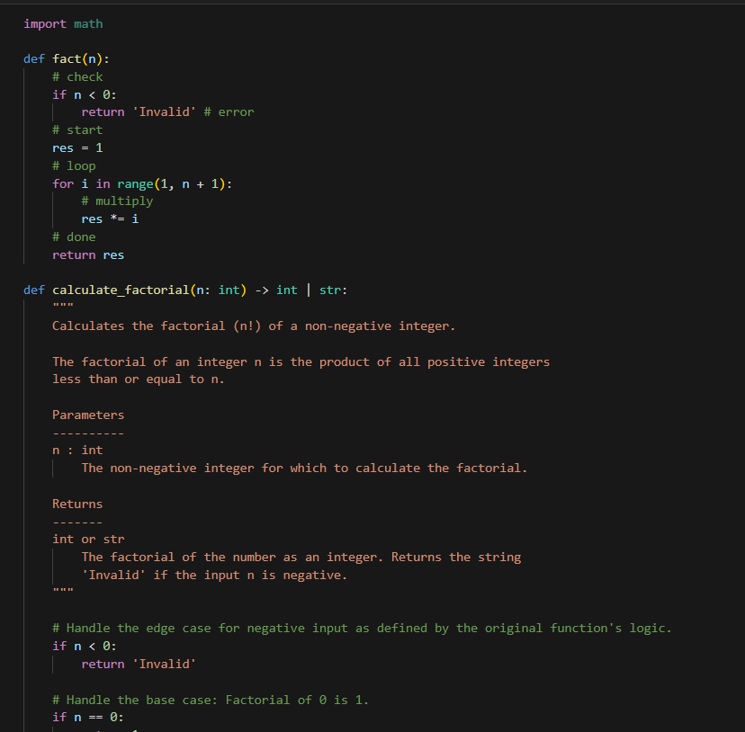

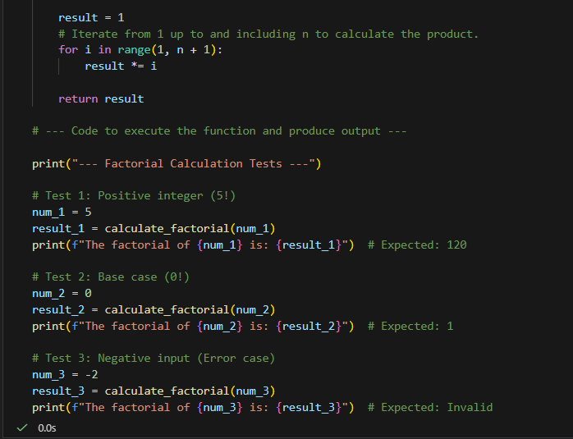
Output:
