Date: 17-11-2025
Name: Chetti Rishika
Mtech – 1st Year
HTNO: 2503B05204

Lab 11 – Data Structures with AI: Implementing Fundamental
Structures.
Task Description #1 – Stack class implementation
Task: Ask AI to implement a stack class with push(), pop(), peek() and
is_empty() methods.

What is a Stack?
- A stack is a linear data structure that follows the Last In, First Out (LIFO) principle.
- The last element added (pushed) is the first one to be removed (popped).
Key Methods in the Implementation:
__init__() | Initializes an empty list to store stack elements.
push(item) | Adds an item to the top of the stack.
pop() | Removes and returns the top item. Returns None if the stack is empty.
peek() | Returns the top item without removing it. Returns None if empty.
is_empty() | Returns True if the stack has no elements; otherwise False.
The stack is implemented using a Python list: self.items = [].
- The end of the list represents the top of the stack.
Advantages of This Implementation:
- Simple and intuitive using Python’s built-in list.
- Efficient operations:
- push() and pop() are O(1) time complexity.
Limitations:
- Python lists may have performance overhead for large stacks due to dynamic resizing.
- For more performance-critical applications, a linked list or deque (from collections) might be preferred.

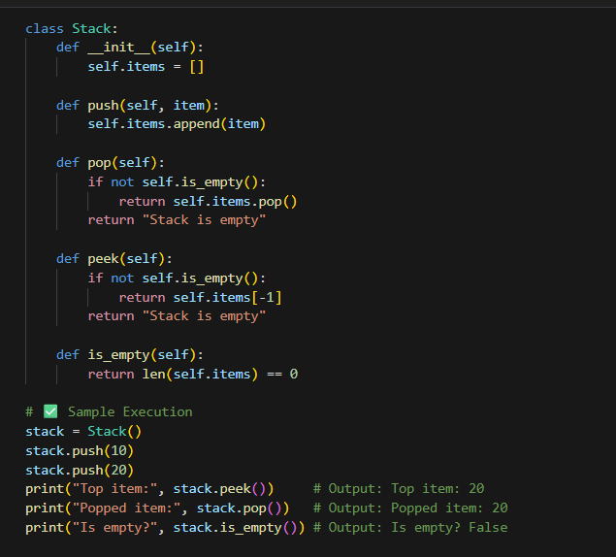
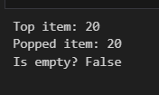
Task Description #2 – Queue Implementation
Task: Use AI to generate a Queue class with enqueue(), dequeue(), and
is_empty().
What is a Queue?
- A queue is a linear data structure that follows the First In, First Out (FIFO) principle.
- The first element added is the first one to be removed like a line at a ticket counter.
- The queue is implemented using a Python list: self.items = [].
- Enqueue uses append() to add to the end.
- Dequeue uses pop(0) to remove from the front.

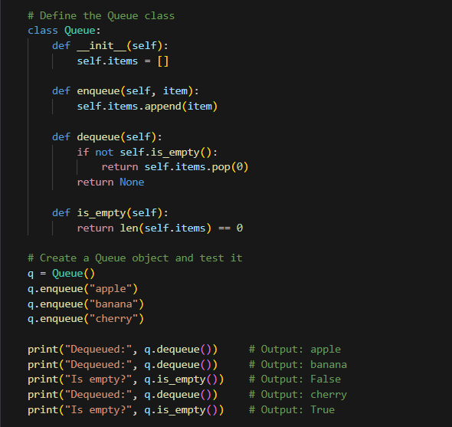
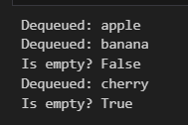
Task Description #3 – Linked List Implementation
Task: Ask AI to create a singly linked list with insert_at_end(),
insert_at_beginning(), and display().
- A linked list is a linear data structure where each element (node) points to the next.
- It allows dynamic memory allocation and efficient insertions/deletions
Advantages:
- Efficient insertions at the beginning (O(1)).
- No need to predefine size like arrays.
Limitations:
- Slower access to elements (O(n) traversal).
- No direct indexing like arrays.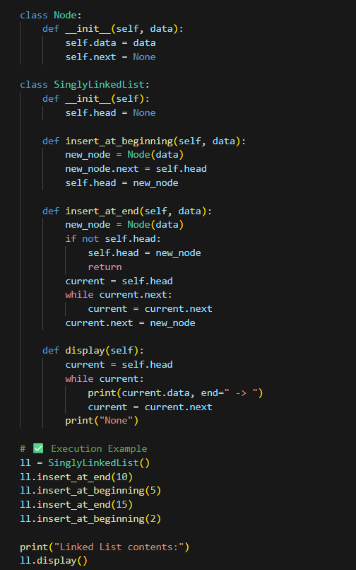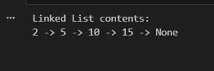
Task Description #4 – Binary Search Tree (BST)
Task: Ask AI to generate a simple BST with insert() and
inorder_traversal().
Definition
A Binary Search Tree is a hierarchical data structure in which each node has:
- A key (value).
- A left child with keys less than the node's key.
A right child with keys greater than or equal to the node's key.