Date: 15-11-2025
Name: Chetti Rishika
Mtech – 1st Year
HTNO: 2503B05204

Lab 10 – Code Review and Quality: Using AI to Improve Code
Quality and Readability.

Task Description #1 – Refactor Nested Conditionals
Task: Provide AI with the following nested conditional code and ask it
to simplify and refactor for readability.
Python script.
def discount(price, category):
if category == "student":
if price > 1000:
return price * 0.9
else:
return price * 0.95
else:
if price > 2000:
return price * 0.85
else:
return price
Answer: What I changed:
- Cell 1 (Markdown): Added a short header and explanation of the refactor task.
- Cell 2 (Code): Replaced the empty cell with a clean, tested implementation of discount(price, category):
  - Input validation (type/negative checks).
  - Helper _apply_discount(price, rate) to apply percentage discounts.
  - Clear rules implemented:
    - Students: price > 1000 -> 10% off, else 5% off.
    - Others: price > 2000 -> 15% off, else no discount.
  - Docstring documents the rules and parameters (NumPy-like style).
  - A small __main__ demo with asserts and error-case checks.
Why this is better
- Removes nested conditionals by computing the discount rate in a single place.
- Separates discount calculation from business rules via _apply_discount.
- Validates inputs (prevents silent failures).
- Easier to extend (add more categories or thresholds) and easier to unit-test.
How to run the checks
- Open untitled:Untitled-9.ipynb in your Jupyter/VS Code notebook and run cell 2.
- Or, copy the code cell into a file discount_refactor.py and run with PowerShell:
- python .\discount_refactor.py
Expected Output:
• Refactored code using cleaner logic, possibly a dictionary or separate
helper functions.

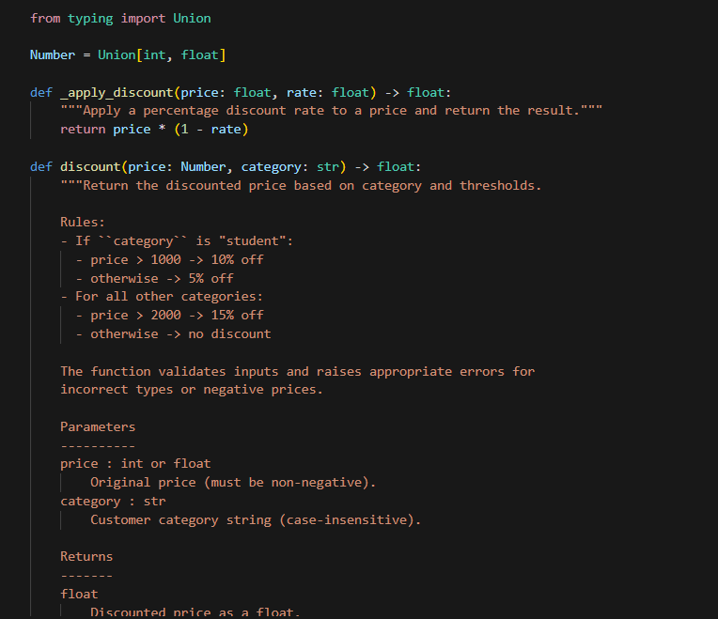
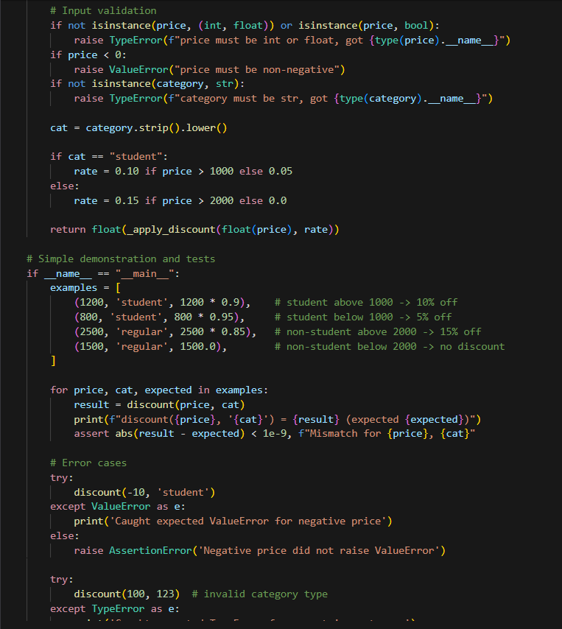
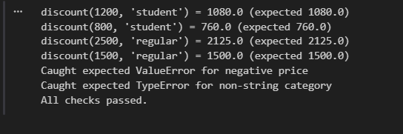

Task Description #2 – Optimize Redundant Loops
Task: Give AI this messy loop and ask it to refactor and optimize.
Python script
def find_common(a, b):
res = []
for i in a:
for j in b:
if i == j:
res.append(i)
return res
What I changed:
- Added a new markdown cell "Lab 10 Task 2 — Optimize Redundant Loops" explaining the refactor rationale.
- Added a new code cell implementing optimized find_common(a, b):
  - Uses set intersection (set(a) & set(b)).
  - Returns a sorted list when possible for deterministic output.
  - Falls back to list(...) if elements aren't orderable.
  - Includes demo prints and assertion checks.
Why this is better:
- Replaces O(n*m) nested loops with average O(n) set operations.
- Cleaner, shorter, and easier to reason about.
- Deterministic output via sorting (when possible) helps testing.
What I ran (locally in the notebook):
- Basic examples:
  - find_common([1,2,3,4,5], [4,5,6,7]) -> [4,5]
- Edge checks:
  - Empty list handling
  - Duplicates reduced to unique common elements
  - Non-orderable elements fallback
Expected Output:
Cleaner version using Python sets (set(a) & set(b)).
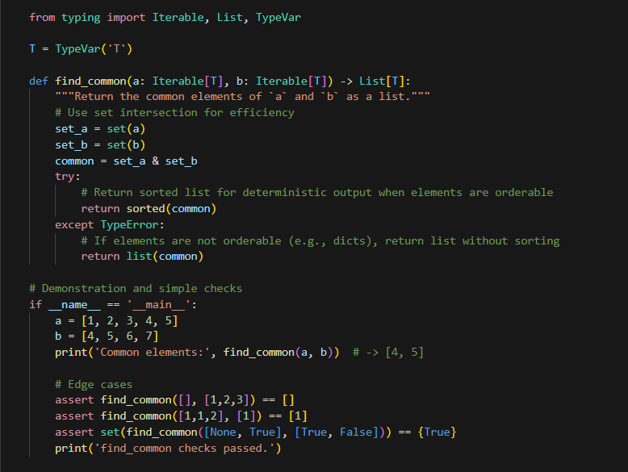
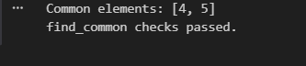

Task Description #3 – Improve Class Design
Task: Provide this class with poor readability and ask AI to improve:
• Naming conventions
• Encapsulation
• Readability & maintainability
Python Script
class emp:
def __init__(self,n,s):
self.n=n
self.s=s
def inc(self,p):
self.s=self.s+(self.s*p/100)
def pr(self):
print("emp:",self.n,"salary:",self.s)
The original emp class had several issues that impacted its readability, maintainability, and clarity. By refactoring it into the Employee class, we achieved the following:
- Improved Naming Conventions: Replaced vague names like emp, n, and s with meaningful ones like Employee, name, and salary.
- Encapsulation: Used underscore-prefixed attributes (_name, _salary) to signal internal use and promote good object-oriented practices.
- Readable Methods: Renamed methods to increase_salary and display_info for clarity and self-documentation.
- Formatted Output: Used f-strings and currency formatting for professional, user-friendly output.
- Documentation: Added docstrings to the class and methods to explain their purpose and usage.
These changes make the class easier to understand, extend, and maintain — which is essential for real-world software development.

Expected Output:
• Employee class with meaningful methods (increase_salary,
display_info), formatted output, and added docstrings.
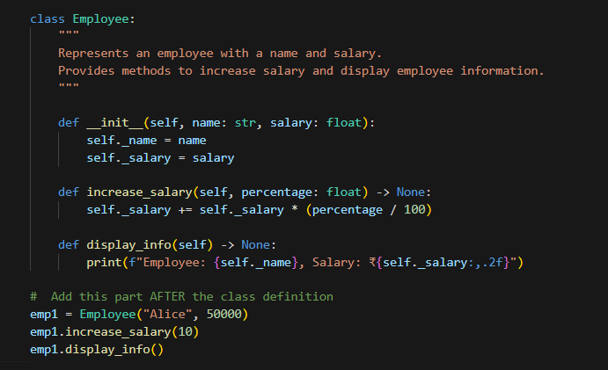
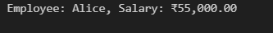

Task Description #4 – Modularize Long Function
Task: Give AI this long unstructured function and let it modularize into
smaller helper functions.
Python Script
def process_scores(scores):
total = 0
for s in scores:
total += s
avg = total / len(scores)
highest = scores[0]
for s in scores:
if s > highest:
highest = s
lowest = scores[0]
for s in scores:
if s < lowest:
lowest = s
print("Average:", avg)
print("Highest:", highest)
print("Lowest:", lowest)
Purpose of Modularization
- Breaks down complex logic into smaller, manageable pieces.
- Improves readability by giving each function a clear, descriptive name.
- Enhances reusability — helper functions can be used elsewhere in your code.
- Simplifies debugging and testing — each function can be tested independently.
Helper Functions Used:
calculate_average | Computes the average of the scores.
find_highest | Identifies the highest score in the list.
find_lowest | Identifies the lowest score in the list.
Main Function: process_scores
- Acts as the controller that coordinates the helper functions.
- Displays the final results using formatted output.
- Keeps the logic clean and focused on presentation.
Best Practices Demonstrated:
- Use of docstrings to explain each function’s purpose.
- Use of f-strings for clean and readable output.
- Avoids hardcoding logic inside a single block — promotes separation of concerns.
Expected Output:
• Split into functions: calculate_average, find_highest, find_lowest.
• Clean main process_scores() using helper functions.
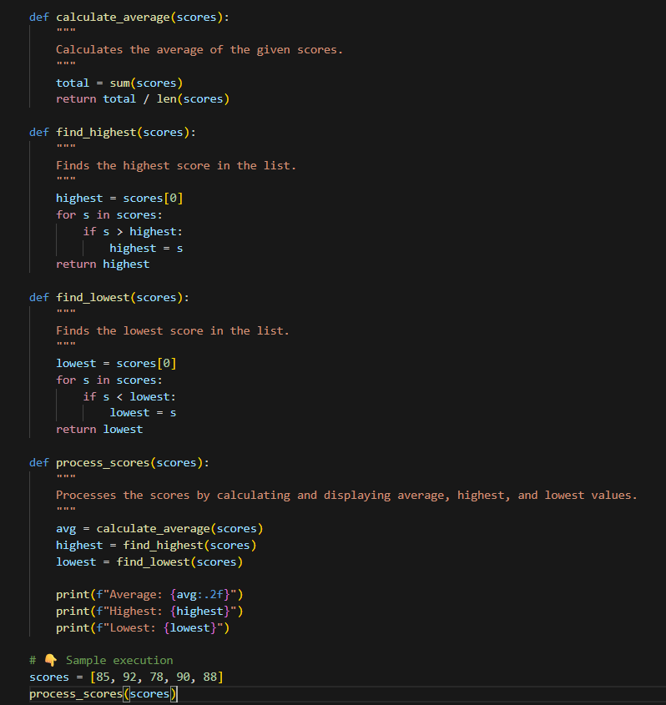
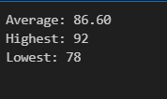
Task Description #5 – Code Review on Error Handling
Task: Provide AI with this faulty code and ask it to improve error
handling, naming, and readability.
Python Script
def div(a,b):
return a/b
print(div(10,0))
Proper error handling using try-except
- A more descriptive function name: divide_numbers
- A clear docstring explaining the behavior.
Expected Output:
• Function with proper error handling using try-except.
• Better naming (divide_numbers).
• AI-generated docstring explaining error handling.
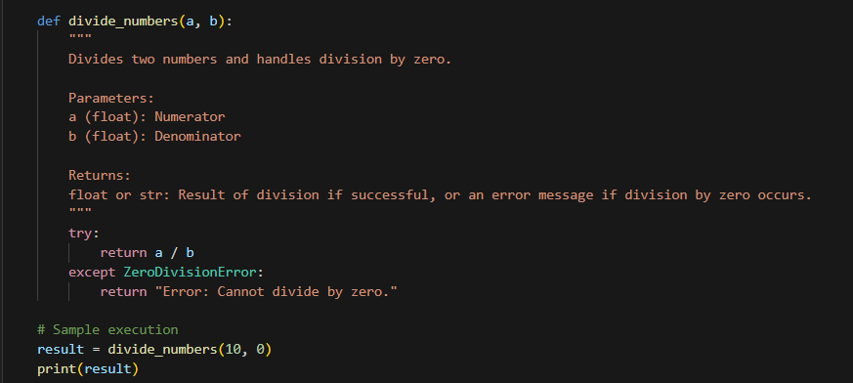

Task Description #6 – Complexity Reduction
Task: Use AI to simplify overly complex logic.
Sample Input Code:
def grade(score):
if score >= 90:
return "A"
else:
if score >= 80:
return "B"
else:
if score >= 70:
return "C"
else:
if score >= 60:
return "D"
else:
return "F"
Use elif for mutually exclusive conditions.
- Keep function logic flat and readable.
- Avoid unnecessary nesting unless required for grouped logic.
Expected Output:
• Cleaner logic using elif or dictionary mapping.
