Date: 20-11-2025
Name: Chetti Rishika
Mtech – 1st Year
HTNO: 2503B05204

Lab 13 – Code Refactoring: Improving Legacy Code with AI
Suggestions:
Task Description #1 – Remove Repetition
Task: Provide AI with the following redundant code and ask it to
refactor
Python Code
def calculate_area(shape, x, y=0):
if shape == "rectangle":
return x * y
elif shape == "square":
return x * x
elif shape == "circle":
return 3.14 * x * x
The DRY Principle The goal is to ensure that "every piece of knowledge has a single, unambiguous, authoritative representation within a system." In simple terms, never write the same piece of code (logic, function, calculation, data structure) twice.
- Maintenance Nightmare: If logic is duplicated (WET: We Enjoy Typing/Waste Everyone's Time), fixing a bug or updating a feature requires changing code in multiple places. It's easy to miss one instance.
- Increased Bugs: Inconsistent fixes across duplicated blocks create new, hard-to-find bugs.
- Reduced Readability: Boilerplate code clutters the file and makes the actual logic harder to follow.
Expected Output
• Refactored version with dictionary-based dispatch or separate
functions.
• Cleaner and modular design
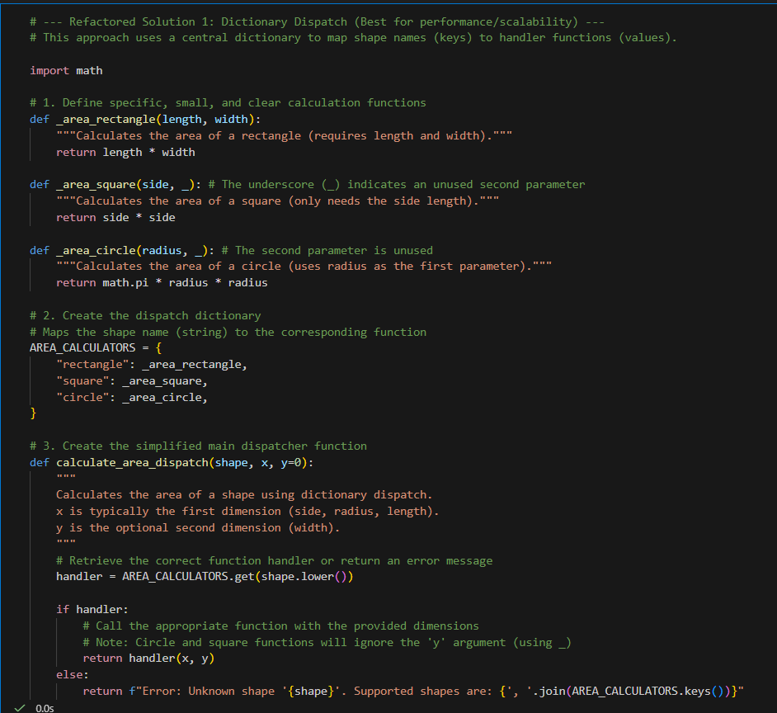
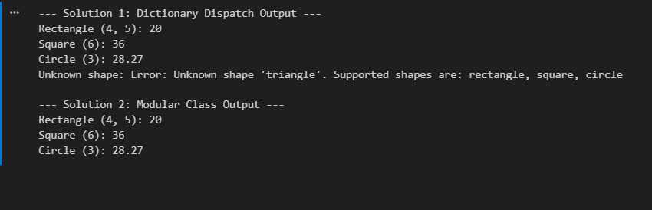

Task Description #2 – Error Handling in Legacy Code
Task: Legacy function without proper error handling
Python Code
def read_file(filename):
f = open(filename, "r")
data = f.read()
f.close()
return data
1. The Problem: "Naked" Resource Management Legacy code often uses simple functions like open(), which requires manually calling close() later. If an error occurs between open() and close(), the close() call is skipped, leaving the file or network connection open (a resource leak). This is referred to as unprotected code.
2. Python's Solution: The Context Manager (with open(...))
- Purpose: To guarantee that specific cleanup operations (like closing a file, releasing a lock, or closing a database connection) happen automatically, regardless of whether the code inside executes successfully or raises an error.
- Keyword: with.
- Benefit: Eliminates resource leaks and simplifies code by removing manual close() calls.
3. Robust Error Handling (try...except)
- Goal: To catch exceptions (errors) and handle them gracefully, preventing the entire program from crashing. This allows for recovery or controlled shutdown.
- The Structure:
  - try: Contains the code that might raise an exception.
  - except SpecificError: Catches a known error type (e.g., FileNotFoundError, PermissionError). This is better than catching a generic Exception because it helps pinpoint the fault.
  - except Exception as e: The generic catch-all for unknown or unexpected errors, often used as the last resort to log the issue.
Expected Output:
AI refactors with with open() and try-except:
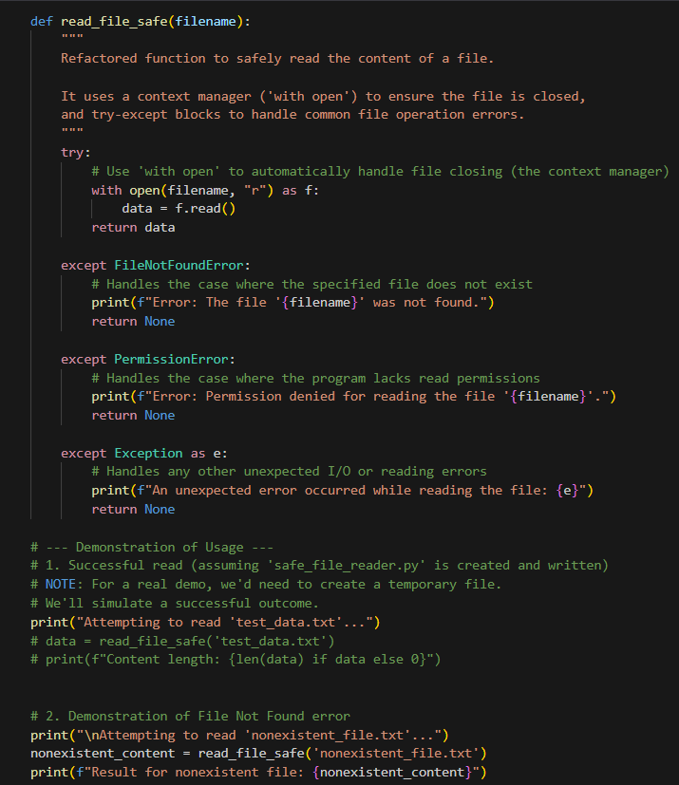
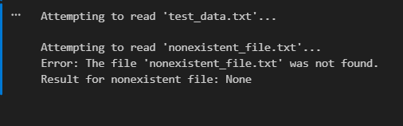
Task Description #3 – Complex Refactoring
Task: Provide this legacy class to AI for readability and modularity
improvements:
Python Code
class Student:
def __init__(self, n, a, m1, m2, m3):
self.n = n
self.a = a
self.m1 = m1
self.m2 = m2
self.m3 = m3
def details(self):
print("Name:", self.n, "Age:", self.a)
def total(self):
return self.m1+self.m2+self.m3
1. Focus on Readability and Naming
- Descriptive Naming (Clarity): Replace cryptic single-letter variables (e.g., n, a, m1) with full, descriptive names (name, age, mark1). This immediately makes the code self-documenting.
- Docstrings: Add docstrings ("""...""") to the class and every method (__init__, calculate_total). This explains the purpose, arguments, and return values, serving as essential documentation for anyone using the code.
2. Achieving Modularity and Scalability
- Data Structure Consolidation: Group related data together. Instead of handling marks as separate attributes (self.m1, self.m2, self.m3), store them in a single list (self.marks = [m1, m2, m3]).
  - Benefit: If you add a fourth mark, you only change the __init__ signature, not the calculation logic.
- Use Built-in Functions: Replace custom, repetitive arithmetic (e.g., m1 + m2 + m3) with efficient, readable Python features like the built-in sum(self.marks).
3. Enhancing Design and Encapsulation
- Single Responsibility Principle: Ensure each method does one thing well (e.g., calculate_total only calculates; get_details only formats and prints information).
- Improved Output: Use modern formatting like f-strings (f"Name: {self.name}") to produce clean, readable results, rather than relying on comma-separated prints.
- Adding Helper Methods: Creating a new method like calculate_average is easy once the data is modular, adding value and functionality to the class without increasing complexity.
Expected Output:
• AI improves naming (name, age, marks).
• Adds docstrings.
• Improves print readability.
• Possibly uses sum(self.marks) if marks stored in a list.
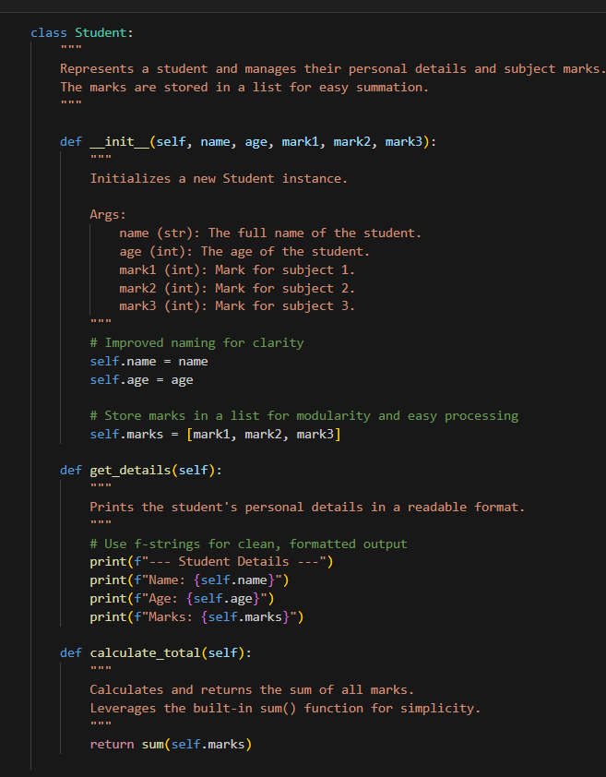
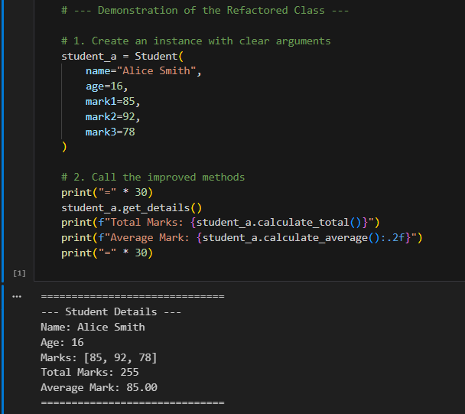
Task Description #4 – Inefficient Loop Refactoring
Task: Refactor this inefficient loop with AI help.
Python Code
nums = [1,2,3,4,5,6,7,8,9,10]
squares = []
for i in nums:
squares.append(i * i)
1. The Problem (Inefficient Loop) The standard loop method (for i in nums: squares.append(i * i)) is functional but inefficient and verbose. It requires:
- Explicitly initializing an empty list (squares = []).
- Repeatedly calling the .append() method, which adds overhead with every iteration.
2. The Solution (List Comprehension) A list comprehension combines the iteration, logic, and list creation into a single, compact expression:
[i * i for i in nums]
# [ expression for item in iterable ]
3. Key Benefits of List Comprehension
- Readability (Idiomacy): It makes the code declarative—the reader immediately knows the intent is to create a new list by transforming elements from the old list. It is the "Pythonic" way to do this operation.
- Efficiency (Performance): List comprehensions are generally faster than standard loops. They are optimized internally by the CPython interpreter, avoiding the overhead of repeated function lookups (like calling .append()).
- Conciseness: It replaces three or four lines of code with a single line, reducing visual clutter.
- Scalability: It can easily integrate conditional logic using an if clause (e.g., [i * i for i in nums if i % 2 == 0]) without significantly complicating the structure.

Expected Output: AI suggested a list comprehension
