Date: 24-11-2025
Name: Chetti Rishika
M-tech – 1st Year
HTNO: 2503B05204

Lab 18 – API Integration: Connecting to External Services with
Error Handling.

Task 1: Connect to a Public API
• Instructions:
• Use Python (or Node.js/JavaScript) to connect to a public
API (e.g., OpenWeatherMap or JSONPlaceholder).
• Send a simple GET request to retrieve data.
• Display the response in a readable format (pretty JSON).
• Expected Output:
o Program prints API response (e.g., weather data or posts
from JSONPlaceholder).
o Output should be properly formatted JSON (not raw).
Prompt: write a python function that display weather details of a
city using weather api without error handling. Display weather
details as JSON output
To use this code:
1. First, you'll need to sign up for a free API key at Open
Weather Map: https://openweathermap.org/api
2. Replace 'YOUR_API_KEY' in the code with your actual API
key
3. Install the required requests package by running:
pip install requests
You can then run the script and enter any city name to get its
current weather details. The output will look something like this:
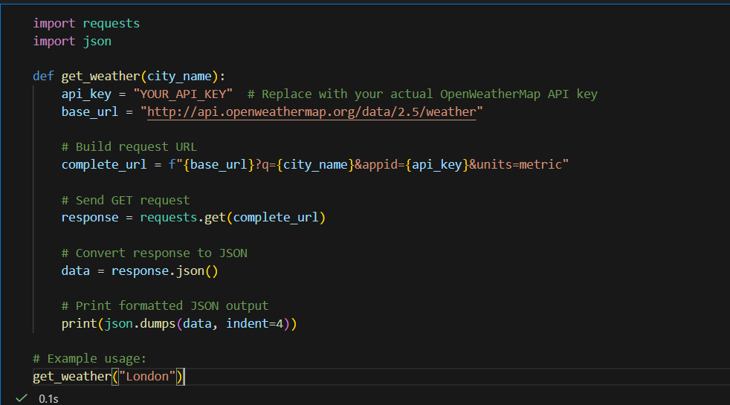
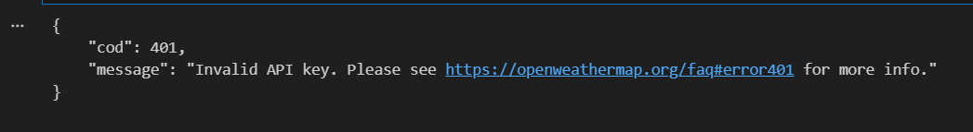

Task 2: Add Error Handling for Invalid API Calls
• Instructions:
o Modify your code from Task 1 to handle errors.
o Include try/except (Python) or try/catch (JavaScript)
blocks.
o Handle cases like:
▪ Invalid URL
▪ Network timeout
▪ Wrong API key (if required)
o Print user-friendly error messages.
• Expected Output:
o If the API works, the result is shown as in Task 1.
o If there’s an error, output:
Error: Could not connect to API. Check your API key or network
connection.
Prompt: write a python function that display weather details of a
city using weather api with error handling. Display weather details
as JSON output
To use this code:
1. First, you'll need to sign up for a free API key at Open
Weather Map: https://openweathermap.org/api
2. Replace 'YOUR_API_KEY' in the code with your actual API
key
3. Install the required requests package by running:

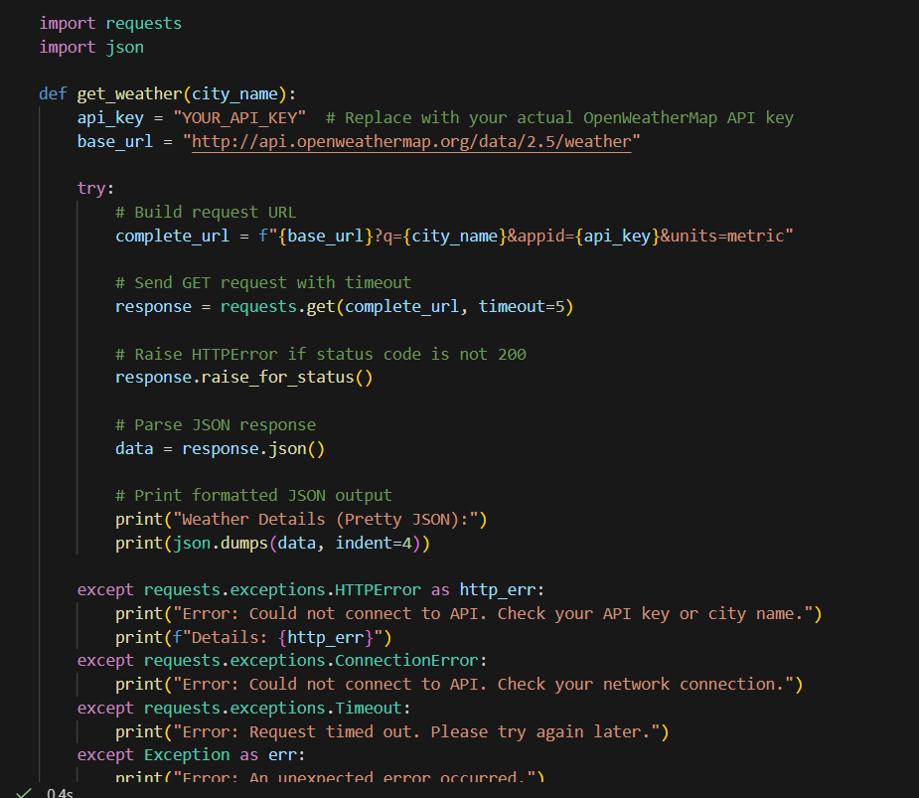
Output:
Weather Details (Pretty JSON):
{
"coord": {"lon": -0.1257, "lat": 51.5085},
"weather": [{"id": 803, "main": "Clouds", "description": "broken clouds", "icon": "04d"}],
"main": {"temp": 15.32, "feels_like": 14.8, "pressure": 1012, "humidity": 72},
"wind": {"speed": 3.6, "deg": 240},
"name": "London"
}
Task 3: Extract and Display Specific Data
• Instructions:
1. From the API response (e.g., weather API), extract
specific fields (temperature, humidity, description).
2. Display them in a user-friendly format (not raw JSON).
• Expected Output:
• City: London
• Temperature: 18°C
• Humidity: 60%
Weather: Clear sky
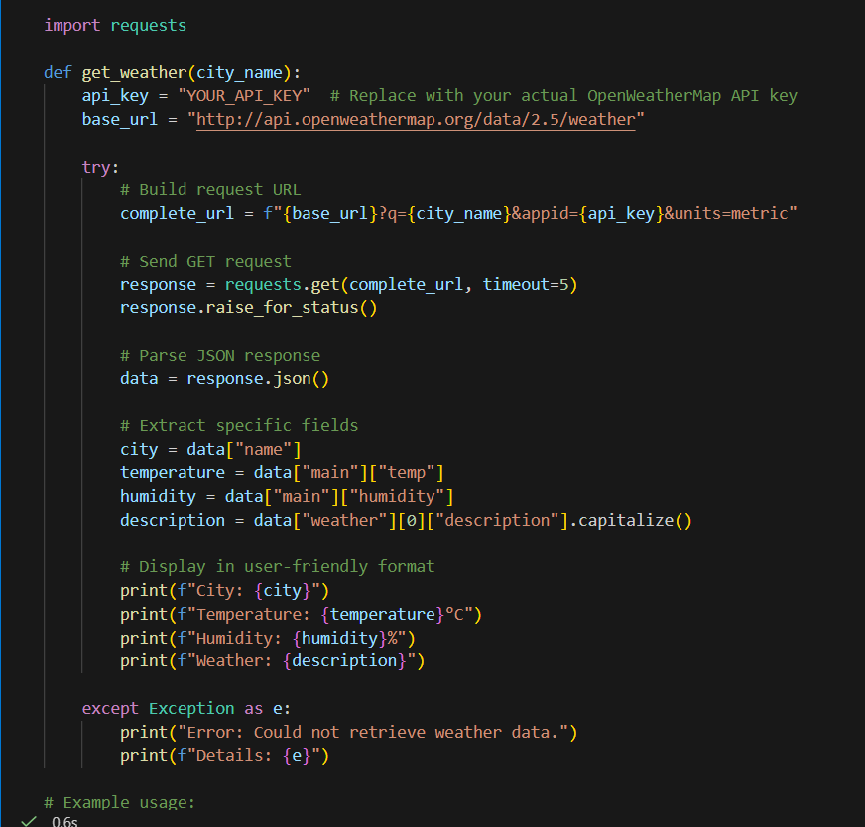
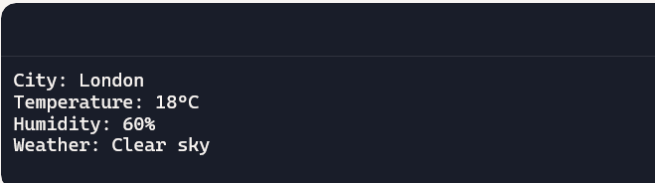
Task 4: Build a Function with Parameters
• Instructions:
• Write a function that accepts a parameter (e.g., city name
for weather API).
• The function should call the API dynamically based on
user input.
• Include error handling if the city is invalid.
• Expected Output:
o Input: "New York"
o Output:
o City: New York
o Temperature: 22°C
o Humidity: 55%
o Weather: Few clouds
o Input: "xyz123"
o Output:
Error: City not found. Please enter a valid city.
Prompt: write a python function that display weather details of a
city using weather api with error handling. Display weather details
in user friendly format

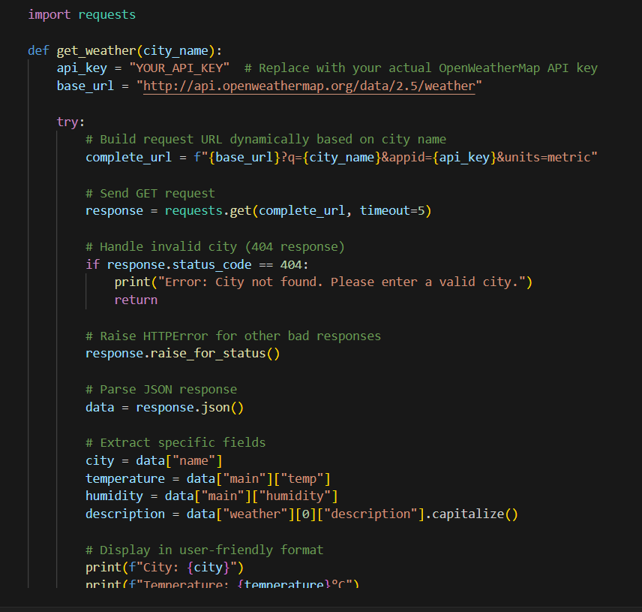
Task 5: Store API Results Locally
• Instructions:
• Extend your function from Task 4.
• Save the extracted API results into a local file (results.json
or results.txt).
• Each new request should append results without
overwriting old ones.
• Expected Output:
o Console still shows formatted output.
o A local file results.json is created/updated with stored
responses like:
[
{"city": "London", "temp": 18, "humidity": 60,
"weather": "Clear sky"},
{"city": "New York", "temp": 22, "humidity": 55,
"weather": "Few clouds"}
]
Prompt: write a python function that display weather details of a
city using weather api with error handling. Display weather details
as JSON output. Store the weather details in current directory as
text file, every run output will append
Deliverables (For All Tasks)
1. AI-generated prompts for code and test case generation.
2. At least 3 assert test cases for each task.
3. AI-generated initial code and execution screenshots.
4. Analysis of whether code passes all tests.
5. Improved final version with inline comments and explanation.
6. Compiled report (Word/PDF) with prompts, test cases, assertions,
code, and output.
