Date: 20-11-2025
Name: Chetti Rishika
Mtech – 1st Year
HTNO: 2503B05204

Lab 12 – Algorithms with AI Assistance: Sorting, searching, and
optimizing algorithms:
Task Description #1 – Linear Search implementation
Task: Write python code for linear_search () function to search a value
in a list and extract its index.
Linear search: (also called sequential search) is a simple algorithm that checks each element in a list one by one until the desired element is found or the list ends.
- Best case: Found at the first element → 1 comparison.
- Worst case: Found at the last element or not present → n comparisons.
- Time complexity: O(n).
- Space complexity: O(1).
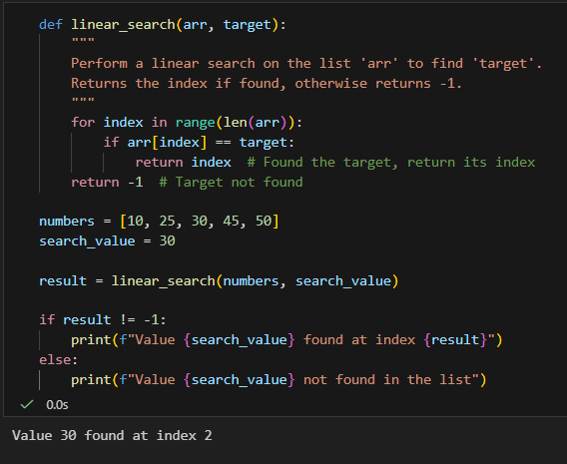
Task Description #2 – Sorting Algorithms
Task: Ask AI to implement Bubble Sort and check sorted output
Bubble Sort: is a simple sorting algorithm that repeatedly compares adjacent elements and swaps them if they are in the wrong order. Over multiple passes, the largest elements "bubble up" to the end of the list, and the process continues until the list is sorted.
- Start at the beginning of the list.
- Compare the first two elements. If the first is greater than the second, swap them.
- Move to the next pair and repeat until the end of the list.
- After the first pass, the largest element is at the end.
- Repeat the process for the remaining unsorted portion until no swaps are needed.
- Best case (already sorted): O(n) comparisons
- Worst case: O(n^2) comparisons/swaps
- Space complexity: O(1) (in-place sorting)
- Bubble Sort is simple but inefficient for large datasets compared to algorithms like Quick Sort or Merge Sort.
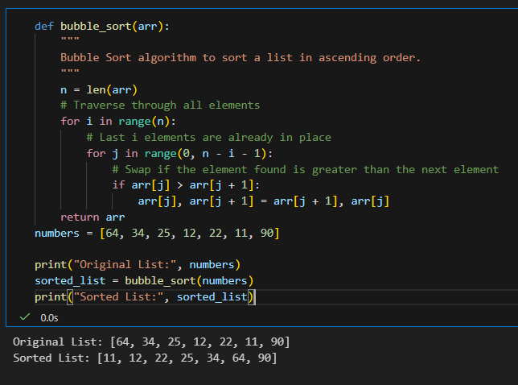

Task Description #3 – Optimization
Task: Write python code to solve below case study using linear
optimization.
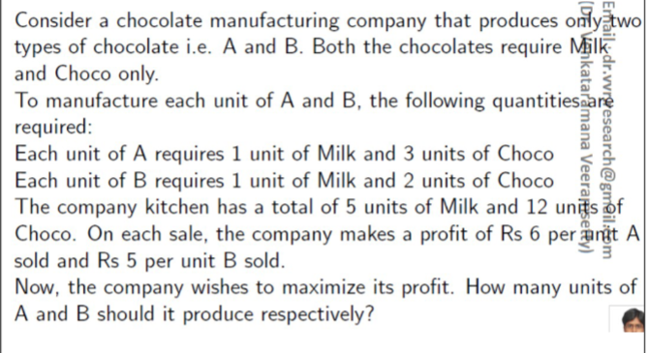

This is a classic linear programming problem. I will first define the variables, the objective function, and the constraints based on the case study, and then provide the Python code using the pulp library to solve it.
Linear Programming Formulation
- Variables:
  - Let A be the number of units of Chocolate A to produce.
  - Let B be the number of units of Chocolate B to produce.
  - Constraint: A >= 0 and B >= 0 (The number of units cannot be negative).
- Objective Function (Maximize Profit):
  - Profit from A is Rs 6 per unit.
  - Profit from B is Rs 5 per unit.
  - Maximize Z = 6A + 5B
- Constraints (Resource Availability):
Milk Constraint:
  - A requires 1 unit of Milk.
  - B requires 1 unit of Milk.
  - Total Milk available is 5 units.
  - Constraint: 1A + 1B <= 5
Choco Constraint:
- A requires 3 units of Choco.
- B requires 2 units of Choco.
- Total Choco available is 12 units.
- Constraint: 3A + 2B <=12
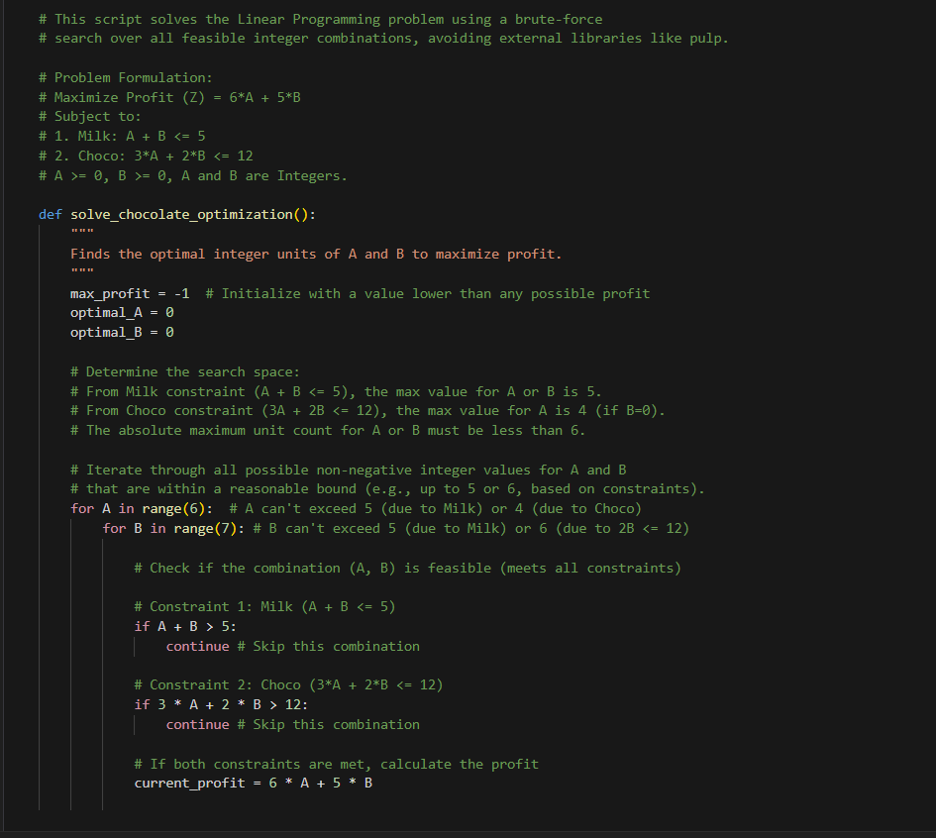
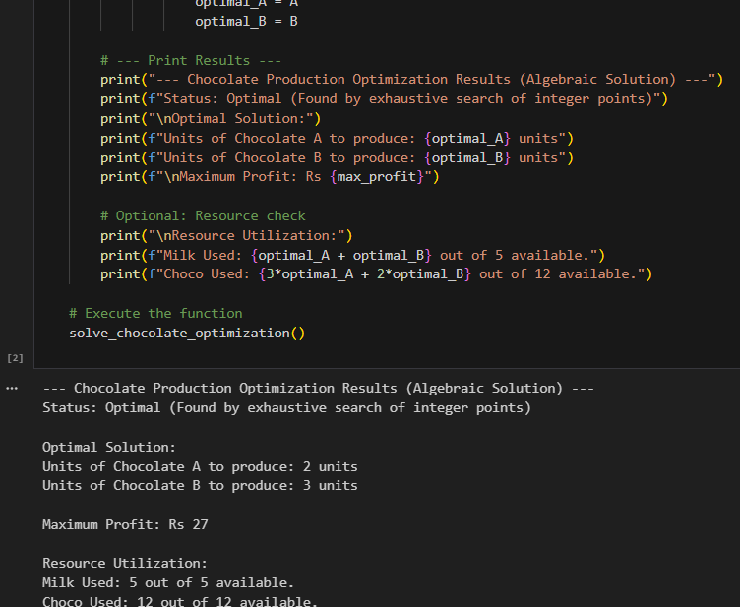

Task Description #4 – Gradient Descent Optimization
Task: Write python code to find value of x at which the function
f(x)=2X3+4x+5 will be minimum

Gradient Descent is an optimization algorithm used to minimize a cost (or loss) function by iteratively adjusting parameters in the direction of the steepest descent of the function. It is one of the most widely used methods in machine learning and deep learning for training models.
Update Rule:
x_{\mathrm{new}}=x_{\mathrm{old}}-\alpha \cdot f'(x_{\mathrm{old}})
- where \alpha = learning rate, f'(x) = derivative of the function.
- The process repeats until convergence (when changes become very small).
- For the function f(x)=2x^3+4x+5:
- Derivative: f'(x)=6x^2+4.
- Gradient descent will iteratively adjust x to minimize f(x).
