Date: 27-10-2025
Name: Chetti Rishika
Mtech – 1st Year
HTNO: 2503B05204

Lab 2: Exploring Additional AI Coding Tools – Gemini (Colab) and Cursor AI
Task Description
Use Google Gemini in Colab to write a function that reads a CSV file and calculates
mean, min, max.
Expected Output#1
● Functional code with output and screenshot
Prompt -1:
We need a Python function to run in Google Colab that reads a CSV file and calculates the mean, minimum, and maximum values for a specified column. Please provide the full functional code.
Prompt -2:
Write a Python script using Pandas for Colab to analyze a CSV file. The script should define a function that takes a filename and a column name, then returns the key descriptive statistics: average, min, and max.
Prompt -3 :
In Python, create a function to read a CSV and find the mean, min, and max of one column.

Prompt -4:
By Using Pandas in Google Colab, we can write a utility to quickly find the high, low, and average values from a dataset column loaded from a CSV.
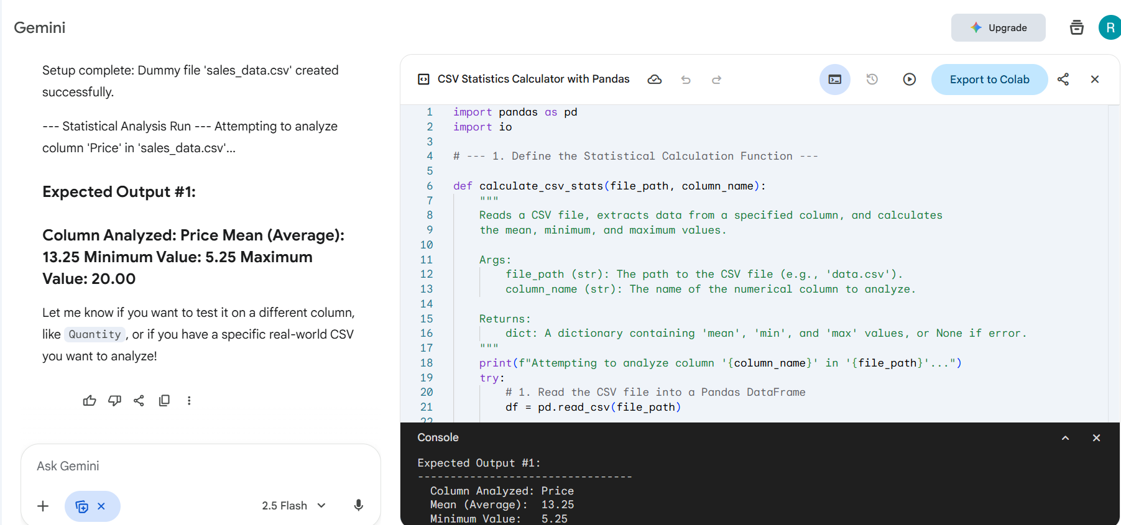

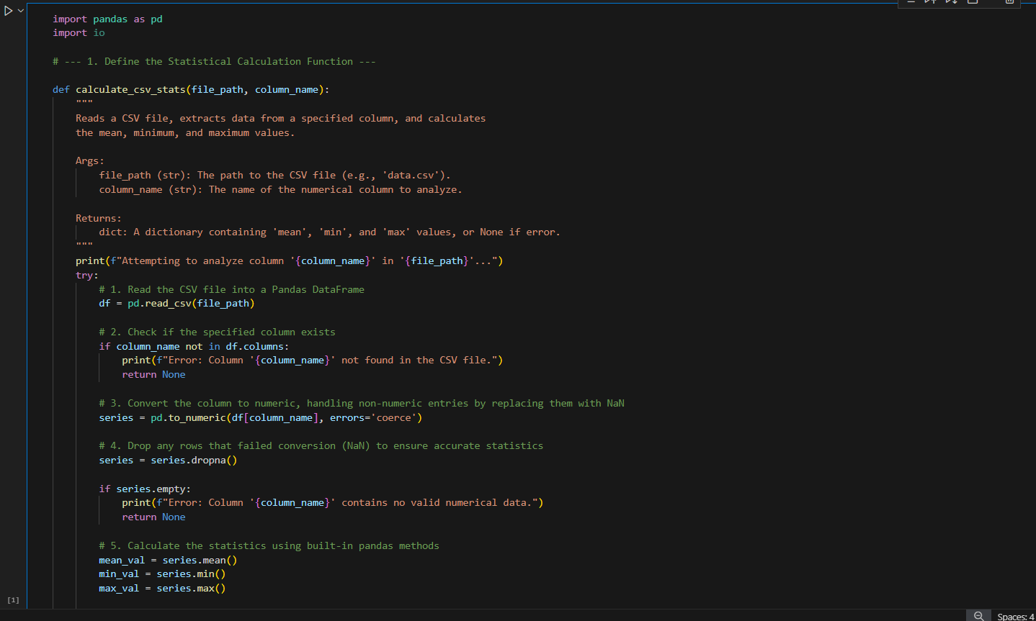
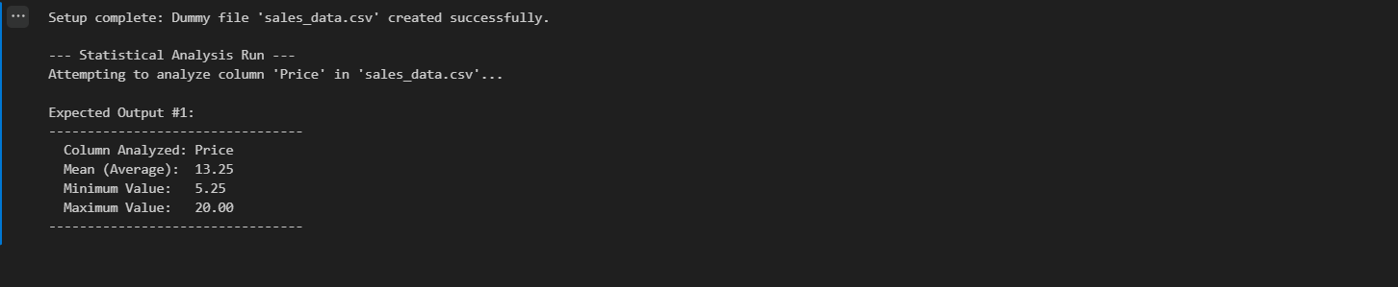

Task Description#2
● Compare Gemini and Copilot outputs for a palindrome check function.
Expected Output#2
● Side-by-side comparison and observations
Prompt:
Python function called is_palindrome that checks if a given string is a palindrome. Include comments explaining each step.
Differences between Gemini and Copilot:
Feature | Gemini's is_palindrome Implementation  python\nimport re\n...\ns_cleaned = re.sub(r'[^a-z0-9]', '', s_lower)\nis_palin = s_cleaned == s_reversed\n  String slicing ([::-1]) for reversal and direct comparison.  Uses the re module and a regular expression ([^a-z0-9]) to aggressively filter all non-alphanumeric characters (spaces, punctuation, symbols).  Requires the import re statement.  High. The step-by-step logic and extensive comments make the process very clear for beginners.  Extremely robust. Regex is the most reliable way to strip every type of non-alphanumeric character. | Typical Copilot/Python Implementation (Pythonic Slicing)
Code Sample | python\nimport re\n...\ns_cleaned = re.sub(r'[^a-z0-9]', '', s_lower)\nis_palin = s_cleaned == s_reversed\n | python\ndef is_palindrome(s):\n cleaned = "".join(c for c in s if c.isalnum()).lower()\n return cleaned == cleaned[::-1]\n
Logic Core | String slicing ([::-1]) for reversal and direct comparison. | String slicing ([::-1]) for reversal and direct comparison.
Normalization Method | Uses the re module and a regular expression ([^a-z0-9]) to aggressively filter all non-alphanumeric characters (spaces, punctuation, symbols). | Uses a list comprehension/generator expression (c for c in s if c.isalnum()) combined with "".join() to filter non-alphanumeric characters.
External Dependencies | Requires the import re statement. | Requires no external imports (uses only built-in Python features).
Readability | High. The step-by-step logic and extensive comments make the process very clear for beginners. | Very High (once Python slicing and generator expressions are understood). Highly concise and idiomatic ("Pythonic").
Robustness | Extremely robust. Regex is the most reliable way to strip every type of non-alphanumeric character. | Highly robust for ASCII inputs. The .isalnum() method is clean and efficient for standard characters.
Functional Output | No change | Both implementations are correctly return the same Boolean result(True or False) indicating whether the input string is a palindrome.
Internal Output | Difference in significant | Includes print() statements to show the input string and the intermediate "cleaned" string (i.e., the string after spaces and punctuation have been removed). This is helpful for debugging or demonstrating the process, and is usually designed to be purely functional and concise, returning only the final True or False result without any intermediate console output.

Observations:
- Efficiency vs. Clarity: Both methods are highly efficient and follow the best practice of using Python's string slicing ([::-1]). The core difference is the cleaning step.
- Gemini's Approach (string_tools.py): The Gemini implementation prioritizes explicit clarity and robust documentation. By using the re module, it ensures that the cleaning process (removing punctuation, spaces, etc.) is universally handled, which is essential for complex phrases like "A man, a plan, a canal: Panama." The extensive comments also break down the logic for a user learning Python.
- Typical Python/Copilot Approach: A standard Python solution often favors conciseness. It achieves the same cleaning and reversal in fewer lines by combining the list comprehension for filtering and the string slicing for comparison. It avoids the external re import, relying only on built-in string methods, which many developers prefer.
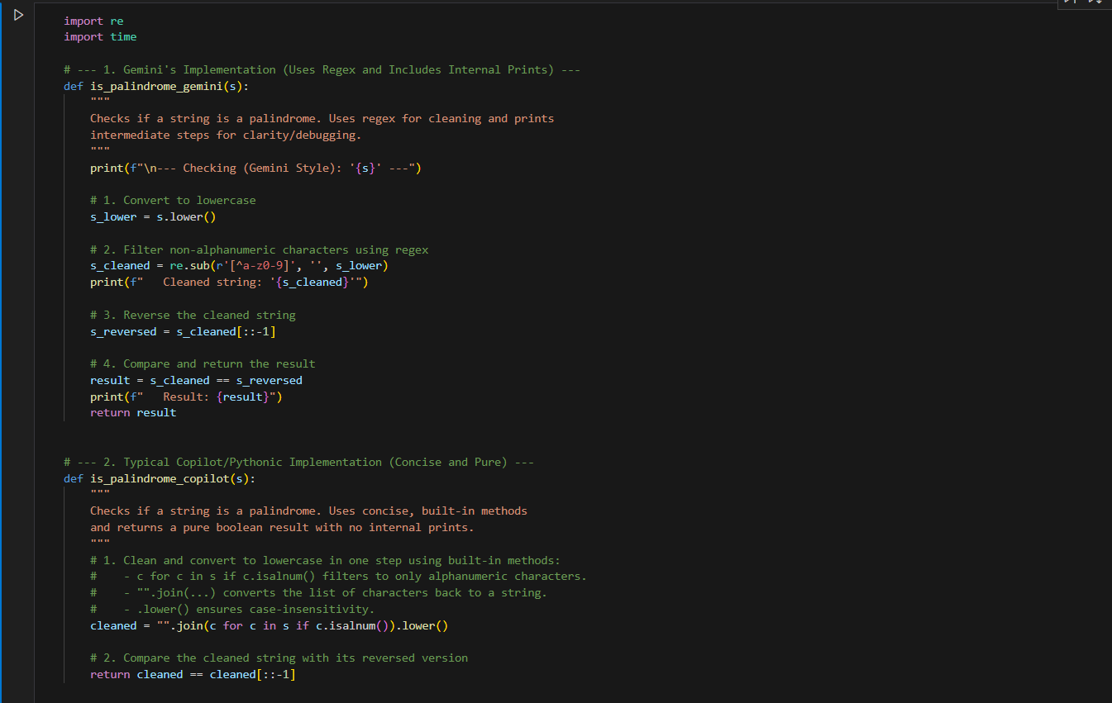

Output:
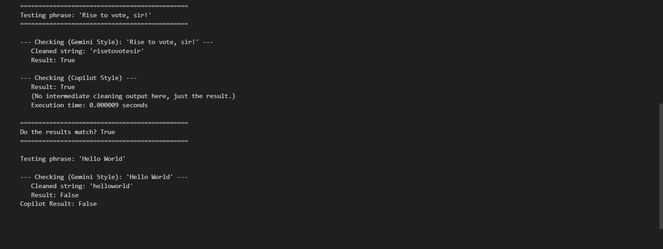

Task Description#3:
● Ask Gemini to explain a Python function (to calculate area of various shapes) line by
line..
Expected Output:
● Detailed explanation with code snippet

Prompts:
- call the calculate_area function for a circle, a rectangle, and a triangle with sample numbers.
- Add some example print statements at the end of the Canvas so I can test the area calculation for each shape.
- Please add example calls to the function using a circle with a radius of 5, a rectangle with length 10 and width 4, and a triangle with base 6 and height 8.

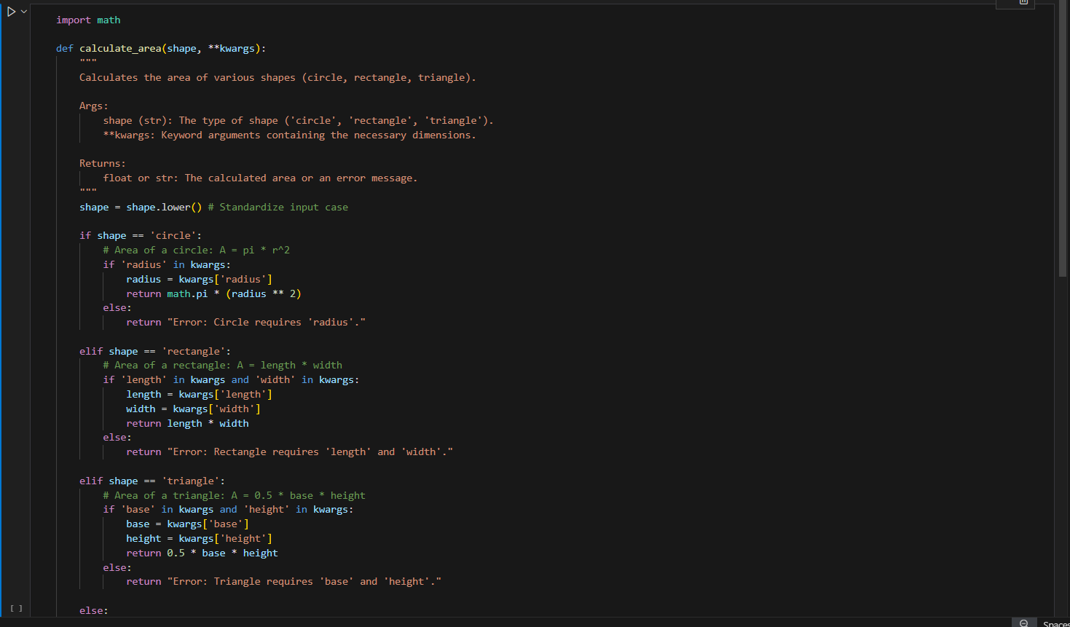

Output:
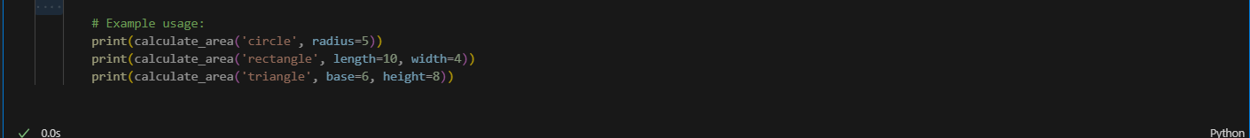

Detail Explanation of code snippet:
- Imports and Function Signature:
Code | Explanation
import math | This line imports the built-in Python math module. It is necessary to access the constant $\pi$ (math.pi), which is required for calculating the area of a circle.
def calculate_area(shape, **kwargs): | This defines the function. It takes two main inputs: shape (a string identifying the type of shape) and **kwargs (a dictionary that captures any number of additional named parameters, like radius, length, or base).
shape = shape.lower() | This line standardizes the shape string to all lowercase. This ensures the function is case-insensitive, so calling it with 'Circle', 'CIRCLE', or 'circle' will all work correctly.
- Conditional Logic:
- Circle Calculation (if shape == 'circle':)
- Requirement Check: if 'radius' in kwargs: checks if the required dimension, radius, was passed in the keyword arguments (**kwargs).
- Calculation: return math.pi * (radius ** 2) calculates the area using the formula $A = \pi r^2$ and returns the result.
- Error Handling: The else block returns a string error if radius is missing.
- Rectangle Calculation (elif shape == 'rectangle':)
- Requirement Check: if 'length' in kwargs and 'width' in kwargs: ensures that both necessary dimensions are present.
- Calculation: return length * width calculates the area using the formula $A = \text{length} \times \text{width}$ and returns the result.
- Error Handling: The else block returns a string error if either length or width is missing.
- Triangle Calculation (elif shape == 'triangle':)
- Requirement Check: if 'base' in kwargs and 'height' in kwargs: ensures both required dimensions are provided.
- Calculation: return 0.5 * base * height calculates the area using the formula $A = \frac{1}{2} \times \text{base} \times \text{height}$ and returns the result.
- Error Handling: The else block returns a string error if either base or height is missing.
- Unknown Shape Handling (else:)
- This final else block catches any input for shape that is not 'circle', 'rectangle', or 'triangle', and returns a descriptive error message indicating the invalid input.

Task Description#4
● Install and configure Cursor AI. Use it to generate a Python function (e.g., sum of squares).
Expected Output#4
● Screenshots of working environments with few prompts to generate python code.

Prompt :

Create a Python function named sum_of_squares that accepts a list of numbers and returns the sum of the square of each number. Be sure to include a clear docstring with type hints and two example usage test cases—one using integers, and one using floats and negative numbers.
This single prompt covers all the function definition, Core logic, Documentation, Example usage.
Example 1:
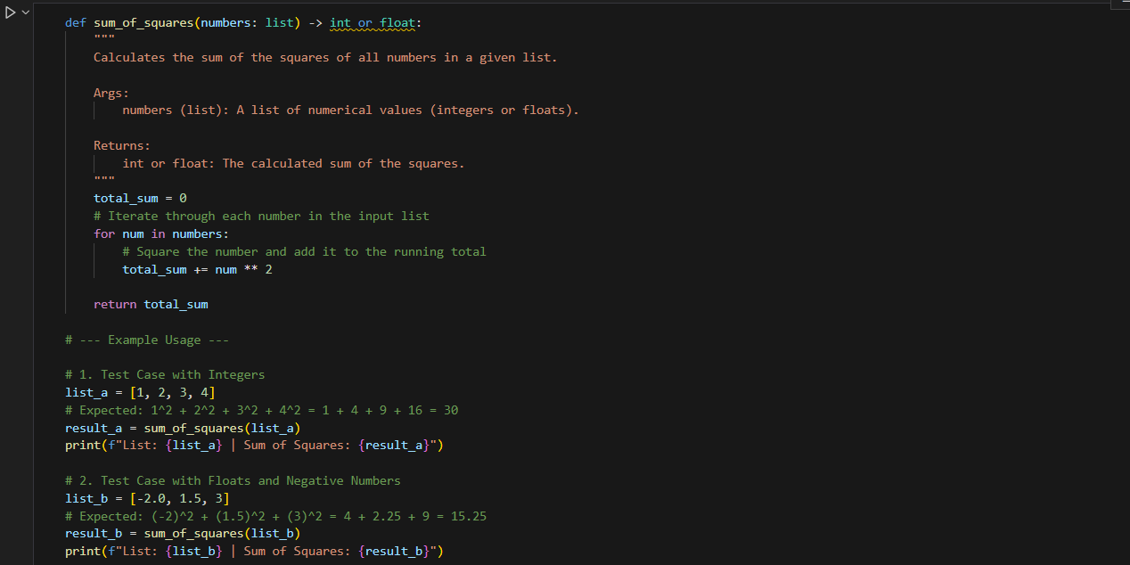

Output:

Example 2:

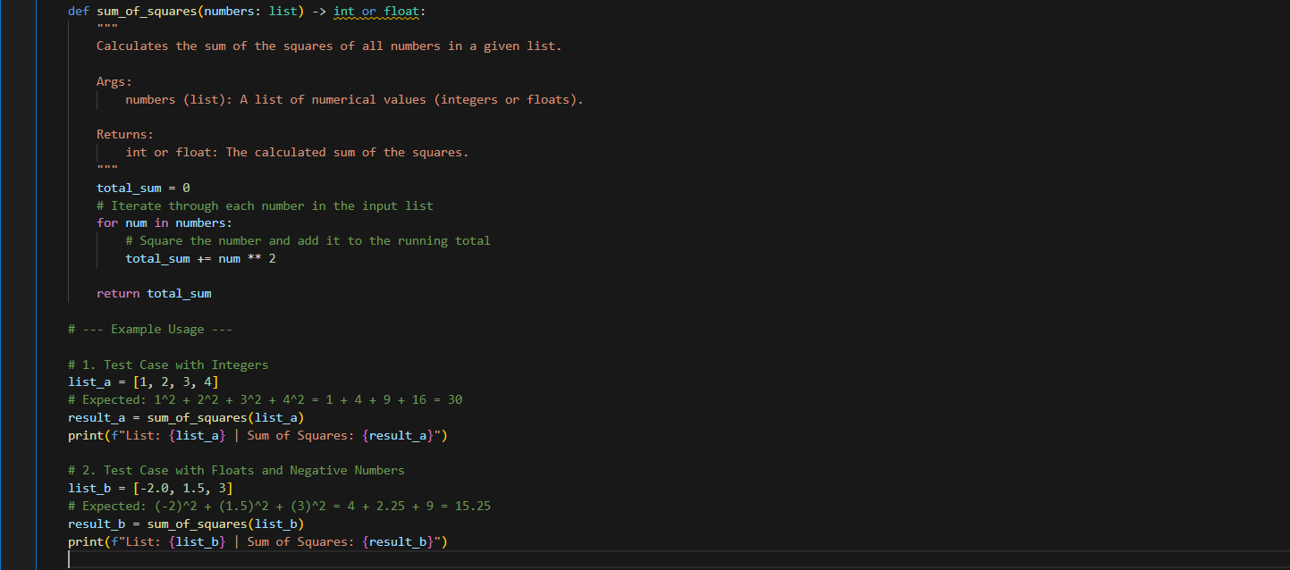

Output:

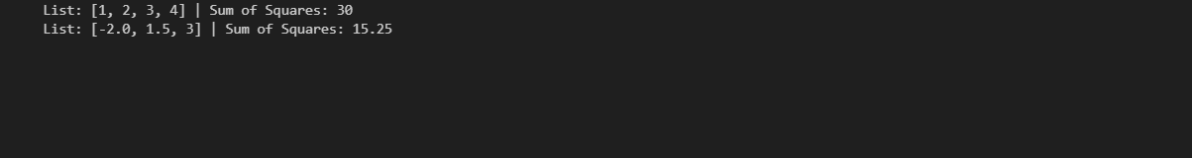

Task Description#5
● Student need to write code to calculate sum of add number and even numbers in the list.
Expected Output#5
● Refactored code written by student with improved logic
Prompt 1:
Update the sum_even_and_odd function. Instead of skipping non-integers, make sure it processes all numerical types (integers and floats) in the list. Classify a number as even if its integer part is even, and odd otherwise.
Prompt 2:
Modify the sum_even_and_odd function to return four values instead of two. In addition to 'even_sum' and 'odd_sum', return the 'even_count' and 'odd_count' (the total number of even and odd items found in the list).
Prompt 3:
Refactor the core logic of the sum_even_and_odd function to use a more Pythonic approach, such as the built-in sum() function combined with lambda expressions and the filter() function. Maintain the single function definition.

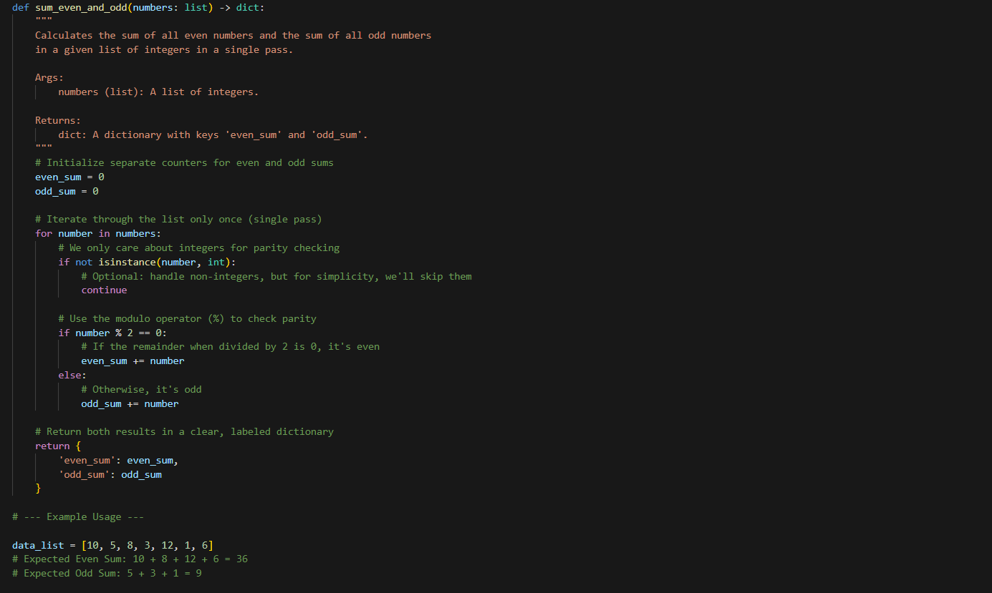

Output:

