AI Assisted Problem Solving Using Python

Date: 28-10-2025
Name: Chetti Rishika
Mtech – 1st Year
HTNO: 2503B05204

Lab 4: Advanced Prompt Engineering – Zero-shot, One-shot, and Few-shot Techniques

Task Description-1
- Zero-shot: Prompt AI to write a function that checks whether a given year is a leap year.
Expected Output-1
- AI-generated function with no examples provided

Prompt
Write a function in python that checks whether a given year is a leap year by taking user input manually.

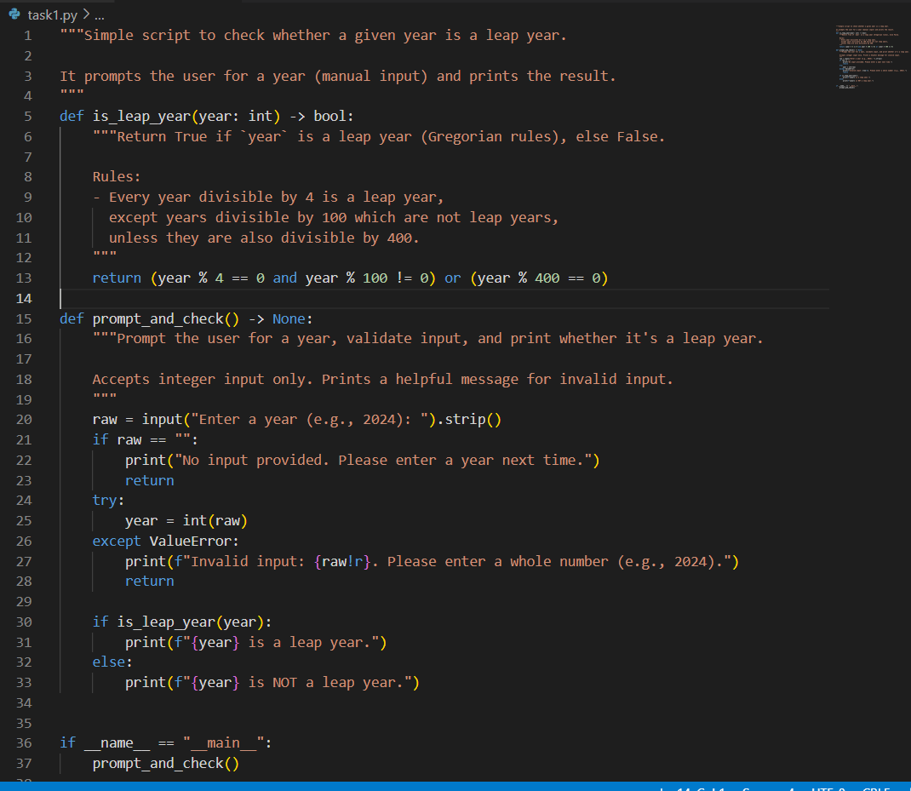

Output:

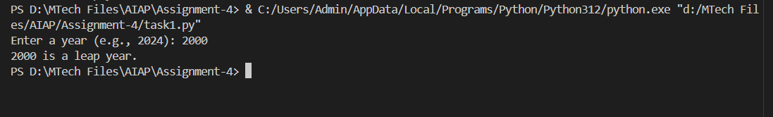

Task Description-2
- One-shot: Give one input-output example to guide AI in writing a function that converts centimeters to inches.
Expected Output-2
- Function with correct conversion logic

Prompt
Write a python function by taking user input manually to convert centimetres to inches like 1 cm = 0.393701 inches

CODE:

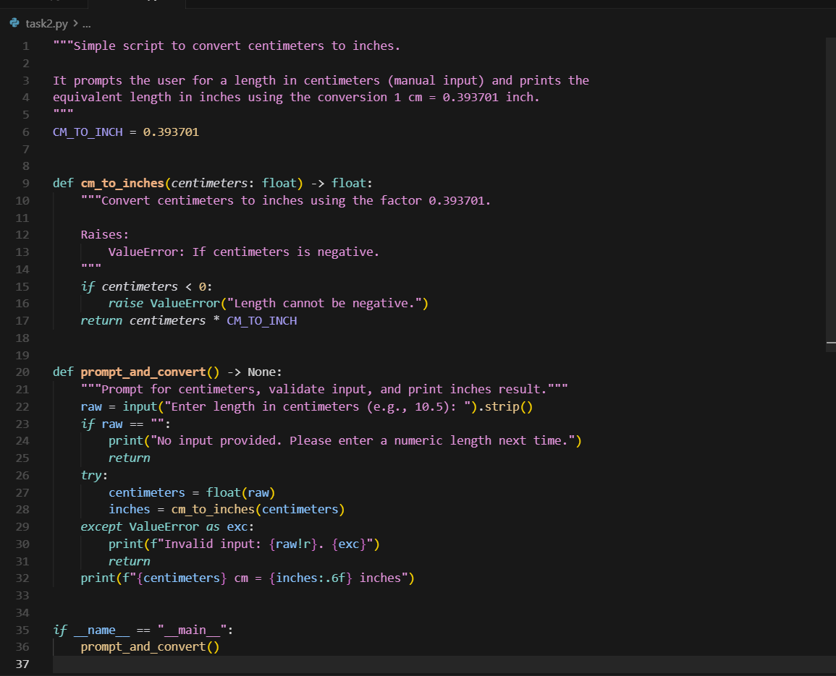

OUTPUT:

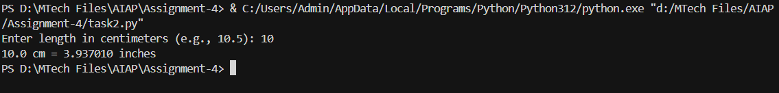

Task Description-3
- Few-shot: Provide 2–3 examples to generate a function that formats full names as “Last, First”.
Expected Output-3
- Well-structured function respecting the examples

Prompt
Generate a function that formats full names as "Last, First" like
Example:
"Chittimalla, Pujitha" as First name: Chittimalla Last name: Pujitha
"Chittimalla, Rajasree " as First name: Chittimalla Last name: Rajasree

CODE:

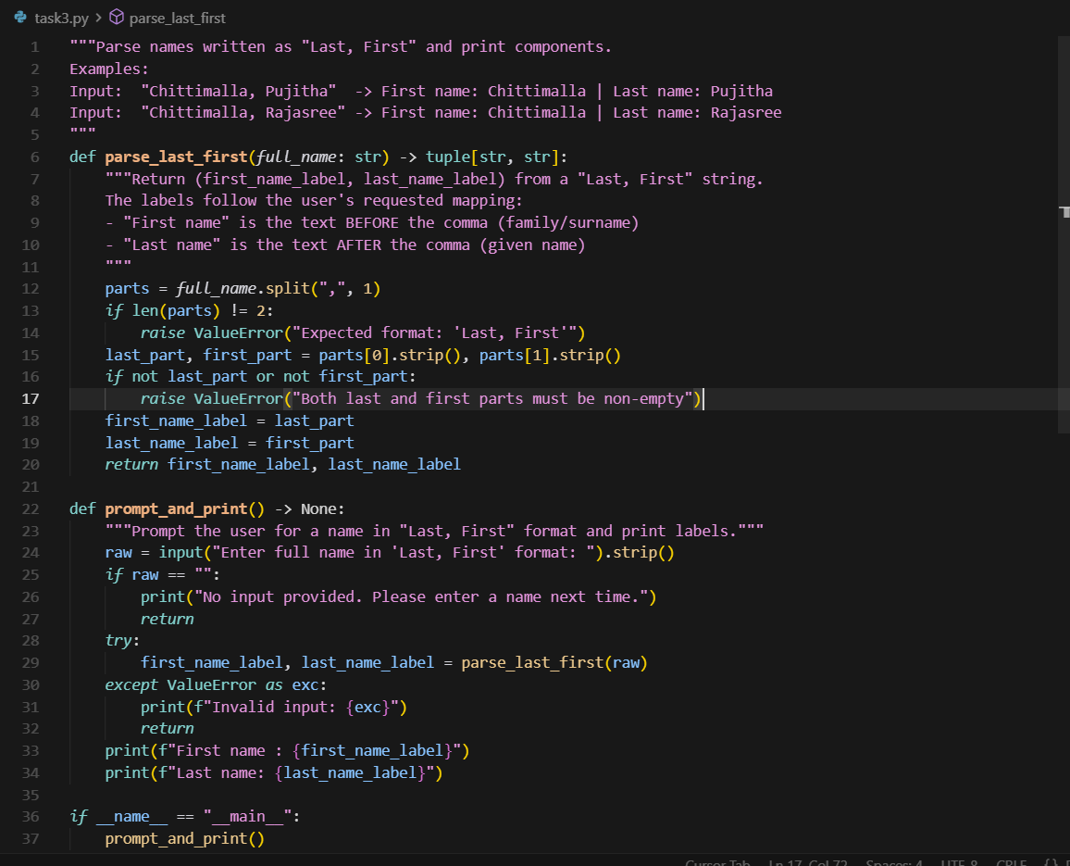

OUTPUT:

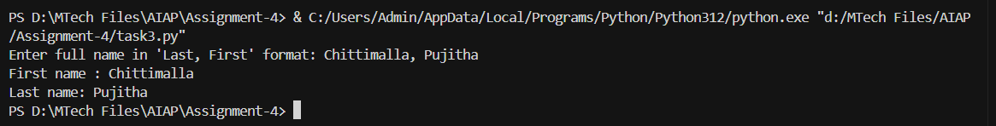

Task Description-4
- Compare zero-shot and few-shot prompts for writing a function that counts the number of vowels in a string.
Expected Output-4
- Functional output and comparative reflection

Prompt
Zero-Shot Prompt :
Generate a python function that counts the number of vowels in a string.
Few-Shot Prompt :
Generate a function that counts the number of vowels in a string. Like in Numbers = 2 vowels, Perfume = vowels, Calender = 3 vowels, Vinayaka = 4 vowels

Zero-Shot Code:

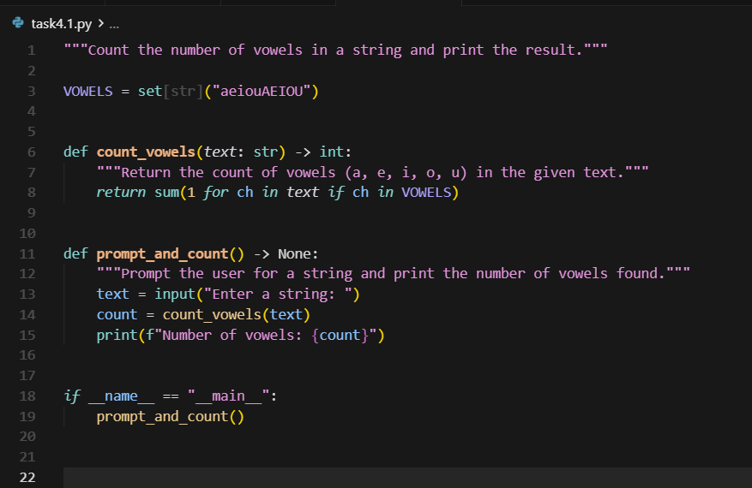

Output:
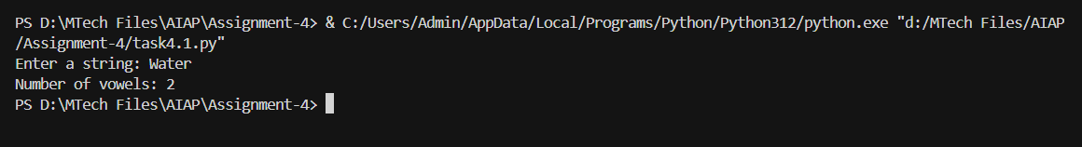
Few-Shot Code:

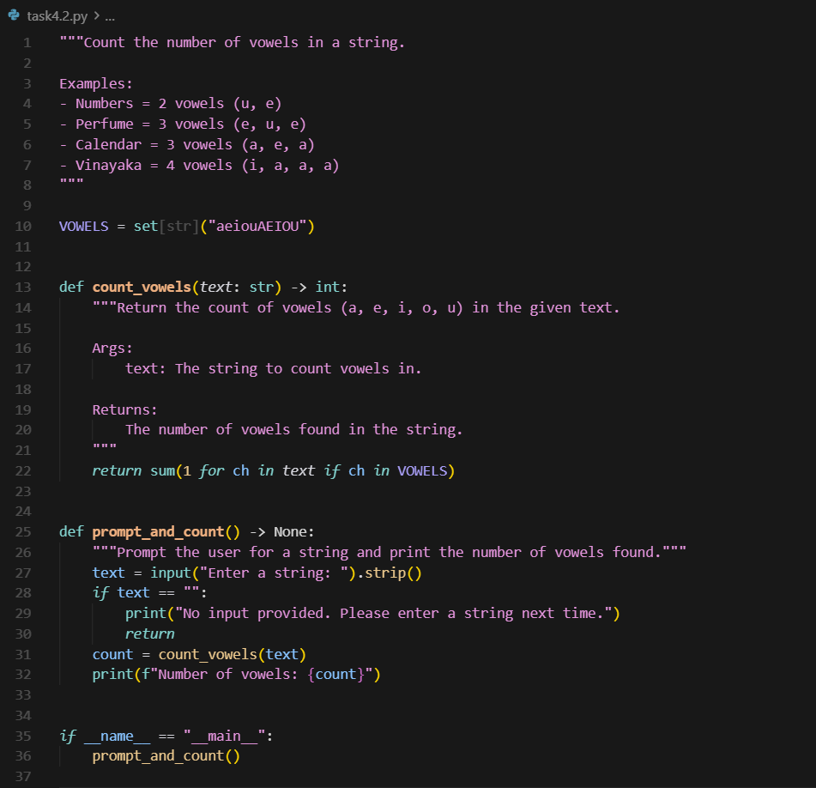

OUTPUT:

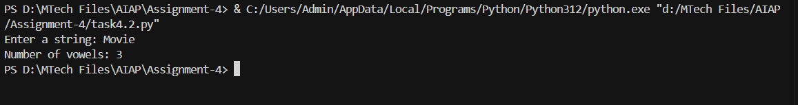

Comparision:

When the task is simple and clear—like writing a function to count the number of vowels in a string—a zero-shot prompt works best. The model can handle it easily without any examples, making the process quicker and simpler.
On the other hand, few-shot prompting is more useful for complex or creative tasks, or when you want the model to follow a specific style or stay consistent with previous examples.

Task Description-5
- Use few-shot prompting to generate a function that reads a .txt file and returns the number of lines.
Expected Output-5
- Working file-processing function with AI-guided logic

Prompt
Write a Python function that takes the file path as input and returns the number of lines in a text file.

Examples:
1) File path : .\xxxx.docx
File Content:
Line 1
Line 2
Line 3
-> function should return: 3

2) Empty file (no bytes)
-> function should return: 0

3) File Path : C:\\Downloads.\xxxxx.pdf
File content:
a
b
c
d
-> function should return: 4

4) Path is missing:
-> function should raise FileNotFoundError

CODE:

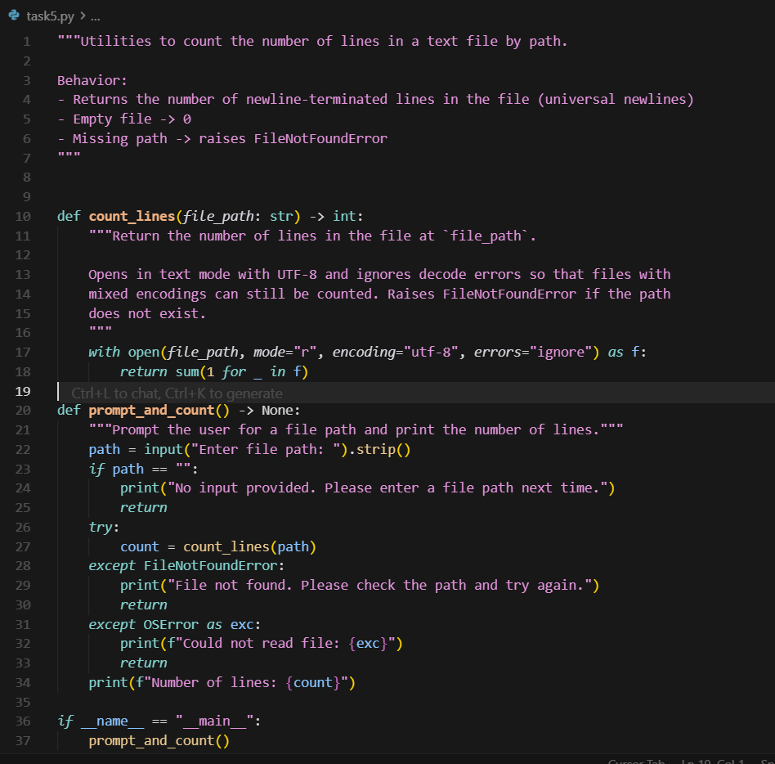

OUTPUT:

