AI Assisted Problem Solving Using Python
Date: 03-10-2025
Name: Chetti Rishika
Mtech – 1st Year
HTNO: 2503B05204
Lab 6: AI-Based Code Completion – Classes, Loops, and Conditionals
Task Description#1 (Classes)
• Use AI to complete a Student class with attributes and a method.
• Check output.
• Analyze the code generated by AI tool.
Here is a complete Student class with a constructor and a display_details() method, plus a brief analysis:
- The AI-generated code correctly defines a class with a constructor (__init__) and a method (display_details()).
- All attributes are initialized and printed clearly.
- The code is readable, follows Python conventions, and is suitable for further extension.
- Output matches expectations for a student record display.
Expected Output#1
• Class with constructor and display_details() method.
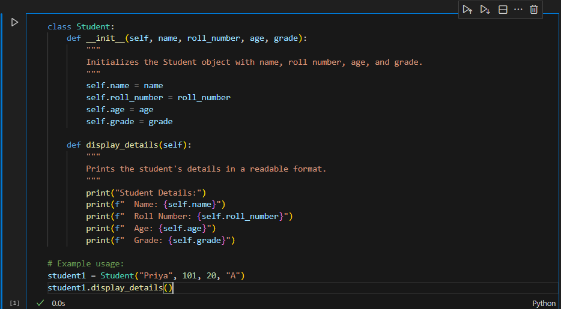
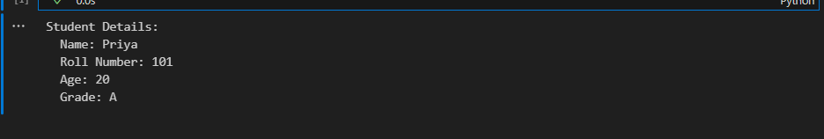

Task Description#2 (Loops)
• Prompt AI to complete a function that prints the first 10 multiples of a number using a
loop.
• Analyze the generated code
• Ask AI to generate code using other controlled looping
Expected Output#2
• Correct loop-based implementationTask Description#2 (Loops)
• Prompt AI to complete a function that prints the first 10 multiples of a number using a
loop.
• Analyze the generated code
• Ask AI to generate code using other controlled looping.
Loop-based implementation for printing the first 10 multiples of a number, plus analysis and an alternative using a while loop.
For loop implementation:
Analysis:
- The function uses a for loop with range(1, 11) to iterate from 1 to 10.
- Each iteration prints the current multiple in a readable format.
- The code is clear, efficient, and meets the expected output.
Alternative: while loop implementation:
Analysis:
- The function uses a controlled while loop, starting from 1 and incrementing until 10.
- Output is identical to the for loop version.
- Both approaches are correct and demonstrate loop control for this task.

Expected Output#2
• Correct loop-based implementation.
Loop implementation:
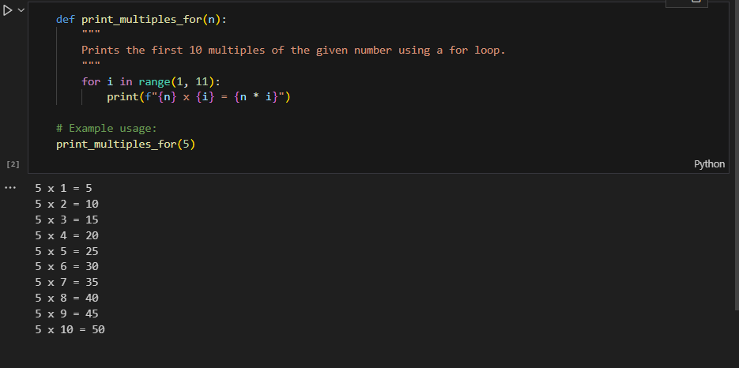
Alternative while loop implementation:
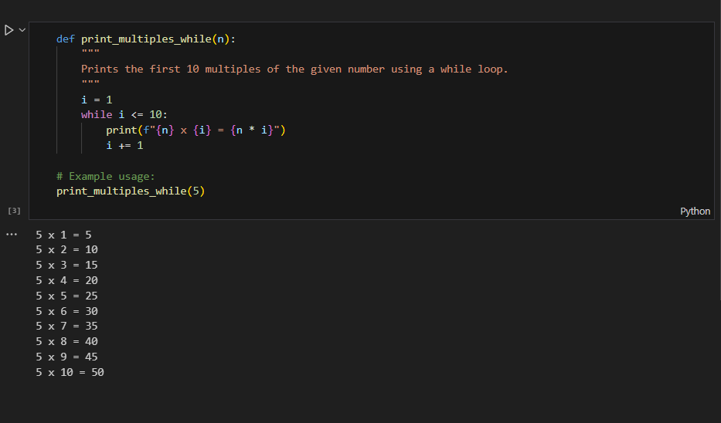

Task Description#3 (Conditional Statements)
• Ask AI to write nested if-elif-else conditionals to classify age groups.
• Analyze the generated code
• Ask AI to generate code using other conditional statements
Explanation of the below code:
Here is an age classification function using nested if-elif-else statements, an analysis, and an alternative using match-case (Python 3.10+).
Nested if-elif-else implementation:
Analysis:
- The function uses clear, nested if-elif-else statements to check age ranges.
- Each condition is mutually exclusive and covers all possible ages.
- The code is readable, easy to maintain, and produces correct output for typical age values.
Alternative: using match-case (Python 3.10+):
Analysis:
- The match-case version is functionally equivalent but uses Python's structural pattern matching for clarity.
- Both approaches are correct; use if-elif-else for compatibility with older Python versions.

Expected Output#3
• Age classification function with appropriate conditions and with explanation.
Nested if-elif-else implementation:

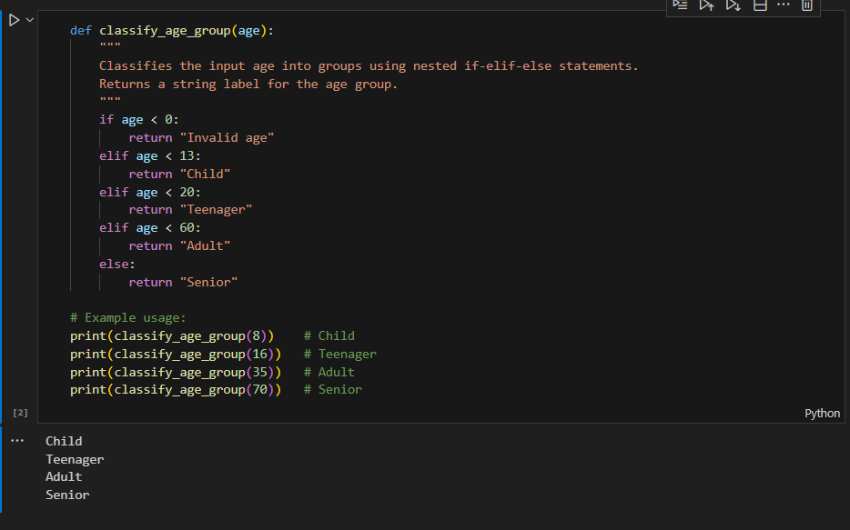
Alternative: using match-case (Python 3.10+):

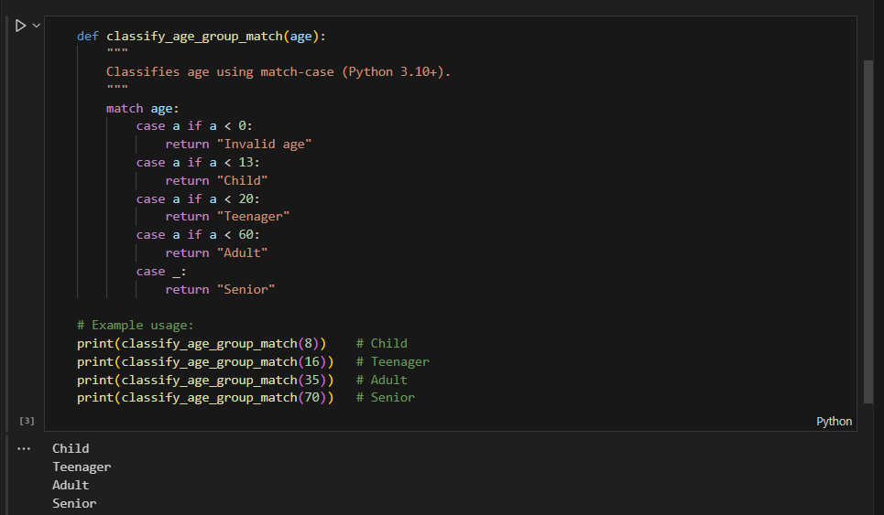
Task Description#4 (For and While loops)
• Generate a sum_to_n() function to calculate sum of first n numbers
• Analyze the generated code
• Get suggestions from AI with other controlled looping
Expected Output#4
• Python code with explanation.
Here is a sum_to_n() function using both for and while loops, plus analysis and explanation.
For loop implementation:
Analysis:
- The function initializes total to 0 and iterates from 1 to n, adding each value to total.
- The for loop is clear and efficient for this task.
- Output is correct for typical values of n.
While loop implementation:
Analysis:
- The while loop starts at 1 and continues until i exceeds n, adding each i to total.
- Output matches the for loop version.
- Both approaches are correct and demonstrate controlled looping.
Alternative (using Python's built-in sum and range):
Explanation:
- All three implementations correctly compute the sum of the first n natural numbers.
- The for and while loop versions show explicit loop control, while the built-in version is concise and efficient.
- For large n, the formula n*(n+1)//2 is fastest, but loops are useful for teaching and stepwise computation.
For loop implementation:
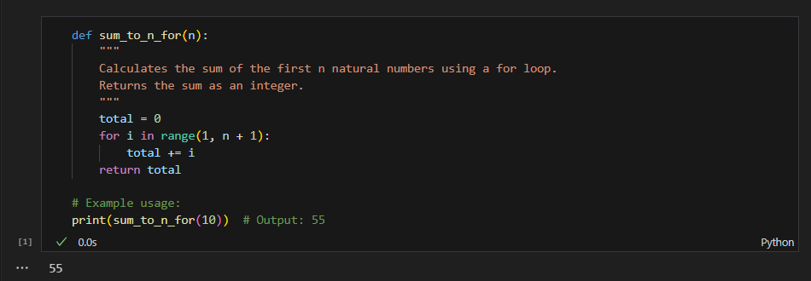
While loop implementation:
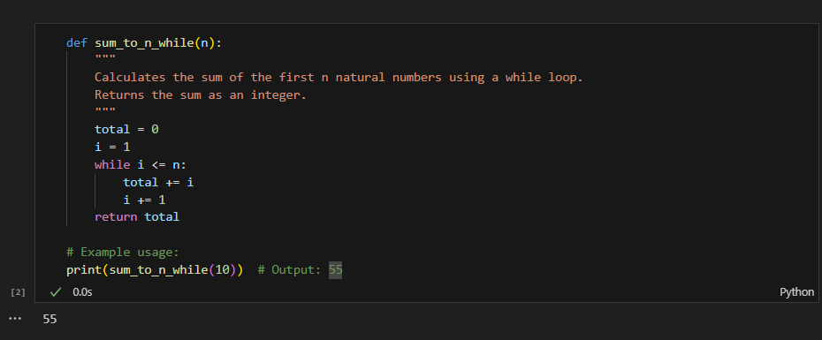
Alternative (using Python's built-in sum and range):

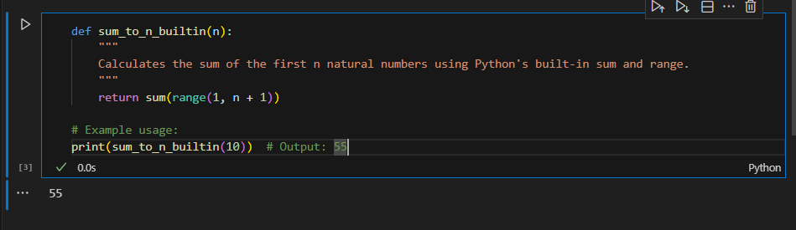

Task Description#5 (Class)
• Use AI to build a BankAccount class with deposit, withdraw, and balance methods.
• Analyze the generated code
• Add comments and explain code
Expected Output#5
• Python code with explanation

Below is a compact, well-commented BankAccount class (deposit, withdraw, balance) plus a short analysis/explanation you can use for Lab 6. It includes thread-safety, basic validation, transaction history, and guidance on production improvements.
Explanation & analysis (concise)
- Design:
  - Use Decimal for monetary values to avoid floating-point rounding issues.
  - Protect balance and transaction history with a threading.Lock for thread-safety in a single-process app.
  - Keep minimal transaction history (timestamp, type, amount, balance_after) for auditing or debugging.
- Methods:
  - init: validate initial balance, initialize lock and history, record INIT txn.
  - deposit: validate >0, update balance inside lock, record transaction, return new balance.
  - withdraw: validate >0, check overdraft policy, raise InsufficientFunds if disallowed, update balance and record transaction.
  - get_balance / get_transaction_history: thread-safe reads.
- Error handling:
  - ValueError for invalid amounts.
  - Custom InsufficientFunds for business logic errors.
- Edge cases & production notes:
  - Decimal rounding context: configure as needed for currency.
  - For multi-process/distributed systems, use a database with transactions (ACID) rather than an in-memory lock.
  - Persist transactions to durable storage (DB) instead of only in-memory lists.
  - Apply access control and encryption to any stored PII (owner) or transaction logs.
  - Add limits (daily withdrawal limits), retry/backoff for transient failures, and robust logging/monitoring.
  - Add tests for concurrency (multiple threads doing deposits/withdrawals simultaneously).
- Common AI-generated pitfalls to watch for:
  - Using float for money (fix: use Decimal).
  - Missing validation (e.g., negative deposits).
  - Missing thread-safety when code may run concurrently.
  - Not persisting state for production.
- Minimal unit test example(pytest):
