AI Assisted Problem Solving Using Python
Date: 03-10-2025
Name: Chetti Rishika
Mtech – 1st Year
HTNO: 2503B05204
Lab 7: AI-Error Debugging with AI: Systematic approaches to finding and fixing bugs
Task Description#1
● Paste a function with a missing colon (add(a, b)), and let AI fix the syntax error.
Python
def add(a, b)
Return a+b
Expected Output#1
def add(a, b):
return a + b
● Corrected function with syntax fix.
- The colon : is required after the function definition line.
- The return statement should be lowercase and properly indented.
- This function now works correctly and returns the sum of a and b.
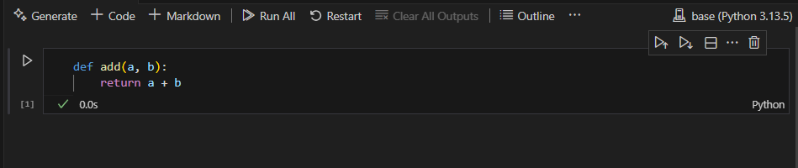

Task Description#2 (Loops)
● Identify and fix a logic error in a loop that causes infinite iteration.
Python
Def count_down(n):
While n >= 0:
Print(n)
N += 1 #Should be n -= 1
Expected Output#2
● AI fixes increment/decrement error.
Here is the corrected Python function with the loop logic fixed to prevent infinite iteration:
def count_down(n):
while n >= 0:
print(n)
n -= 1 # Decrement n to ensure the loop eventually ends
Explanation:
- The original code used n += 1, which increases n and causes the loop to run forever.
- The fix is to use n -= 1, which decreases n each time, so the loop will eventually exit when n becomes less than 0.
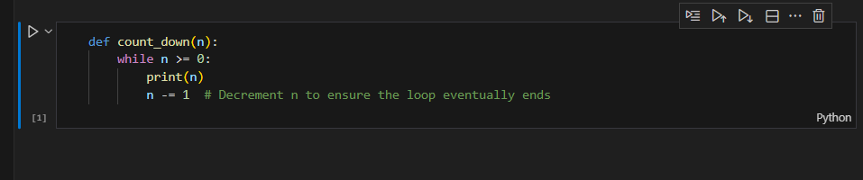

Task Description#3
● Debug a runtime error caused by division by zero. Let AI insert try-except
#debug the following code
def divide(a, b):
Return a/b
Print(divide(10, 0))
Expected Output#3
● Corrected function with safe error handling.

Here is the corrected Python function with safe error handling for division by zero using try-except:
def divide(a, b):
try:
return a / b
except ZeroDivisionError:
print("Error: Division by zero is not allowed.")
return None

print(divide(10, 0))
Explanation:
- The function uses a try-except block to catch ZeroDivisionError.
- If b is zero, it prints an error message and returns None instead of crashing.
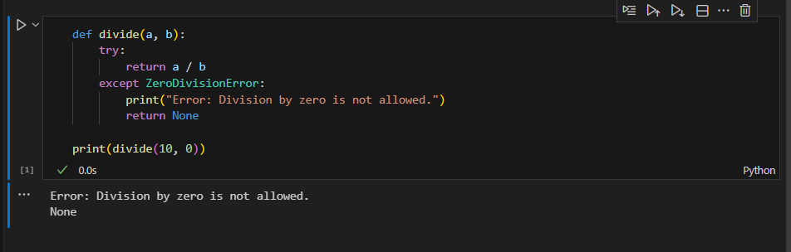

Task Description#4
● Provide a faulty class definition (missing self in parameters). Let AI fix it
Python
Class Rectangle:
Def __init__(length, width):
Self.length = length
Self.width = width
Expected Output#4
● Correct __init__() method and explanation
Here is the corrected Python class definition with the proper use of self in the __init__ method, plus a brief explanation:
class Rectangle:
def __init__(self, length, width):
self.length = length
self.width = width

def area(self):
return self.length * self.width

def perimeter(self):
return 2 * (self.length + self.width)
Explanation:
- In Python, every instance method (including __init__) must have self as the first parameter.
- self refers to the current object instance, allowing you to set instance attributes (self.length, self.width).
- The original code missed self in the parameter list and used Self (capital S), which is incorrect.
- The corrected code uses lowercase self consistently and includes it in the parameter list.
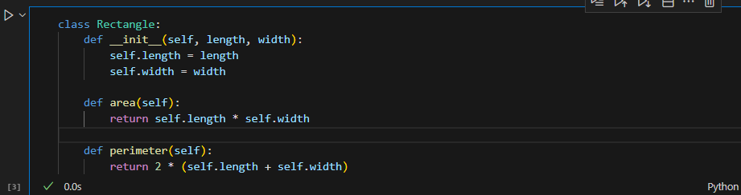

Task Description#5
● Access an invalid list index and use AI to resolve the Index Error.
Python
Numbers = [1, 2, 3]
Print(numbers[5])
Expected Output#5
● AI suggests checking length or using safe access logic.

Here is the corrected Python code with safe access logic to avoid an IndexError when accessing a list:
numbers = [1, 2, 3]
index = 5

if 0 <= index < len(numbers):
print(numbers[index])
else:
print(f"Error: Index {index} is out of range. List length is {len(numbers)}.")

Explanation:
- Before accessing numbers[index], the code checks if index is within the valid range (0 to len(numbers) - 1).
- If the index is invalid, it prints an error message instead of raising an exception.
- This prevents the program from crashing due to an IndexError.
