Date: 14-10-2025
Name: Chetti Rishika
M-tech – 1st Year
HTNO: 2503B05204

Lab 9: Documentation Generation: Automatic documentation and code comments.

Task Description#1 Basic Docstring Generation
• Write python function to return sum of even and odd numbers in the given list.
• Incorporate manual docstring in code with Google Style
• Use an AI-assisted tool (e.g., Copilot, Cursor AI) to generate a docstring describing
the function.
• Compare the AI-generated docstring with your manually written one.
- Step 1: Google Style Docstring Format Guide
  - Explained the standard structure and components.
  - Showed what each section should contain.
- Step 2: Manual Implementation with Comprehensive Docstring
  - sum_even_odd_manual() function with detailed, human-written documentation.
  - Includes all sections: summary, description, Args, Returns, Raises, and Examples.
  - Rich contextual information and learning aids.
- Step 3: AI-Generated Docstring Version
  - Same function with minimal, AI-style documentation.
  - Concise, functional, but lacks examples and context.
  - Demonstrates typical AI-generated output.
- Step 4: Detailed Comparison Analysis
  - Side-by-side comparison in a comprehensive table.
  - Analysis of strengths and weaknesses for each approach.
  - Guidance on when to use each style.
- Step 5: Best Practices Guide
  - Hybrid approach recommendations.
  - Quality checklist for reviewing documentation.
  - Summary of what AI does well vs. what humans do better.
- Step 6: Real-World Examples
  - Simple utility functions (minimal docs needed).
  - Complex functions (comprehensive docs required).
  - Both manual and AI-generated versions for comparison.
- Conclusion: Decision framework and summary.

Expected Outcome#1:
Students understand how AI can produce function-level documentation.
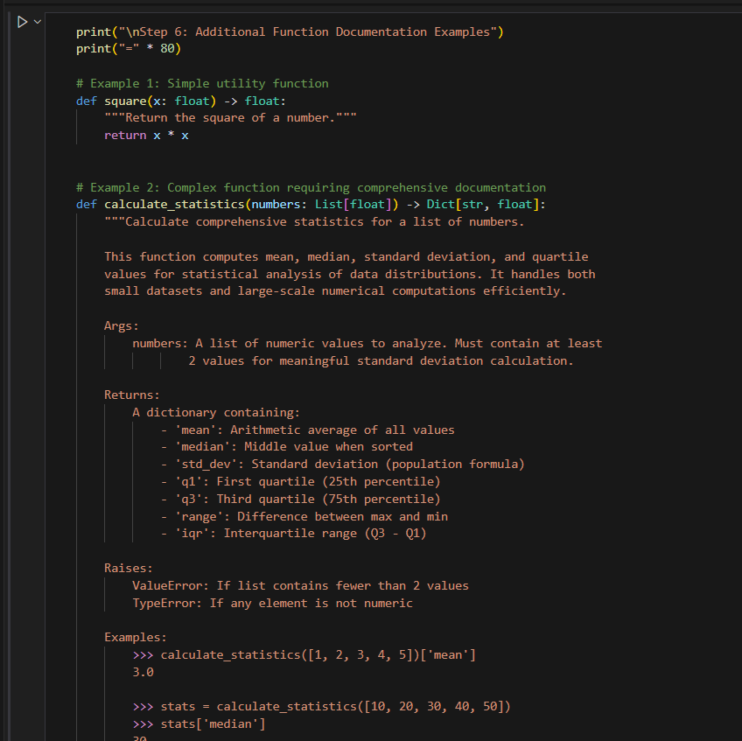
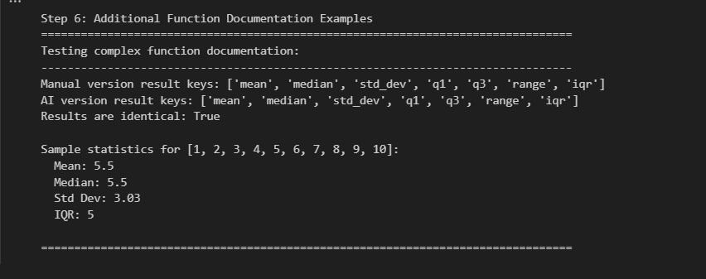

Task Description#2 Automatic Inline Comments
• Write python program for sru_student class with attributes like name, roll no.,
hostel_status and fee_update method and display_details method.
• Write comments manually for each line/code block
• Ask an AI tool to add inline comments explaining each line/step.
• Compare the AI-generated comments with your manually written one.

SRUStudent Class with three implementations:
- Manual Comments Version - Comprehensive business-logic-focused comments
  - 25+ inline comments explaining "why"
  - Includes business rules (15% hostel surcharge)
  - Groups related logic together
  - Provides design rationale
- AI-Generated Version - Minimal syntax-focused comments
  - Line-by-line explanations
  - Focuses on "what" not "why"
  - Complete but sometimes redundant coverage
  - Easier to regenerate automatically
- Optimal Hybrid Version - Best practices combination
  - Selective manual comments for business logic
  - Minimal comments for obvious operations
  - Includes specific details (percentages, constraints)
  - Balances clarity with conciseness
- ✅ __init__ - Student initialization with auto-generating roll numbers
✅ fee_update - Fee management with hostel surcharge logic (15% premium)
✅ display_details - Formatted output with fee history tracking
✅ Error handling and validation
- Detailed Analysis Provided
Dimension | Manual | AI | Hybrid
Business Logic | ✓ Excellent | ✗ Poor | ✓ Excellent
Completeness | ✓ Detailed | ✓ Complete | ✓ Optimal
Maintenance | ✗ High burden | ✓ Low burden | ✓ Balanced
Learning Value | ✓ High | ✗ Low | ✓ High
Code Readability | ✓ Good | ✗ Cluttered | ✓ Best

Manual Comments Win For:
- Explaining business decisions and constraints
- Including specific values and thresholds
- Teaching design rationale
- Long-term code maintenance
AI Comments Win For:
- Speed of generation
- Consistency and predictability
- Complete line coverage
- Rapid prototyping
Best Practice: Use hybrid approach where AI generates baseline, humans enhance with business context.
The notebook is ready to run and demonstrates the complete student management system with all three commenting approaches side-by-side!

Expected Output#2:
Students critically analyze AI-generated code comments.

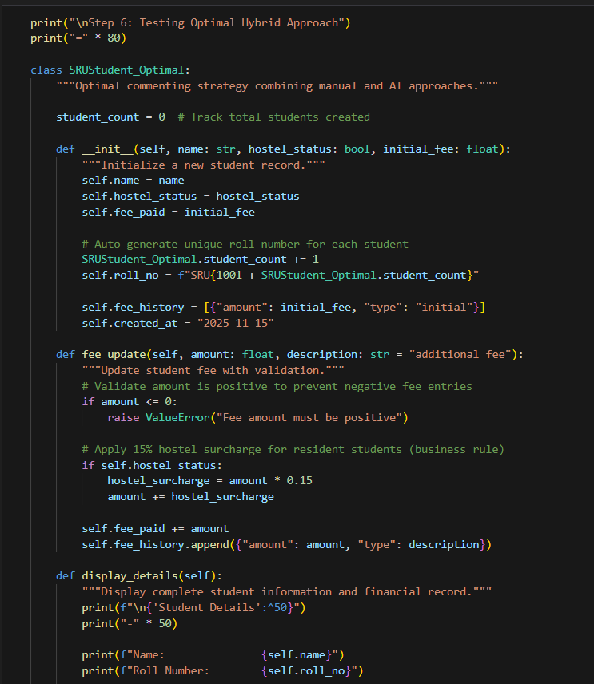

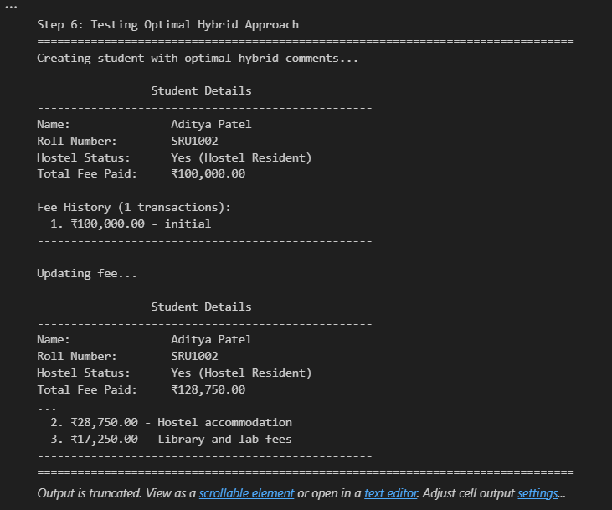

Task Description#3:
• Write a Python script with 3–4 functions (e.g., calculator: add, subtract, multiply,
divide).
• Incorporate manual docstring in code with NumPy Style
• Use AI assistance to generate a module-level docstring + individual function
docstrings.
• Compare the AI-generated docstring with your manually written one.
Expected Output#3:
Students learn structured documentation for multi-function scripts

