**COMP3123 – Full Stack Development Lab 3 Questions**

**Cheuk Man Sit (101422756)**

**Employee.js**

**Index.js**

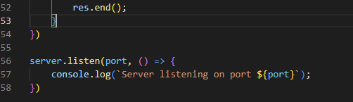

**Output**

