**ArduBabyFX**

**BillyCdiy 23 Apr 2024**

**Introduction:**

* Refer to this youtube video.

<https://youtu.be/QShoFLM_k4k>

* or Scan this QRcode



**ArduBabyFX** is a half credit card size retro game console for 8-bit games. The product is designed and produced by **BillyCdiy** based on the open source design from the product “ArduboyFX” (refer to arduboy.com ). It comes pre-loaded with 417 open source games developed by members of the Arduboy community (refer to community.arduboy.com). You can develop your own games in C++ using Arduino IDE or download additional games from the Arduboy community. The external interface allows you to attach sensors ( e.g. temperature/humidity sensors) or other external devices for your STEM projects. **This unit need to be hand carried when boarding a flight as it uses lithium batteries.**

**How to play**

* Turn on the power (switch on top right).
* The last game played will show up on the OLED display.

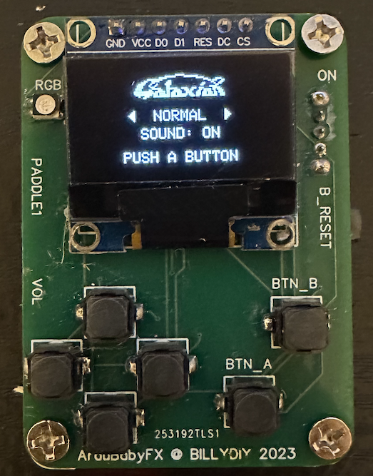

* To switch to another game , go to the menu by pressing the Reset button (middle right).

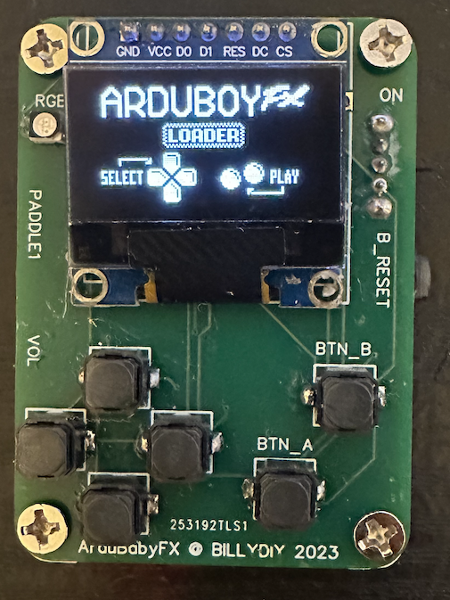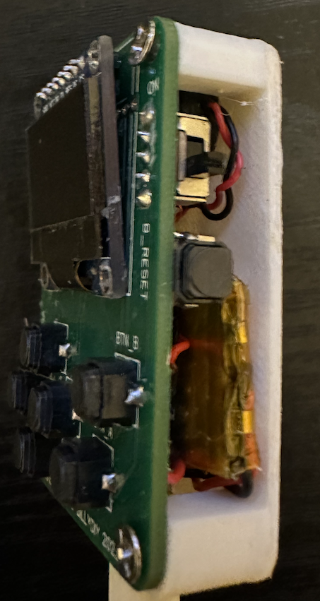

* Navigate the submenus by pressing the left or right buttons.
* Go down to each submenu by pressing the down button, then use up or down buttons to navigate games within the submenu.
* Press button A (bottom right) to start the game.
* Press button B to start the last game.
* Games are controlled by the navigation buttons (up, down, left, right) and the fire buttons (A, B).
* Use the paddle/wheels to control a select set of games under the submenu “BILLY”, e.g.:
  + Galaxian
  + Picovaders (invader)
  + Breakout.
  + ArduboyNG (ping pong)

**Battery**

* Switch off the device before charging.
* Plug a USB-C cable to the USB-C port.
* Connect the other end to your charger or your computer.
* There is no charging indicator, but there is battery protection from over charge or short circuit.
* The Lithium battery will be fully charged in 4 hours and last for 8 hours.
* There is no auto-power save. Turn off the device when not in use.
* **This unit need to be hand carried when boarding a flight as it uses lithium batteries.**

**How to program or load other games**

* Refer to this youtube video.

https://youtu.be/QShoFLM_k4k

* or Scan this QRcode



**Specifications**

* 16MB Flash RAM – capacity for 500+ 8-bit games.
* Processor: Arduino ProMicro with ATMEGA 32U4 micro controller running at 8/16Mhz.
* OLED monochrome display with 80x128 pixels (SSD-1306)
* RGB LEDS for game lighting effects
* Mini speaker for game sound effects
* Soft and quiet buttons for
  + Reset: also brings up the Menu.
  + Navigation: up, down, left, right.
  + Fire and option: A and B.
* USB-C interface for charging and for connection to the computer for programming or game loading.
* Lithium battery (350mAH) – up to 8 hours of continuous game operation.

**Additional features offered by ArduBabyFX**

* Total 417 games curated by BillyCDiy including games controlled using paddles/wheels.
* Left paddle/wheel for analog game control for selected games (top left)
* A volume control for sound effect level ( bottom left).

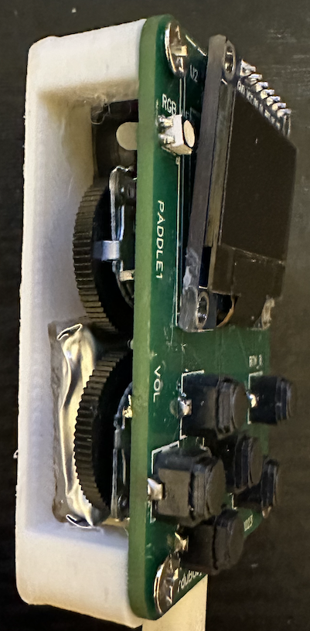

==== END ===