20181004a independent subgroups in a study

cheungngo

October 4, 2018

### 

Suppose we need to combine the results of two independent subgroups, e.g. treatment1 and treatment2 in a meta-analysis. e.g. in the OCD-TMS study they did a three arm experiment where both 1Hz, 10Hz and sham has been included

### 

### Looking at the data (YBOCS score)

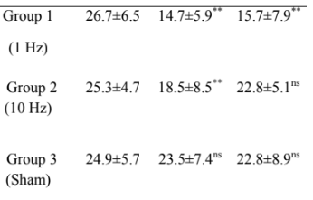

Y-BOCS for different groups

### 

### Constructing the functions

m_ind_group = function (n1,n2,m1,m2) {  
 (n1*m1+n2*m2)/(n1+n2)  
}

### 

sd_ind_group = function(n1,n2,m1,m2,s1,s2) {  
 sqrt(((n1-1)*s1^2+(n2-1)*s2^2+(n1*n2)/(n1+n2)*(m1-m2)^2)/(n1+n2-1))  
}

### 

### Calculation of the ‘pre’ combined (10Hz and 1Hz) score

pre_m = m_ind_group(15,15,26.7,25.3)  
pre_sd = sd_ind_group(15,15,26.7,25.3,6.5,4.7)  
print(c(pre_m,pre_sd))

## [1] 26.000000 5.618504

### 

### Calculation of the ‘post’ (0 months) combined (10Hz and 1Hz) score

post_m = m_ind_group(15,15,14.7,18.5)  
post_sd = sd_ind_group(15,15,14.7,18.5,5.9,8.5)  
print(c(post_m,post_sd))

## [1] 16.600000 7.444368

### 

### The rest would be left to the second part: difference of outcome within study