20181004b differences of outcomes within a study

cheungngo

4 October 2018

### 

From the first document ‘independent subgroups in a study’, we combined the outcomes (pre and post) for the 1Hz group and the 10Hz group  
But to compute the effect size against the control group, we need to first compute by comparing the means of the pre and post outcomes

### 

### Looking at the data again (YBOCS score)

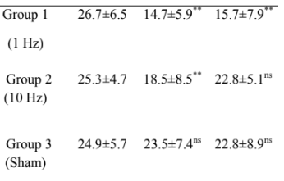

Y-BOCS for different groups

### Also from the previous results:

pre_m=26  
pre_sd=5.618504  
post_m=16.6  
post_sd=7.444368  
print(c(pre_m,pre_sd,post_m,post_sd))

## [1] 26.000000 5.618504 16.600000 7.444368

### Constructing the functions:

m_diff = function(m1,m2) {  
 m1-m2  
}

### 

sd_diff = function(sd1,sd2,r) {  
 sqrt(sd1^2 + sd2^2 - 2*r*sd1*sd2)  
}

### 

### Calculating the differences between outcomes

We may take r=0.5; but this could also be imputated using the results of the past researches

treatment_m = m_diff(post_m,pre_m)  
treatment_sd = sd_diff(post_sd,pre_sd,r=0.5)  
control_m = m_diff(23.5,24.9)  
control_sd = sd_diff(7.4,5.7,r=0.5)  
print(c(treatment_m,treatment_sd))

## [1] -9.400000 6.720118

print(c(control_m,control_sd))

## [1] -1.400000 6.713419

### 

### SMD between the treatment arms and control arm

hedgesg <- function(n1, m1, sd1, n2, m2, sd2) {  
df <- n1 + n2 - 2  
J <- 1 - (3 / (4*df - 1))  
S <- sqrt(((n1-1)*(sd1^2) + (n2-1)*(sd2^2))/df)  
d <- (m1-m2) / S  
g <- J*d  
return(g)  
}

hedgesg(30,treatment_m,treatment_sd,15,control_m,control_sd)

## [1] -1.16995