20181008a combining outcomes within a study

cheungngo

8 October 2018

### 

Sometimes we may need to combine the data reported from a study, e.g. they are reporting two related scales, or, they are reporting subscales separately without the aggregate scores.

### 

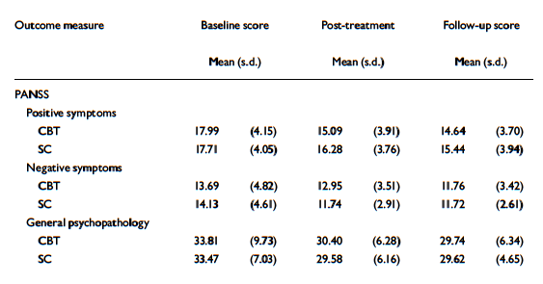

LUCIA R. VALMAGGIA 2005

### 

For example, in an RCT conducted in 2005, they are trying to look for any improvements in PANSS score after CBT in schiz patients. However, only the subscale has been reported. Therefore, we need to combine the scores before the meta-analysis.

### 

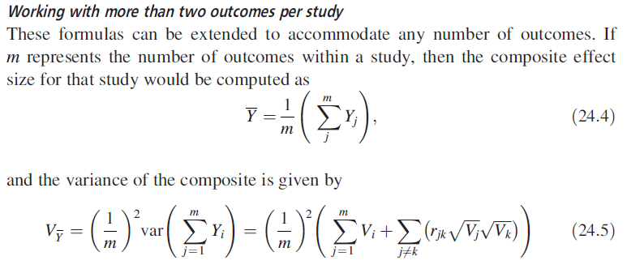

Borenstein

### 

### Setting up the functions

m_subgroup = function(m) {  
 sum(m) / length(m)  
}

sd_subgroup = function(sd,r) {  
 k = length(sd)  
 a = (1/k)^2  
 b = sum(sd^2)  
 x = matrix(rep(0,k^2),nrow = k)  
 for (i in 1:k) {  
 for(j in 1:k) {  
 x[i,j] = r[i,j]*sd[i]*sd[j]  
 }  
 }  
 x[lower.tri(x,diag = T)] = 0  
 c = sum(x)  
 sqrt(a*(b+c))  
}

### 

### Defining r

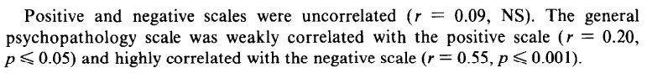

r between the PANSS subgroup

r_PANSS = matrix(c(0,0.09,0.2,0.09,0,0.55,0.2,0.55,0),byrow = T,nrow = 3)  
r_PANSS

## [,1] [,2] [,3]  
## [1,] 0.00 0.09 0.20  
## [2,] 0.09 0.00 0.55  
## [3,] 0.20 0.55 0.00

### 

### Combining the scores

pre_CBT_m = m_subgroup(c(17.99,13.69,33.81))  
pre_CBT_sd = sd_subgroup(c(4.15,4.82,9.73),r_PANSS)  
c(pre_CBT_m,pre_CBT_sd)

## [1] 21.830000 4.356326

### Verify by hand

a = (1/3)^2  
b = sum(c(4.15,4.82,9.73)^2)  
c = 0.09*4.15*4.82 + 0.2*4.15*9.73 + 0.55*4.82*9.73  
sqrt(a*(b+c))

## [1] 4.356326

### Combining the others

pre_SC_m = m_subgroup(c(17.71,14.13,33.47))  
pre_SC_sd = sd_subgroup(c(4.05,4.61,7.03),r_PANSS)  
post_CBT_m = m_subgroup(c(15.09,12.95,30.4))  
post_CBT_sd = sd_subgroup(c(3.91,3.51,6.28),r_PANSS)  
post_SC_m = m_subgroup(c(16.28,11.74,29.58))  
post_SC_sd = sd_subgroup(c(3.76,2.91,6.16),r_PANSS)

### The results

results = matrix(c(pre_CBT_m,pre_CBT_sd,post_CBT_m,post_CBT_sd,  
 pre_SC_m,pre_SC_sd,post_SC_m,post_SC_sd),  
 byrow = T,  
 nrow = 2)  
colnames(results) = c('Pre-mean','(SD)','Post-mean','(SD)')  
rownames(results) = c('CBT','SC')  
results

## Pre-mean (SD) Post-mean (SD)  
## CBT 21.83 4.356326 19.48 3.078894  
## SC 21.77 3.531992 19.20 2.906457