20181013b Simple algebra

cheungngo

October 13, 2018

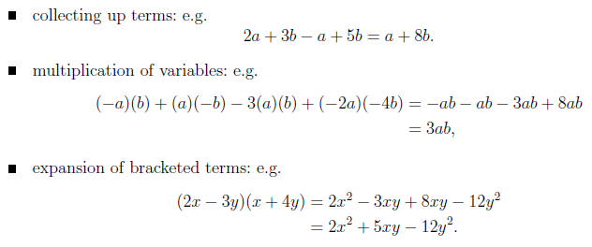

Sample questions

### 

### Simplify()

f = yacas('-a*b + a*-b - 3*a*b + (-2*a)*(-4*b)')  
PrettyForm(f)

##   
## 2 * a * 4 * b - ( 2 * a * b + 3 * a * b )

f_sim = yacas(Simplify(f)) # must add yacas or else would just add the word Simplify before the expression  
PrettyForm(f_sim)

##   
## 3 * a * b

### 

### Expand()

f = yacas('(2*x-3*y)*(x+4*y)')  
PrettyForm(f)

##   
## ( 2 * x - 3 * y ) * ( x + 4 * y )

f_expand = yacas(Expand(f))  
PrettyForm(f_expand)

##   
## 2 2  
## 2 * x + 5 * y * x - 12 * y