20181013c Set operation

cheungngo

October 13, 2018

### Basic examples of Set Operations in R

x <- c(sort(sample(1:20, 9)), NA)  
y <- c(sort(sample(3:23, 7)), NA)  
x

## [1] 2 3 4 5 6 10 11 14 18 NA

y

## [1] 4 11 12 16 18 21 23 NA

union(x, y)

## [1] 2 3 4 5 6 10 11 14 18 NA 12 16 21 23

intersect(x, y)

## [1] 4 11 18 NA

setdiff(x, y)

## [1] 2 3 5 6 10 14

setdiff(y, x)

## [1] 12 16 21 23

setequal(x, y)

## [1] FALSE

### 

### Sample questions

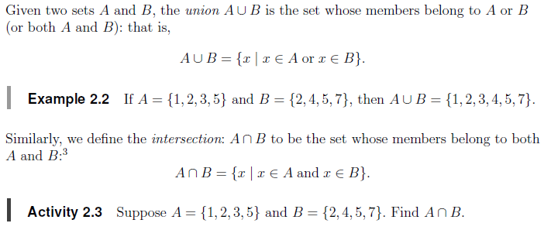

Sample questions (union and intersect)

# Example 2.2  
A = c(1,2,3,5)  
B = c(2,4,5,7)  
union(A,B)

## [1] 1 2 3 5 4 7

# Activity 2.3  
intersect(A,B)

## [1] 2 5