20181013e mosaic and simple graphing

cheungngo

October 13, 2018

library(mosaic)  
library(Ryacas)

### makeFun()

Let f = x+3

f = makeFun(x+3~x)  
f

## function (x)   
## x + 3

### Composite functions in mosaic

Suppose f(x) = x+1, g(x) = x^4;  
Now to find the composite function g(f(x))

f = makeFun(x+1~x)  
g = makeFun(x^4~x)  
x = Sym('x')  
g(x=x+1) # g(f(x))

## expression((x + 1)^4)

f(x=x^4) # f(g(x))

## expression(x^4 + 1)

And this would be easier than just using Ryacas

### plotFun()

Let f = x+3 again

f = makeFun(x+3~x)  
plotFun(f(x)~x, x.lim=c(-5,5))

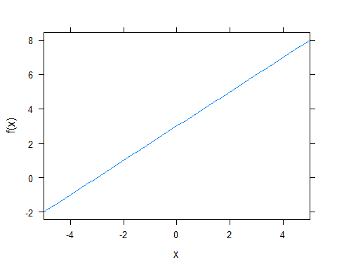

### what about a composition function

g = makeFun(x^4~x)  
h = g(x=x+1) # f(x) = x+1  
h # expression((x + 1)^4)

## expression((x + 1)^4)

# You may just need to copy and paste the expression (otherwise quite clumpsy)  
h = makeFun((x + 1)^4~x)  
plotFun(h(x)~x,x.lim=c(-100,100))

