20181014a quadratic and polynomial

cheungngo

October 14, 2018

library(Ryacas)  
library(mosaic)

### Quadratic equations

Let y = x^2 - 6x + 5 Find the root

x = Sym('x')  
f = Sym(x^2-6*x+5)  
yacas(Solve(f == 0,x)) # No '' within yacas (already Sym)

## expression(list(x == 1, x == 5))

# plotting the function  
f = makeFun(x^2-6*x+5~x)  
plotFun(f(x)~x,xlim = c(0,6))

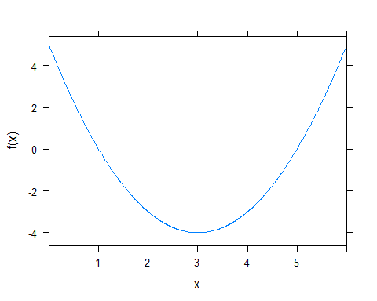

# One can also factorize the equation for a better presentation  
yacas('Factor(x^2-6*x+5)')

## expression((x - 5) * (x - 1))

### Polynomial functions

Let y = x*3 + 4*x^2 + 3x Solve x when y = 0

x = Sym('x')  
f = Sym(x*3 + 4*x^2 + 3*x)  
yacas(Factor(f)) # Factorized function

## expression(4 * ((x + 3/2) * x))

yacas(Solve(f==0,x))

## expression(list(x == 0, x == -3/2))

fx = makeFun(x*3 + 4*x^2 + 3*x~x)  
plotFun(fx(x)~x,xlim = c(-3,3))

