20181014b simultaneous equations

cheungngo

October 14, 2018

library(Ryacas)  
library(mosaic)

### Solve()

Let y = 2*x - 1;  
and y = x + 2

y = Sym('y')  
x = Sym('x')  
Solve(List(2*x - 1 == y, x + 2 == y), List(x,y))

## expression(list(list(x == 3, y == 5)))

# Plotting the equations  
plotFun(2*x - 1 ~ x,xlim = c(0,6))

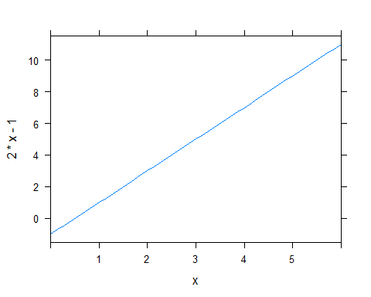

plotFun(x + 2 ~ x,xlim = c(0,6), add = T) # add=T for the added one

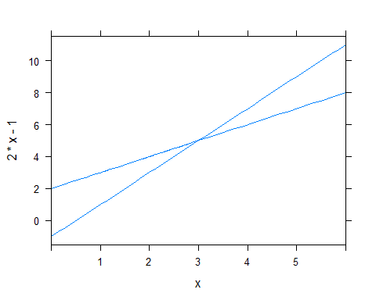

### A more complicated example

Let:  
x + 2*y + 7*z = 1  
3*x + 2*y + 2*z = 7*  
*-2*x + 3*y + z = 7

y = Sym('y')  
x = Sym('x')  
z = Sym('z')  
Solve(List(x + 2*y + 7*z == 1,  
 3*x + 2*y + 2*z == 7,  
 -2*x + 3*y + z == 7),   
 List(x, y, z))

## expression(list(list(x == 59/73, y == 231/73, z == -64/73)))

N('%')

## expression(list(list(x == 0.808219178, y == 3.1643835616, z ==   
## -0.8767123287)))