20181014c Demand and supply

cheungngo

October 14, 2018

library(Ryacas)  
library(mosaic)

### using Solve()

demand: q = 250 - 4*p - p^2 supply: q = 2*p^2 - 3*p - 40

p = Sym('p')  
q = Sym('q')  
Solve(List(250 - 4*p - p^2 == q,   
 2*p^2 - 3*p - 40 == q),  
 List(p,q))

## expression(list(list(p == p, q == 250 - 4 * p - p^2)))

Not able to solve in this way

### finding p first

for q = q, 250 - 4*p - p^2 = 2*p^2 - 3*p - 40*  
*Therefore, 3*p^2 + p - 290 = 0

Solve(3*p^2 + p - 290 == 0,p)

## expression(list(p == -10, p == 29/3))

And we can find p == -10 (impossible) or p == 29/3  
Substitute p == 29/3 into the equation

qd = makeFun(250 - 4*p - p^2 ~ p)  
qs = makeFun(2*p^2 - 3*p - 40 ~ p)  
qd(29/3)

## [1] 117.8889

qs(29/3)

## [1] 117.8889

### sketching the curves

plotFun(qd(p)~p,xlim = c(0,20))

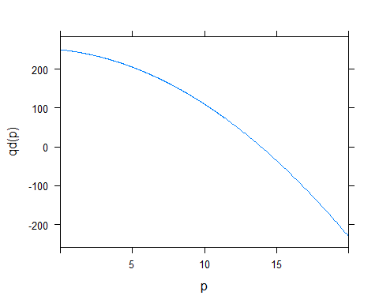

plotFun(qs(p)~p,xlim = c(0,20),add = T)

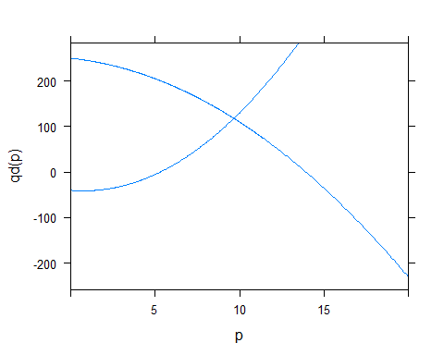

### What about p against q

Solve(250 - 4*p - p^2 == q, p)

## expression(list(p == -((root(16 - -4 * (250 - q), 2) + 4)/2),   
## p == -((4 - root(16 - -4 * (250 - q), 2))/2)))

Solve(2*p^2 - 3*p - 40 == q, p)

## expression(list(p == (root(9 - -8 * (q + 40), 2) + 3)/4, p ==   
## (3 - root(9 - -8 * (q + 40), 2))/4))

# Only plotting the positve functions  
plotFun(-((4 - root(16 - -4 * (250 - q), 2))/2) ~ q, xlim = c(-200,200), ylab = 'Price', xlab = 'Quantity')

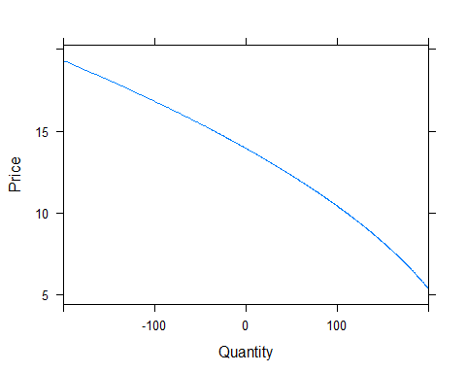

plotFun((root(9 - -8 * (q + 40), 2) + 3)/4 ~ q, xlim = c(-200,200), add = T)

