20181014d exponentials and natural logs

cheungngo

October 14, 2018

library(mosaic)

### Exponentials

plotFun(exp(x)~x,xlim = c(170,200))

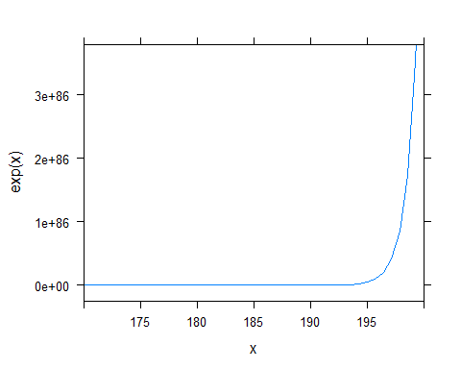

### Natural log

plotFun(logb(x,base = exp(1))~x)

