20181015a trigonometrical functions

cheungngo

October 15, 2018

library(Ryacas)  
library(mosaic)

### sin(x)2+cos(x)2 == 1

x = Sym('x')  
f1 = makeFun(sin(x)^2+cos(x)^2~x)  
plotFun(f1(x)~x,ylim = c(-2,2))

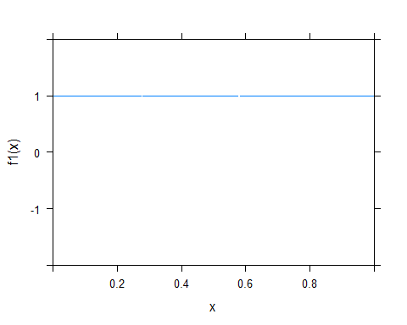

i = seq(-3.14,3.14,0.01)  
mean(sapply(i,function(i){1-f1(i)}))

## [1] 1.394398e-17

### 

### sin(2x) == 2*sin(x)*cos(x)

f2 = makeFun(sin(2*x)~x)  
f3 = makeFun(2*sin(x)*cos(x)~x)  
mean(sapply(i,function(i) {f2(i)-f3(i)}))

## [1] -9.376884e-19

Int_f3 = Integrate(2*sin(x)*cos(x),x)  
Int_f3

## expression(-(cos(-2 * x)/2))

deriv(Int_f3,x)

## expression(-sin(-2 * x))

# to prove sin(2*x) == -sin(-2 * x)  
f4 = makeFun(-sin(-2 * x)~x)  
mean(sapply(i, function(i) {f2(i)-f4(i)}))

## [1] 0

### 

### cos(2*x) == cos(x)^2 - sin(x)^2

f5 = makeFun(cos(2*x)~x)  
f6 = makeFun(cos(x)^2 - sin(x)^2 ~x)  
mean(sapply(i,function(i) {f5(i)-f6(i)}))

## [1] 5.380676e-18

Int_f6 = Integrate(cos(x)^2 - sin(x)^2, x)  
Int_f6

## expression(-(sin(-2 * x)/2))

deriv(Int_f6,x)

## expression(cos(-2 * x))

# to prove cos(-2*x) == cos(2*x)  
f7 = makeFun(cos(-2 * x)~x)  
mean(sapply(i,function(i) {f5(i)-f7(i)}))

## [1] 0

combining:  
cos(2*x) == cos(x)^2 - sin(x)^2 &*  
*sin(x)^2 + cos(x)^2 == 1*  
*We can get cos(2*x) == 2*cos(x)^2 -1 or 1 - 2*sin(x)^2