20181015c standard derivatives

cheungngo

October 15, 2018

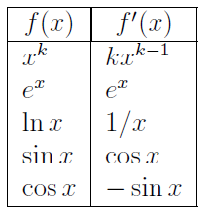

Standard derivatives

### 

library(Ryacas)  
library(mosaic)

### x^k

x = Sym('x')  
k = Sym('k')  
deriv(x^k,x)

## expression(k * x^(k - 1))

plotFun(x^3~x)

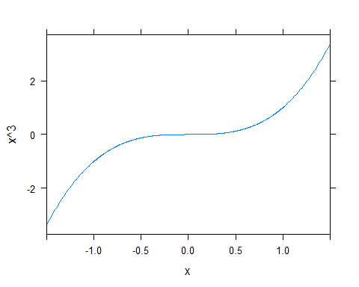

deriv(x^3,x)

## expression(3 * x^2)

plotFun(3 * x^2~x, add = T)

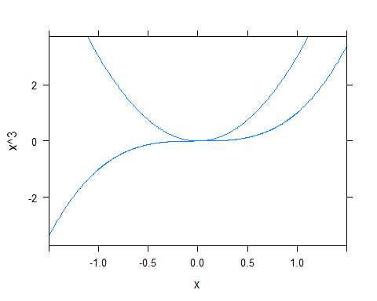

### exp(x)

deriv(exp(x),x)

## expression(exp(x))

### logb(x)

deriv(logb(x,base = exp(1)),x)

## expression(1/x)

plotFun(logb(x,base = exp(1))~x)

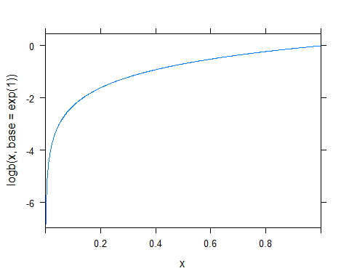

plotFun(1/x~x)

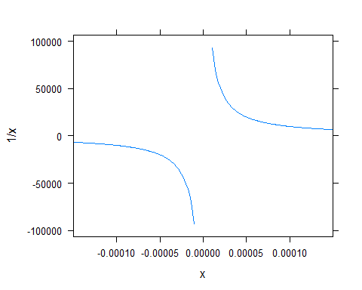

### sin(x)

deriv(sin(x),x)

## expression(cos(x))

plotFun(sin(x)~x,xlim=c(-3.14,3.14))

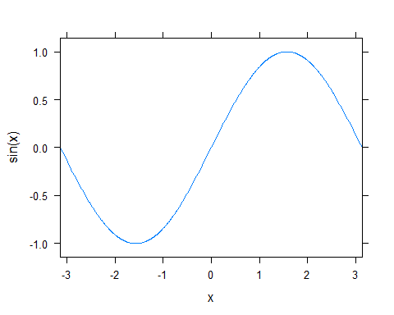

plotFun(cos(x)~x,add=T)

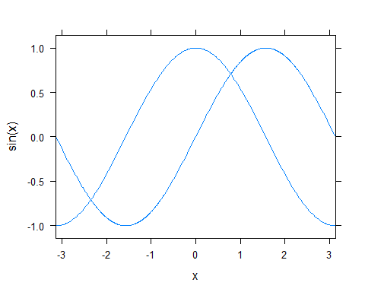

### cos(x)

deriv(cos(x),x)

## expression(-sin(x))

plotFun(cos(x)~x,xlim=c(-3.14,3.14))

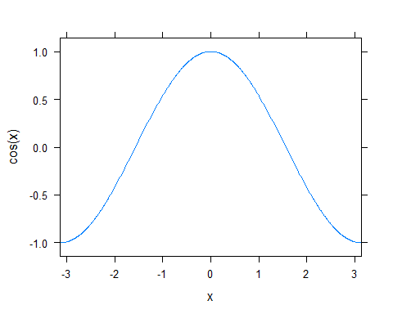

plotFun(-sin(x)~x,add=T)

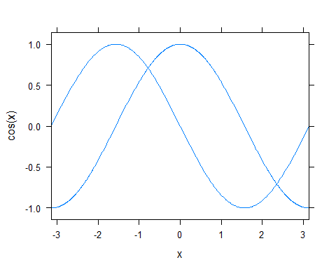

#### note that for trigonometrical function it tends to shift leftward for both sin and cos derivatives