20181015d derivatives rules

cheungngo

15 October 2018

library(Ryacas)  
library(mosaic)

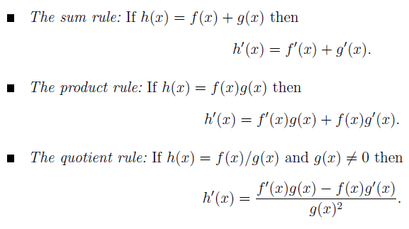

Basic rules in derivatives

Let f(x) = x^2; g(x) = x^3;

x = Sym('x')  
f = x^2 # No yacas()  
g = x^3 # No yacas()  
df = deriv(f,x)  
dg = deriv(g,x)

### Sum rule

LHS = deriv(f+g,x)  
RHS = df + dg  
LHS

## expression(2 * x + 3 * x^2)

RHS

## expression(2 * x + 3 * x^2)

### 

### Product rule

LHS = deriv(f*g,x)  
RHS = df*g + dg*f  
LHS

## expression(5 * x^4)

RHS

## expression(2 * x^4 + 3 * x^4)

Simplify(RHS)

## expression(5 * x^4)

### 

### Quotient rule

LHS = deriv(f/g,x)  
RHS = (df*g-dg*f)/g^2  
LHS

## expression((x^3 * (2 * x) - 3 * x^4)/x^6)

RHS

## expression((2 * x^4 - 3 * x^4)/x^6)

Simplify(LHS)

## expression(-1/x^2)

Simplify(RHS)

## expression(-1/x^2)

### 

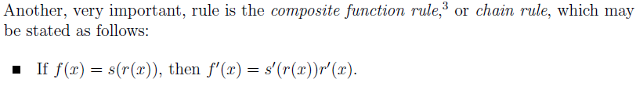

Composite function rule

Suppose h(x) = f(g(x)), find h’(x)

fx = makeFun(x^2~x)  
h = fx(g)  
LHS = deriv(h,x)  
df

## expression(2 * x)

dfx = makeFun(2*x~x)  
RHS = dfx(g)*dg  
LHS

## expression(6 * x^5)

RHS

## expression(2 * (x^3 * (3 * x^2)))

Simplify(RHS)

## expression(6 * x^5)

### 

### Differentiation using log

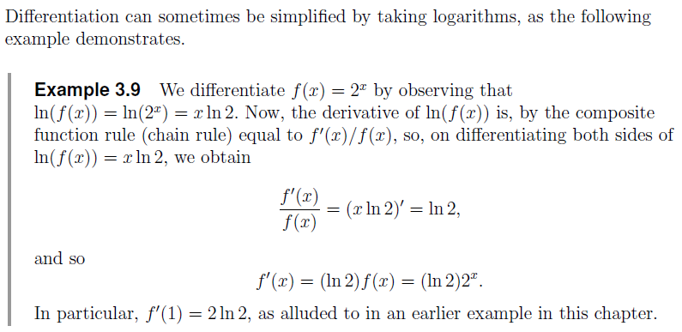

Differentiation using log

Let f(x) = x^x  
Taking log on both sides => log(f(x)) = xlog(x)  
For the LHS, d/dx log(f(x)) == 1/(f(x)) * f’(x) (composite rule)  
For the RHS, d/dx xlog(x) == 1(log(x)) + (1/x)x == log(x) + 1 (product rule)  
=> f’(x) == f(x) * (1/x + 1) == x^x (log(x) + 1)

deriv(x^x,x)

## expression(x^x * (log(x) + 1))