20181016a Optimization in differentiation

cheungngo

October 16, 2018

library(Ryacas)  
library(mosaic)

### Critical points

f’(x) > 0 => increasing value  
f’(x) < 0 => decreasing value  
f’(x) = 0 => min / max value

f’‘(x) > 0 => trough  
f’‘(x) < 0 => peak  
f’’(x) = 0 => can be an inflexion

Let f(x) = 2*x^3 - 9*x^2 + 1  
Find the critical points

x = Sym('x')  
f = 2*x^3 - 9*x^2 + 1  
df = deriv(f,x)  
ddf = deriv(df,x)

# Finding the x of the critical points  
Solve(df==0,x)

## expression(list(x == 0, x == 3))

# Finding the y of the critical points  
Eval(f,list(x = c(0,3)))

## [1] 1 -26

# Determining max or min  
Eval(ddf,list(x = c(0,3)))

## [1] -18 18

Conclusion: (0,1) being maxima; (3,-26) being minima

plotFun(2*x^3 - 9*x^2 + 1~x)

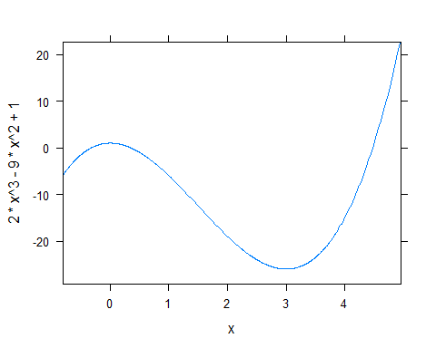

### Global or local maxima / minima

To get the biggest maxima, we just calculate all the f(x) of the critical points  
But the greatest maxima may not necessarily mean it is the greatest among f(x)  
In this way we need to estimate f(x) towards the extremes

Let f(x) = x^3 - 6*x^2 + 11*x - 6

f = x^3 - 6*x^2 + 11*x - 6  
df = deriv(f,x); df = Simplify(df); df

## expression(3 * x^2 - 12 * x + 11)

ddf = deriv(df,x); ddf = Simplify(ddf); ddf

## expression(6 * (x - 2))

# x in critical points  
Solve(df==0,x)

## expression(list(x == (root(12, 2) + 12)/6, x == (12 - root(12,   
## 2))/6))

# y in critical points  
Eval(f,list(x=c((root(12, 2) + 12)/6, (12 - root(12, 2))/6)))

## [1] -0.3849002 0.3849002

# Max or Min  
Eval(ddf,list(x=c((root(12, 2) + 12)/6, (12 - root(12, 2))/6)))

## [1] 3.464102 -3.464102

# Global or Local  
Limit(f,x,Infinity)

## expression(Inf)

Limit(f,x,-Infinity)

## expression(-Inf)

So the critical points are only local maxima and minima

# Confirmed by graph  
plotFun(x^3 - 6*x^2 + 11*x - 6 ~ x)

