20181105 prcomp for CMC

cheungngo

November 6, 2018

library(readr)  
X20181105 <- read_csv("20181105.csv") # 20181105.csv as an example

## Parsed with column specification:  
## cols(  
## .default = col_double(),  
## VeChain = col_integer()  
## )

## See spec(...) for full column specifications.

View(X20181105)  
CMC_change = X20181105

### prcomp()

PC_1105 = prcomp(na.omit(CMC_change))

### rotation plot

CN_1105 = rownames(PC_1105$rotation)  
head(CN_1105)

## [1] "Bitcoin" "Ethereum" "XRP" "BitcoinCash" "EOS"   
## [6] "Stellar"

CN_1105 = as.factor(CN_1105)

plot(PC_1105$rotation[,1:2])  
text(PC_1105$rotation[,1:2], labels = CN_1105, pos = 4, cex = 0.5)

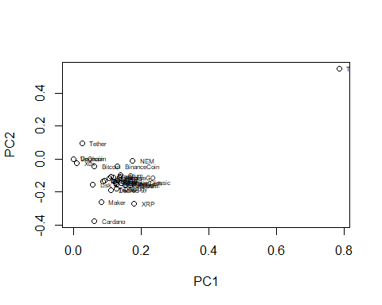

plot(PC_1105$rotation[,1:2], xlim = c(0,0.25), ylim = c(-0.5,0.1))  
text(PC_1105$rotation[,1:2], labels = CN_1105, pos = 4, cex = 0.5, xlim = c(0,0.25), ylim = c(-0.5,0.1))

