**Class: CS331**

**Class No: 50518**

**Section: 32**

**Name of Course: Database Systems**

**Project Name: Electronic Medical Records Database**

**Project #: 1**

**Name: Chevano Gordon**

**Student ID: 2562**

**Date:**

**Due Date: 10/07/19**

**Cut-Off: 10/12/19**

**Objective:**

**Objective 1:** Create a database to manage patient medical records

**Objective 2:** Create a UML diagram

**Objective 3:** Create searches and output using relational algebra

UML Design

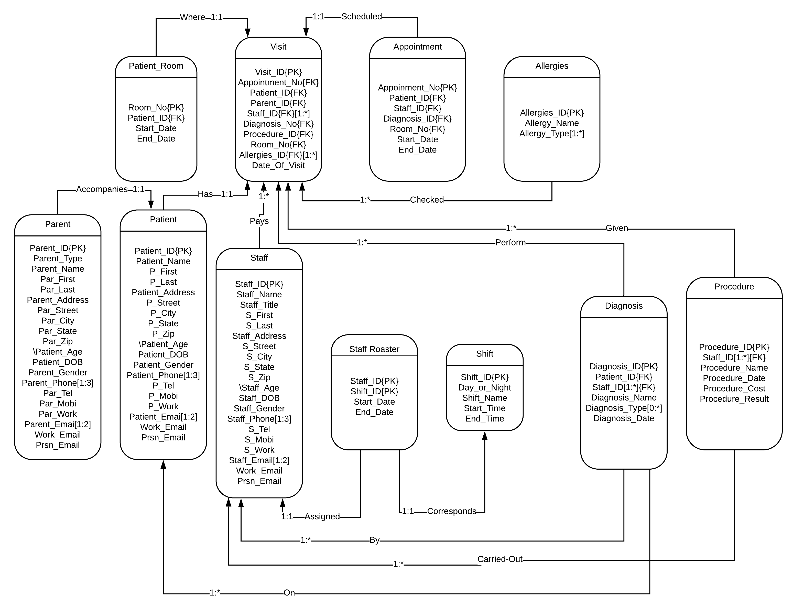

Convert UML to Relations

Patient (PATIENT_ID, P_First, P_Last, P_Street, P_City, P_State, P_Zip, Patient_Age, Patient_DOB, Patient_Gender)

Patient_Phone (PATIENT_ID, PHONE)

Patient_Email (PATIENT_ID, EMAIL)

Parent (PARENT_ID, Parent_Type, Par_First, Par_Last, Par_Street, Par_City, Par_State, Par_Zip, Parent_Age, Parent_DOB, Parent_Gender)

Parent_Phone (PARENT_ID, PHONE)

Parent_Email (PARENT_ID, EMAIL)

Patient_Room (ROOM_NO, Patient_ID, Start_Date, End_Date)

Staff (STAFF_ID, Staff_Title, S_First, S_Last, S_Street, S_City, S_State, S_Zip, Staff_Age, Staff_Gender)

Staff_Phone (STAFF_ID, PHONE)

Staff_Email (STAFF_ID, EMAIL)

Shift (SHIFT_ID, Day_or_Night, Shift_Name, Start_Time, End_Time)

Staff_Roaster (STAFF_ID, SHIFT_ID, Start_Date, End_Date)

Diagnosis (DIAGNOSIS_ID, Patient_ID, Diagnosis_Date)

Diagnose_By_Staff (DIAGNOSIS_ID, STAFF_ID)

Diagnosis_Type (DIAGNOSIS_ID, Type_ID)

Procedure (PROCEDURE_ID, Procedure_Name, Prcedure_Date, Procedure_Cost, Procedure_Result)

Procedure_Staff (PROCEDURE_ID, STAFF_ID)

Convert UML to Relations(Cont’d)

Appointment (APPOINTMENT_ID, Patient_ID, Staff_ID, Diagnosis_ID, Room_No, Start_Date, End_Date)

Allergies (ALLERGIES_ID, Allergy_Name)

Allergies_Type (ALLERGIES_ID, TYPE_ID)

Visit (VISIT_ID, Appoinment_No, Patient_ID, Parent_ID, Diagnosis_ID, Procedure_ID, Room_No, Date_Of_Visit)

Staff_Visit (VISIT_ID, STAFF_ID)

Allergies_On_Visit (VISIT, ALLERGIES_ID)

Q&A

Q1: Identify procedures performed for patient John Carter visit this month. Display the patient name, procedure name, date of procedure and procedure cost.

A: $LastMonth← δ_{ProcedureDate≥\text{09-01-2019" ⋀ Prcedure_Date ≤"}09-30-2019"}(Π_{Procedure_{Name}, Procedure_{Date}, Procedure_{Cost}, Procedure_{ID}}(Procedure))$

$Name← δ_{P_{First}="\text{John"} ⋀ P_{Last}="\text{Carter"}}\left(Π_{P_{First}, P_{Last}, Patient_{ID}}(Patient)\right)$

FindName $←δ_{Visit.Parent_{ID}=Name.Patient_{ID}}(Π_{P_{First}, P_{Last}}\left(Name×Visit\right))$

FindMonth $←δ_{Visit.Procedure_{ID}=LastMonth.Procedure_{ID}}(Π_{Procedure_{Name}, Procedure_{Date}, Procedure_{Cost}}(LastMonth×Visit))$

Result $←Π_{P_{First}, { P}_{Last}, Procedure_{Name}, Procedure_{Date}, Procedure_{cost}}(FindName×FindMonth)$

Q2: Identify patients that have never received the Smallpox Vaccine. Display the patient age, date of birth, and address.

A: $Vaccine←δ_{ProcedureName="Smallpox"}(Π_{Procedure_{ID}}(Procedure))$

$Vaccinated←δ_{Visit.Procedure_{ID}= Vaccine.Procedure_{ID}}(Π_{Procedure_{ID}, Patient_{ID}}(Vaccine×Visit))$

$VaccinatedPatient←δ_{Vaccinated.Patient_ID= Patient.Patient_ID}(Vaccinated×Patient)$

UnvaccinatedPatient $←Π_{Patient_{ID}}\left(Patient\right)-Π_{Patient_{ID}}(VaccinatedPatient)$ $Result←{δ_{Patient.Patient_{ID}= UnvaccinatedPatient.Patient_ID }(∏}_{Patient_{Age}, DOB, P_{Street}, P_{City}, P_{State}, P_{Zip }}\left(Patient×UnvaccinatedPatient\right))$

Q3: Identify the procedures performed by a Cardiologist last year. Display the procedure name, procedure date, and patient name.

A: $Cardiologist←δ_{Staff_{Title}="Cardiologist"}(Π_{Staff_{ID}}(Saff))$

$LastYear← δ_{ProcedureDate ≥"\text{01-01-2018}"\bigwedge{ ProcedureDate ≤ "12-31-2018"} } (Π_{Procedure_{ID}, Procedure_{Name}, Procedure_{Date}}(Procedure))$

$LastYearCardiologistsToPatient← δ_{Cardiologist.Staff_{ID}=Visit.Staff_{ID} \bigwedge{ Visit.Procedure_{ID}= LastYear.Procedure_{ID}}}(Π_{Patient_{ID}, Procedure_{Name}, Procedure_{Date}}(Visit×Cardiologist×LastYear))$

$LastYearCardiologistPatients← δ_{Patient.Patient_{ID}= LastYearCardiologistToPatient.Patient_{ID} }(Patient×LastYearCardiologistToPatient)$

Result $←{Π }_{ P_{First}, P_{Last}, Procedure_{Name}, Procedure_{Date},}(LastYearCardiologistPatients)$

Q4: Identify patients with an abnormal Red Cell Count yesterday. Display the patient name, procedure name, and procedure result.

A: $YesterdayAbnormalRedCellCount←δ_{Diagnosis_{Name}="\text{Red Cell Count" ⋀ Diagnosis_Date = "10-06-2019"} }(Π_{Diagnosis_{ID}}(Diagnosis))$

$PatientsToTreatment←δ_{Visit.Diagnosis_{ID }= YesterdayAbnormalRedCellCount\text{.Diagnosis_ID}}(Π_{Patient_{ID}, Procedure_{ID}}(Visit×Diagnosis))$

$FindPatients←δ_{Patient.Patient_{ID}=PatientsToTreatment.Patient_{ID} }(Π_{P_{First}, P_{Last}}(Patient×PatientsToTreatment))$

$FindTreatment←δ_{Procedure.Procedure_{ID}=PatientsToTreatment.Procedure_{ID} }(Π_{Procedure_{Name}, Procedure_{result}}(Procedure×PatientsToTreatment))$

$Result←Π_{P_{First}, P_{Last}, Procedure_{Name}, Procedure_Result}(FindPatients×FindTreatment)$

Q5: Identify patients who were diagnosed with cancer last month and are being treated with chemotherapy. Display the patient name and treatment.

A: CancerLastMonth $←δ_{Diagnosis_{Name}="\text{Cancer"} ⋀ Diagnosis_{Date }\text{≥"09-01-2019"} ⋀ Diagnosis_{Date} ≤"09-30-2019"}(Π_{Diagnosis_{ID}}(Diagnosis))$

ChemotherapyTreated $←δ_{Procedure_{Name}="chemotherapy"}(Π_{Procedure_{ID}, Procedure_{Name}}(Procedure))$

PatientsToTreatment $←δ_{Visit.Diagnosis_{ID}=CancerLastMonth.Diagnosis_{ID} \bigwedge{Visit}.Procedure_{ID}=ChemotherapyTreated.Procedure_{ID}}(Π_{Patient_{ID}, Procedure_{Name}}(ChemotherapyTreated×CancerLastMonth))$

Result $←δ_{PatientsToTreatment.Patient_{ID}= Patient.Patient_{ID} }(Π_{P_{First},{ P}_{Last}, Procedure_{Name}}(PatientsToTreatment×Patient))$

Q6: Identify staffs who have not performed any procedures in the last 2-year. Display the staff name.

A: ProceduresInLast2Years $←δ_{Procedure_{Date} ≥"10-07 – 2017" }(Π_{Procedure_{ID} }(Procedure))$

PerformingStaffs $←δ_{Visit.Procedure_{ID}= ProceduresInLast2Years.Procedure_{ID}}(Π_{Staff_{ID}}\left(Visit×ProceduresInLast2Years\right))$

UnderperformingStaffs $←Π_{Staff_{ID}}\left(Staff\right)- Π_{Staff_{ID}}(PerformingStaffs)$

Result $←δ_{Staff.Staff_{ID} = UnderperformingStaffs.Staff_{ID}} (Π_{S_{First,} S_{Last}}\left(Staff×UnderperformingStaffs\right))$

Q7: Identify patients who have not visited with medical staff in the last 10-years. Display the patient name and the patient email.

A: FrequentPatients $←δ_{DateOfVisit ≥ "10-07 – 2009" }(Π_{Patient_ID }(Visit))$

InfrequentPatients $←Π_{Patient_{ID}}\left(Patient\right)- Π_{Patient_{ID}}(FrequentPatients)$

Result $←δ_{Patient.Patient_{ID}= InfrequentPatients.Patient_{ID} }(Π_{P_{First}, { P}_{Last}, Work_{Email, }Prsn_{Email} }(Patient×InfrequentPatients))$

Q8: Identify the number of procedures performed in the last week. Display two columns: Procedure name and number of procedures. Display one row for each distinct procedure name. Use an aggregate function and grouping operation to answer this question.

A: LastWeek $←δ_{Procedure_{Date}≥"09-28-2019" \bigwedge{ Procedure_{Date}≤"10-05-2019"}}(Π_{Procedure_{ID}, Procedure_Name} (Procedure))$

LastWeekProcedures $←δ_{Visit.Procedure_{ID}= LastWeek.Procedure_{ID}}(Π_{Procedure_{ID}, Procedure_{Name}}\left(Visit×LastWeek\right))$

$ρResult(Procedure Name, Number of Procedures)$

Procedure_Name $I_{count Procedure_{ID}}(LastWeekProcedures)$

Q9: Identify the number of patients who had performed procedures in the last 3-Years. Display three columns: patient name, number of procedures, and total cost. Display one row for each distinct patient name. Use an Aggregate Function or Grouping Operation to answer this question

A: Last3Years $←δ_{Procedure_{Date}≥"10-07-2016" }(Π_{Procedure_{ID}, Procedure_cost} (Procedure))$

Last3YearsProcedures $←δ_{Visit.Procedure_{ID}= Last3Years.Procedure_{ID}}(Π_{Procedure_{ID}, Procedure_{cost}, Patient_{ID}}\left(Visit×Last3Years\right))$

PatientsToProcedures $←δ_{Visit.Patient_{ID} = Last3YearsProcedures.Patient_{ID} }(Π_{P_{First}, { P}_{Last}, Procedure_{ID}, Procedure_{cost}}\left(Visit×Last3Years\right))$

$ρResult(Patient Name, Number of Procedures, Total Cost)$

P_First, P_Last $I_{count Procedure_{ID}, sum Procedure_{cost}}(PatientsToProcedures)$

Q10: Identify the revenue generated by each procedure in the last 2-weeks. Display three columns: procedure name, number of procedures, and total cost. Display one row for each distinct procedure name. Use an Aggregate Function or Grouping Operation to answer this question.

A: Last2Weeks $←δ_{Procedure_{Date}≥"09-23-2019" }(Π_{Procedure_{Name}, Procedure_cost} (Procedure))$

$ρResult(Procedure Name, Number of Procedures, Total Cost)$

Procedure_Name $I_{count Procedure_{Name}, sum Procedure_{cost}}(PatientsToProcedures)$