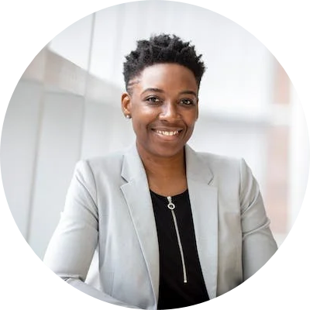

Cat | cat@gmail.com | catb/linkedin

# Professional Profile

I am a software developer with 10 years experience.

# Technical Skills

* Object oriented programming
* Java
* MMM

# Experience

**OMD** *Jan 2020 - Mar 2022*I was responsible for fixing pipeline issues and data cleaning

**Microsoft** *Jan 2018 - Jan 2020*I was the Data Science team lead.