**AMPU 3243 Chinese Calligraphy (2024 Sem-C)**

**Assignment 1**

**Student ID: B220177C Marks:**

**Name: Chew Sin Ai**

**Lecturer:** Lee Boon Fei (Vincent)

**Question 1: (20 Marks):**

* 1. **What are Four Treasures of Chinese Calligraphy?**  ***(8 Marks)***
* Four Treasures of Chinese Calligraphy refers to the four types of stationery used by scholars of Ancient China when writing, namely the writing brush(笔), inkstick(墨), paper(纸) and inkstone(砚).
* The writing brush is an invention of Ancient China for the purpose of writing and drawing. It comprises of two parts, the head and the shaft. The head is made of animal furs, which is soft and resilient, thus enable the Chinese to write each character with combination of different strokes (such as the dot stroke 点 , the left-slanting downward stroke 撇, the horizontal stroke 横 and the right-slanting downward stroke 捺)and to paint landscape that emphasize on motion and dynamic changes. The shaft is made of bamboo, wood and others.
* Ink sticks are ink in a solid form to be ground for writing, painting and rubbing. The use of it tremendously helped the preserving, spreading and evolution of written characters, while also giving traditional Chinese painting and calligraphy a unique and artistic look.
* The term ‘Paper’ here specifically refers to the type of paper used in calligraphy or Chinese painting. Usually, Xuan Paper will be used in writing Chinese Calligraphy.
* Inkstone is used along with the writing brush, inkstick and paper. Inkstone is a container that used to rub the ink stick to get the liquid ink(墨).
  1. **Explain six main Chinese Calligraphy Scripts with Features** ***(12 Marks)***

The 6 main Chinese Calligraphy Scripts are oracle bone script(甲骨文), seal script(篆书), clerical script(隶书), cursive script(草书), running script(行书), and standard script(楷书).

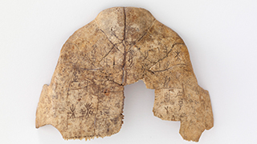

**oracle bone script(甲骨文)**

* It is mostly used for divination, also known as "Bu Ci", and is mostly engraved through deeds, also known as "book deeds". In addition to a large number of tortoise shells and beast bones, there are also a few jade and pottery tablets unearthed in Yin Ruins and Zhouyuan over the years.
* The glyph is folded square. The stylistic strokes vary in complexity. The position of the shape symbol is generally uncertain. It is widely used in combined text.

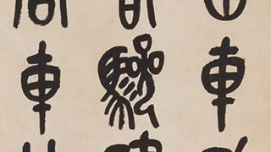

**seal script(篆书)**

* Seal script, or so-called Small seal script, is the official script in the Qin Dynasty, and it is the oldest of the five styles. Seal Script characters look solid and stable. It is known as the “seal style” because the characters are tall and symmetrical.

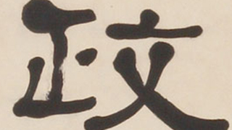

**clerical script(隶书)**

* The most obvious feature of the official script is that the beginning of the horizontal painting is like a silkworm head, and the end is like a goose tail.
* There are more phonetic characters, so the words recorded with the help of phonetic characters are also richer.
* Li materials are more common in bamboo and silk, monuments, cliffs and utensils.
* In order to write faster, Cheng Miao of Qin Dynasty changed the smooth and even strokes of seal characters and sought to be even, resulting in the official/clerical script.

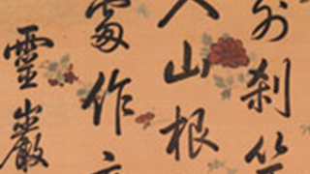

**running script(行书)**

* The character of this style looks smoother and more connective compared to Regular

Script.

* The lines in Good Running Script works have a consistent, energetic flow. If the

work doesn’t flow, it just looks choppy.

* Good Running Script requires a great deal of time and practice.

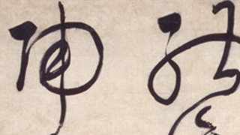

**cursive script(草书)**

* Cursive script evolved from the official script, followed the official script rules, picked on the horizontal painting, and the left and right waves were distinct.
* This is the cursive style of writing. Cursive script calligraphers simplify the left side of each character and give more space and emphasis to the right side.
* Cursive script calligraphers write quickly and use many abrupt brush turns and dramatic strokes.
* Cursive script is divided into many types, such as Zhang Cao(章草), Jin Cao(令草), and Kuang Cao(狂草).
* Zhang Cao(章草) was originated from the Clerical Script of the Western Han Dynasty.
* Jin Cao(令草) was a further development from Zhang Cao. It is simplified from the Standard Script of the Eastern Han Dynasty.
* Kuang Cao(狂草) was a further development from Jin Cao. Its strokes were expressed in a more abstract. Matured in the Tang Dynasty.

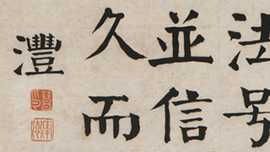

**standard script(楷书)**

* The shape of the standard script is rectangular, the longitudinal structure is compact, and the pointillist is rich in form. There are eight strokes, the so-called "Yong" character eight strokes, which forms a more beautiful and vivid font stroke.
* This standard style of writing is the most easily and widely recognised style.
* Each stroke is clear and separated. The speed and strength for writing each stroke should be equal in order to balance each character.

**Question 2 (30 Marks): Exercise of character ‘永’ regular script**

|  |  |  |
| --- | --- | --- |
| **Rubrics** | **Weightage** | **Score** |
| Quality of stroke line | 10% |  |
| Structure | 10% |  |
| Overall artistic atmosphere | 10% |  |
| Total | |  |

**Question 3 (50 Marks): Copywriting of regular script**

|  |  |  |
| --- | --- | --- |
| **Rubrics** | **Weightage** | **Score** |
| Quality of stroke line | 20% |  |
| Structure | 20% |  |
| Overall artistic atmosphere | 10% |  |
| Total | |  |

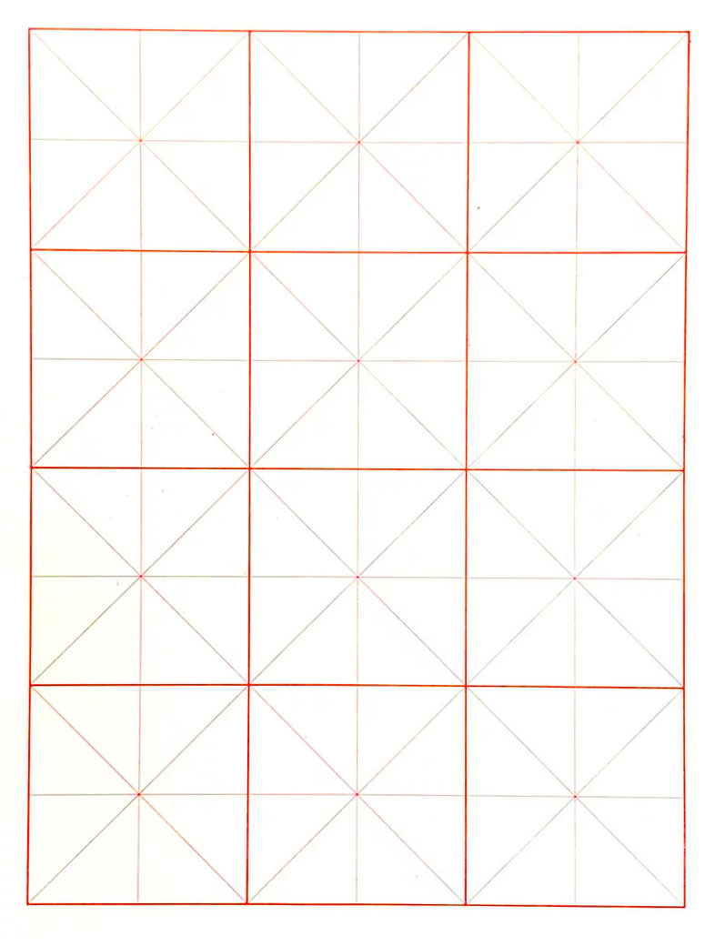

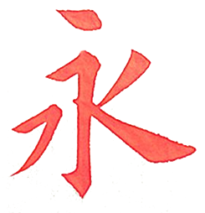























**Appendix 1: Copybook of ‘永’**

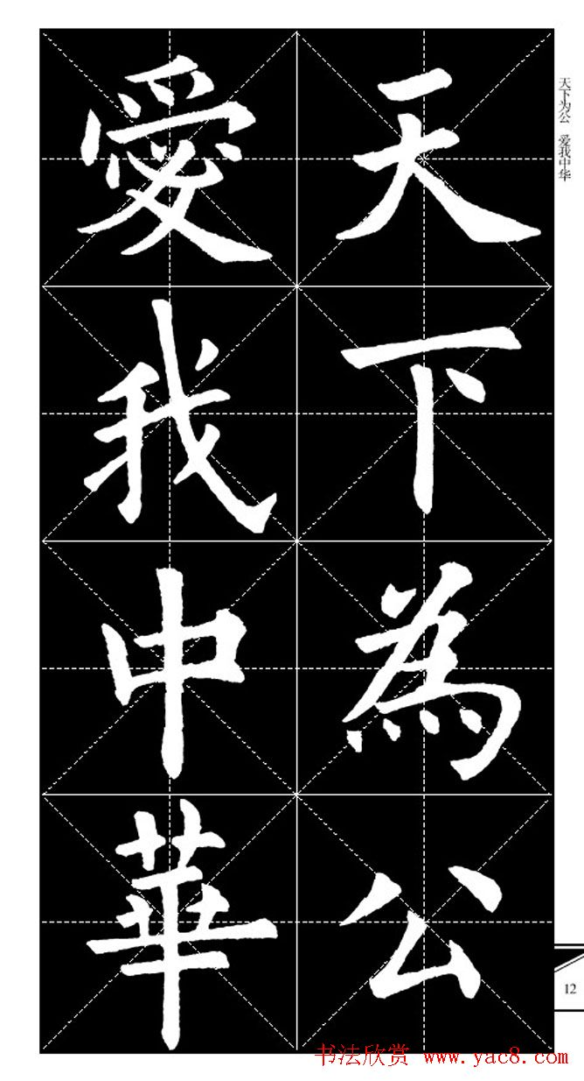

**Appendix 2: Copybook**