Differential Gene Expression Analysis Using RNAi Perturbation in Cancer Cell Lines

1. Introduction
Differential gene expression analysis is used to quantify the expression of genes at different times or conditions, such as before or after treatment. RNAi is a gene silencing mechanism that can be used as a treatment to silence genes, like in cancer cell lines, and stop disease-related processes. NRDE2 is a gene involved in RNA splicing and is a mediator in expression of proteins involved in mitosis. Knocking out NRDE2 function has been linked to genomic instability. In this study, we will analyze the differential gene expression between control breast cancer cell lines with the NRDE2 gene and treated cell lines with the NRDE2 gene knocked out to identify statistically significant transcriptomic differences between the two in breast cancer cells

Materials and Methods
Data Acquisition
Using the script provided in the project, 6 raw single-end read fastq files were downloaded. The nf-core/rnaseq v3.14.0 pipeline was executed for quality control and trimming was performed using the TrimGalore default settings. Salmon quantification was done using GC bias correction. MultiQC report was generated to analyze the quality of all samples. Sequence depth was fairly good for most of the samples, with all having a read count of around 20 million reads (treated3 sample had the lowest coverage with under 17 million unique reads). Sequence quality scores for all samples were excellent, with Phred scores for a vast majority of reads >33. The reference genome used was Homo_sapiens.GRCh38.dna_sm.primary_assembly.fa.gz and the annotation was Ensembl release 114: Homo_sapiens.GRCh38.114.gtf.gz
Pipeline Configuration
- Pipeline: nf-core/rnaseq v3.14.0
- Trimming: Enabled using TrimGalore (default settings)
- Quantification: Salmon with GC bias correction
- Reference Genome: Ensembl GRCh38 (Homo_sapiens.GRCh38.114.gtf.gz)
- Indexing: Indices generated during pipeline execution with --save_reference option
Differential Expression Analysis
Transcript abundances were imported using tximport, and DESeq2 was used to perform the statistical analysis. Apeglm method for log2fold changes was used to shrink the dispersion estimates. Multiple testing correction was done using the Benjamini-Hochberg method to control the false discovery rate (FDR), statistical significance was evaluated at FDR <0.05.

Results

Mapping rate and Read count for each sample
Sample Name | % Aligned | M Aligned | CFR | M Bias | % Dups | % GC | M Seqs | % BP Trimmed | % Dups | % GC | M Seqs
control1 | 91.1% | 55.8 | 100.0% | 0.0 | 65.5% | 49% | 61.4 | 1.4% | 61.0% | 49% | 61.2
control2 | 92.3% | 58.8 | 100.0% | 0.0 | 67.2% | 49% | 63.9 | 1.2% | 62.8% | 49% | 63.8
control3 | 93.2% | 52.2 | 100.0% | 0.0 | 66.9% | 49% | 56.1 | 1.4% | 62.7% | 49% | 55.9
treated1 | 92.6% | 53.4 | 100.0% | 0.0 | 66.5% | 49% | 57.8 | 1.2% | 62.1% | 49% | 57.7
treated2 | 92.9% | 54.7 | 100.0% | 0.0 | 67.0% | 49% | 58.9 | 1.0% | 62.7% | 49% | 58.9
treated3 | 92.8% | 43.1 | 100.0% | 0.0 | 63.9% | 49% | 46.4 | 1.0% | 59.7% | 49% | 46.4

Differential Expression Findings: 10 most highly significant differentially expressed genes
feature_id baseMean log2FoldChange lfcSE
<chr> <dbl> <dbl> <dbl>
1 ENSG00000175334 6420. 1.65 0.0665
2 ENSG00000163041 7967. 1.66 0.0724
3 ENSG00000196396 6616. 1.15 0.0539
4 ENSG00000105976 9559. 1.57 0.0761
5 ENSG00000128595 22959. 1.48 0.0726
6 ENSG00000101384 11781. 1.31 0.0671
7 ENSG00000124333 2741. 1.48 0.0758
8 ENSG00000117632 16768. 1.34 0.0716
9 ENSG00000145919 2706. 1.28 0.0747
10 ENSG00000213281 6960. 1.18 0.0687

Total significant genes (FDR < 0.05): 3616

Upregulated in RNAi vs. Control: 1908
Downregulated in RNAi vs. Control: 1708
MA Plot
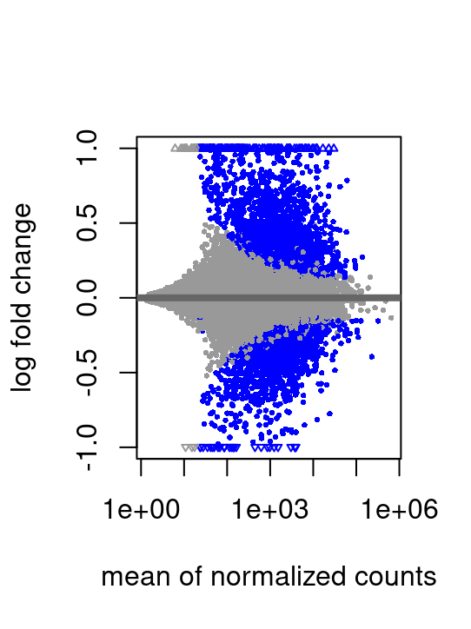
The MA plot shows that there are a significant amount of genes, in blue, that are differentially expressed between treatment and control groups. Log2fold changes reduced the variance for low-count genes. There are both upregulated and downregulated genes that are differentially expressed, with more upregulated genes, and more significant genes are highly or moderately expressed with high log2fold changes.
PCA Plot: 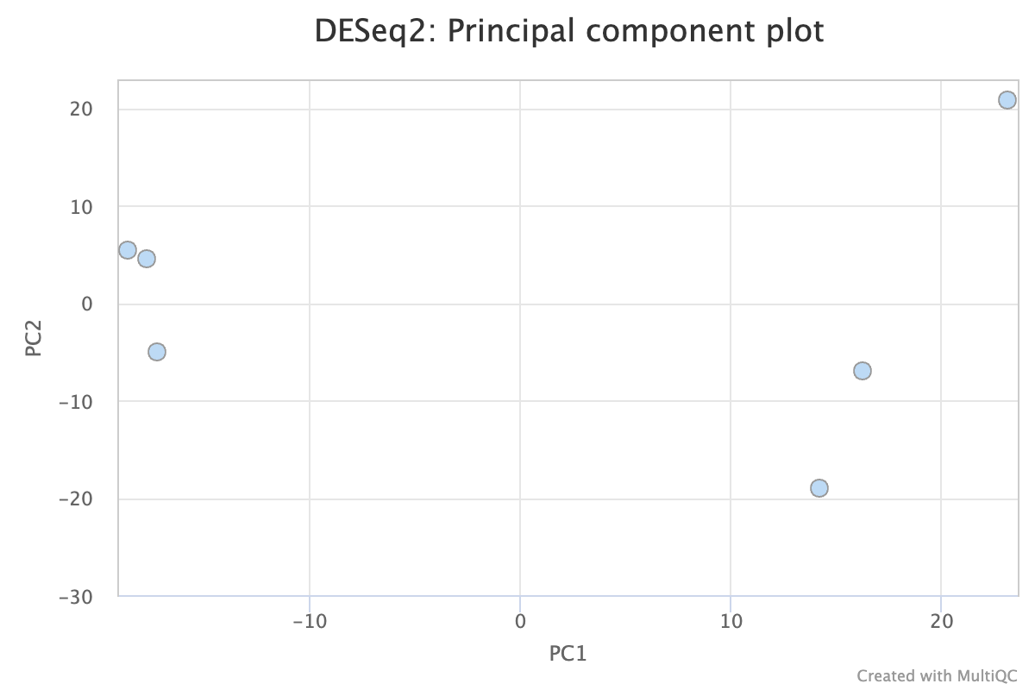
Left to right: control1, control2, control3, treated1, treated2, treated3
The PCA plot shows that the treatment group and control group are separated along PC1 which indicates the variation is due to treatment. There is clustering in control group along PC2 but it’s more spread out in the treatment group, indicating more variability in the group.
Dispersion Plot
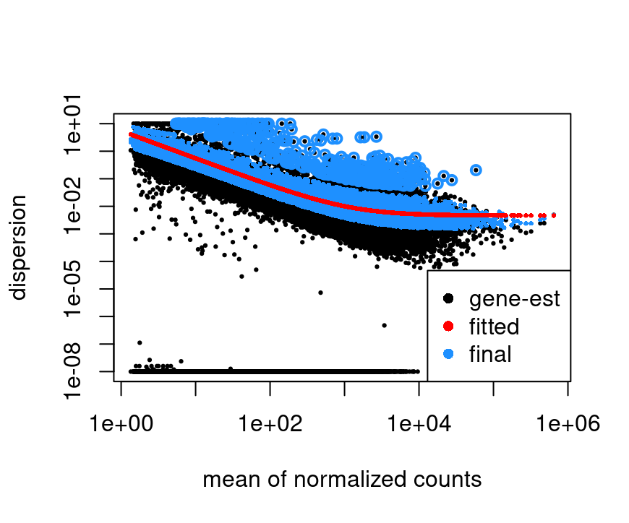
The dispersion plot shows that as gene expression increases, gene dispersion estimates decrease.
P-value Histogram
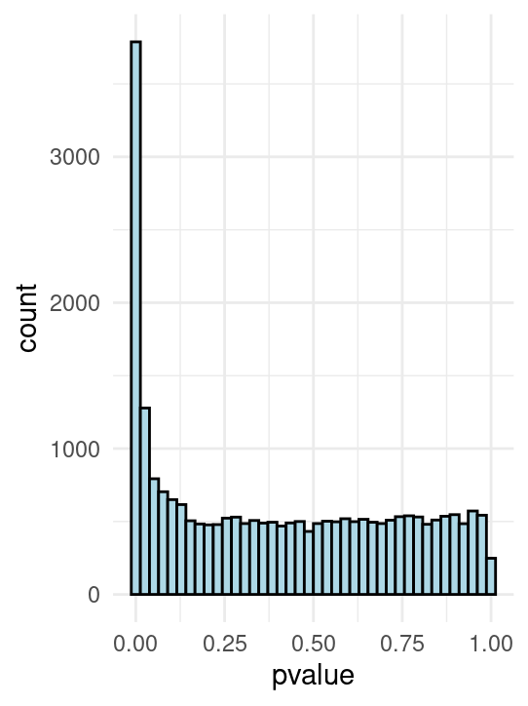
The histogram shows an enrichment of low p-values which indicates there are over 3500 statistically significantly differentially expressed genes. There are no significant artifacts, and the distribution is uniform which is good.
Volcano Plot
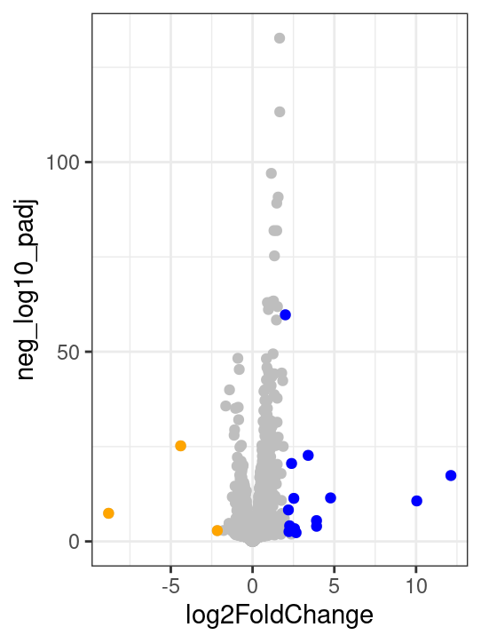
The volcano plot shows that there are statistically significantly differentially expressed genes. Especially many genes in the blue (treatment) group are upregulated, where some orange (control) group genes are downregulated, which shows a response to treatment. However, most genes are not showing differential expression.

4. Discussion

Overall, the data show significant differential gene expression between control and treatment groups, indicating significant response to treatment. There is strong evidence that many genes are impacted by the downstream effects of RNAi silencing of NRDE2 gene. It would be interesting to characterize the genes that are impacted to understand the biological processes that are affected by this treatment. The data was robust and low p-values gave high-confidence to the results. It seems like NRDE2 gene is a very central gene mediating expression of many other genes.

5. Appendix
Software Versions
- nextflow/24.10.4
- nf-core/rnaseq/3.14.0
- Salmon v1.10.0
- DESeq2 version 1.40.2
- Tximport/3.21
- R/4.4.0
- TrimGalore/0.6.6
Command Line Scripts
Provide all command-line inputs used during the analysis. For readability, format these commands using a monospace font or code blocks.
Samplesheet
Include the samplesheet used for the analysis in CSV format:

Appendix

#Make final and copy slurm script into working directory to download fastq files
[ac10596@log-1 ac10596]$ mkdir ngs.final
[ac10596@log-1 ngs.final]$ srun --account=pr_284_general --time=4:00:00 --mem=4GB --pty /bin/bash
srun: job 60347642 queued and waiting for resources
[ac10596@log-1 ac10596]$ cp /scratch/work/courses/BI7653/project.2025/download.sh $SCRATCH/ngs.final
[ac10596@log-1 ac10596]$ cd ngs.final
[ac10596@log-1 ngs.final]$ ls
download.sh
[ac10596@log-1 ngs.final]$ nano download.sh

#Download script
#!/bin/bash
#
#SBATCH --nodes=1
#SBATCH --tasks-per-node=1
#SBATCH --cpus-per-task=1
#SBATCH --time=5:00:00
#SBATCH --mem=8GB
#SBATCH --job-name=download_fastqs
#SBATCH --account=pr_284_general

module purge

wget ftp://ftp.sra.ebi.ac.uk/vol1/fastq/SRR781/000/SRR7819990/SRR7819990.fastq.gz
echo _ESTATUS_ [ wget SRR7819990 ]: $?
wget ftp://ftp.sra.ebi.ac.uk/vol1/fastq/SRR781/001/SRR7819991/SRR7819991.fastq.gz
echo _ESTATUS_ [ wget SRR7819991 ]: $?
wget ftp://ftp.sra.ebi.ac.uk/vol1/fastq/SRR781/002/SRR7819992/SRR7819992.fastq.gz
echo _ESTATUS_ [ wget SRR7819992 ]: $?
wget ftp://ftp.sra.ebi.ac.uk/vol1/fastq/SRR781/003/SRR7819993/SRR7819993.fastq.gz
echo _ESTATUS_ [ wget SRR7819993 ]: $?
wget ftp://ftp.sra.ebi.ac.uk/vol1/fastq/SRR781/004/SRR7819994/SRR7819994.fastq.gz
echo _ESTATUS_ [ wget SRR7819994 ]: $?
wget ftp://ftp.sra.ebi.ac.uk/vol1/fastq/SRR781/005/SRR7819995/SRR7819995.fastq.gz
echo _ESTATUS_ [ wget SRR7819995 ]: $?
echo _END_ [ download.slurm ]: $(date)

srun: job 60347642 has been allocated resources
sba[ac10596@cm001 ngs.final]$ sbatch download.sh
Submitted batch job 60347643
[ac10596@cm001 ngs.final]$ squeue -u ac10596
JOBID PARTITION NAME USER ST TIME NODES NODELIST(REASON)
60347642 short bash ac10596 R 0:45 1 cm001
60347643 short download ac10596 R 0:30 1 cm007
[ac10596@cm001 ngs.final]$ squeue -u ac10596
JOBID PARTITION NAME USER ST TIME NODES NODELIST(REASON)
60347642 short bash ac10596 R 34:18 1 cm001
[ac10596@cm001 ngs.final]$ ls
download.sh SRR7819991.fastq.gz SRR7819994.fastq.gz
slurm-60347643.out SRR7819992.fastq.gz SRR7819995.fastq.gz
SRR7819990.fastq.gz SRR7819993.fastq.gz
[ac10596@cm001 ngs.final]$ less slurm-60347643.out

#See what the fastq files are
[ac10596@cm001 ngs.final]$ less /scratch/work/courses/BI7653/project.2025/project_fastqs.txt

control1 SRR7819990.fastq.gz
control2 SRR7819991.fastq.gz
control3 SRR7819992.fastq.gz
treated1 SRR7819993.fastq.gz
treated2 SRR7819994.fastq.gz
treated3 SRR7819995.fastq.gz

#Downloading references
[ac10596@cm001 ngs.final]$ latest_release=$(curl -s 'http://rest.ensembl.org/info/software?content-type=application/json' | grep -o '"release":[0-9]*' | cut -d: -f2)
wget -L ftp://ftp.ensembl.org/pub/release-${latest_release}/fasta/homo_sapiens/dna/Homo_sapiens.GRCh38.dna_sm.primary_assembly.fa.gz
wget -L ftp://ftp.ensembl.org/pub/release-${latest_release}/gtf/homo_sapiens/Homo_sapiens.GRCh38.${latest_release}.gtf.gz
--2025-05-09 22:37:53-- ftp://ftp.ensembl.org/pub/release-114/fasta/homo_sapiens/dna/Homo_sapiens.GRCh38.dna_sm.primary_assembly.fa.gz
=> ‘Homo_sapiens.GRCh38.dna_sm.primary_assembly.fa.gz’
Resolving ftp.ensembl.org (ftp.ensembl.org)... 193.62.193.169
Connecting to ftp.ensembl.org (ftp.ensembl.org)|193.62.193.169|:21... connected.
Logging in as anonymous ... Logged in!
==> SYST ... done. ==> PWD ... done.
==> TYPE I ... done. ==> CWD (1) /pub/release-114/fasta/homo_sapiens/dna ... done.
==> SIZE Homo_sapiens.GRCh38.dna_sm.primary_assembly.fa.gz ... 942484168
==> PASV ... done. ==> RETR Homo_sapiens.GRCh38.dna_sm.primary_assembly.fa.gz ... done.
Length: 942484168 (899M) (unauthoritative)

Homo_sapiens.GRCh38. 100%[=====================>] 898.82M 26.3MB/s in 30s

2025-05-09 22:38:24 (29.9 MB/s) - ‘Homo_sapiens.GRCh38.dna_sm.primary_assembly.fa.gz’ saved [942484168]

--2025-05-09 22:38:24-- ftp://ftp.ensembl.org/pub/release-114/gtf/homo_sapiens/Homo_sapiens.GRCh38.114.gtf.gz
=> ‘Homo_sapiens.GRCh38.114.gtf.gz’
Resolving ftp.ensembl.org (ftp.ensembl.org)... 193.62.193.169
Connecting to ftp.ensembl.org (ftp.ensembl.org)|193.62.193.169|:21... connected.
Logging in as anonymous ... Logged in!
==> SYST ... done. ==> PWD ... done.
==> TYPE I ... done. ==> CWD (1) /pub/release-114/gtf/homo_sapiens ... done.
==> SIZE Homo_sapiens.GRCh38.114.gtf.gz ... 64228966
==> PASV ... done. ==> RETR Homo_sapiens.GRCh38.114.gtf.gz ... done.
Length: 64228966 (61M) (unauthoritative)

Homo_sapiens.GRCh38. 100%[=====================>] 61.25M 8.52MB/s in 7.3s

2025-05-09 22:38:32 (8.40 MB/s) - ‘Homo_sapiens.GRCh38.114.gtf.gz’ saved [64228966]

[ac10596@cm001 ngs.final]$ ls
download.sh SRR7819991.fastq.gz
Homo_sapiens.GRCh38.114.gtf.gz SRR7819992.fastq.gz
Homo_sapiens.GRCh38.dna_sm.primary_assembly.fa.gz SRR7819993.fastq.gz
slurm-60347643.out SRR7819994.fastq.gz
SRR7819990.fastq.gz SRR7819995.fastq.gz

#Creating nf-core script

[ac10596@log-1 ngs.final]$ mv slurm_template_ac2.sh nf_final.sh
[ac10596@log-1 ngs.final]$ nano nf_final.sh

#!/bin/bash
#
#SBATCH --nodes=1
#SBATCH --tasks-per-node=1
#SBATCH --cpus-per-task=1
#SBATCH --time=8:00:00
#SBATCH --mem=4GB
#SBATCH --job-name=final
#SBATCH --account=pr_284_general
#SBATCH --mail-type=FAIL
#SBATCH --mail-user=ac10596@nyu.edu

#Load the most recent version of nextflow
module purge
module load nextflow/24.10.4

#run nf-core pipeline
nextflow run nf-core/rnaseq -r 3.14.0 \
--input /scratch/ac10596/ngs.final/samplesheet.csv \
--outdir res \
--fasta /scratch/ac10596/ngs.final/Homo_sapiens.GRCh38.dna_sm.primary_assembly.fa.>
--gtf /scratch/ac10596/ngs.final/Homo_sapiens.GRCh38.114.gtf.gz \
--extra_salmon_quant_args \"--gcBias\" \
--save_reference \
-profile nyu_hpc \
--account=pr_284_general \
-c /scratch/work/courses/BI7653/hw8.2025/rnaseq.config \
-params-file /scratch/work/courses/BI7653/hw8.2025/rnaseq.json

#Samplesheet contents
sample,fastq_1,fastq_2,strandedness
control1,/scratch/ac10596/ngs.final/SRR7819990.fastq.gz,,auto
control2,/scratch/ac10596/ngs.final/SRR7819991.fastq.gz,,auto
control3,/scratch/ac10596/ngs.final/SRR7819992.fastq.gz,,auto
treated1,/scratch/ac10596/ngs.final/SRR7819993.fastq.gz,,auto
treated2,/scratch/ac10596/ngs.final/SRR7819994.fastq.gz,,auto
treated3,/scratch/ac10596/ngs.final/SRR7819995.fastq.gz,,auto

R Markdown:

> library(tximport)
> library(DESeq2)
> library(tidyverse)
── Attaching core tidyverse packages ────────────
✔ dplyr 1.1.4 ✔ readr 2.1.5
✔ forcats 1.0.0 ✔ stringr 1.5.1
✔ ggplot2 3.5.1 ✔ tibble 3.2.1
✔ lubridate 1.9.3 ✔ tidyr 1.3.1
✔ purrr 1.0.2
── Conflicts ─────────── tidyverse_conflicts() ──
✖ lubridate::%within%() masks IRanges::%within%()
✖ dplyr::collapse() masks IRanges::collapse()
✖ dplyr::combine() masks Biobase::combine(), BiocGenerics::combine()
✖ dplyr::count() masks matrixStats::count()
✖ dplyr::desc() masks IRanges::desc()
✖ tidyr::expand() masks S4Vectors::expand()
✖ dplyr::filter() masks stats::filter()
✖ dplyr::first() masks S4Vectors::first()
✖ dplyr::lag() masks stats::lag()
✖ ggplot2::Position() masks BiocGenerics::Position(), base::Position()
�� purrr::reduce() masks GenomicRanges::reduce(), IRanges::reduce()
✖ dplyr::rename() masks S4Vectors::rename()
✖ lubridate::second() masks S4Vectors::second()
✖ lubridate::second<-() masks S4Vectors::second<-()
✖ dplyr::slice() masks IRanges::slice()
ℹ Use the 8;;http://conflicted.r-lib.org/conflicted package to force all conflicts to become errors
> library(apeglm)
> library(AnnotationDbi)

Attaching package: ‘AnnotationDbi’

The following object is masked from ‘package:dplyr’:

select

> library(org.Hs.eg.db)

> > # Create info for metadata and file paths
> sample_names <- c("control1", "control2", "control3", "treated1", "treated2", "treated3")
> condition <- factor(c("Control", "Control", "Control", "treated", "treated", "treated"),
+ levels = c("Control", "treated"))
> > samples_df <- data.frame(row.names = sample_names, condition = condition)
> > > files <- file.path("/scratch/ac10596/ngs.final/res/salmon", sample_names, "quant.sf")
> names(files) <- sample_names
> > tx2gene <- read.table("/scratch/ac10596/ngs.final/res/salmon/tx2gene.tsv", header = FALSE, sep = "\t")
> > txi <- tximport(files, type = "salmon", tx2gene = tx2gene)
reading in files with read_tsv
1 2 3 4 5 6
summarizing abundance
summarizing counts
summarizing length
> > dds <- DESeqDataSetFromTximport(txi, colData = samples_df, design = ~ condition)
using counts and average transcript lengths from tximport
> > # Filter out low-count genes
> dds <- dds[rowSums(counts(dds)) >= 10, ]
> > # Run DESeq2
> dds <- DESeq(dds)
estimating size factors
using 'avgTxLength' from assays(dds), correcting for library size
estimating dispersions
gene-wise dispersion estimates
mean-dispersion relationship
final dispersion estimates
fitting model and testing
> > # Shrink LFC for better interpretability
> res <- results(dds, contrast = c("condition", "treated", "Control"), alpha = 0.05)
> > res.lfcShrink <- lfcShrink(dds,
+ res = res,
+ coef = "condition_treated_vs_Control",
+ type = "apeglm")
using 'apeglm' for LFC shrinkage. If used in published research, please cite:
Zhu, A., Ibrahim, J.G., Love, M.I. (2018) Heavy-tailed prior distributions for
sequence count data: removing the noise and preserving large differences.
Bioinformatics. https://doi.org/10.1093/bioinformatics/bty895
Warning message:
In nbinomGLM(x = x, Y = YNZ, size = size, weights = weightsNZ, offset = offsetNZ, :
the line search routine failed, unable to sufficiently decrease the function value
> > # View metadata on result columns
> mcols(res.lfcShrink)$description
[1] "mean of normalized counts for all samples"
[2] "log2 fold change (MAP): condition treated vs Control"
[3] "posterior SD: condition treated vs Control"
[4] "Wald test p-value: condition treated vs Control"
[5] "BH adjusted p-values"
> > # Tidy results into tibble
> res_tbl <- res.lfcShrink %>%
+ as.data.frame() %>%
+ rownames_to_column("feature_id") %>%
+ as_tibble()
> > res.lfcShrink
log2 fold change (MAP): condition treated vs Control
Wald test p-value: condition treated vs Control
DataFrame with 24752 rows and 5 columns
baseMean log2FoldChange
<numeric> <numeric>
ENSG00000000003 1510.9879 -0.0198363
ENSG00000000419 2218.7111 0.3163816
ENSG00000000457 956.0047 -0.2504218
ENSG00000000460 1597.9898 -0.0646700
ENSG00000000938 1.9074 0.0116568
... ... ...
ENSG00000310560 1829.40931 -0.23043375
ENSG00000310562 2.30361 -0.00851995
ENSG00000310566 3.63869 -0.03215344
ENSG00000310576 711.42383 0.37610923
ENSG00000310577 3.34197 -0.01665767
lfcSE pvalue
<numeric> <numeric>
ENSG00000000003 0.0896152 7.97517e-01
ENSG00000000419 0.0745655 5.33244e-06
ENSG00000000457 0.0865694 1.26858e-03
ENSG00000000460 0.0825927 3.79189e-01
ENSG00000000938 0.1820551 5.69203e-01
... ... ...
ENSG00000310560 0.091688 0.00437718
ENSG00000310562 0.181895 0.65941615
ENSG00000310566 0.185330 0.17439077
ENSG00000310576 0.144489 0.00139228
ENSG00000310577 0.183207 0.26756370
padj
<numeric>
ENSG00000000003 8.98224e-01
ENSG00000000419 7.99916e-05
ENSG00000000457 8.92445e-03
ENSG00000000460 5.99215e-01
ENSG00000000938 NA
... ...
ENSG00000310560 0.02397247
ENSG00000310562 NA
ENSG00000310566 NA
ENSG00000310576 0.00960983
ENSG00000310577 NA
> # Histogram of raw p-values
> ggplot(res_tbl, aes(pvalue)) +
+ geom_histogram(bins = 40, fill = "lightblue", color = "black") +
+ theme_minimal()
Warning message:
Removed 24 rows containing non-finite outside
the scale range (`stat_bin()`).
> > # MA Plot
> plotMA(res.lfcShrink)
> > # Add -log10(FDR) for volcano-style plot
> res_tbl <- res_tbl %>% mutate(neg_log10_padj = -log10(padj))
> > ggplot(res_tbl, aes(x = log2FoldChange, y = neg_log10_padj)) +
+ geom_point(color = "gray") +
+ geom_point(data = ~.x %>% filter(log2FoldChange > 2 & neg_log10_padj > 2),
+ color = "blue") +
+ geom_point(data = ~.x %>% filter(log2FoldChange < -2 & neg_log10_padj > 2),
+ color = "orange") +
+ theme_bw()
Warning message:
Removed 8656 rows containing missing values or
values outside the scale range (`geom_point()`).
> > # Vector of DEGs (padj < 0.05)
> sig_genes <- res_tbl %>%
+ filter(!is.na(padj)) %>%
+ filter(padj < 0.05) %>%
+ pull(feature_id)
> > # ENSEMBL -> SYMBOL conversion
> ensembl2symbol <- AnnotationDbi::select(org.Hs.eg.db,
+ keys = sig_genes,
+ columns = "SYMBOL",
+ keytype = "ENSEMBL") %>%
+ as_tibble()
'select()' returned 1:many mapping between
keys and columns
> > # Merge and show top genes
> top_genes_tbl <- inner_join(res_tbl, ensembl2symbol,
+ by = c("feature_id" = "ENSEMBL")) %>%
+ arrange(padj)
> > top_genes_tbl %>% head(10)
# A tibble: 10 × 8
feature_id baseMean log2FoldChange lfcSE
<chr> <dbl> <dbl> <dbl>
1 ENSG00000175334 6420. 1.65 0.0665
2 ENSG00000163041 7967. 1.66 0.0724
3 ENSG00000196396 6616. 1.15 0.0539
4 ENSG00000105976 9559. 1.57 0.0761
5 ENSG00000128595 22959. 1.48 0.0726
6 ENSG00000101384 11781. 1.31 0.0671
7 ENSG00000124333 2741. 1.48 0.0758
8 ENSG00000117632 16768. 1.34 0.0716
9 ENSG00000145919 2706. 1.28 0.0747
10 ENSG00000213281 6960. 1.18 0.0687
# ℹ 4 more variables: pvalue <dbl>, padj <dbl>,
# neg_log10_padj <dbl>, SYMBOL <chr>

# Total significant genes at padj < 0.05
> sig_genes <- res_tbl %>%
+ filter(!is.na(padj), padj < 0.05)
>
> nrow(sig_genes)
[1] 3616
>
> # Filter for genes with FDR < 0.05
> sig_genes <- res_tbl %>% filter(!is.na(padj), padj < 0.05)
>
> # Count upregulated genes (higher in RNAi)
> upregulated <- sig_genes %>% filter(log2FoldChange > 0)
>
> # Count downregulated genes (lower in RNAi)
> downregulated <- sig_genes %>% filter(log2FoldChange < 0)
>
> # Display the results
> cat("Total significant genes (FDR < 0.05):", nrow(sig_genes), "\n")
Total significant genes (FDR < 0.05): 3616
> cat(" Upregulated in RNAi vs. Control:", nrow(upregulated), "\n")
Upregulated in RNAi vs. Control: 1908
> cat(" Downregulated in RNAi vs. Control:", nrow(downregulated), "\n")
Downregulated in RNAi vs. Control: 1708
# Plot dispersion estimates
> plotDispEsts(dds)

