Batch Script

#!/bin/bash
#SBATCH --nodes=1
#SBATCH --tasks-per-node=1
#SBATCH --cpus-per-task=4
#SBATCH --time=8:00:00
#SBATCH --mem=4GB
#SBATCH --job-name=RNAseq_wk8
#SBATCH --account=pr_284_general
#SBATCH --mail-user=ac10596@nyu.edu

#Load the most recent version of nextflow
module purge
module load nextflow/24.10.4

#From draft script
nextflow run nf-core/rnaseq -r 3.14.0 \
--input /scratch/work/courses/BI7653/hw8.2025/rnaseq_samplesheet.csv \
--outdir res \
--fasta /scratch/work/courses/BI7653/hw8.2025/hg38/Homo_sapiens.GRCh38.dna_sm.primary_assembly.fa.gz \
--gtf /scratch/work/courses/BI7653/hw8.2025/hg38/Homo_sapiens.GRCh38.111.gtf.gz \
--extra_salmon_quant_args \"--gcBias\" \
--save_reference \
-profile nyu_hpc \
--account=pr_284_general \
-c /scratch/work/courses/BI7653/hw8.2025/rnaseq.config \
-params-file /scratch/work/courses/BI7653/hw8.2025/rnaseq.json # note: we pass the JSON or YAML file >

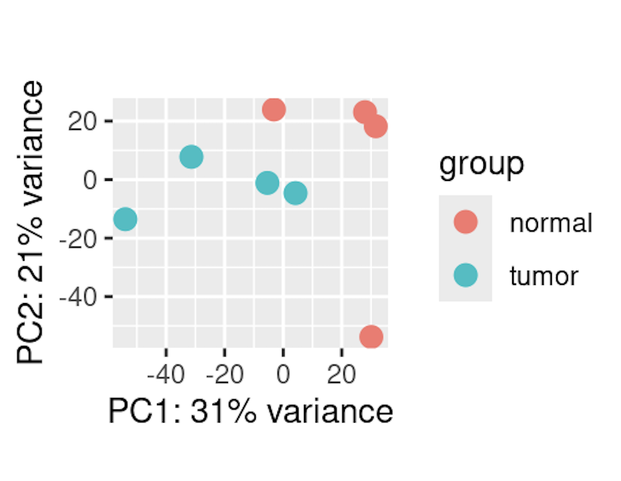
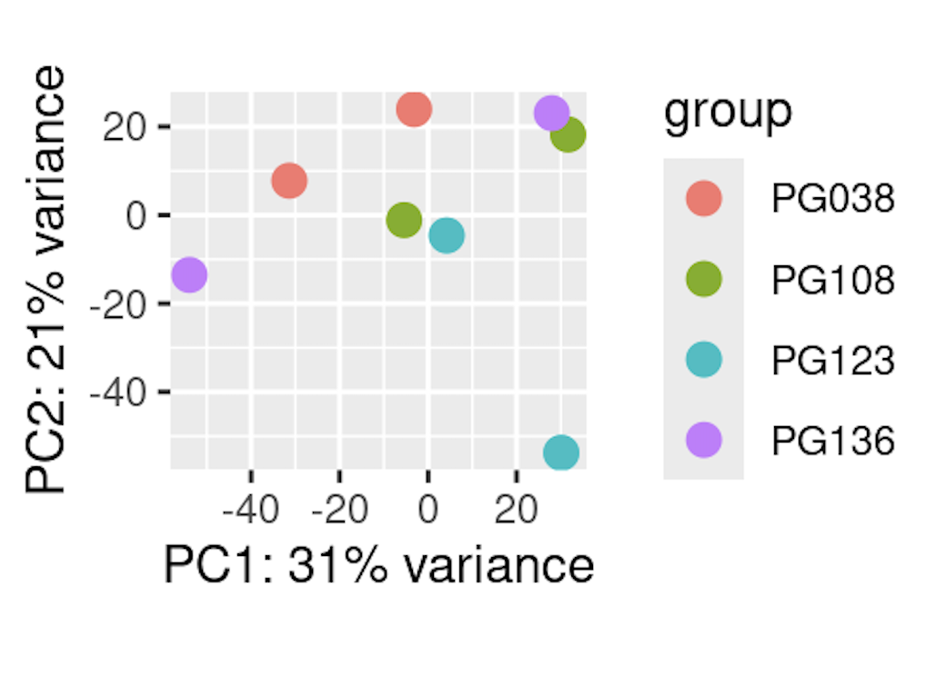
PCA Plots:
PCA Plot by Patient
PCA Plot by Condition

