URL: [Click-Here](https://chewyuhan.github.io/FIT3179-Asm2/)

Screenshot:

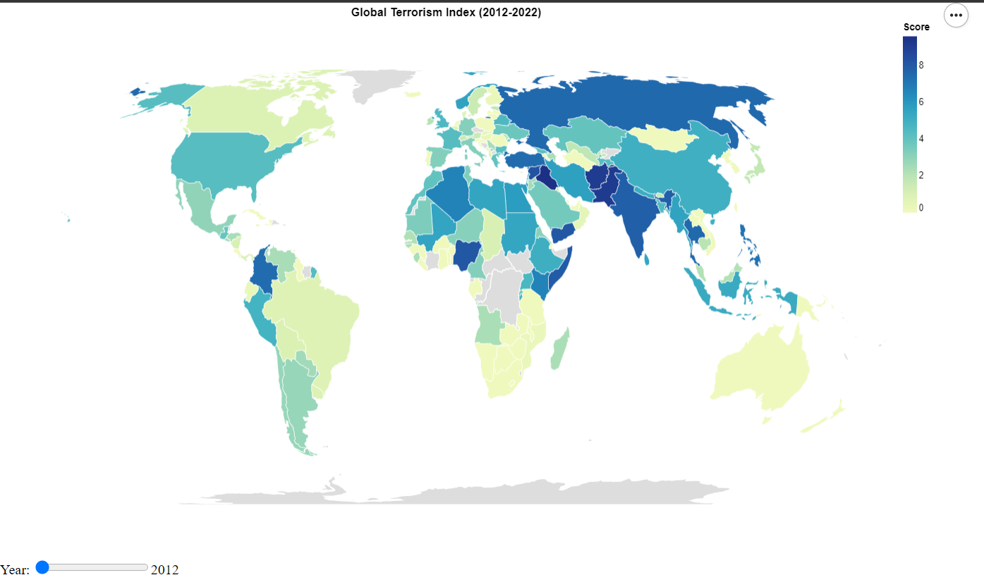

* Domain of the Visualisation: The domain of the visualisation is the "Global Terrorism Index (GTI)," which assesses the impact of terrorism in 163 countries, covering 99.7% of the world's population. It aims to understand how the impact of terrorism varies across countries and over time.
* Visualised Dataset:
  + Attributes: The dataset used in the visualisation includes the following attributes:
    - "Country": The name of the countries.
    - "Year": The year for which the Global Terrorism Index (GTI) data is being visualised.
    - "Score": The GTI score, representing the impact of terrorism on a scale from 0 to 10.
  + Source and Author: The data source is the Institute for Economics and Peace (IEP). The authorship of the data belongs to IEP.
  + Data Transformation: The dataset given is clean and tidy. I just removed some unused data, such as ISO 3C code. Normalisation is not needed because the data itself represents the score for a specific year, and the data originally had been normalised into a range of 0–10.
  + Justification for the Choropleth Map:
    - A choropleth map is chosen to visualise GTI scores across countries, effectively using colours to show variations in terrorism impact.
    - A slider allows users to explore how GTI scores change over time, aiding trend analysis.
    - A proportional symbol map typically represents data using different-sized symbols, which might not be as suitable for visualising the distribution of a single continuous variable like the GTI score across countries.
    - Dot maps are often used for displaying point data, which may not be appropriate for country-level data unless you are plotting specific incidents.