**Game Plug**

*System and Vision Document*

Problem description

The creation of +100 video games every year for the past 50 years has caused some games to get lost or forgotten. Through the proposed Software we would, within a specified time frame, create a data base of video games in which the user can input specify characteristics and categories for videogames, and the software will recommend videogames ranked by matching characteristics.

The software will break video games down by age rating, type, characteristics, and gaming system. Though the video game database system the user will be provided a better solution to finding video games that appeal to the user. This system allows for video games to be highlighted that are accessibly to multiple groups and persons.

Functionality

This systems scope will be limited to four gaming platforms, which are PC, Wii, PS4, and Xbox One. This system will not contain a complete history and coverage of all videogames created, because many older games came out on older specific consoles and are not transferable to other gaming systems. The four systems were selected to provide the largest pool of games without excess gaming systems. This will alleviate database clutter and provide a more efficient, larger database with provided data. This system will store information about the users such as an email as well as specifications for video game to compile the list.

This software will act as a bridge between video games and people looking for a new game to play and will decreases time spent searching for a new game to play. This system works by arranging and categorizing video game elements that appeal to users, while hiding non-desirable categories and genres, which will allow users to find video games that meet a specified requirement quickly and efficiently.

Business Opportunity

Indie video games that are not released on popular platform, such as PS4, will not be found in the initial web searches. This Video game recommendation software will help users looking for specialized games that are created by smaller companies, in finding and recommending a video game quickly and efficiently. The software also works in weeding out and present game suitable for the user’s specifications.

The Video game recommendation software helps in adjusting and arranging video games information related to the users request and checking the database then ranking games and displaying the output for the user. The administrators will input and modify all video game data and information. The video game recommender software will allow users to get quick results for simple or complex queries while providing more game exposure to gamers.

There is a demand for more exposure for smaller indie video game company’s products (i.e. video games). Indie video game developers and smaller game development companies would highly benefit from the exposure the game plug, video game recommender software can supply. The exposure our software can provide would, in an essence, recommend the buyer’s video game to its intended audience through our categorization algorithm, and eventually cause the purchase of the recommended video game. Game Plug will allow video game players to be introduced to smaller company’s product at the same time as other bigger, mass market games. The Game plug software will seek to rectify the divide caused by less access and employee personnel. The software, game plug – a video game recommender, will increase business for smaller companies.

Interface Functionality Requirements

* Display Input option list - Provide a list of characteristics and categories the user can implement to better cater to the user's game specifications.
* Text box (Characteristics) – The user will be able to enter into field 1 the first characteristic. The user will be able to enter field 1 the game title.
* Text box (Age) – The user will be able to enter the field age rating.
* Text box (Type) – The user will be able to enter the field the different types of video games offered in the data base. This would include categories such as: FPS, RPG, and casual.
* Text box (System) – The user will be able to enter the field
* System output (Rank) – After submitting form the system will rank the specified characteristics based on matches.
* Access - Program can be accessed over the internet to better utilize the program.

Interface Non-Functionality Requirements

• Recoverability – In order to improve the communication between system and user, recovering previous results will be manage by an email of recommended list of games being optionally added at the end of the results.

Business Requirements

* Database - Data must be entered before a request can be approved.
* Evaluate data – Through regular updates, the system will look for new games published every 1-2 months the system makes the overall project management much easier and flexible.
* Product Visibility – This software will be fundamental in increasing user access and showcase video games that are not promoted by big video game development companies.
* Access – This software should be made accessible to persons with different disabilities such as but not limited to: blind, Deaf, Handicaps/ movement disabilities, etc.

Regulatory/Security Requirements

* Administrator - The system will limit data base access to authorized users.
* Admin editor - The system will limit insertion and deletion of games to authorized users.
* Admin Data entry - General users can enter requests to include game but cannot approve or delete requests.
* Admin approval - Members of Admin can enter or approve a request.
* Large Database storage - vast amounts of video game data can be stored, to improve video game data base categories

Supplementary specification

*Design*

* Remote Access - All functionality shall be available remotely through an internet connection.
* Design for Ease-of-Use - The user interface of Gam plug software shall be designed for ease-of-use and shall be appropriate for a computer-literate user community with no additional training on the System.
* Online Help - Each feature of the C-Registration System shall have built-in online help for the user. Online Help shall include step by step instructions on using the System. Online Help shall include definitions for terms and acronyms
* New Releases Downloadable - Upgrades to the Vide game database shall be downloadable from the UNIX Server over the internet
* Software Limitations - The SDMS software limitations are defined by the limitations of its support web server and database server.

*Availability*

* The game Plug software website shall be available 24 hours a day, 7 days a week. There shall be no more than 4% down time. The user must be able to access all the resources of the website virtually anytime.

*Supportability*

* Game plug software website must be compatible with almost all leading browsers.
* All the plug-ins that are embedded within the website must be compatible with the browsers.
* If compatible plug-ins not there should be an option for appropriate trouble shooting guidance to install the plus-in.

*Online User Documentation and Help System Requirements*

* Online support concerning administration issues & user interface tutorials
* File and release notes are to be delivered on website to the user in each release.
* User guides and Administration guides are to be provided per customer request.

*User Interfaces*

* All interaction with the software will occur through a web-based interface.
* The game plug software will be accessed through a secure user interface requiring the use of an email to receive results.
* Any unexpected system operation will be announced to the user with an error web page stating the cause of the error. In the event that a cause cannot be readily determined a generic error message will be presented.
* The layout of the web interface will conform to a standard screen resolution of 1024x768.

*Licensing Requirements*

Licensing enforcement requirements or other usage restriction requirements which are to be exhibited by the software.

*Legal, Copyright and Other Notices*

Necessary legal disclaimers, warranties, copyright notices, patent notice, and wordmark, trademark, or logo compliance issues for the software.

Glossary

Remote access - ability to access a computer or a network remotely through a network connection.

Data base - set of data held in a computer that is accessible in various ways.

Video game – a game played by electronically manipulating images produced by a computer program on a television screen or other display screen.

Data Definitions

|  |  |  |
| --- | --- | --- |
| *Name* | *Type* | *Maximum Length* |
| Text boxes | text | 40 |
| Email address | text | 40 |
|  |  |  |

Use cases

*Admin*

* Add game – Admin can add game to database upon release of game.
* Add category – Admin can add or edit category option based on game characteristics.
* Delete game – Admin can delete game if no longer available.
* Delete category – Admin can delete a category when it is no longer relevant.
* Update database – Admin can update database all at once if many games are released
* System shutdown – incase of security breech system can be shut down by admin.
* System update – When windows or other operating system or browser updated system will update to accommodate new update

*User*

* Select category – User can select desired game category to include in recommended game list
* Deselect category - User can deselect desired game category in recommended game list
* Enter email – User can include email to be emailed a list of recommended games
* Sort List - User can sort through recommended video game list by most filled specifications or least filled specifications among other categories.

Use case diagram

Game Plug Software

Add Categories

Add game

Admin

Delete game

Edit Database

System update

System shutdown

Deselect Categories

User

Select Categories

Email list

Use cases 1

Actors: User

Main scenario: receive recommended video game list

1. User inputs site name
2. User enters email address to be sent the list
3. User selects to include categories
4. User selects categories to not include
5. User clicks age range slider and slides to desired age range
6. User confirms selections
7. List is emailed to user
8. User receives list
9. User receives list in order of most categories that match selected specifications
10. user exits website

Alternate: No email address enter

1. User can choose not to input email
2. User selects to include categories
3. User selects categories to not include
4. User clicks age range slider and slides to desired age range
5. User confirms selections
6. User receives list
7. User receives list in order of most categories that match selected specifications
8. List will not be saved upon exit of website or software

Use cases 2

Actors: Admin

Main scenario: add to database

1. Enter credentials to gain access to administrator mode
2. Receive information about video game
3. Categorize game based on characteristics
4. Submit documentation to software
5. Software will start including updated list within next search

Alternate:

5a. incorrect credentials enter to many times and access is restricted for 30 minutes

5b. Software doing a manual update and data base inaccessible

**Game Plug**

*System and Vision Document*

*Group Members*

* Diamond Beverly
* Tyra Buchannan
* Cheyenne Holland

Iteration 1

*Use cases selected*

Actors: Admin

Main scenario: add game

1. Enter credentials to gain access to administrator mode
2. Receive information about video game
3. Input game information into database
4. Submit documentation to software
5. Software will start including updated list within next search

Alternate:

1. Video game is already listed in database

*Iteration Milestones*

|  |  |
| --- | --- |
| *Milestones* | *Time* |
| Create UI Prototype | 1 day |
| Begin working on first iteration | 2 days |
| Complete first iteration | 14 days |

*Iteration Plan*

|  |  |
| --- | --- |
| *Objectives* | *Assigned to* |
| Requirements workshop | *Everybody* |
| Create Supplementary requirements | *Diamond* |
| Create Glossary | *Diamond* |
| Technical meeting   * Test guidelines | *Everybody* |
| Initial use case model | *Tyra* |
| Initial risk list | *Cheyenne* |
| Initial issue list | *Cheyenne* |
| Project status meeting | *Everyone* |
| Implement use case | *Everybody* |
| Elaboration use case | *Everyone* |

*UI Prototype*

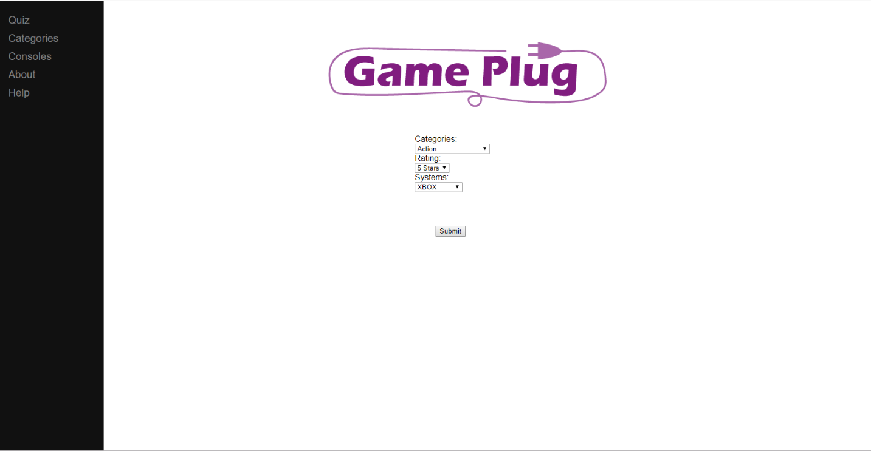

*UI Prototype Design*

GAME PLUG

Categories

Quiz

Get results!

About

Help

System

Rating

category