# CS-340 Client/Server Development

**Dr. Wilson**

**Cheyenne Nave**

**October 17, 2024**

## About the Project/Project Title

This project provides Grazioso Salvare, an animal-training company, information about dogs at various animal shelter locations to identify and categorize available dogs for life-saving training purposes.

## Motivation

Grazioso Salvare trains dogs for search and rescue operations. They have partnered with a non-profit organization in Texas to provide information about local animal shelters. I have imported the database and built an index to navigate it properly, while also using CRUD operations to create, read, update, and delete entries.

## Getting Started

To start, follow the steps below:

* Ensure the following tools are accessible and ready to use:
  + Jupyter Notebook
  + PyMongo
  + Python
  + Mongoimport
  + Mongosh
* Using Mongo Terminal
  + Open a terminal and start a Mongo session
    - Access by typing “mongosh”
  + Import the database labeled “AAC”
  + Use the database with keywords “use AAC”
  + To navigate, use the findOne() function in Mongo
  + Animals can be searched with ID number, breed, type, and name
* Using Jupyter Notebook
  + Import the Dashboard into Jupyter and open as a new file
  + Run the cell
  + Click on the Dash app running on 127.0.0.1
  + The Dash app should open in a new window
    - The Grazioso Salvare Logo will display above different search options based on what the user is looking for. These include Water Rescue, Mountain/Wilderness Rescue, Disaster Rescue and Individual Tracking. These options can be selected to produce dogs that fit each rescue style including their geolocation on the provided map. Also, a pie chart of Preferred Dogs is provided to illustrate the breeds available for selection.
    - The information in the database used for this application is processed through a Python CRUD module to correctly Create, Read, Update, and Delete entries. As data changes through new dogs coming into various shelters, adoptions taking place, updates to records, and other possible changes, CRUD allows the database to be manipulated to reflect the correct information.

## Installation

Install Mongo for database use and navigation. Also, ensure a Python reader/writer is installed. Jupyter Notebook is needed to run the Dash app on 127.0.0.1.

## Usage

Below are screenshots of the project working.

### Code Example

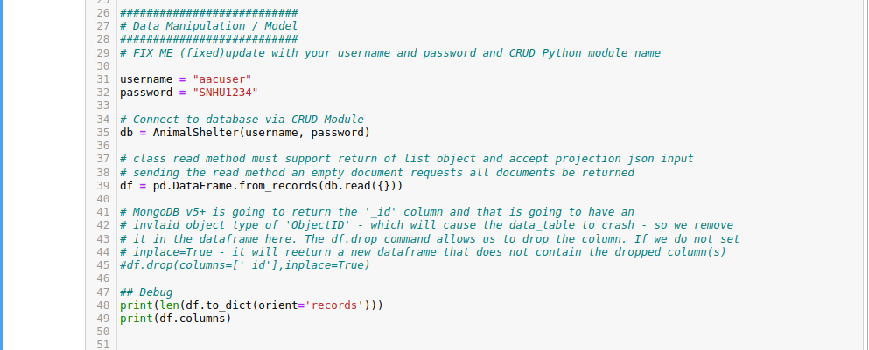

### Tests

Above is an example of the explain function that can be used.

## Roadmap/Features (Optional)

## *Note:* This README has been updated for CRUD module and Dash App functionality as of October 17, 2024.

## Contact

Cheyenne Nave