Triage and Safety-Profile Discovery in FDA Adverse Event Reports:
Predicting Serious Outcomes and Clustering Drugs by Reported Reactions
Orko Mookerjee, Che-Yu Liu, Nikhil Jain
SIADS 696 Milestone II, University of Michigan School of Information

1. Introduction
The FDA Adverse Event Reporting System (FAERS) receives roughly 1.5 million case reports a year from manufacturers, clinicians, pharmacists, consumers and lawyers. Each report names one or more suspect drugs and the reactions the reporter observed. Safety reviewers face two recurring problems. First, triage: serious cases (those involving hospitalization or death) must be found quickly among a large majority of non-serious ones. Second, pattern discovery: reviewers want to know which drugs are reported with similar reactions, so that a new report or a new drug can be read against a known safety profile.
We address both with one reproducible pipeline built on 8.5 million FAERS cases from 2020 to mid-2026. In Part A (supervised) we predict whether a case involves hospitalization or death using only information available when the report arrives: patient demographics, who reported it and from where, and which drugs are suspected. We deliberately exclude the reaction terms, because terms such as DEATH or HOSPITALISATION restate the outcome. We compare four model families (logistic regression, Bernoulli naive Bayes, random forest and histogram gradient boosting) under a strict time split: we train on 2020-2024, tune on early 2025 and test once on the following four quarters. In Part B (unsupervised) we describe each of the 500 most-reported suspect ingredients by the reactions reported with it, and cluster those profiles with k-means and with hierarchical (Ward) clustering. Seriousness is compared across clusters only after they are fixed. A final notebook scores a new quarter end to end and tags every case with the clusters of its drugs.
The motivation is practical. Seriousness drives regulatory reporting timelines (15-day expedited reports), yet in spontaneous reports it is coded inconsistently, and manual review does not scale. A ranked queue with calibrated probabilities lets reviewers read the most likely serious cases first. Clusters of drugs with similar reaction profiles give context for hypothesis generation. Neither output is causal: FAERS has no denominator of exposed patients, so we treat both as decision support.
Main findings. (A) Histogram gradient boosting is the best family. On the held-out test year it reaches an average precision (PR-AUC) of 0.602 and ROC AUC of 0.818, against 0.534 / 0.788 for logistic regression and a 0.262 floor. Drug identity and report origin carry most of the signal. Performance drifts down as new drugs appear, and the remaining errors are mostly reports with too little information, outcomes that are serious by other criteria, or inconsistent labels. (B) With each report's evidence split among its suspect drugs, TF-IDF reaction profiles form clinically recognizable groups: injectable biologics, GLP-1 agonists, opioids, cytotoxic chemotherapy, inhaled respiratory drugs, HIV antiretrovirals, ADHD stimulants and others. k-means and Ward clustering agree moderately (ARI 0.56). Although no outcome was used in fitting, the clusters separate the serious-outcome rate from 0.2% (topical acne and sunscreen products) to 63% (substances of abuse). Over time, the GLP-1 cluster's share of reports tripled. Novel contributions relative to prior FAERS work: an explicit audit for target leakage and for a target-coding change at 2021Q4; time-based validation with a held-out future year; and a case-weighting fix that keeps a few thousand templated reports from defining the profiles of common drugs.

2. Related Work
Seriousness prediction. Zhao et al. (2023) built GCAP, a graph-based multi-task deep network that predicts whether a drug-reaction pair leads to a serious outcome and which of seven outcome classes it falls into, using drug structures and reaction semantics. Routray et al. (2020) trained neural classifiers on a manufacturer's case reports to decide seriousness and its category from report text, reaching 83-93% accuracy. Both use the reaction or narrative as input. Our task is different and harder: we predict the outcome without the reactions, which would leak it, so that the model can rank cases at intake. We also validate on later quarters rather than on a random split, and we calibrate the probabilities.
Disproportionality and data mining in FAERS. The proportional reporting ratio (PRR; Evans et al., 2001) and its Bayesian relatives are the standard signal-detection tools. Sakaeda et al. (2013) show how to mine the public FAERS files with these statistics, and Harpaz et al. (2012) review data-mining methods for adverse drug events. These methods score one drug-reaction pair at a time. Our PPMI representation borrows the PRR idea, but we use whole profiles to group drugs.
Drugs grouped by side effects. Campillos et al. (2008) showed that drugs with similar side-effect profiles (from package inserts) tend to share protein targets. Tatonetti et al. (2012) mined FAERS for drug effects and interactions, correcting for confounding, and released the OFFSIDES and TWOSIDES resources. We cluster post-marketing reporting profiles rather than labels, compare two clustering methods, measure stability, and check the clusters against outcomes and time afterwards. This project is new work and does not extend a Milestone I project.

3. Data Source
Source and format. We used the FDA FAERS Quarterly Data Extract Files in XML (ICH E2B) format, downloaded from the FDA website (U.S. FDA, 2026) as one zip per quarter: 26 zips from 2020Q1 to 2026Q2, about 3.4 GB compressed. Each XML safetyreport element holds report fields (report id and version, receipt dates, report type, reporter qualification, country, seriousness flags), patient fields (age with unit, age group, sex, weight) and repeated drug (role, product, active ingredient) and reaction (MedDRA preferred term) elements.
Records and coverage. Notebook 1 streams each XML file and keeps one row per case, the latest safetyreportversion, and drops FDA's deleted cases: 8,555,729 cases from 23 quarters. Three quarters (2023Q3, 2024Q1, 2024Q4) could not be read because their zips use Deflate64 compression, which Python's zipfile does not support. We document this as a known gap. After cleaning (Section 4), 8,477,316 cases remain. They carry 14.0 million case-ingredient rows (7,183 distinct ingredients) and 25.4 million case-reaction rows (21,654 distinct MedDRA terms).
Important variables. The supervised target y_hosp_or_death is true when the case records death or hospitalization (26.1% of the 98.9% of cases with a known target). Inputs are age, sex, weight, reporter qualification, report type, occurrence country, the number of drugs and suspect ingredients, and the suspect ingredients themselves. Part B uses the suspect ingredients and reaction terms. Age is missing for 43.6% of cases, sex for 15.4% and weight for 83.5%.

4. Feature Engineering and Preprocessing

Cleaning (notebook 2)
- Target rebuilt from raw codes. FAERS codes seriousness flags as 1 = yes, 2 = no. Up to 2021Q3 the XML writes only "1", so a blank means no. From 2021Q4 both codes are written and a blank means unknown. Notebook 2 detects the yes-only quarters from the data (2020Q1-2021Q3). The earlier team version had turned every blank into "no", which made the target artificially rarer after 2021Q4. Unknown targets (1.2%) are dropped from modeling.
- Patient fields. Sex code 0 becomes missing. Age is converted to years from its unit, and age group (neonate to elderly, ICH E2B bands) comes from age or else from the reporter's code. Weights outside 0.3-350 kg, or above 40 kg under age 2, are set to missing (1,229 values).
- Cases with no suspect drug are dropped (24,814).
- Duplicates. Cases identical on sex, age, weight, country, receipt month and the exact drug and reaction lists are grouped. Groups of 2-5 with at least two reactions are duplicates and the newest is kept (53,599 dropped). Groups larger than 5 are flagged as mass reports (114,860 cases; templated litigation or program reports).
- Ingredients standardized. Combination products are split (DOLUTEGRAVIR SODIUM\LAMIVUDINE gives two ingredients), and trailing salt words are removed (RANITIDINE HYDROCHLORIDE becomes RANITIDINE) unless only a mineral would remain.

Modeling population and split (notebooks 3-4)
The EDA (notebook 3) produced 15 findings that drive the feature decisions. Four of them concern leakage. (1) Reaction terms restate the target: DEATH cases are 99% positive and HOSPITALISATION 96%. (2) The expedited (15-day) flag is assigned because a case is serious (44% vs 4% positive). (3) Legacy cases first received before 2020 are 42% positive, because serious cases attract follow-up versions. (4) The mass-report flag is computed over all years, so it would carry future information. All four are excluded. The modeling population is cases with a known target, received from 2020 on, and not mass reports (8,012,423 cases). It is split by FAERS quarter (Table 1).
Table 1. Modeling population and time-based split (notebook 4).
Split | Quarters | Cases | Positive rate | Use
Train | 2020Q1-2024Q3 | 5,914,363 | 0.258 | 1,000,000-row stratified sample used for fitting
Validation | 2025Q1-2025Q2 | 626,361 | 0.260 | tuning, threshold choice, calibration
Test | 2025Q3-2026Q2 | 1,471,699 | 0.262 | evaluated once, at the end

Final features (440 columns)
All levels, vocabularies and scalers are learned from training data only. Patient: age in years (median-imputed, standardized), age group (one-hot, including missing), sex (one-hot, including missing), weight in kg (median-imputed, standardized), and age-missing and weight-missing indicators. Missingness carries signal: cases with missing age are 18% positive vs 32% with age present. Report: reporter qualification, report type, and occurrence country (the 10 most common training countries, else OTHER, one-hot), plus an is-US flag. Drug counts: log1p of the number of drugs, suspect ingredients and suspect ingredients outside the drug vocabulary, standardized. Drug identity: 400 binary flags for the most frequent training-period suspect ingredients, which cover 80% of mentions and appear on 88% of training cases, 82% of validation cases and 76% of test cases. Categories with fewer than 1,000 training cases are merged into an infrequent level. The complete list is in Appendix A.

Part B representation (notebook 6)
For clustering, each of the 500 most-reported suspect ingredients (85% of ingredient mentions) is described by its evidence across the 1,000 most-reported reaction terms (85% of reaction mentions). The outcome terms DEATH and HOSPITALISATION and all mass reports are removed. A plain count of co-reported pairs is dominated by a few very large reports: 1% of cases (more than 10 suspect drugs or 30 reactions) produce 40% of all pairs, and about 4,600 templated Canadian reports (median 27 drugs and 49 reactions) produce 13% alone. We therefore weight each pair by 1 / (number of suspect ingredients on the case), which splits a case's evidence among its drugs. From this 500 x 1,000 matrix we build three representations. Share: each row divided by its total (the original team notebook's choice). TF-IDF: log(1 + evidence) times inverse document frequency across drugs, rows scaled to unit length. PPMI: positive pointwise mutual information, log(observed / expected), which is the disproportionality idea behind the PRR. Each is reduced to 50 dimensions with truncated SVD and scaled to unit length.

5. Part A: Supervised Learning

5.1 Methods
Workflow. Notebook 4 builds the 440-column matrices and fits the scaler and encoders on the training sample only. Notebook 5 then (1) tunes each model family on a 300,000-row training subsample, scoring candidates on the validation quarters; (2) compares the tuned families with 5-fold cross-validation inside the training period; (3) refits each family on the full 1,000,000-row training sample, chooses a decision threshold on validation and evaluates once on test; and (4) runs calibration, feature importance, ablation, sensitivity, trade-off and failure analyses on the best model. The final model, its calibrator and threshold are saved and reused by the scoring pipeline (notebook 7).
Model families and justification. We compare four families with different mechanisms (Table 2). Logistic regression is linear and discriminative: the log-odds are a weighted sum of the features, so each coefficient reads directly as a drug, country or reporter effect. It is the interpretable baseline from the proposal. Bernoulli naive Bayes is a generative probabilistic model that assumes features are independent given the class. It is very fast and tests whether the presence or absence of drugs and categories alone is enough; scaled numeric columns are binarized at the training mean. A random forest averages deep trees grown on bootstrap samples with random feature subsets, and captures interactions such as drug x age without careful tuning. Histogram gradient boosting (scikit-learn's LightGBM-style implementation; Ke et al., 2017) adds shallow trees one at a time, each fitting the previous errors, and is usually the strongest learner on mixed tabular data. All four use the same 440 features, so differences come from the learner, not the representation. Trees are unaffected by the standardization the linear models need.
Hyperparameter tuning. For each family we searched a small grid (Appendix Table 10) and kept the setting with the highest validation average precision: the regularization strength C for logistic regression, the smoothing alpha for naive Bayes, the features per split and minimum leaf size for the random forest (200 trees, half-sample bootstraps), and the learning rate, leaves per tree and number of boosting rounds for gradient boosting. Tuning on later quarters rather than a random fold selects settings that hold up over time.
Table 2. Model families, tuned settings and validation average precision (AP) of the tuning run (300,000 training rows).
Family | Mechanism | Tuned setting | Validation AP
Logistic regression | linear, discriminative | {C: 10.0} | 0.551
Naive Bayes (Bernoulli) | generative, probabilistic | {alpha: 0.1} | 0.521
Random forest | bagged trees | {max_features: 0.1, min_samples_leaf: 5} | 0.608
Gradient boosting (histogram) | boosted trees | {learning_rate: 0.1, max_leaf_nodes: 127, max_iter: 300} | 0.625

5.2 Evaluation

Metrics
Positives are 26% of cases, and a reviewer reads a ranked queue from the top. Our primary metric is average precision (AP, the area under the precision-recall curve), which rewards purity at the top of the ranking and whose chance level equals the positive rate (Saito & Rehmsmeier, 2015). We also report ROC AUC for comparison with the literature, the Brier score (the mean squared error of the probabilities, a calibration check), and, at a decision threshold, precision, recall and F1. The threshold maximizes F1 on validation and is then applied unchanged to test.

Overall results
Table 3 compares the families with 5-fold stratified cross-validation (250,000 training-period rows; mean ± standard deviation over folds). The ranking is clear and the fold-to-fold spread (at most 0.004 AP) is an order of magnitude smaller than the gaps between families. Table 4 gives each family refit on 1,000,000 rows and evaluated on the test year (2025Q3-2026Q2, 1471699 cases). Gradient boosting leads on every metric: AP 0.602 vs 0.587 (random forest), 0.534 (logistic regression) and 0.508 (naive Bayes). At its validation-chosen threshold it flags 38.6% of cases with precision 0.499 and recall 0.738. Every family scores slightly lower on test than on validation (gradient boosting validation AP 0.635), the first sign of the drift discussed below.
Table 3. 5-fold cross-validation on the training period (mean ± standard deviation over folds). Fit time is per fold on 200,000 rows.
Family | Average precision | ROC AUC | Brier score | Fit (s)
prior | 0.258 ± 0.000 | 0.500 ± 0.000 | 0.192 ± 0.000 | 0.0
logistic regression | 0.567 ± 0.003 | 0.802 ± 0.003 | 0.149 ± 0.001 | 5.3
naive Bayes | 0.516 ± 0.003 | 0.777 ± 0.002 | 0.207 ± 0.001 | 0.5
random forest | 0.624 ± 0.003 | 0.823 ± 0.002 | 0.141 ± 0.001 | 25.8
gradient boosting | 0.645 ± 0.004 | 0.834 ± 0.003 | 0.136 ± 0.001 | 187.0

Table 4. Best model of each family, trained on 1,000,000 rows, evaluated once on the test year. Threshold = F1-optimal on validation. Alerts = share of cases flagged.
Family | AP | ROC AUC | Brier | Thresh. | Precision | Recall | F1 | Alerts | Fit (s)
prior | 0.262 | 0.500 | 0.193 | 0.500 | 0.000 | 0.000 | 0.000 | 0.0% | 0
logistic regression | 0.534 | 0.788 | 0.156 | 0.253 | 0.458 | 0.767 | 0.573 | 43.9% | 21
naive Bayes | 0.508 | 0.778 | 0.217 | 0.164 | 0.447 | 0.780 | 0.568 | 45.6% | 2
random forest | 0.587 | 0.811 | 0.147 | 0.318 | 0.485 | 0.749 | 0.589 | 40.4% | 190
gradient boosting | 0.602 | 0.818 | 0.145 | 0.310 | 0.499 | 0.738 | 0.596 | 38.6% | 265

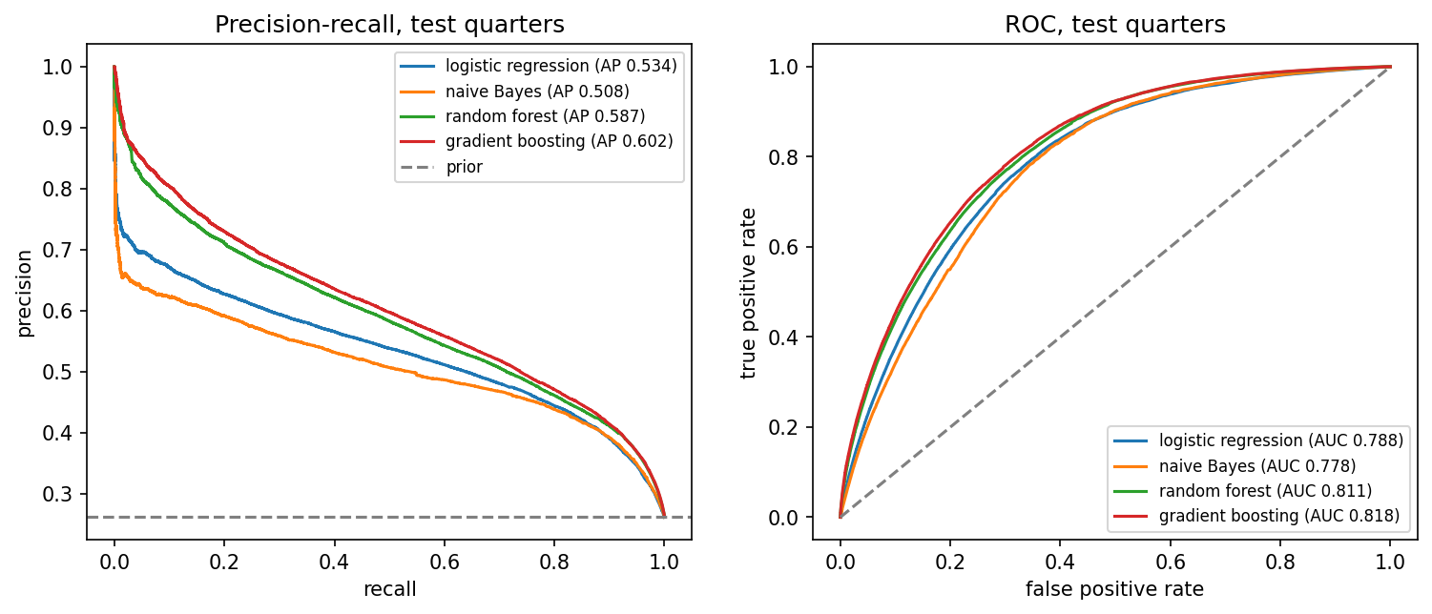
Figure 1. Precision-recall (left) and ROC (right) curves on the test year for the four families. The dashed line in the left panel is the positive rate (the AP of a random ranking).
Calibration. Gradient boosting's raw probabilities are already close to the diagonal (test Brier 0.1449; Figure 2). Isotonic regression fitted on validation barely changes the Brier score (0.1448), and because its step function ties many scores it slightly lowers AP (0.596 vs 0.602). The pipeline therefore ranks by the raw score and shows the calibrated value only as the displayed probability. Naive Bayes is badly over-confident, as its independence assumption predicts, and logistic regression is slightly under-confident at the top.
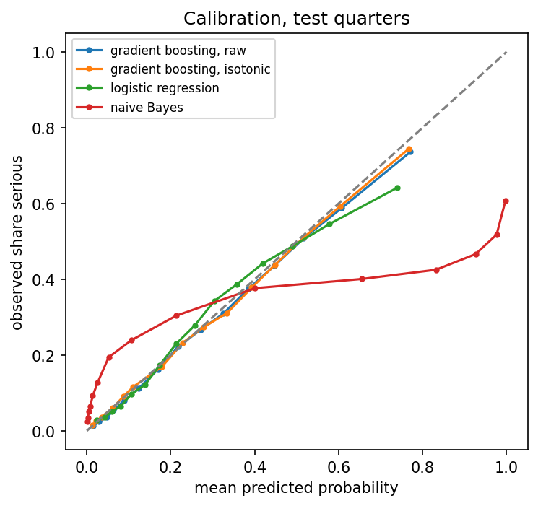
Figure 2. Calibration on the test year: observed share of serious cases against mean predicted probability, in 15 equal-size bins.

Feature importance and ablation (gradient boosting)
We measured permutation importance on 150,000 validation cases: each original feature (all its one-hot columns together) is shuffled and the drop in AP recorded, over three repeats. We also ran an ablation: the model is retrained (500,000 rows) without each feature group, and on each group alone (Figure 3). The most important single features are the drug flags (as a block) (0.158), US vs non-US origin (0.072), reporter type (0.046), followed by report type (0.044) and number of drugs (0.025). In the ablation, removing the drug flags costs the most (AP -0.067), followed by the report group (-0.064); removing the patient group (-0.018) or the drug counts (-0.008) costs less, because the remaining features partly stand in for them. Alone, drug identity reaches AP 0.496 and report origin 0.464. The model needs both what was taken and who reported it from where: ex-US reports reaching the FDA are mostly serious ones forwarded by manufacturers, while US consumer and lawyer reports are mostly not. Among individual drugs, the largest AP drops come from dupilumab, acetaminophen, clozapine, treprostinil, leuprolide.
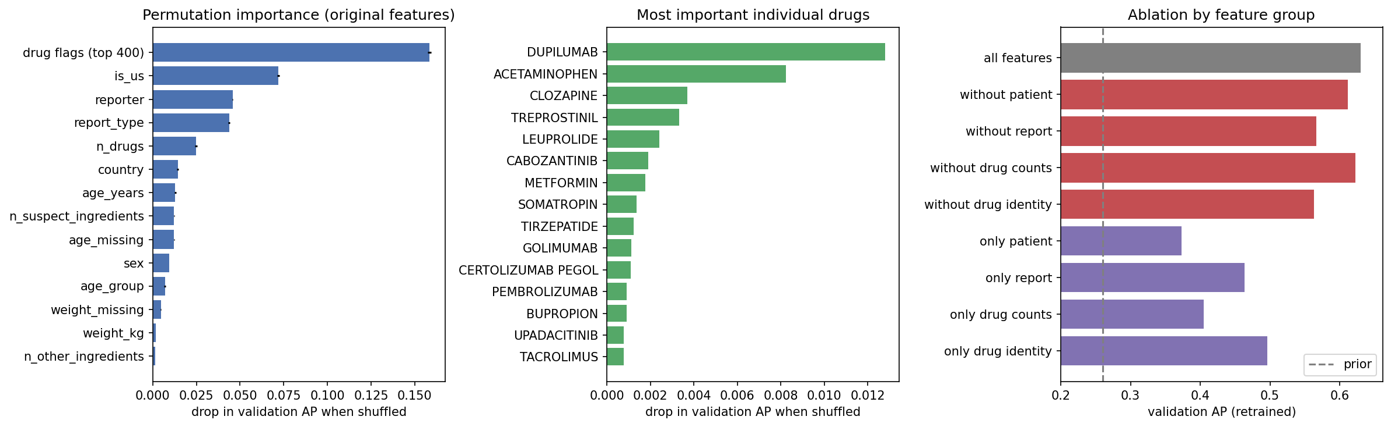
Figure 3. Gradient boosting: permutation importance of the original features (left) and of individual drug flags (center), measured as the drop in validation AP; ablation by feature group, retrained without (red) or with only (purple) each group (right).

Sensitivity analysis
We varied one choice at a time, retraining on 500,000 rows and scoring on validation (Figure 4). Hyperparameters: across learning rates 0.03-0.3 and 100-600 rounds, AP ranges over 0.599-0.631; only a low learning rate with few rounds (underfitting) or a high rate with many rounds (overfitting) falls off the plateau. Tree size (15-255 leaves) spans 0.599-0.631. Drug vocabulary: AP rises from 0.563 with no drug flags to 0.630 with 400, gaining about 0.01 AP per doubling of the vocabulary and still rising at 400, so a larger vocabulary (or drug classes) would help. Training size: AP grows from 0.496 with 10,000 rows to 0.635 with 1,000,000, still rising by about 0.01 per tripling of the data, so the 1,000,000-row sample costs little accuracy compared with all 5.9 million training cases. Random seed: five seeds give 0.629 ± 0.0002, so the differences above are real.
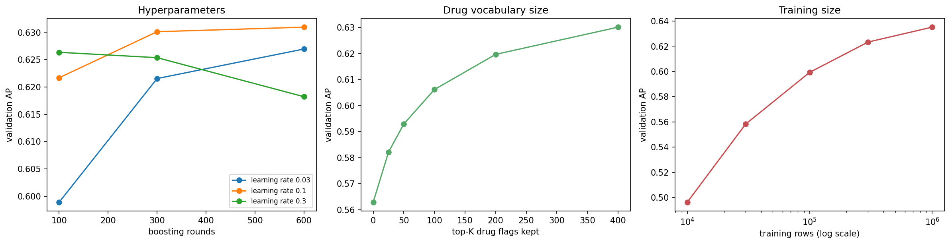
Figure 4. Sensitivity of gradient boosting (validation AP): learning rate x boosting rounds (left), number of drug flags kept (center), training-set size (right).

Trade-offs
Precision vs recall. Table 5 turns the calibrated model into operating points: each row targets a recall on validation and reports what happens on test. Catching 80% of serious cases means reviewing about 454 of every 1,000 reports at 0.47 precision. Pushing recall to 95% raises the load by half again (668 per 1,000) while precision falls to 0.37. Where to operate is a staffing decision; the model makes the cost of each choice explicit. Speed vs accuracy. Naive Bayes trains in 2 s but loses 0.09 AP; logistic regression takes 21 s, the random forest 190 s and gradient boosting 265 s on 1,000,000 rows for the best accuracy (Figure 5, center). Scoring a full quarter takes under a minute for any family, so training cost is the only real constraint. Accuracy vs interpretability. Logistic regression gives readable coefficients at a cost of about 0.07 AP. Stability over time. AP falls from 0.651 in 2025Q1 to 0.580 in 2026Q2 (Figure 5, right), with logistic regression degrading in parallel. Notebook 4 shows why: the share of cases with at least one top-400 training drug falls from 88% (train) to 76% (test) as new drugs enter the market. Retraining each quarter would be part of any deployment.
Table 5. Operating points of the calibrated gradient boosting model. The threshold is chosen on validation to reach the target recall, then applied to test.
Target recall (val) | Threshold | Precision (test) | Recall (test) | Flagged | Reviews per 1,000
0.50 | 0.474 | 0.596 | 0.503 | 22.1% | 221
0.70 | 0.348 | 0.511 | 0.718 | 36.7% | 367
0.80 | 0.256 | 0.466 | 0.810 | 45.4% | 454
0.90 | 0.179 | 0.413 | 0.901 | 57.0% | 570
0.95 | 0.099 | 0.371 | 0.948 | 66.8% | 668

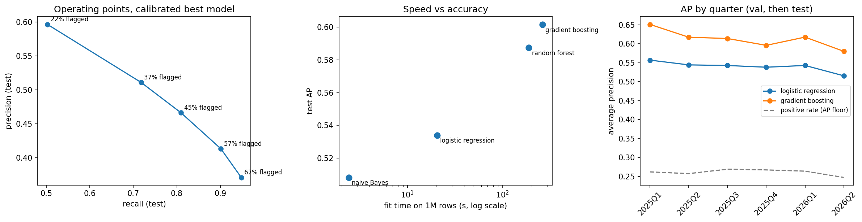
Figure 5. Trade-offs: precision and recall at the operating points of Table 5 (left); training time vs test AP per family (center); AP by quarter over validation and test, with the positive rate as the floor (right).

Failure analysis
Errors on the test year at the F1 threshold concentrate in identifiable segments (Table 6). Cases with neither age nor sex (FNR 0.447), consumer reports (0.426) and lawyer reports (0.768) miss the most serious cases, and cases with no top-400 drug have low AP (0.489). In the other direction, ex-US reports from health professionals are flagged almost always (FPR 0.734), because most of them are serious. We then picked five failures by rule rather than by hand (Appendix Table 9) and read their full ingredient and reaction lists. Those lists are not model inputs; we use them only to understand the errors. Three kinds of failure stand out:
- Reports with too little (or contradictory) information: examples A, B, D. All three are US consumer reports with no age or sex and one or two drugs. Example A lists conestat alfa, a rare drug outside the vocabulary, and the case is coded as hospitalized while its only reaction is "no adverse event". diclofenac (B) is a common, mostly non-serious drug whose only listed reaction is "hospitalisation". Example D lists mometasone | olopatadine (a nasal spray and eye drops) with a reported death and a device complaint. The features describe a low-risk report, and nothing available at intake contradicts that. Fix: treat sparse reports as their own queue (or flag them for follow-up) rather than trusting a low score; add drug-class or Part B cluster features so an unseen drug like A inherits a class risk.
- Serious, but not by our definition: example C. The most confident false positive (p = 0.998) is a 92-drug report from a health professional in CA, one of the templated Canadian reports, describing a congenital anomaly after exposure via breast milk. A congenital anomaly is itself an FDA seriousness criterion, but not hospitalization or death, so the label is negative. Every feature (ex-US, health professional, many drugs) points to "serious", and in the regulatory sense the model is right. Fix: predict the full seriousness flag, or the seriousness criteria as a multi-label target, as Zhao et al. (2023) do.
- Label noise: example E. A male 38-year-old's report from a physician lists fentanyl | cocaine | diamorphine with respiratory acidosis, heart rate increased, somnolence, respiratory depression, miosis, yet it is coded as neither hospitalization nor death (p = 0.991). Across all confident false positives, 4.9% list a reaction that is almost always serious (death, sepsis, cardiac arrest, respiratory failure...), against 1.2% of true negatives: four times as often. Label noise explains only part of the false positives, but it caps the precision any model can reach. Fix: audit labels with reaction-based rules and train with noise-robust losses.
End-to-end pipeline. Notebook 7 applies the saved preprocessing, model and calibrator to the most recent quarter (2026Q2, 416,272 cases) without refitting anything. It flags 38.7% of cases for review with precision 0.477 and recall 0.748 (AP 0.580), the mean calibrated probability is 0.266 against an observed rate of 0.246, and 85% of cases are tagged with at least one Part B drug cluster, so a reviewer sees both a risk score and the safety-profile group of each suspect drug.
Table 6. Error rates by segment on the test year (gradient boosting, F1 threshold). FNR = share of serious cases missed; FPR = share of non-serious cases flagged.
Segment | Share of test | Positive rate | AP | FNR | FPR
all test cases | 100.0% | 0.262 | 0.602 | 0.262 | 0.262
no top-400 drug on the case | 23.9% | 0.234 | 0.489 | 0.313 | 0.289
age and sex both missing | 14.2% | 0.161 | 0.425 | 0.447 | 0.160
consumer reporter | 51.1% | 0.189 | 0.532 | 0.426 | 0.141
lawyer reporter | 1.1% | 0.126 | 0.389 | 0.768 | 0.033
health professional, outside US | 26.4% | 0.450 | 0.643 | 0.093 | 0.734
single drug on the case | 48.1% | 0.199 | 0.551 | 0.352 | 0.174
10+ drugs on the case | 9.8% | 0.439 | 0.705 | 0.143 | 0.529

6. Part B: Unsupervised Learning

6.1 Methods
Workflow. We count drug-reaction evidence, build three representations, cluster each with two methods for k = 4 to 30, choose k with a fixed rule, compare all six combinations, describe and visualize the chosen solution, and only then attach outcomes and time trends (notebook 6).
Methods and justification. We chose two algorithms with different mechanisms. k-means partitions drugs around k centroids by minimizing within-cluster squared distance. On unit-length SVD vectors this approximates cosine similarity. It is fast, and its centroids can assign a new or changed drug profile without refitting, which the pipeline needs. Agglomerative (hierarchical) clustering starts from single drugs and repeatedly merges the closest pair of groups. It is deterministic, needs no random start, and its tree shows nested structure. Because the unit of analysis is 500 drugs rather than millions of reports, both run on the full data, so no subsample is needed. The proposal planned report-level clustering, but drug-level profiles turned out more interpretable and directly comparable with pharmacology.
Hyperparameters. For agglomerative clustering we compared average, complete and Ward linkage. Average linkage chains (95% of drugs in one cluster at k = 8), complete linkage leaves a quarter to a half of the drugs in one cluster, and Ward gives balanced clusters with the best silhouette from k = 8 up, so we use Ward. For both methods we scanned k from 4 to 30 (k-means with 20 random starts each). Rule for k: among solutions whose largest cluster holds at most 25% of the drugs and whose bootstrap stability ARI is at least 0.5, take the highest silhouette. Silhouette keeps rising slowly up to k = 30 for every representation (Figure 6), and the Ward tree is nested, so there is no single natural k. We cap k at 30 (about 17 drugs per cluster, roughly a therapeutic class) for readability and test k = 26-34 in the sensitivity analysis.

6.2 Evaluation
Metrics. With no ground truth we use four internal criteria. Silhouette (cosine; is a drug closer to its own cluster than to the next?) and Davies-Bouldin (average similarity of each cluster to its nearest neighbor; lower is better) measure cohesion and separation. Largest-cluster share catches degenerate solutions that score well while putting most drugs in one cluster. Bootstrap stability is the mean adjusted Rand index (ARI; Hubert & Arabie, 1985) between the full-data clustering and clusterings refit on 20 random 80% subsets: 1 means identical and 0 means chance agreement. Silhouette is not comparable across representations, so it chooses k within a representation. Stability and balance are comparable across all of them. Finally, we check external meaning after fitting: the serious-outcome rate of each cluster, and how its share of reports changes over time.
Table 7. Best solution per representation and method at the chosen k, with the original notebook's setting for reference. Silhouette is comparable only within a representation.
Representation | Method | k | Silhouette | Davies-Bouldin | Largest cluster | Stability (ARI)
PPMI | agglomerative | 30 | 0.342 | 1.62 | 8.8% | 0.670
PPMI | k-means | 29 | 0.373 | 1.51 | 10.4% | 0.691
TF-IDF | agglomerative | 30 | 0.263 | 1.50 | 10.2% | 0.724
TF-IDF | k-means | 30 | 0.274 | 1.56 | 8.4% | 0.571
share | agglomerative | 29 | 0.303 | 1.73 | 7.6% | 0.647
share | k-means | 30 | 0.327 | 1.64 | 7.8% | 0.633
share (original notebook) | k-means | 12 | 0.232 | 2.08 | 13.8% | 0.625

Table 7 summarizes the six combinations. Once evidence is weighted, all of them keep the largest cluster near 10% of drugs. The original notebook's result, with 380 of 400 drugs in one cluster at k = 4, came from plain counts on uncleaned lists. On TF-IDF, Ward clustering is the most stable solution overall (ARI 0.72), while k-means is the least stable (0.57). On PPMI both methods reach about 0.67-0.69. We keep TF-IDF as the main representation because its weights explain each cluster directly, and k-means as the main method because of its centroids. Ward clustering serves as the check that the groups are not an artifact of one algorithm. The two agree moderately (ARI 0.56; Figure 8).
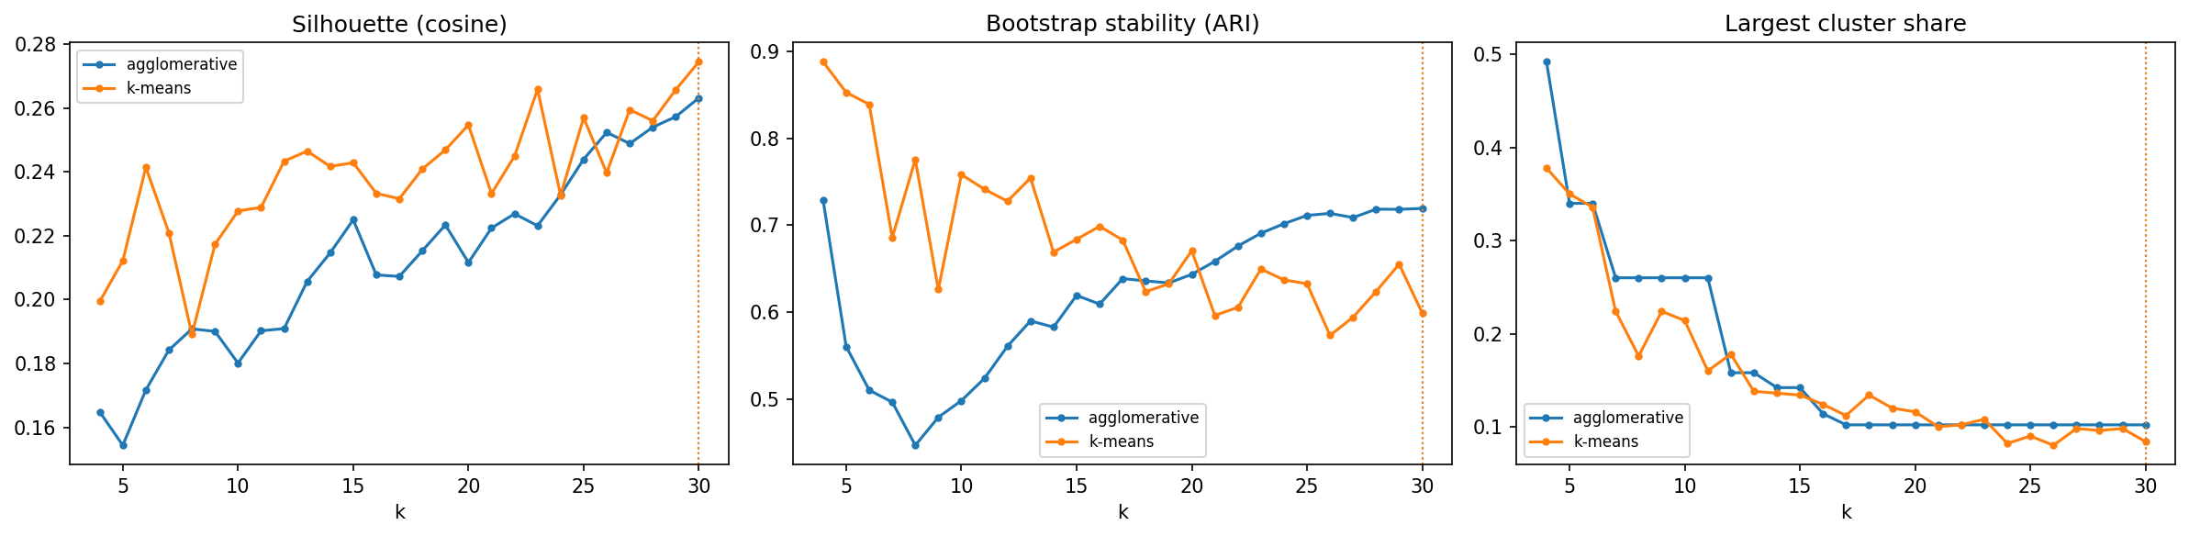
Figure 6. Choosing k for the TF-IDF representation: silhouette (left), bootstrap stability (center) and largest-cluster share (right) for k-means and Ward clustering. Dotted lines mark the chosen k = 30. Silhouette and balance improve slowly with k while k-means stability declines, so there is no single natural k.
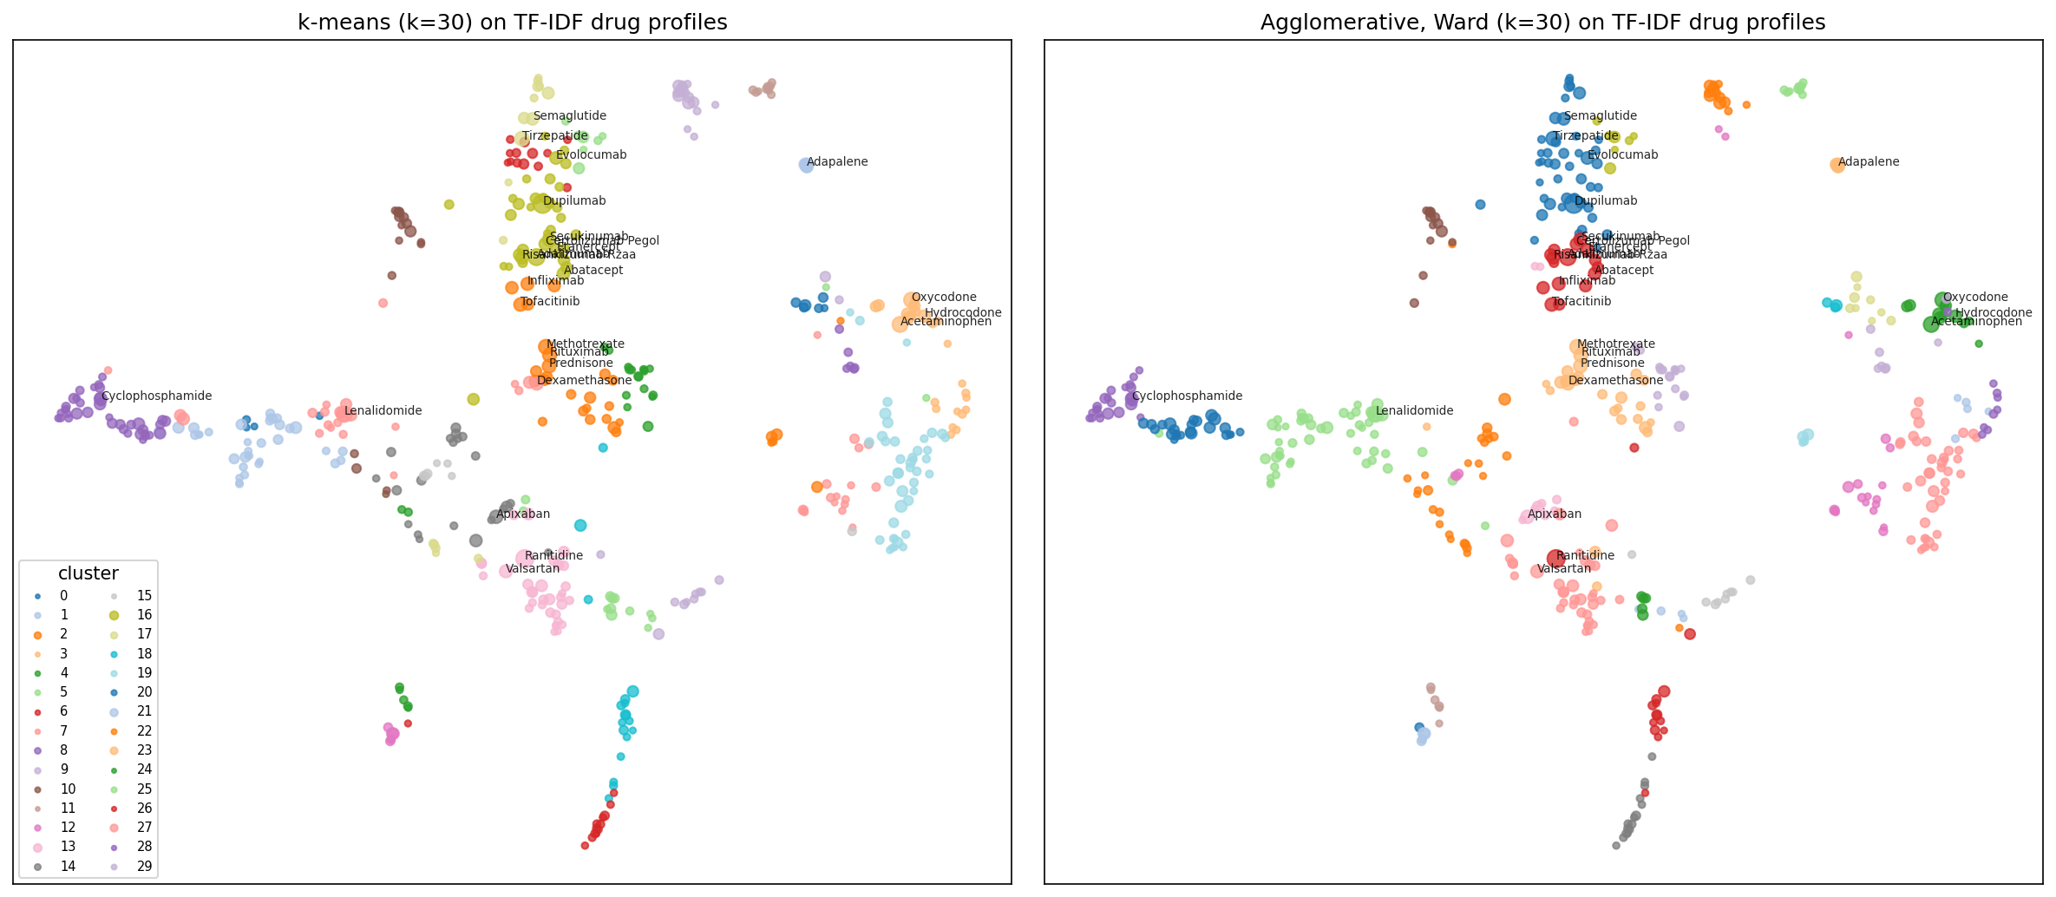
Figure 7. UMAP projection of the 500 drug profiles (for display only), colored by k-means (left) and Ward clusters (right). Point size grows with the number of reports. The same regions (biologics top center, oncology lower left, opioids and psychiatric drugs right, topical and device products at the edges) appear under both methods.
What the clusters are. Table 8 lists the 10 largest k-means clusters (all 30 are in Table 12, Appendix B), named by us from their members, with their most characteristic reactions (highest average TF-IDF weight; heatmap in Figure 10, Appendix B) and the outcome rate measured afterwards. Most clusters correspond to recognizable therapeutic classes even though no drug class was supplied: cytotoxic chemotherapy with febrile neutropenia and myelosuppression; opioids with dependence and neonatal withdrawal; psychiatric and antiepileptic drugs with intentional overdose; inhalers with wrong device technique; contraceptive implants and IUDs with device expulsion; ADHD stimulants with product substitution and changed therapeutic response; older HIV regimens (tenofovir disoproxil, efavirenz) with bone loss. Some clusters capture reporting behavior rather than pharmacology: device-delivered injectables (somatropin, pegfilgrastim, epinephrine) group by device malfunctions, and one cluster (cetirizine, folic acid, alendronate) exists because those products are listed on the templated Canadian rheumatoid-arthritis reports and inherit their reactions.
Table 8. The 10 largest k-means clusters (TF-IDF, k = 30), sorted by the share of their cases involving hospitalization or death. The outcome was not used for clustering. Share = the cluster's share of all cases, mean of the first four vs the last four quarters.
Cluster (our name) | Drugs | Most-reported members | Characteristic reactions | Serious | Share 2020 → 2026
Cytotoxic chemotherapy | 39 | Cyclophosphamide | Carboplatin | Doxorubicin | Paclitaxel | Febrile neutropenia | Myelosuppression | Off label use | 52.2% | 4.7% → 5.6%
Cardiopulmonary, anticoagulants | 22 | Apixaban | Sacubitril | Rivaroxaban | Macitentan | Diarrhoea | Dyspnoea | Off label use | 46.1% | 6.9% → 2.8%
Psychiatric, antiepileptic | 42 | Clozapine | Pregabalin | Quetiapine | Levetiracetam | Drug ineffective | Intentional overdose | Poisoning deliberate | 42.9% | 7.1% → 5.4%
Myeloma, immuno-oncology | 23 | Lenalidomide | Dexamethasone | Pembrolizumab | Pomalidomide | Off label use | Fatigue | Drug ineffective | 41.9% | 8.4% → 7.4%
Oral and targeted oncology | 35 | Palbociclib | Bevacizumab | Capecitabine | Trastuzumab | Fatigue | Malignant neoplasm progression | Diarrhoea | 39.9% | 5.9% → 5.2%
Opioids, acetaminophen | 15 | Acetaminophen | Oxycodone | Hydrocodone | Morphine | Drug withdrawal syndrome neonatal | Dependence | Learning disability | 36.0% | 4.5% → 2.8%
RA and immunosuppressants | 25 | Methotrexate | Rituximab | Prednisone | Tofacitinib | Drug ineffective | Anti-cyclic citrullinated peptide antibody positive | Off label use | 32.0% | 11.4% → 7.9%
Cardiometabolic, ranitidine | 33 | Ranitidine | Valsartan | Metformin | Aspirin | Acute kidney injury | Drug ineffective | Dizziness | 29.4% | 10.1% → 5.1%
Injectable biologics | 36 | Dupilumab | Adalimumab | Secukinumab | Etanercept | Needle issue | Drug ineffective | Injection site pain | 17.6% | 16.4% → 23.2%
GLP-1 agonists, insulins | 16 | Tirzepatide | Semaglutide | Insulin Glargine | Dulaglutide | Diarrhoea | Drug ineffective | Nausea | 16.4% | 2.6% → 9.4%

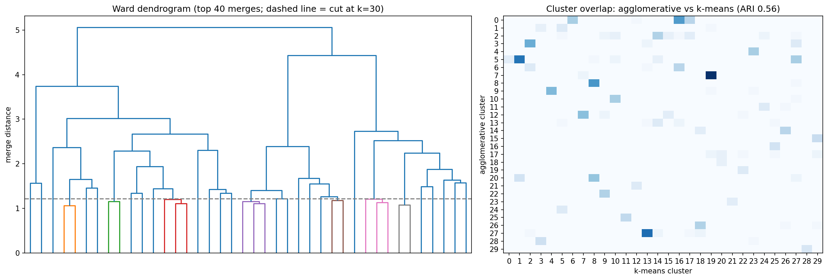
Figure 8. Ward clustering: dendrogram of the last 40 merges with the cut at k = 30 (left), and the overlap between Ward and k-means clusters (right; darker = more shared drugs). Large, distinctive groups map one-to-one, while the general clusters split differently.
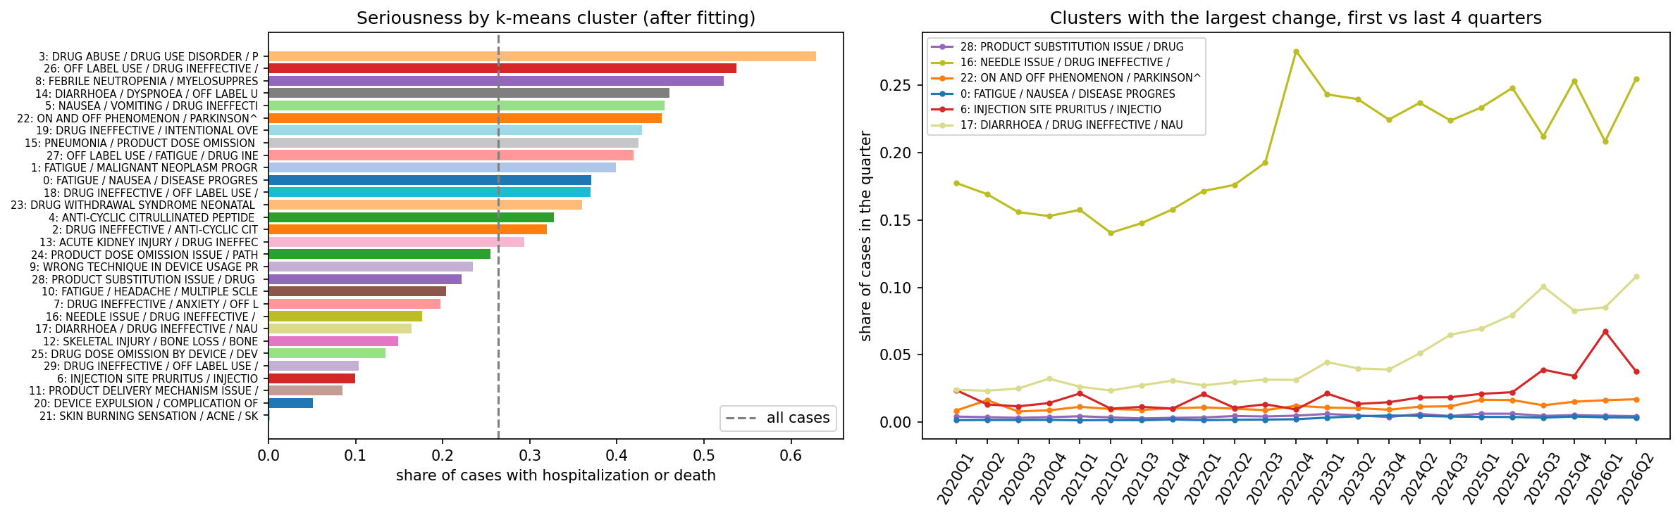
Figure 9. After clustering: share of cases with hospitalization or death per k-means cluster (left; dashed line = all cases), and the clusters whose share of quarterly reports changed most (right).
External check. Although the outcome was never used, cluster seriousness ranges from 0.2% (topical acne and sunscreen products) and 5% (contraceptive devices) to 52-54% (cytotoxic chemotherapy, hospital antibiotics) and 63% (substances of abuse). This shows the profiles carry clinically meaningful severity information. Over time, the GLP-1 and insulin cluster (tirzepatide, semaglutide) grew from 2.6% to 9.4% of all cases, and injectable biologics from 16% to 23%. The ranitidine-led cardiometabolic cluster fell from 10% to 5% as litigation-driven reports faded, and the topical acne and sunscreen cluster fell from 3.9% to 0.2% after a short-lived reporting wave.

6.3 Sensitivity analysis
We re-ran k-means on TF-IDF while changing one choice at a time and measured agreement with the main solution by ARI (Appendix Figure 11). Other random seeds give a mean ARI of 0.59, which is the noise floor. Nearby k values (26-34) give 0.62 and the SVD dimension (10-100, or none) gives 0.63: both are as close as a re-seed, so these choices matter little. Vocabulary size (300-800 drugs, 500-2,000 reactions) gives 0.57, slightly below the seed level. The largest effect is the case weighting: plain counts agree with the weighted solution at only ARI 0.45, which confirms that the templated reports reshape the clusters. Overall, the distinctive clusters (chemotherapy, opioids, inhalers, contraceptive devices, ADHD stimulants, HIV) reappear under every setting, while the general "drug ineffective / off label use" clusters exchange members.

7. Discussion

7.1 Part A
Surprises. First, how much of the signal sits in where a report comes from rather than who the patient is: country and reporter type rival the drugs themselves, which reflects FAERS's reporting rules (manufacturers must forward serious foreign cases) more than biology. Second, how easy it is to leak the outcome: our first feature lists included the expedited flag and report version, each of which made the model look far better than it could be at intake. Third, how often the "errors" were really label problems: the most confident false positive is a congenital anomaly (serious, but not by our definition), and confident false positives list nearly-always-serious reactions four times as often as true negatives.
Challenges. (1) Leakage was everywhere: reaction terms, the expedited flag, legacy follow-ups and the mass-report flag each looked like strong predictors, and each had to be removed after we traced why (notebook 3). (2) Scale: 8 million cases do not fit most learners on a 5 GB Deepnote machine, so we trained on a stratified 1,000,000-row sample and showed in the sensitivity analysis what more data would buy. (3) Time: a random split would have overstated performance; the time split exposed drift, which we quantified per quarter.
With more time we would map ingredients to RxNorm and ATC classes so that unseen drugs inherit a class-level risk; feed the Part B cluster of each drug as a feature, which is already wired into the pipeline; add a second-stage model that uses the narrative once a case is opened; retrain quarterly with a monitored drift alarm; and recover the three missing quarters with a Deflate64 reader.

7.2 Part B
Surprises. The biggest was how much a few thousand templated reports distorted the first clustering: they define a "rheumatoid arthritis" profile for acetaminophen, ranitidine and oxycodone. A one-line weighting fixed it. We were also surprised that 30 clusters built only from reported reactions line up with therapeutic classes, and that their outcome rates span 0.2% to 63% without the outcome ever being used.
Challenges. (1) Choosing k: silhouette rose slowly with k and never peaked, so we made the cap an explicit readability choice and tested the neighborhood rather than claiming a natural k. (2) Algorithm stability: k-means on TF-IDF is only moderately stable (ARI 0.57). We report this honestly, use Ward clustering as a cross-check, and note that the unstable part is concentrated in the general clusters. (3) Computation: an earlier run spent most of its time in thread contention on a tiny 500 x 50 problem. Limiting k-means to one thread made the whole scan take minutes.
With more time we would map ingredients to RxNorm and ATC classes to measure agreement with pharmacology directly, fix over-stripped names (DIMETHYL FUMARATE becomes DIMETHYL), cluster at the report level as the proposal planned (TF-IDF on each report's reactions with mini-batch k-means), and track cluster membership quarter by quarter to flag drugs whose profile moves.

8. Ethical Considerations
Part A. A triage model decides which reports a human reads first, so its errors have consequences. False negatives, meaning serious cases ranked low, delay review; our failure analysis shows they concentrate in reports with unfamiliar drugs and sparse demographics, often from consumers. Performance also differs by country and reporter, so a single threshold treats groups differently. We address this by (a) using the model only to order a queue, never to discard reports, so every report is still reviewed within regulatory timelines; (b) reporting performance by segment and by quarter and monitoring drift, since the model ages as new drugs appear; (c) calibrating probabilities so displayed risks are honest; and (d) excluding features that could encode a reporter's identity. Sex and age are used as clinical risk factors. Their effect should be audited before deployment so the model does not deprioritize, for example, women's reports because of reporting patterns.
Part B. Cluster labels can be misread as causal claims ("drug X causes reaction Y") or as rankings of drug safety. Our cluster seriousness rates reflect who reports and why: litigation, media attention, novelty and reporting programs all inflate counts, and FAERS has no exposure denominator. Publishing such groupings without that context could unfairly harm manufacturers or frighten patients into stopping needed treatment. We present clusters only as hypothesis-generating summaries, show their reporting artifacts (templated reports, device complaints), and recommend confirmation with disproportionality statistics and clinical review. Both parts use public, de-identified FAERS data. We publish only aggregates and a 100-record sample, and make no attempt to re-identify patients.

9. Statement of Work
Orko Mookerjee: data acquisition (notebook 1: streaming XML parser, case-version handling), the first data-review notebook, and the first drug-reaction clustering notebook that Part B extends; domain framing. Che-Yu Liu: literature review and the first gradient-boosting notebook that Part A extends; supervised modeling. Nikhil Jain: data cleaning V2 (target-coding fix, deduplication, ingredient standardization), EDA and leakage audit, feature engineering and baselines, final supervised and unsupervised pipelines, evaluation, the scoring pipeline, the repository and the report. All members reviewed code and results and edited the report.

10. Project Submission:

Link to GitHub repository: https://github.com/cheyuliu-design/SIADS696_Milestone2

Data source (weblink, as data > 25MB): https://fis.fda.gov/extensions/FPD-QDE-FAERS/FPD-QDE-FAERS.html

Google Doc Link: https://docs.google.com/document/d/15e-l-7EQZ2BKFnk2cSwN0TVec9CHYV7W

References
Campillos, M., Kuhn, M., Gavin, A.-C., Jensen, L. J., & Bork, P. (2008). Drug target identification using side-effect similarity. Science, 321(5886), 263-266. https://doi.org/10.1126/science.1158140
Evans, S. J. W., Waller, P. C., & Davis, S. (2001). Use of proportional reporting ratios (PRRs) for signal generation from spontaneous adverse drug reaction reports. Pharmacoepidemiology and Drug Safety, 10(6), 483-486. https://doi.org/10.1002/pds.677
Harpaz, R., DuMouchel, W., Shah, N. H., Madigan, D., Ryan, P., & Friedman, C. (2012). Novel data-mining methodologies for adverse drug event discovery and analysis. Clinical Pharmacology & Therapeutics, 91(6), 1010-1021. https://doi.org/10.1038/clpt.2012.50
Hubert, L., & Arabie, P. (1985). Comparing partitions. Journal of Classification, 2(1), 193-218. https://doi.org/10.1007/BF01908075
Ke, G., Meng, Q., Finley, T., Wang, T., Chen, W., Ma, W., Ye, Q., & Liu, T.-Y. (2017). LightGBM: A highly efficient gradient boosting decision tree. Advances in Neural Information Processing Systems, 30.
McInnes, L., Healy, J., & Melville, J. (2018). UMAP: Uniform manifold approximation and projection for dimension reduction. arXiv:1802.03426.
Pedregosa, F., Varoquaux, G., Gramfort, A., et al. (2011). Scikit-learn: Machine learning in Python. Journal of Machine Learning Research, 12, 2825-2830.
Rousseeuw, P. J. (1987). Silhouettes: A graphical aid to the interpretation and validation of cluster analysis. Journal of Computational and Applied Mathematics, 20, 53-65. https://doi.org/10.1016/0377-0427(87)90125-7
Routray, R., Tetarenko, N., Abu-Assal, C., et al. (2020). Application of augmented intelligence for pharmacovigilance case seriousness determination. Drug Safety, 43(1), 57-66. https://doi.org/10.1007/s40264-019-00869-4
Saito, T., & Rehmsmeier, M. (2015). The precision-recall plot is more informative than the ROC plot when evaluating binary classifiers on imbalanced datasets. PLoS ONE, 10(3), e0118432. https://doi.org/10.1371/journal.pone.0118432
Sakaeda, T., Tamon, A., Kadoyama, K., & Okuno, Y. (2013). Data mining of the public version of the FDA Adverse Event Reporting System. International Journal of Medical Sciences, 10(7), 796-803. https://doi.org/10.7150/ijms.6048
Tatonetti, N. P., Ye, P. P., Daneshjou, R., & Altman, R. B. (2012). Data-driven prediction of drug effects and interactions. Science Translational Medicine, 4(125), 125ra31. https://doi.org/10.1126/scitranslmed.3003377
U.S. Food and Drug Administration. (2026). FDA Adverse Event Reporting System (FAERS) quarterly data extract files [Data set]. https://fis.fda.gov/extensions/FPD-QDE-FAERS/FPD-QDE-FAERS.html
Zhao, H., Ni, P., Zhao, Q., Liang, X., Ai, D., Erhardt, S., Wang, J., Li, Y., & Wang, J. (2023). Identifying the serious clinical outcomes of adverse reactions to drugs by a multi-task deep learning framework. Communications Biology, 6, 870. https://doi.org/10.1038/s42003-023-05243-w

Appendix A. Complete Feature List (Part A)
40 patient, report and count columns (prefix = transform: num = median-imputed and standardized; count = log1p and standardized; flag = 0/1; cat = one-hot, "infrequent_sklearn" = levels with fewer than 1,000 training cases): num__age_years, num__weight_kg, count__n_drugs, count__n_suspect_ingredients, count__n_other_ingredients, flag__age_missing, flag__weight_missing, flag__is_us, cat__sex_female, cat__sex_male, cat__sex_missing, cat__age_group_adolescent, cat__age_group_adult, cat__age_group_child, cat__age_group_elderly, cat__age_group_infant, cat__age_group_missing, cat__age_group_neonate, cat__reporter_consumer, cat__reporter_lawyer, cat__reporter_missing, cat__reporter_other_hcp, cat__reporter_pharmacist, cat__reporter_physician, cat__report_type_not_available, cat__report_type_other, cat__report_type_spontaneous, cat__report_type_study, cat__report_type_infrequent_sklearn, cat__country_AU, cat__country_CA, cat__country_CN, cat__country_DE, cat__country_ES, cat__country_FR, cat__country_GB, cat__country_IT, cat__country_JP, cat__country_OTHER, cat__country_US.
400 drug flags (1 if the ingredient is a suspect on the case), in order of training-period frequency: ranitidine, dupilumab, adalimumab, lenalidomide, oxycodone, acetaminophen, methotrexate, adapalene, rituximab, apixaban, tofacitinib, valsartan, secukinumab, avobenzone, octisalate, octocrylene, hydrocodone, etanercept, prednisone, sacubitril, evolocumab, morphine, dexamethasone, infliximab, cyclophosphamide, abatacept, diclofenac, fluticasone, tocilizumab, tramadol, hydromorphone, certolizumab pegol, palbociclib, upadacitinib, clozapine, pomalidomide, emtricitabine, apremilast, albuterol, pembrolizumab, ritonavir, risankizumab-rzaa, dulaglutide, tacrolimus, ibrutinib, ibuprofen, insulin glargine, metformin, ustekinumab, pegfilgrastim, levonorgestrel, tenofovir disoproxil, nivolumab, carboplatin, buprenorphine, ocrelizumab, vedolizumab, leuprolide, mycophenolate mofetil, tirzepatide, treprostinil, nirmatrelvir, doxorubicin, prednisolone, hydroxychloroquine, levodopa, venetoclax, aspirin, human immunoglobulin g, vincristine, paclitaxel, denosumab, ruxolitinib, fentanyl, budesonide, somatropin, minoxidil, amlodipine, vilanterol trifenatate, methylprednisolone, bevacizumab, carbidopa, capecitabine, pregabalin, quetiapine, golimumab, semaglutide, atorvastatin, cyclosporine, erenumab-aooe, leflunomide, sodium chloride, formoterol, omeprazole, dimethyl, pantoprazole, rivaroxaban, trastuzumab, oxaliplatin, gabapentin, levothyroxine, etoposide, levetiracetam, umeclidinium, onabotulinumtoxina, insulin lispro, mepolizumab, pimavanserin, ofatumumab, bortezomib, furosemide, cabozantinib, voxelotor, sertraline, omalizumab, amoxicillin, empagliflozin, cytarabine, aripiprazole, docetaxel, fluorouracil, lenvatinib, atezolizumab, pirfenidone, cisplatin, cetirizine, codeine, galcanezumab-gnlm, olanzapine, teriflunomide, ixekizumab, natalizumab, risperidone, macitentan, alprazolam, dextrose, fingolimod, sulfasalazine, esomeprazole, ribociclib, ambrisentan, hydrochlorothiazide, guselkumab, daratumumab, osimertinib, interferon beta-1a, lamotrigine, trimethoprim, gemcitabine, calcium chloride, efavirenz, venlafaxine, sulfamethoxazole, bupropion, azithromycin, etonogestrel, ipilimumab, magnesium chloride, metoprolol, estradiol, sodium oxybate, naproxen, sodium lactate, letrozole, clonazepam, imatinib, isotretinoin, rosuvastatin, clopidogrel bisulfate, ciprofloxacin, diazepam, abiraterone, infliximab-dyyb, azathioprine, methadone, lansoprazole, niraparib, tiotropium, valbenazine, oxycodone terephthalate, salmeterol, copper, ivacaftor, bisoprolol, pertuzumab, rilpivirine, vancomycin, lorazepam, everolimus, nintedanib, montelukast, lisinopril, cannabidiol, diphenhydramine, polyethylene glycol 3350, naltrexone, ramipril, belimumab, glatiramer, dasatinib, duloxetine, topiramate, tezacaftor, escitalopram oxalate, leucovorin, levofloxacin, lamivudine, naloxone, sarilumab, ethinyl estradiol, ixazomib, hydrocortisone, olaparib, amphetamine, mirtazapine, zoledronic acid, propranolol, fluoxetine, exenatide, lidocaine, tenofovir alafenamide, pemetrexed, oxymorphone, paliperidone palmitate, sofosbuvir, elexacaftor, enoxaparin, eculizumab, folic acid, remdesivir, unspecified ingredient, dapagliflozin propanediol, irinotecan, warfarin, latanoprost, dalfampridine, alcohol, tazobactam, lacosamide, metronidazole, alendronate, fludarabine, sildenafil, piperacillin, eltrombopag olamine, axitinib, tadalafil, caffeine, cobicistat, enzalutamide, abemaciclib, dextromethorphan, methylphenidate, benralizumab, celecoxib, ceftriaxone, spironolactone, losartan, doxycycline, hydroxyprogesterone caproate, dolutegravir, aflibercept, amiodarone, citalopram, octreotide, carbamazepine, velpatasvir, timolol, durvalumab, fulvestrant, azacitidine, selexipag, dextroamphetamine, carfilzomib, brimonidine, insulin human, mometasone, ondansetron, zolpidem, valproic acid, bosentan, nicotine, insulin aspart, riociguat, bendamustine, epinephrine, dabrafenib, loratadine, pseudoephedrine, diroximel, nilotinib, potassium chloride, romosozumab-aqqg, sitagliptin, elvitegravir, amphetamine aspartate, lifitegrast, lurasidone, mesalamine, dapagliflozin, rimegepant, heparin, ifosfamide, esketamine, cabotegravir, linezolid, trametinib dimethyl sulfoxide, bimatoprost, loperamide, allopurinol, olopatadine, amitriptyline, mycophenolic acid, simvastatin, temozolomide, dabigatran etexilate, relugolix, pancrelipase amylase, pancrelipase protease, pancrelipase lipase, trazodone, baclofen, dextroamphetamine saccharate, avapritinib, teriparatide, siponimod, alpelisib, isopropyl alcohol, paroxetine, lisdexamfetamine, valproate, meropenem, propofol, ezetimibe, promethazine, palivizumab, clindamycin, sodium citrate, tamsulosin, anakinra, alirocumab, filgrastim, apalutamide, cocaine, bamlanivimab, melphalan, rifaximin, acyclovir, ticagrelor, fexofenadine, guaifenesin, epirubicin, cenegermin-bkbj, teduglutide, acalabrutinib, cholecalciferol, obinutuzumab, ozanimod, alectinib, tozinameran, liraglutide, tafamidis, ipratropium, brexpiprazole, mirabegron, ravulizumab-cwvz, etanercept-szzs, clavulanate, haloperidol, midazolam, amikacin, zopiclone, valacyclovir, thalidomide, diltiazem, rifampin, oxazepam, lutetium lu-177 vipivotide tetraxetan, clarithromycin, voriconazole, selinexor, antihemophilic factor human recombinant, diamorphine, fluconazole, baricitinib, human c1-esterase inhibitor, fremanezumab-vfrm, varenicline, bictegravir, encorafenib, triamcinolone acetonide, sunitinib, betamethasone, norethindrone, carvedilol, phenytoin, daunorubicin, darbepoetin alfa, moxifloxacin, glycopyrrolate.

Appendix B. Supplementary Results
Table 9. Failure examples chosen by rule from the test year. Reactions and the full ingredient list were not model inputs.
Example | Case id | p(serious) | Label | Reporter, country, drugs | Suspect ingredients (first 6) | Reactions (first 8)
A. false negative, no known drug | 25957795 | 0.039 | serious | consumer, US, 1 | conestat alfa | no adverse event
B. false negative, known drug | 26782616 | 0.003 | serious | consumer, US, 1 | diclofenac | hospitalisation
C. false positive | 26901066 | 0.998 | not serious | other_hcp, CA, 92 | rituximab | adalimumab | hydrocortisone | pantoprazole | dexamethasone | alendronate | congenital anomaly | exposure via breast milk
D. false negative, consumer, no age/sex | 24117356 | 0.004 | serious | consumer, US, 2 | mometasone | olopatadine | death | device delivery system issue
E. false positive, 5 or fewer drugs | 25824268 | 0.991 | not serious | physician, US, 3 | fentanyl | cocaine | diamorphine | respiratory acidosis | heart rate increased | somnolence | respiratory depression | miosis | overdose | drug abuse | drug withdrawal syndrome

Table 10. Full hyperparameter search for Part A (300,000 training rows, scored on validation).
Family | Setting | Validation AP | ROC AUC | Fit (s)
logistic regression | {C: 0.01} | 0.544 | 0.797 | 51
logistic regression | {C: 0.1} | 0.550 | 0.799 | 28
logistic regression | {C: 1.0} | 0.551 | 0.798 | 37
logistic regression | {C: 10.0} | 0.551 | 0.798 | 15
naive Bayes | {alpha: 0.1} | 0.521 | 0.785 | 2
naive Bayes | {alpha: 1.0} | 0.521 | 0.785 | 2
naive Bayes | {alpha: 10.0} | 0.521 | 0.785 | 1
random forest | {max_features: sqrt, min_samples_leaf: 5} | 0.599 | 0.818 | 59
random forest | {max_features: sqrt, min_samples_leaf: 25} | 0.562 | 0.802 | 73
random forest | {max_features: sqrt, min_samples_leaf: 100} | 0.531 | 0.786 | 69
random forest | {max_features: 0.1, min_samples_leaf: 5} | 0.608 | 0.821 | 243
random forest | {max_features: 0.1, min_samples_leaf: 25} | 0.574 | 0.807 | 162
random forest | {max_features: 0.1, min_samples_leaf: 100} | 0.542 | 0.792 | 97
gradient boosting | {learning_rate: 0.05, max_leaf_nodes: 31, max_iter: 300} | 0.604 | 0.821 | 504
gradient boosting | {learning_rate: 0.1, max_leaf_nodes: 31, max_iter: 300} | 0.613 | 0.825 | 117
gradient boosting | {learning_rate: 0.1, max_leaf_nodes: 63, max_iter: 300} | 0.621 | 0.829 | 93
gradient boosting | {learning_rate: 0.1, max_leaf_nodes: 127, max_iter: 300} | 0.625 | 0.830 | 209
gradient boosting | {learning_rate: 0.05, max_leaf_nodes: 63, max_iter: 600} | 0.621 | 0.829 | 191
gradient boosting | {learning_rate: 0.2, max_leaf_nodes: 63, max_iter: 300} | 0.622 | 0.829 | 148
gradient boosting | {learning_rate: 0.1, max_leaf_nodes: 255, max_iter: 300} | 0.624 | 0.829 | 651

Table 11. Ablation by feature group (gradient boosting retrained on 500,000 rows, validation AP).
Variant | Columns | Validation AP | Change vs all
all features | 440 | 0.630 | +0.000
without patient | 426 | 0.612 | -0.018
without report | 417 | 0.566 | -0.064
without drug counts | 437 | 0.622 | -0.008
without drug identity | 40 | 0.563 | -0.067
only patient | 14 | 0.373 | -0.257
only report | 23 | 0.464 | -0.166
only drug counts | 3 | 0.405 | -0.225
only drug identity | 400 | 0.496 | -0.134

Table 12. All 30 k-means clusters (TF-IDF, k = 30), sorted by the share of their cases involving hospitalization or death (measured after clustering).
Cluster (our name) | Drugs | Most-reported members | Characteristic reactions | Serious | Share 2020 → 2026
Substances of abuse, sedatives | 11 | Alcohol | Cocaine | Propofol | Zopiclone | Drug abuse | Drug use disorder | Poisoning deliberate | 62.9% | 1.0% → 0.9%
Hospital antibiotics | 13 | Vancomycin | Tazobactam | Piperacillin | Ceftriaxone | Off label use | Drug ineffective | Pathogen resistance | 53.7% | 1.5% → 1.0%
Cytotoxic chemotherapy | 39 | Cyclophosphamide | Carboplatin | Doxorubicin | Paclitaxel | Febrile neutropenia | Myelosuppression | Off label use | 52.2% | 4.7% → 5.6%
Cardiopulmonary, anticoagulants | 22 | Apixaban | Sacubitril | Rivaroxaban | Macitentan | Diarrhoea | Dyspnoea | Off label use | 46.1% | 6.9% → 2.8%
IV and dialysis fluids | 12 | Sodium Chloride | Dextrose | Calcium Chloride | Magnesium Chloride | Nausea | Vomiting | Drug ineffective | 45.5% | 0.9% → 0.7%
Parkinson's disease | 7 | Levodopa | Pimavanserin | Carbidopa | Foslevodopa | On and off phenomenon | Parkinson^s disease | Fall | 45.2% | 1.0% → 1.5%
Psychiatric, antiepileptic | 42 | Clozapine | Pregabalin | Quetiapine | Levetiracetam | Drug ineffective | Intentional overdose | Poisoning deliberate | 42.9% | 7.1% → 5.4%
Cystic fibrosis, rare disease | 7 | Ivacaftor | Cannabidiol | Tezacaftor | Elexacaftor | Pneumonia | Product dose omission issue | Diarrhoea | 42.5% | 0.9% → 0.6%
Myeloma, immuno-oncology | 23 | Lenalidomide | Dexamethasone | Pembrolizumab | Pomalidomide | Off label use | Fatigue | Drug ineffective | 41.9% | 8.4% → 7.4%
Oral and targeted oncology | 35 | Palbociclib | Bevacizumab | Capecitabine | Trastuzumab | Fatigue | Malignant neoplasm progression | Diarrhoea | 39.9% | 5.9% → 5.2%
Late-line oncology | 4 | Lutetium Lu-177 Vipivotide Tetraxetan | Selinexor | Trifluridine | Tipiracil | Fatigue | Nausea | Disease progression | 37.1% | 0.2% → 0.4%
Common anti-infectives, NSAIDs | 18 | Ibuprofen | Ritonavir | Amoxicillin | Azithromycin | Drug ineffective | Off label use | Nausea | 37.0% | 3.1% → 2.4%
Opioids, acetaminophen | 15 | Acetaminophen | Oxycodone | Hydrocodone | Morphine | Drug withdrawal syndrome neonatal | Dependence | Learning disability | 36.0% | 4.5% → 2.8%
Supplements in templated RA reports | 17 | Cetirizine | Folic Acid | Alendronate | Pseudoephedrine | Anti-cyclic citrullinated peptide antibody positive | Pemphigus | Duodenal ulcer perforation | 32.7% | 1.0% → 1.0%
RA and immunosuppressants | 25 | Methotrexate | Rituximab | Prednisone | Tofacitinib | Drug ineffective | Anti-cyclic citrullinated peptide antibody positive | Off label use | 32.0% | 11.4% → 7.9%
Cardiometabolic, ranitidine | 33 | Ranitidine | Valsartan | Metformin | Aspirin | Acute kidney injury | Drug ineffective | Dizziness | 29.4% | 10.1% → 5.1%
Newer HIV/HCV antivirals | 7 | Lamivudine | Tenofovir Alafenamide | Dolutegravir | Sofosbuvir | Product dose omission issue | Pathogen resistance | Fatigue | 25.5% | 0.7% → 0.3%
Inhaled respiratory (device use) | 16 | Fluticasone | Albuterol | Budesonide | Formoterol | Wrong technique in device usage process | Device delivery system issue | Product delivery mechanism issue | 23.5% | 2.6% → 2.5%
ADHD stimulants | 6 | Amphetamine | Methylphenidate | Dextroamphetamine | Amphetamine Aspartate | Product substitution issue | Drug ineffective | Therapeutic response changed | 22.2% | 0.4% → 0.5%
Multiple sclerosis therapies | 18 | Ocrelizumab | Dimethyl | Natalizumab | Fingolimod | Fatigue | Headache | Multiple sclerosis relapse | 20.4% | 2.8% → 2.6%
Mixed CNS and psychiatric | 18 | Sodium Oxybate | Isotretinoin | Montelukast | Esketamine | Drug ineffective | Anxiety | Off label use | 19.8% | 1.7% → 2.1%
Injectable biologics | 36 | Dupilumab | Adalimumab | Secukinumab | Etanercept | Needle issue | Drug ineffective | Injection site pain | 17.6% | 16.4% → 23.2%
GLP-1 agonists, insulins | 16 | Tirzepatide | Semaglutide | Insulin Glargine | Dulaglutide | Diarrhoea | Drug ineffective | Nausea | 16.4% | 2.6% → 9.4%
Older HIV regimens (bone loss) | 6 | Emtricitabine | Tenofovir Disoproxil | Efavirenz | Rilpivirine | Skeletal injury | Bone loss | Bone density decreased | 14.9% | 0.9% → 0.4%
Device-delivered injectables | 9 | Somatropin | Pegfilgrastim | Medroxyprogesterone | Enoxaparin | Drug dose omission by device | Device mechanical issue | Device delivery system issue | 13.4% | 1.9% → 2.2%
OTC products, COVID antiviral | 12 | Nirmatrelvir | Minoxidil | Polyethylene Glycol 3350 | Dextromethorphan | Drug ineffective | Off label use | Dizziness | 10.4% | 1.5% → 1.3%
Injectables, injection-site reactions | 13 | Onabotulinumtoxina | Abaloparatide | Galcanezumab-Gnlm | Naltrexone | Injection site pruritus | Injection site rash | Injection site pain | 9.9% | 1.6% → 4.5%
Ophthalmics | 10 | Aflibercept | Latanoprost | Brimonidine | Cenegermin-Bkbj | Product delivery mechanism issue | Eye irritation | Drug ineffective | 8.5% | 1.7% → 0.8%
Contraceptive implants, IUDs | 6 | Levonorgestrel | Estradiol | Copper | Etonogestrel | Device expulsion | Complication of device removal | Product adhesion issue | 5.1% | 1.8% → 1.4%
Topical acne, sunscreen | 4 | Adapalene | Avobenzone | Octisalate | Octocrylene | Skin burning sensation | Acne | Skin irritation | 0.2% | 3.9% → 0.2%

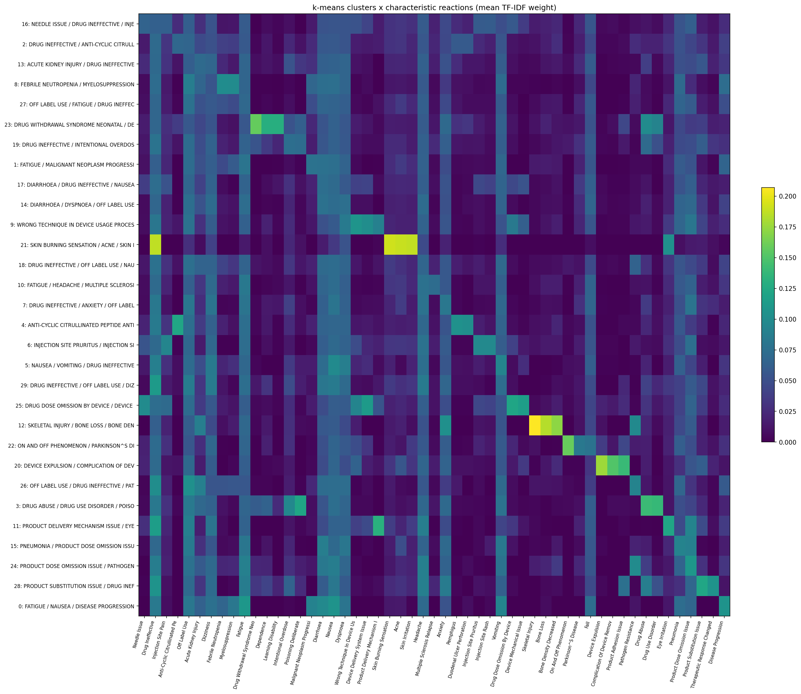
Figure 10. Cluster-by-reaction heatmap (k-means): mean TF-IDF weight of each cluster's three most characteristic reactions. Most clusters own a distinct block of reactions, while a few general clusters share "drug ineffective", "fatigue" and "off label use".
Table 13. Linkage comparison for agglomerative clustering (TF-IDF). Tiny = clusters with fewer than 3 drugs.
Linkage | k | Silhouette | Largest cluster | Tiny clusters
average | 8 | 0.348 | 94.8% | 3
average | 12 | 0.233 | 92.0% | 5
average | 16 | 0.172 | 72.0% | 6
average | 20 | 0.156 | 69.4% | 8
complete | 8 | 0.184 | 53.8% | 0
complete | 12 | 0.176 | 50.4% | 2
complete | 16 | 0.175 | 33.4% | 4
complete | 20 | 0.164 | 26.4% | 4
ward | 8 | 0.191 | 26.0% | 0
ward | 12 | 0.191 | 15.8% | 0
ward | 16 | 0.208 | 11.4% | 0
ward | 20 | 0.212 | 10.2% | 0

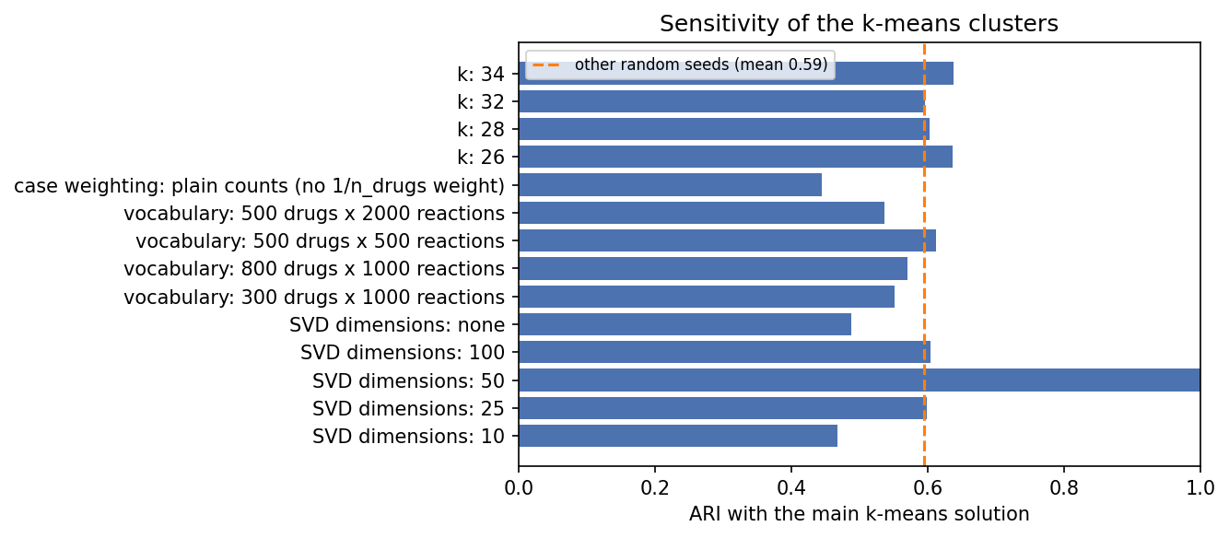
Figure 11. Sensitivity of the k-means clusters: ARI with the main solution when one setting changes. The dashed line is the mean over 10 other random seeds.

Appendix C. Reproducibility
Code: notebooks 01-07 in the GitHub repository (see README). Notebook 01 parses the raw XML (hours; not re-run for this report). Notebooks 02-07 regenerate every table (reports/tables/*.csv) and figure (reports/figures/*.png) used here; reports/build_report/ rebuilds this document from them. Random seeds are fixed (42 for Part A, 0 for Part B). Environment: Python 3.10, pandas 2.3, scikit-learn 1.7, pyarrow 25, umap-learn 0.5.

