Resolve complaint management system
using AWS cloud services
Prepared in the partial fulfillment of there Summer Internship Program on AWS



Under the guidance of
Mrs. Sumana Bethala, APSSDC
Mr. Juttuka Lovababu, APSSDC
Submitted by BATCH NO : 88
Cheyyeti Hemanth kumar , BVCEC Odalarevu(Batch 1)
Kakarapalli Teja Venkatesh ,BVCEC Odalarevu(Batch 1)
Ambati Dolanadh , BVCEC Odalarevu(Batch 1)
Kalluri Leela Naga Babu , BVCEC Odalarevu(Batch 1)
Sunkara Chandrika , BVCEC Odalarevu(Batch 1)

ACKNOWLEDGEMENT

I would like to express my sincere gratitude to everyone who contributed to the successful completion of my project titled "Resolve Complaint System Deployment Using AWS (Linux)." This project provided me with an excellent opportunity to enhance my knowledge of modern web development, cloud computing, and server deployment practices.

I express my heartfelt thanks to my project guide, Mrs. Sumana Bethala, for providing valuable guidance, continuous encouragement, and constructive suggestions throughout the development of this project. Their support and expertise greatly helped me in understanding the concepts and successfully implementing the project.

I would also like to thank the Department of Computer Science and Engineering, Bonam Venkata Chalamayya Engineering College, for providing the necessary resources, infrastructure, and a learning environment that enabled me to complete this project successfully.
My sincere appreciation goes to all the faculty members of the department for their valuable support and technical guidance during the course of this project.
I would like to extend my gratitude to Amazon Web Services (AWS) for providing reliable cloud services such as Amazon EC2, Amazon Route 53, and AWS Identity and Access Management (IAM), which were essential in developing and deploying this project. I also acknowledge the role of GitHub for enabling version control and source code management, and Nginx for serving the deployed application throughout the project lifecycle.

Finally, I express my deepest gratitude to my parents, family members, and friends for their constant encouragement, motivation, and unwavering support, which inspired me to complete this project successfully.

THANK YOU

Sincerely,
Cheyyeti Hemanth kumar , 24221A0527, cheyyetihemanthkumar@gmail.com
Kakarapalli teja Venkatesh , 24221A0551 , tejavenkatesh48@gmail.com
Ambati Dolanadh , 24221A0508, ambatidolanadh2244@gmail.com
Kalluri Leela Naga Babu , 24221A0554 , kallurileelanagababu@gmail.com
ABSTRACT
This project presents the design, development, and deployment of a
Resolve Complaint System using React.js and Amazon Web Services (AWS). The primary objective of the project is to provide a modern, responsive, and reliable platform that allows users to register, track, and resolve complaints efficiently, while implementing cloud-based deployment on a self-managed Linux server.
The website was developed using React.js, Vite, TypeScript, and Tailwind CSS, enabling a fast, type-safe, and component-based user interface. The application was deployed on an Amazon EC2 (Linux) instance, where Node.js, npm, and Git were installed to clone the project from GitHub, install dependencies, and build the production version of the application. The built files are served using the Nginx web server on Port 80. Amazon Route 53 was configured to resolve a custom domain name to the EC2 instance's public IP, allowing users to access the system through a domain name. AWS Identity and Access Management (IAM) was used to securely manage SSH key-pair access and Security Group rules for the EC2 instance.
The complete source code is version-controlled and hosted on GitHub, from which it is cloned directly onto the EC2 instance during deployment. This approach demonstrates a practical, self-managed alternative to fully managed cloud hosting, giving direct control over the server environment, web server configuration, and deployment process.
The project demonstrates the practical implementation of modern web development, Linux server administration, and cloud computing technologies to build a scalable, secure, and efficient web application. It provides a strong foundation for future enhancements such as HTTPS/SSL integration, backend API development, database connectivity, and automated deployment scripting, making it suitable for real-world institutional or organizational use.
TABLE OF CONTENTS

S.No Content Pg.No
1. INTRODUCTION 5
2. METHODOLOGY 6
3. TECHNOLOGY STACK 8
4. SYSTEM DESIGN / ARCHITECTURE 12
5. IMPLEMENTATION 22
6. RESULTS 25
7. CONCLUSION 28

1. INTRODUCTION
In the digital era, organizations require a strong online presence to effectively manage user interactions, feedback, and grievances. A responsive, well-deployed complaint resolution system acts as a primary digital platform that provides an accessible channel for users to register complaints, track their status, and receive timely resolutions.
The Resolve Complaint System was developed with the objective of creating a responsive and reliable web application that allows users to submit and track complaints through a simple, user-friendly interface. The frontend of the application was developed using React.js, Vite, TypeScript, and Tailwind CSS, enabling a component-based architecture that improves maintainability, reusability, and application performance. The website follows responsive web design principles to provide an optimal user experience across desktops, tablets, and mobile devices.
For deployment, the production build generated by Vite was deployed on an Amazon EC2 (Linux) instance. Node.js, npm, and Git were installed on the server to clone the project from GitHub, install dependencies, and build the application. The build output is served using the Nginx web server, configured to listen on Port 80. Amazon Route 53 was used to resolve a custom domain name to the EC2 instance's public IP, allowing end users to access the application through a
domain name rather than a raw IP address. AWS Identity and Access Management (IAM) was implemented to securely manage SSH access and Security Group rules for the EC2 instance.
The complete source code is maintained in a GitHub repository, providing version control, branch management, and collaborative development. This project demonstrates the practical implementation of modern web development, Linux server administration, and AWS cloud services in building and deploying a production-ready dynamic web application. It provides a scalable and reliable solution for managing complaints while establishing a foundation for future enhancements such as backend integration, database connectivity, HTTPS configuration, and automated deployment.

2. METHODOLOGY
The development of the Resolve Complaint System Deployment Using AWS (Linux) followed a structured and systematic methodology to ensure the successful completion of the project objectives. The methodology was divided into several phases, including requirements gathering, system design, frontend development, version control, testing, and deployment on AWS EC2. Each phase was executed by following modern web development and Linux server deployment best practices.
2.1. Requirements Gathering
The project began with the analysis of functional and technical requirements for developing a modern complaint resolution system. The primary objective was to create a responsive, reliable, and user-friendly web application that allows users to register and track complaints. Requirements for self-managed cloud deployment, secure server access, and domain configuration were also identified.
2.2. System Design
Based on the identified requirements, the overall architecture of the application was designed. A component-based architecture was selected using React.js, Vite, TypeScript, and Tailwind CSS to improve code reusability, type safety, and maintainability. The deployment architecture was designed using an Amazon EC2 (Linux) instance for hosting, Nginx as the web server, Amazon Route 53 for domain resolution, and AWS IAM for secure access management.
2.2. System Design
Based on the identified requirements, the overall architecture of the application was designed. A component-based architecture was selected using React.js to improve code reusability and maintainability. The website was planned with multiple sections such as Home, About, Vision & Mission, Departments, Facilities, Gallery, Events, and Contact. The deployment architecture was designed using Amazon S3 for static website hosting, Amazon CloudFront for content delivery, and AWS IAM for secure access management.
2.3. Frontend Development
The frontend application was developed using React.js and Vite, with TypeScript for type-safe development and Tailwind CSS for styling. Individual reusable components were created to simplify development and maintenance. The interface was designed with modern layouts and navigation, ensuring compatibility across different screen sizes.
2.4. Version Control
The complete source code was maintained using Git and hosted on GitHub. Version control enabled efficient tracking of project changes, code backup, and easy management of updates throughout development. GitHub also served as the source repository cloned directly onto the EC2 instance during deployment.
2.5. Testing
The application was manually tested to verify the functionality of all sections, forms, navigation, responsiveness, and browser compatibility. Additional testing was performed after deployment to verify that the website was correctly served via Nginx and accessible through the configured domain name.
2.6. Deployment
The production build of the React application was generated using Vite and deployed on an Amazon EC2 (Linux) instance. Node.js and npm were installed to build the application, and Nginx was configured to serve the build files on Port 80. The Security Group was configured to allow inbound HTTP traffic. AWS IAM was used to manage SSH keypair access throughout the deployment process.
2.7. Domain Configuration
To make the application accessible via a custom domain, Amazon Route 53 was configured to resolve the domain name to the EC2 instance's public IP address, allowing users to access the system directly through the browser using the domain name.
The methodology adopted for the development of the Resolve Complaint System ensured a structured, scalable, and efficient implementation process. By integrating modern frontend development with a self-managed AWS EC2 deployment, the project successfully demonstrates practical, real-world server administration and cloud hosting practices.

3. TECHNOLOGY STACK
The Resolve Complaint System Deployment Using AWS (Linux) project was developed using a modern web development and cloud deployment technology stack. The following technologies and services were used throughout the implementation.

3.1. Development Platform
• Visual Studio Code (VS Code): Used as the primary Integrated
Development Environment (IDE) for developing the application, managing project files, and editing source code.

3.2. Frontend Technologies
- React.js: Used to develop the user interface using reusable components, improving code maintainability and scalability.
- Vite: Used as the frontend build tool for faster development, hot module replacement, and optimized production builds.
- TypeScript: Used to add static typing to the application, improving code reliability and reducing runtime errors.
- Tailwind CSS: Used for designing responsive layouts and styling components efficiently using utility-first classes.

3.3. Version Control
- Git: Used for source code version control and tracking project changes throughout development.
- GitHub: Used to host the project repository and maintain the complete source code, cloned directly onto the EC2 instance during deployment.

3.4. Cloud Platform
• Amazon Web Services (AWS): Used for hosting the application on a Linux server, managing domain resolution, and securing access to cloud resources.

3.5. AWS Services
- Amazon EC2 (Elastic Compute Cloud): Used to host and run the Linux server on which the application is deployed and served.
- Amazon Route 53: Used to manage DNS and resolve the custom domain name to the EC2 instance's public IP address.
- AWS Identity and Access Management (IAM): Used to securely manage SSH key-pair authentication and Security Group access rules for the EC2 instance.

3.6. Web Server
• Nginx: Configured on the EC2 Linux instance to serve the production build of the React application on Port 80.

3.7. Package Manager
• Node Package Manager (npm): Used to install project dependencies, manage packages, and execute build commands on the server.

3.8. Build Tool
• Vite Build System: Used to generate optimized production-ready build files for deployment on the EC2 instance.

3.9. Security & Access
- SSH Key-Pair Authentication: Used to securely access and manage the EC2 instance.
- Security Groups: Configured to allow inbound HTTP traffic on Port 80 while restricting unnecessary access.

3.10. Deployment
- Self-Managed Linux Hosting: The production build of the React application was deployed directly onto an Amazon EC2 (Linux) instance and served using Nginx, made accessible through Amazon Route 53 domain resolution.
- This technology stack provides a lightweight, secure, and cost-effective environment for developing, hosting, and managing the Resolve Complaint System. By integrating modern frontend development with self-managed AWS EC2 deployment, the project demonstrates practical, hands-on cloud server administration skills.

4. SYSTEM DESIGN / ARCHITECTURE
The Resolve Complaint System Deployment Using AWS (Linux) is designed as a modern, self-managed cloud-based web application that provides a responsive and reliable platform for registering and resolving complaints. The architecture follows a layered approach consisting of frontend development, source code management, deployment on an EC2 Linux server, web server configuration, domain resolution, and security management. This design ensures easy maintenance, direct control over the hosting environment, and simplified deployment using Amazon Web Services (AWS).
The frontend application is developed using React.js, Vite, TypeScript, and Tailwind CSS, which provide a component-based, type-safe architecture for building reusable and maintainable user interface components. The complete source code is maintained in a GitHub repository, allowing efficient version control and collaboration during development.
To deploy the application, the project is cloned directly from GitHub onto an Amazon EC2 (Linux) instance. On this server, Node.js and npm are installed to install project dependencies and build the production version of the application using npm run build. The generated build files are then served using the Nginx web server, configured to listen on Port 80 for incoming HTTP requests.
To make the application accessible through a memorable web address, Amazon Route 53 is configured to resolve a custom domain name to the EC2 instance's public IP address. AWS Identity and Access Management (IAM) is used to securely manage SSH key-pair authentication for server access and to configure Security Group rules that control inbound network traffic.
The architecture adopted for this project provides a secure, lightweight, and directly controllable deployment environment on a self-managed Linux server. The following subsections explain each component of the architecture in detail.

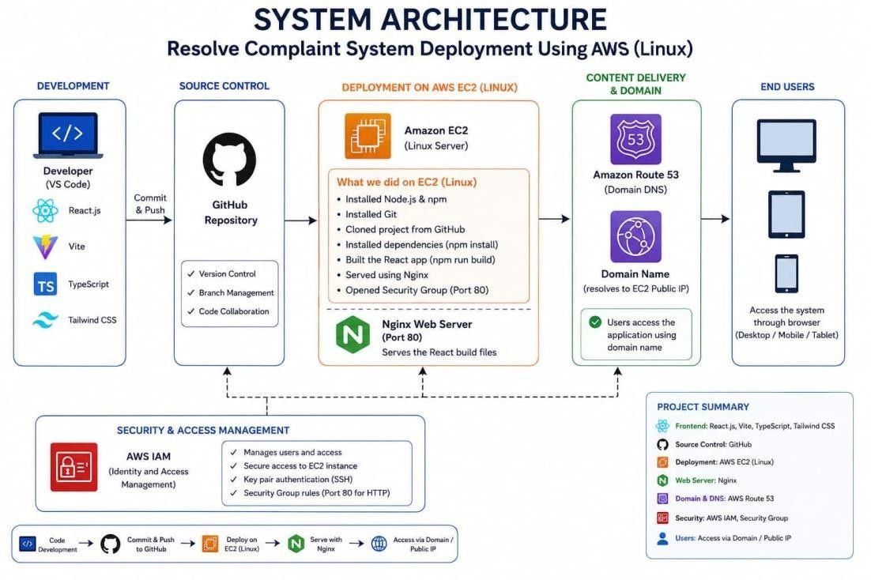
4.1. Frontend Development Layer
The frontend of the Resolve Complaint System was developed using React.js along with Vite as the build tool, TypeScript for type-safe development, and Tailwind CSS for styling. This combination ensures fast development builds, strong type checking, and a clean, responsive user interface. The application code was written and maintained in VS Code, with components structured to support the core complaint-resolution workflows of the system. The frontend is fully responsive and provides a consistent, user-friendly interface across desktop, tablet, and mobile devices, allowing end users to access the system seamlessly through any browser.

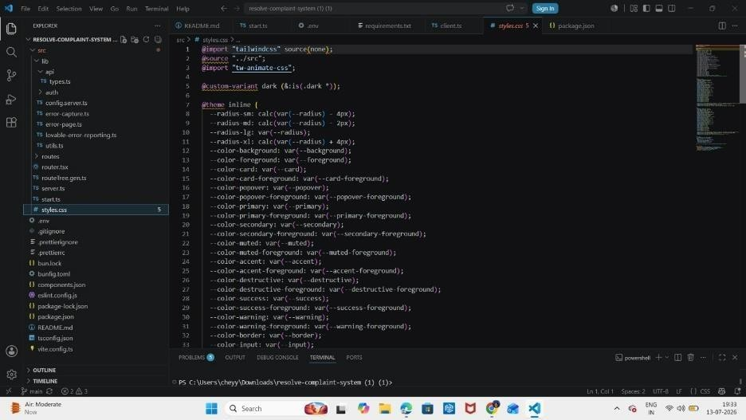
4.2. Source Code Management – GitHub
The project source code is maintained in a GitHub repository. GitHub provides version control and serves as the source repository for the deployment process.
- Stores the complete React project source code
- Tracks code changes using Git
- Maintains project versions
- Supports branch management and code collaboration
- Serves as the source cloned onto the EC2 instance during deployment
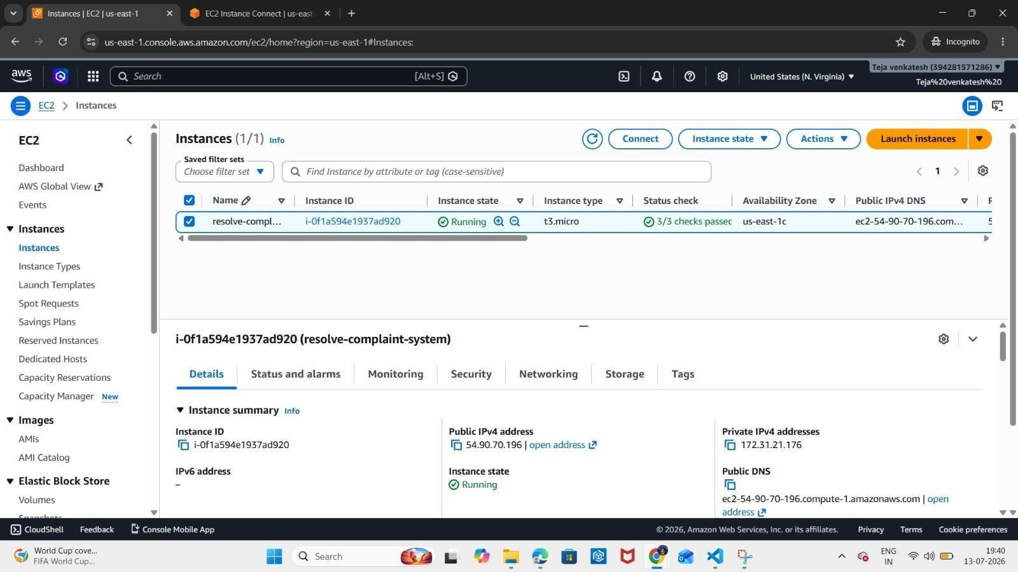

4.3. Build Automation – Amazon EC2 (Linux)
Instead of a separate build service, the build process for the
Resolve Complaint System is carried out directly on the Amazon EC2 (Linux) instance where the application is deployed.
- Installs Node.js and npm on the EC2 instance
- Installs Git and clones the project repository from GitHub
- Installs project dependencies (npm install)
- Builds the React application (npm run build)
- Generates the production-ready build files, ready to be served by Nginx
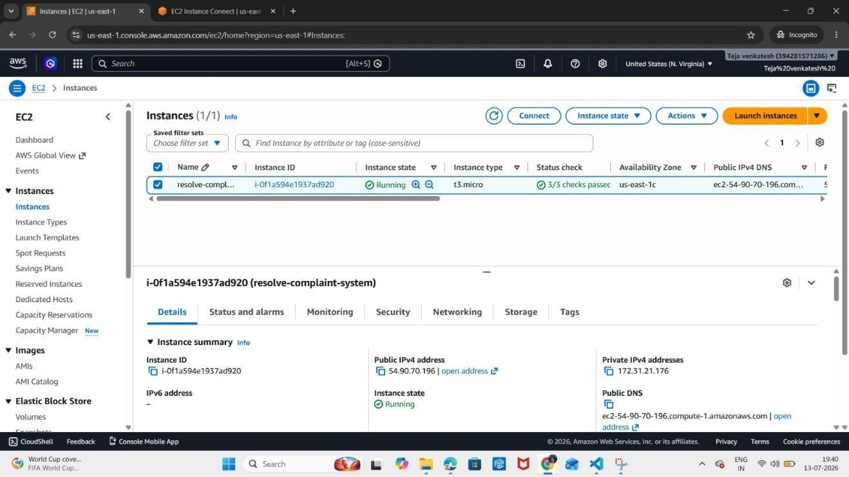

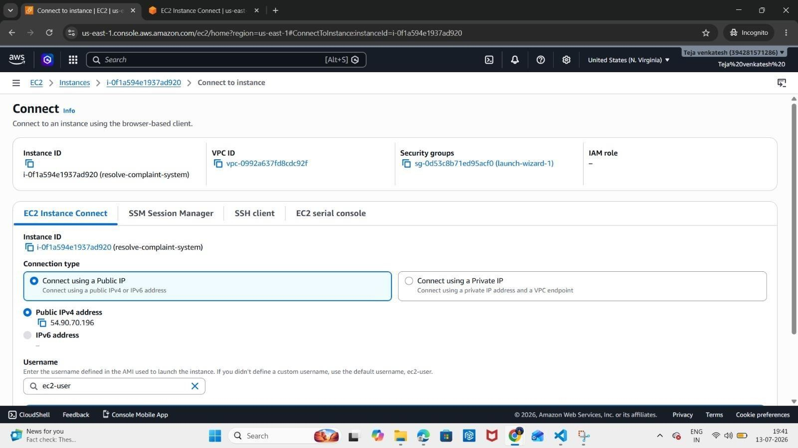
4.4. Web Server Configuration – Nginx
Nginx is configured on the EC2 instance to serve the built React application to end users.
- Serves the static React build files
- Listens on Port 80 for incoming HTTP traffic
- Acts as the entry point for all user requests to the application

4.5. Content Delivery & Domain – Amazon Route 53
Amazon Route 53 is used to manage the domain and route traffic to the application.
- Resolves the custom domain name to the EC2 instance's public IP
- Provides reliable DNS management for the system
- Allows users to access the application via a domain name instead of a raw IP address
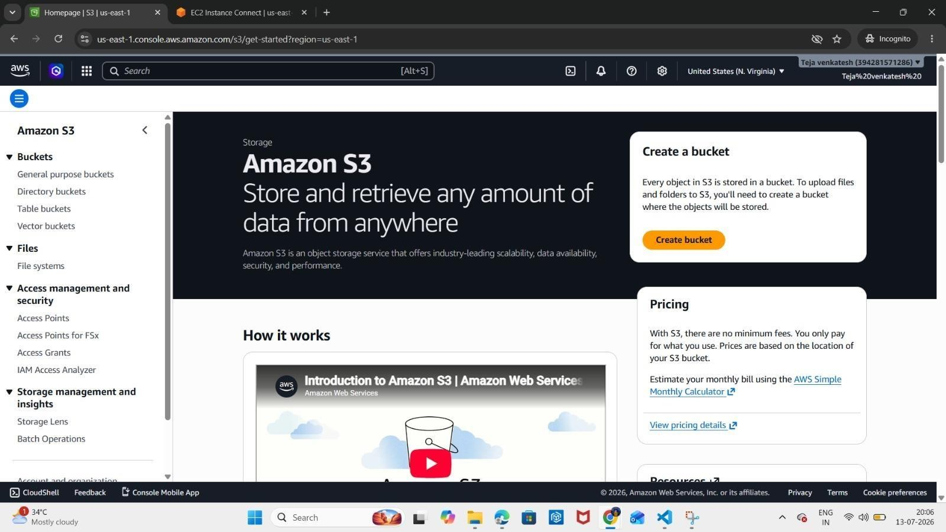

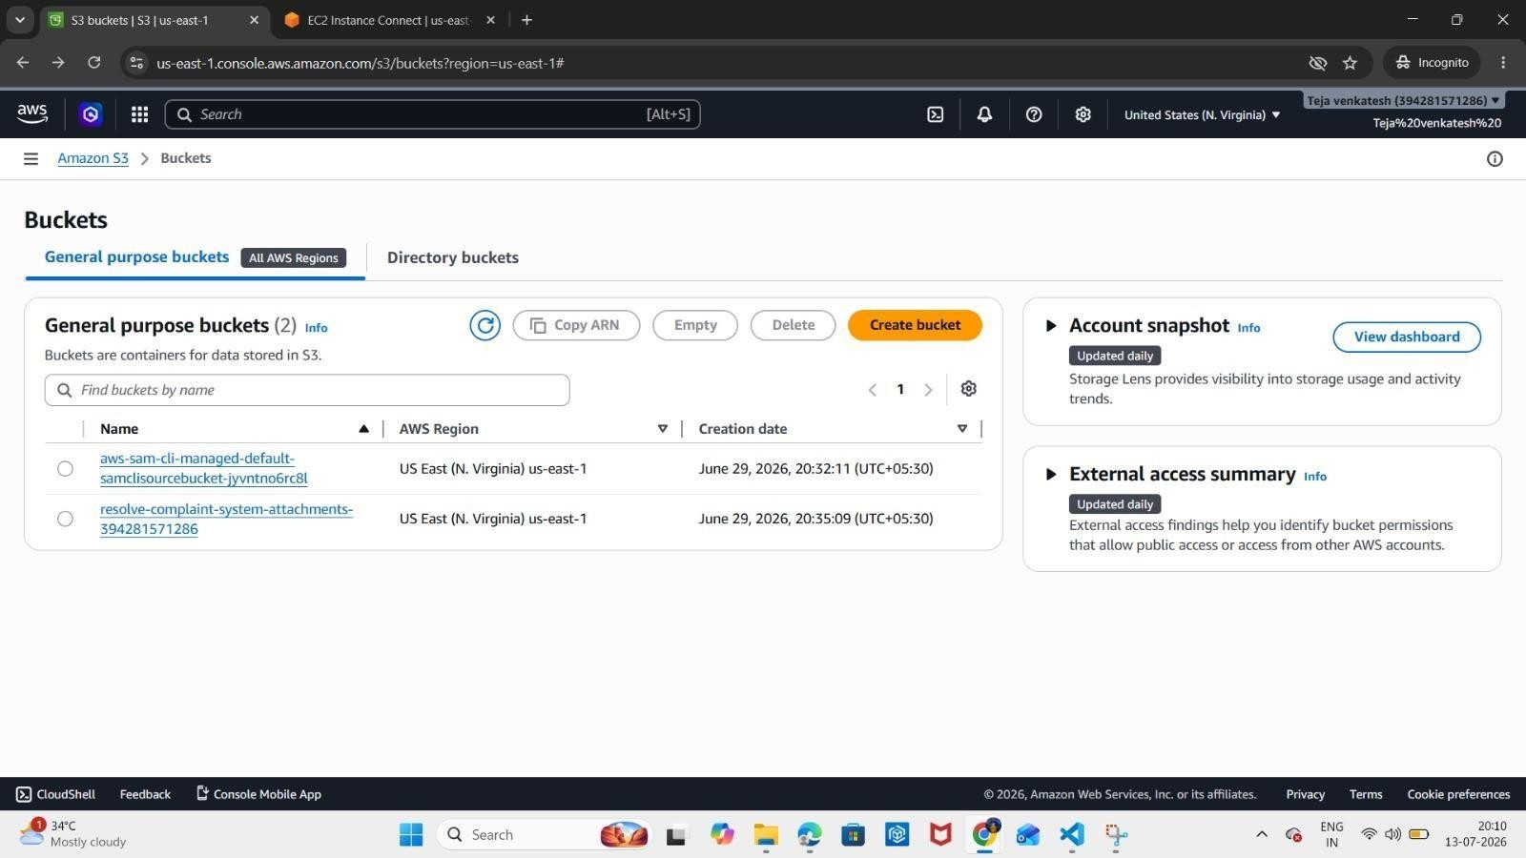

4.6. Security Layer – AWS IAM
AWS Identity and Access Management (IAM) provides secure access control for the EC2 instance and related resources.
- Manages users and access permissions
- Secures access to the EC2 instance
- Enforces key-pair authentication (SSH) for server access
- Configures Security Group rules to allow HTTP traffic on Port 80
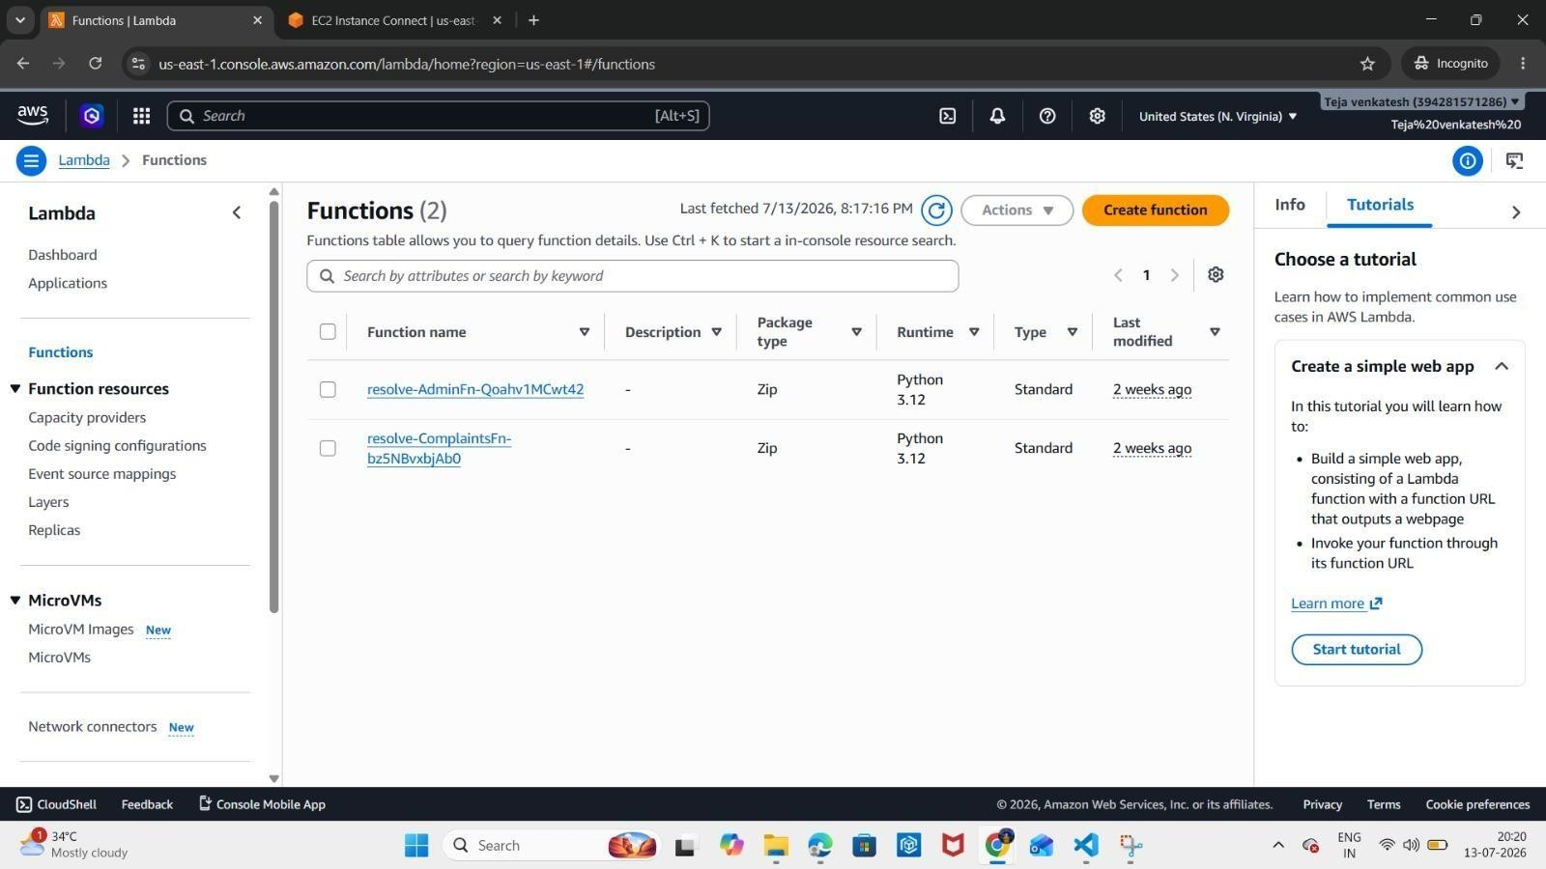

4.7. Security Layer – AWS IAM
AWS Identity and Access Management (IAM) provides secure access control for AWS resources.
- Creates IAM users and roles
- Manages permissions securely
- Controls access to the EC2 instance
- Enforces key-pair authentication (SSH) for server login
- Implements least-privilege access
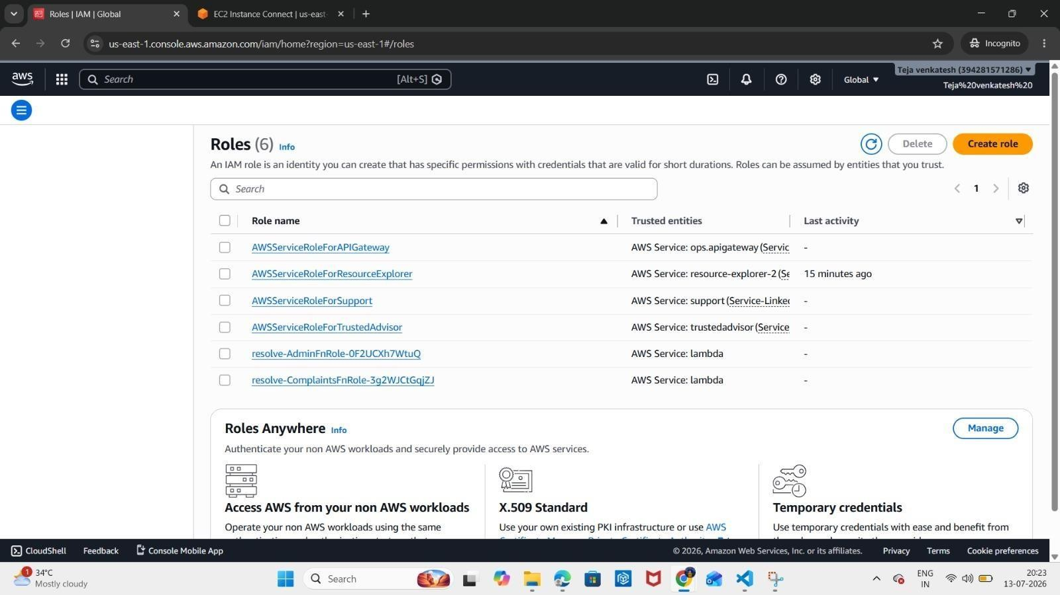
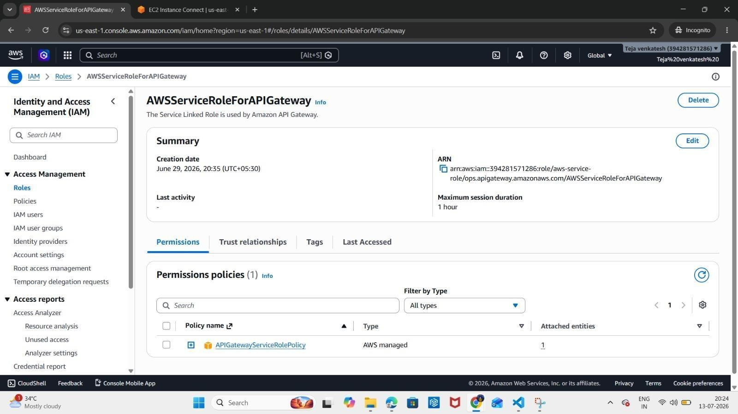

5. IMPLEMENTATION
The implementation of the Resolve Complaint System Deployment Using AWS (Linux) translates the system design into a fully functional cloud-based web application. This section describes how the frontend application was developed and how AWS services were configured to host the website on a Linux-based EC2 instance. The implementation focused on developing a responsive user interface, deploying the application on AWS EC2, serving it using Nginx, and managing secure access and domain routing.

5.1. Frontend Development Using React.js
The Resolve Complaint System was developed using React.js, Vite, TypeScript, and Tailwind CSS. The application follows a component-based architecture to improve code reusability and maintainability, and was developed in VS Code.
The user interface was designed to provide a responsive experience across desktop, tablet, and mobile devices, supporting the core complaint-registration and resolution workflows of the system.

5.2. Source Code Management with GitHub
The complete project source code was maintained using Git and hosted on GitHub.
Features:
- Stores complete project source code
- Tracks code changes
- Maintains version history
- Supports branch management and code collaboration

5.3. Deployment on Amazon EC2 (Linux)
The application was deployed on an Amazon EC2 Linux instance. The following steps were performed directly on the server:
- Installed Node.js and npm
- Installed Git
- Cloned the project repository from GitHub
- Installed project dependencies using npm install
- Built the production version of the application using npm run build
- Opened the required Security Group port (Port 80) for HTTP access

5.4. Web Server Configuration Using Nginx
Nginx was configured on the EC2 instance to serve the React build files.
Features:
- Serves static production build files
- Listens on Port 80 for incoming HTTP requests
- Acts as the reverse-facing web server for all client requests

5.5. Domain and DNS Configuration Using Amazon Route 53
Amazon Route 53 was used to manage the domain name and route traffic to the deployed application.
Features:
- Resolves the custom domain name to the EC2 instance's public IP
- Provides reliable DNS management
- Enables users to access the application via a domain name instead of a raw IP address

5.6. Security Using AWS IAM
AWS Identity and Access Management (IAM) was used to securely manage access to the EC2 instance and related resources.
Features:
- Manages users and access permissions
- Enforces key-pair authentication (SSH) for secure server access
- Configures Security Group rules to permit HTTP traffic on Port 80
- Implements least-privilege access

  - Final Website Deployment
After successful deployment, the Resolve Complaint System became accessible through the configured domain name, resolved via Amazon Route 53 to the EC2 instance's public IP, and served through Nginx.
The deployed application includes the core complaintmanagement functionality, accessible across desktop, tablet, and mobile browsers.

  - Final Website Deployment
After successful deployment, the Resolve Complaint System became accessible through the configured domain name, resolved via Amazon Route 53 to the EC2 instance's public IP, and served using Nginx on Port 80.
The deployed website includes:
- Responsive Home Page
- Complaint Registration Section
- Complaint Tracking / Status Section
- User Dashboard
- About / Information Section
- Contact Section

6. RESULTS

The implementation of the Resolve Complaint System Deployment Using AWS (Linux) successfully achieved the objectives of developing, hosting, and securely deploying a modern web application on a self-managed cloud server. The system was tested for functionality, responsiveness, and cloud deployment. The following results demonstrate the successful implementation of the project.

6.1. Responsive Resolve Complaint System
The Resolve Complaint System was successfully developed using React.js, Vite, TypeScript, and Tailwind CSS. The application provides a modern, responsive interface that allows users to register and track complaints from different devices.
6.2. Successful Deployment on EC2
The production build of the React application was successfully deployed on an Amazon EC2 Linux instance and served using Nginx on Port 80. The application became publicly accessible through the configured domain name.

6.3. Reliable Domain Resolution
Amazon Route 53 successfully resolved the custom domain name to the EC2 instance's public IP, allowing users to access the system through a memorable domain name rather than a raw IP address.

6.4. Secure Cloud Environment
Secure access to the EC2 instance and AWS resources was achieved using AWS IAM, SSH key-pair authentication, and Security Group configuration.
The implementation ensured:
- Secure SSH access to the EC2 instance
- Controlled inbound traffic via Security Group rules (Port 80)
- Safe and restricted deployment environment.

6.5. User Experience and Performance
The website provides a smooth and user-friendly browsing experience.
Key features include:
- Responsive user interface
- Easy navigation across complaint-related sections
- Reliable page delivery via Nginx
- Compatibility across desktop, tablet, and mobile devices
Testing confirmed that all pages, forms, navigation, and complaint workflows functioned correctly after deployment.

The overall results demonstrate that the College Portfolio Website Deployment Using AWS DevOps successfully meets its intended objectives of responsive web development, cloud hosting, and build automation. The integration of React.js, Amazon S3, Amazon CloudFront, AWS IAM, AWS CodeBuild, and AWS CodePipeline provides a scalable, secure, and efficient solution for hosting a modern static web application. The project also establishes a strong foundation for future enhancements such as backend integration, custom domain configuration, and advanced deployment automation.
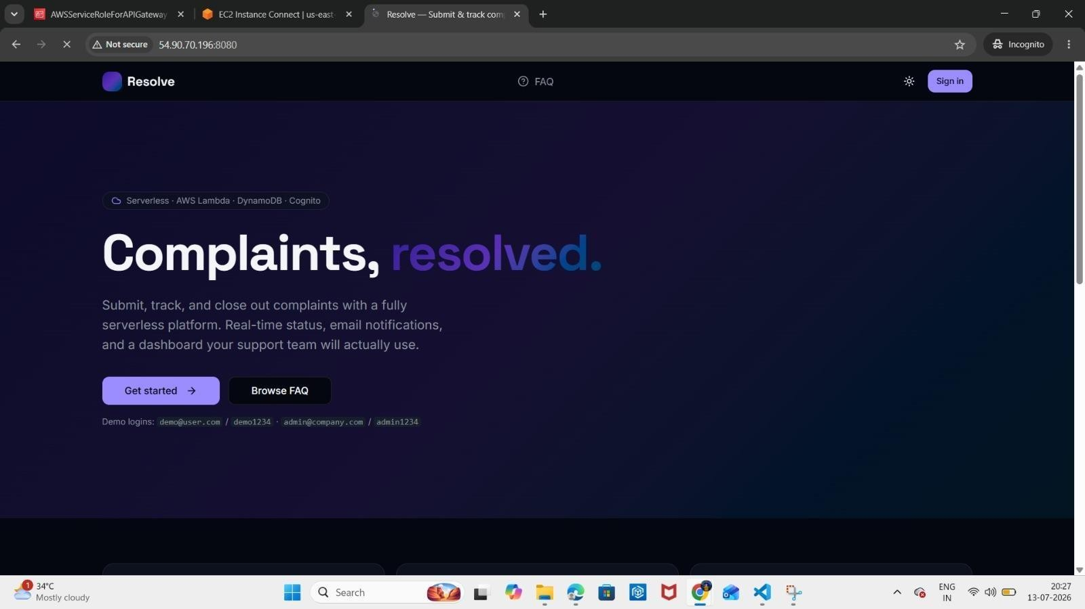

6.6.

Screenshots

of

the

output

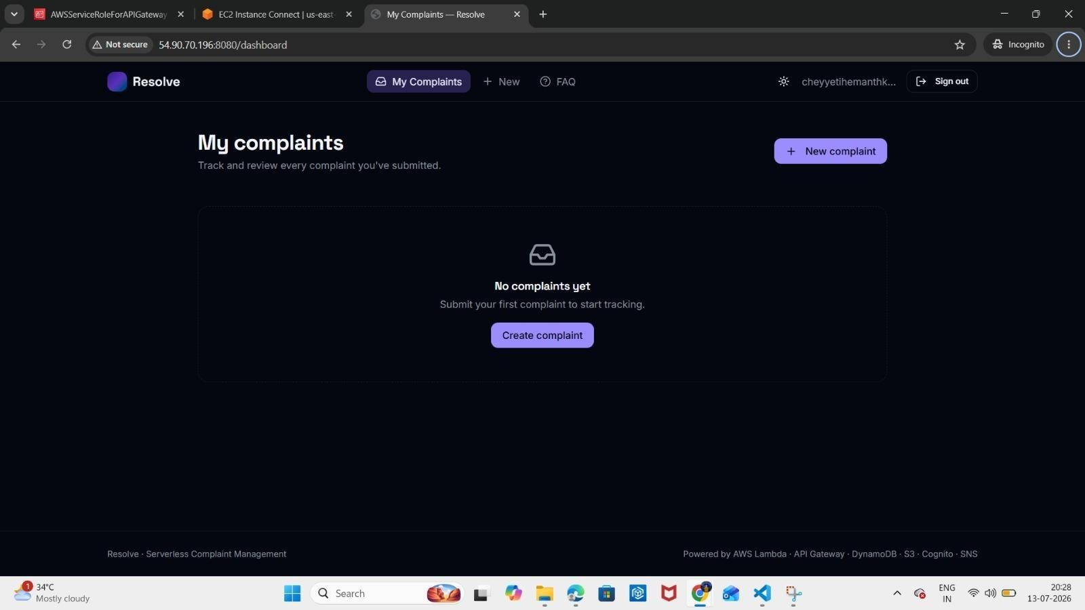

7. CONCLUSION
The Resolve Complaint System Deployment Using AWS (Linux) was successfully designed, developed, and deployed using modern web development and self-managed cloud server technologies. The project achieved its primary objective of creating a responsive, user-friendly, and reliable platform that allows users to register and track complaints efficiently, while implementing practical cloud hosting and secure server management practices.
The application was developed using React.js, Vite, TypeScript, and Tailwind CSS, providing a modern, type-safe, component-based architecture and an enhanced user experience across different devices. The application was successfully deployed on an Amazon EC2 (Linux) instance, where Node.js, npm, and Git were used to clone the project from GitHub, install dependencies, and build the production-ready application. The built files were served using the Nginx web server on Port 80, and Amazon Route 53 was configured to resolve a custom domain name to the EC2 instance's public IP, allowing users to access the system through a domain name. Secure access to the EC2 instance was managed using AWS Identity and Access Management (IAM), along with SSH key-pair authentication and Security Group rules, ensuring controlled and reliable server access.
The project also demonstrates the practical implementation of source code management by integrating GitHub for version control, branch management, and collaborative development, with the repository cloned directly onto the server during deployment. This self-managed deployment approach provided hands-on experience with Linux server administration, manual build automation, and direct web server configuration, in contrast to fully managed cloud hosting solutions.
Overall, the project successfully combines modern frontend development with AWS EC2 cloud hosting and Linux server administration to deliver a scalable, secure, and production-ready web application. The developed system provides a strong foundation for future enhancements such as HTTPS/SSL integration, backend API development, database connectivity, automated deployment scripting, and containerization, making it suitable for real-world organizational deployment.

